Supplementary Figures

TITLE: Proteomic analysis reveals a novel therapeutic strategy using Fludarabine for steroid-resistant asthma exacerbation
Authors’ full names: Xiaoming Liu^{a,b+}, Xiang Li^{a,b+}, Ling Chen^{a,b}, Alan Hsu^{b,c,d}, Kelly L. Asquith^{a,b}, Chi Liu^{e}, Karen Laurie^{f}, Ian Barr^{f}, Paul S. Foster^{a,b,*+}, and Ming Yang^{a,b,*+}
Authors’ affiliation(s):

ªSchool of Biomedical Sciences and Pharmacy, College of Health, Medicine and Wellbeing, University of Newcastle, Callaghan, NSW, Australia.
^{b}Priority of Research Center for Health Lungs, Hunter Medical Research Institute (HMRI), University of Newcastle, New Lambton Heights, NSW, Australia.
^{c}School of Medicine and Public Health, College of Health, Medicine and Wellbeing, University of Newcastle, Callaghan, NSW, Australia.
^{d}Programme in Emerging Infectious Diseases, Duke – National University of Singapore (NUS) Medical School, Singapore.
^{e}Department of Physiology, School of Basic Medicine Science, Central South University, Changsha, Hunan, China.
^{f}WHO Collaborating Centre for Reference and Research on Influenza, The Peter Doherty Institute for Infection and Immunity, Melbourne, VIC, Australia.
+Xiaoming Liu & Xiang Li contributed equally to this work and share first authorship; Ming Yang and Paul S. Foster contributed equally to this work and share last authorship.
Short title: Fludarabine inhibits asthma exacerbation
+Correspondence: Ming Yang and Paul S. Foster, Priority Research Centre for Healthy Lungs, Hunter Medical Research Institute, Lookout Road, New Lambton, NSW 2305, Australia. Emails: Ming.Yang@newcastle.edu.au, and Paul.Foster@newcastle.edu.au.

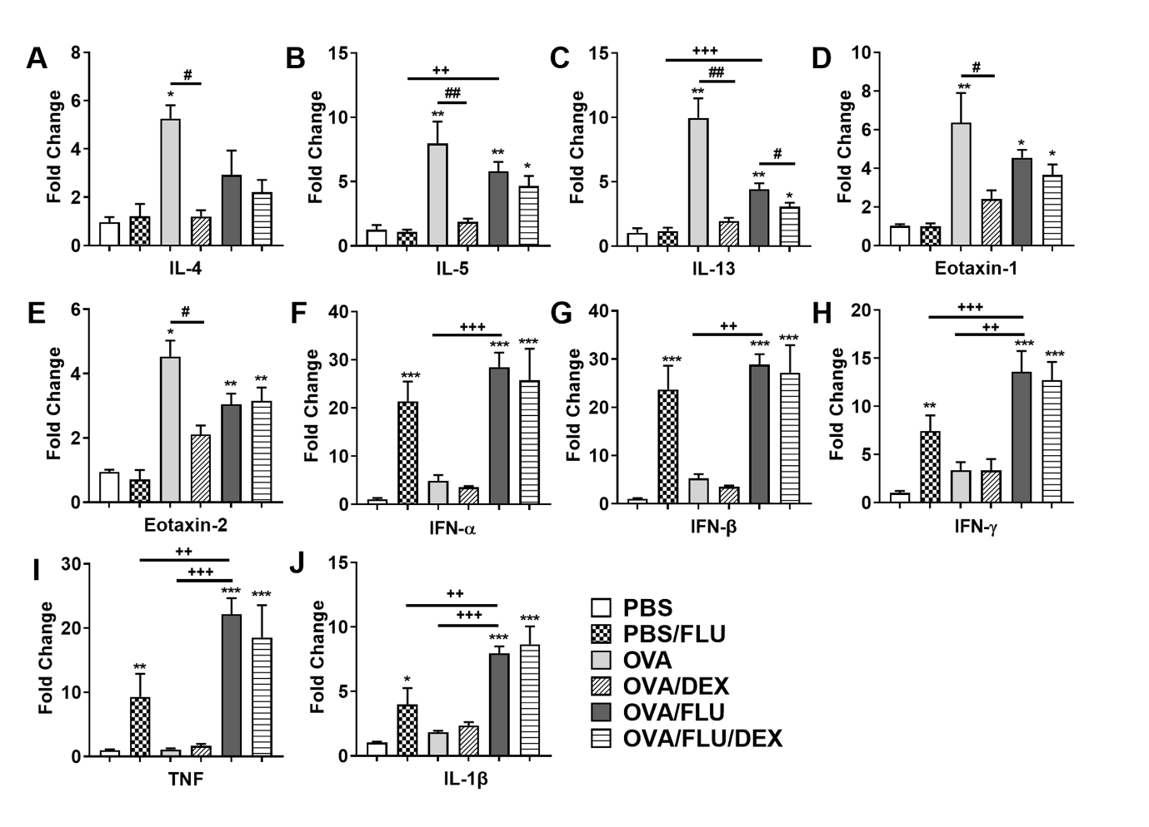

Supplementary Figure 1. Effects of FLU infection and DEX on inflammatory cytokine expression in mice lungs with allergic asthma. Cytokine production in lung tissues obtained from the same model as in Figure 1 was assessed on day 24 (5 days post infection). The mRNA levels of Th2 cytokines IL-4 (A), IL-5 (B), IL-13 (C), eotaxin-1 (D), eotaxin-2 (E); non-Th2 cytokines IFN-α (F), IFN-β (G), IFN-γ (H), TNF (I), IL-1β (J), were quantified by qPCR, the fold change was normalized to HPRT expression. Data are presented as mean ± SEM (n = 6-8 mice/group) and are representative of three independent experiments. *Designates significant differences from PBS-treated group (*p < 0.05, **p < 0.01, ***p < 0.001). #Designates significant differences from DEX-treated groups (#p < 0.05, ##p < 0.01). +Designates significant differences compared to OVA/FLU treated groups (++p < 0.01, +++p < 0.001).

Supplementary Figure 2. Whole blot presentation of STAT1 and phospho-STAT1 (P-STAT1) expression. (A) 20 µg of lung proteins from each group as the same conditions in Figure 5 and (B) 20 µg of lung proteins from each group as the same conditions in Figure 6 were loaded on different stain-free gels and transferred to PVDF membranes after separation. Anti-STAT1 Ab and anti-phospho-STAT1 (Tyr701) Ab were firstly stained and visualized, then the blots were stripped to re-incubate with β-actin (42 kDa) as a loading control. Arrows indicated at 91 and 84 kDa were the two isoforms of STAT1 (Stat1α, Stat1β) and phospho-STAT1 (p-Stat1α and p-Stat1β).

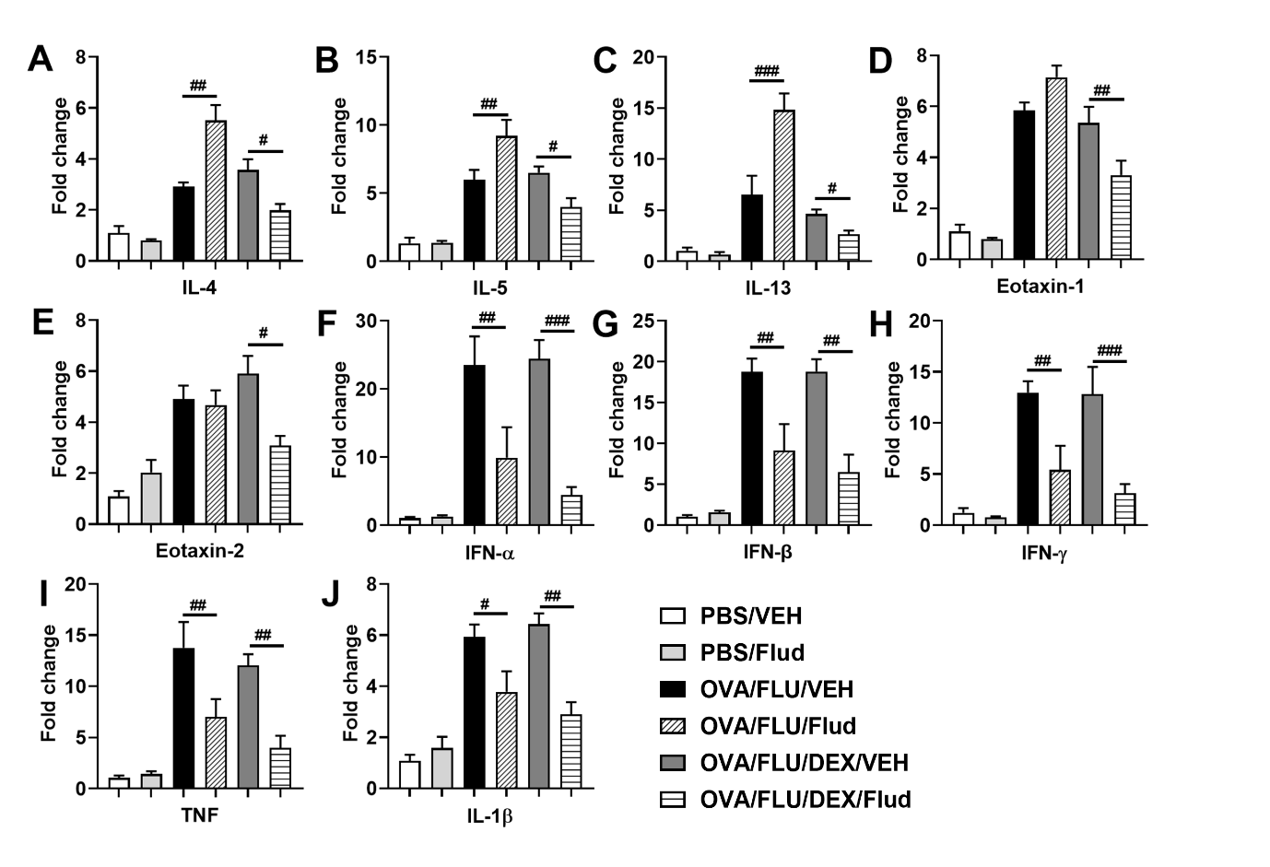

Supplementary Figure 3. Effects of Fludarabine and its combination with DEX on inflammatory cytokines expression in mice lungs with FLU-induced asthma exacerbation. Cytokine production in lung tissues obtained from same model in Figure 5 was assessed on day 24 (5 days post infection). The mRNA levels of Th2 cytokines IL-4 (A), IL-5 (B), IL-13 (C), eotaxin-1 (D), eotaxin-2 (E); non-Th2 cytokines IFN-α (F), IFN-β (G), IFN-γ (H), TNF (I), and IL-1β (J), were quantified by qPCR, the fold change was normalized to HPRT expression. Data are presented as mean ± SEM (n = 6-8 mice/group) and are representative of three independent experiments. Results are representative of three independent experiments. #Designates significant differences between Flud-treated and isotype-treated groups (#p < 0.05, ##p < 0.01, ###p < 0.001).

