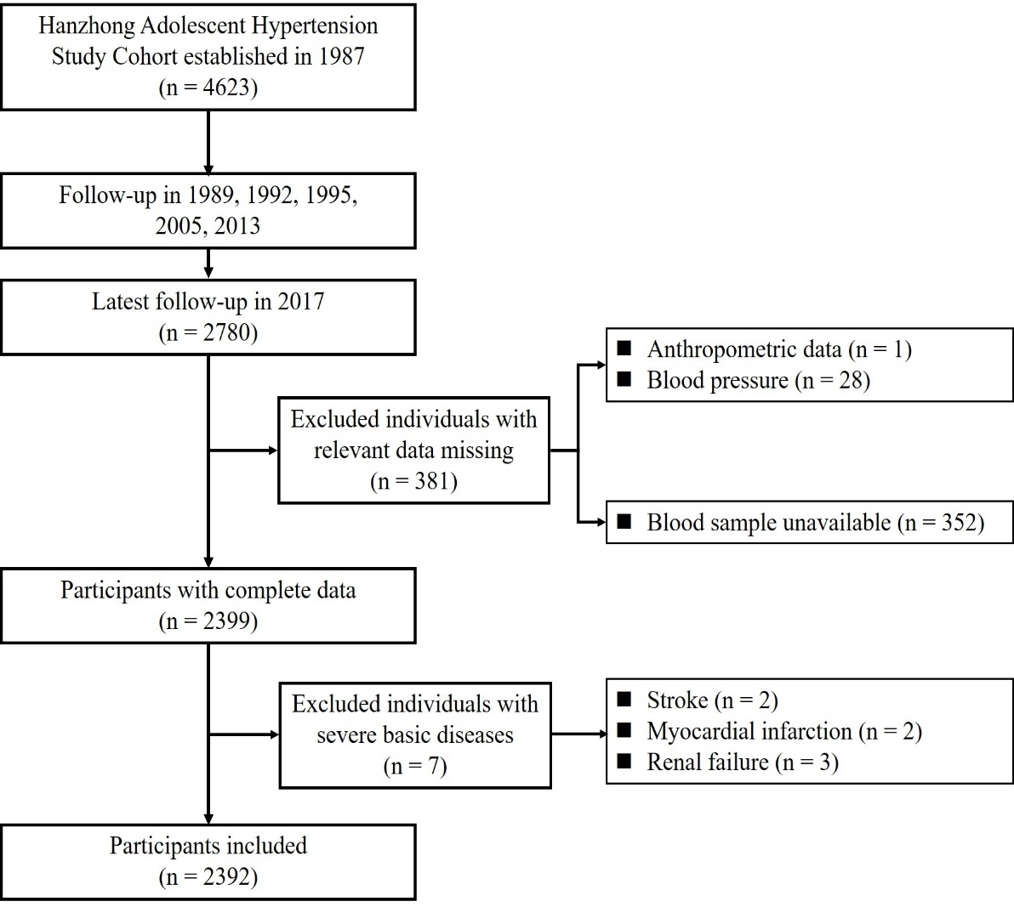Figure S1. Flow diagram for recruitment of participants in cross-sectional study.

Table S1. Information on genotyped SNPs of RNLS
SNP | Position | Region | Alleles ª | MAF | P-value^{b†} | Potential function prediction
rs10509540 | 88263276 | intron 7 | T/C | 0.250 | 0.376 | —
rs7922058 | 88274282 | intron 7 | A/G | 0.274 | 0.675 | miRNA
rs999951 | 88276610 | intron 6 | C/G | 0.240 | 0.250 | —
rs10887800 | 88316086 | intron 5 | A/G | 0.469 | 0.869 | —
rs796945 | 88391080 | intron 4 | T/C | 0.448 | 0.867 | —
rs1935582 | 88432773 | intron 4 | A/T | 0.483 | 0.620 | —
rs7076491 | 88471164 | intron 4 | T/C | 0.135 | 0.724 | —
rs2296545 | 88583080 | exon 1 | C/G | 0.403 | 0.226 | Splicing
rs2576178 | 88583641 | exon 1 | G/A | 0.451 | 0.401 | transcription factor binding site
rs17109290 | 88584404 | exon 1 | A/G | 0.129 | 1 | transcription factor binding site
SNP, single nucleotide polymorphism; MAF, minor allele frequency. †parents only (parental generation).
^{b}P values of Hardy-Weinberg equilibrium test. ª Alleles are presented as major: minor allele.

Table S2. Relationship between various characteristics and BP levels (n=2392).
Characteristics | Systolic Blood Pressure |  | Diastolic Blood Pressure
 | β | P value | β | P value
Serum renalase (μg/mL) | 0.056 | 0.003 | 0.046 | 0.015
Gender (Male) | -0.192 | <0.001 | -0.258 | <0.001
Age (years) | 0.124 | <0.001 | 0.070 | <0.001
BMI (kg/m²) | 0.313 | <0.001 | 0.289 | <0.001
Total cholesterol (mmol/L) | 0.049 | 0.011 | 0.052 | 0.007
eGFR (mL/min/1.73m²) | 0.040 | 0.045 | 0.031 | 0.121
Diabetes mellitus (n, %) | 0.028 | 0.140 | 0.023 | 0.229
Triglycerides (mmol/L) | 0.030 | 0.141 | 0.049 | 0.016
BMI, body mass index; eGFR, estimated glomerular filtration rate.

Table S3. Characteristics of human studies on renalase and hypertension