Supplementary Figure 1. XRD patterns of representative clay samples. Illite-smectite mixed layer (I/S), smectite, illite, chlorite and kaolinite are the main clay minerals in the section. AD, EG, T and Hyd represent aid-dried, glycol-saturated, heated and hydrazine-saturated states, respectively.

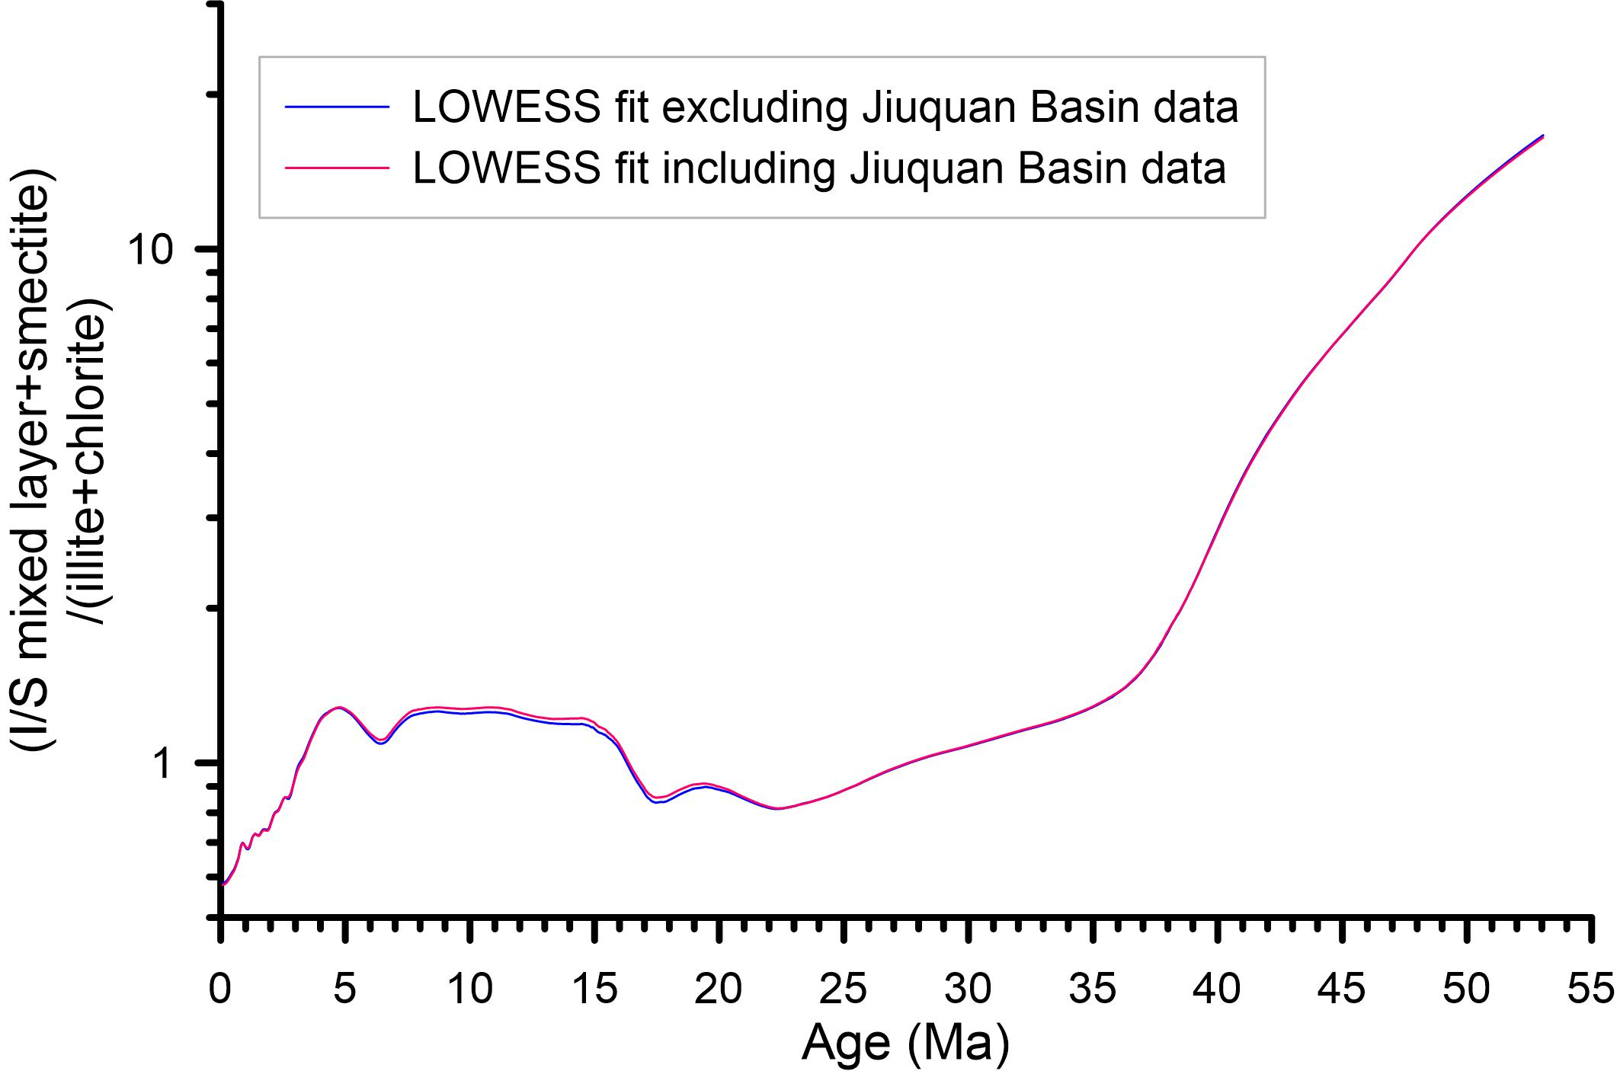
Supplementary Figure 2. Locally-weighted scatterplot smoothing (LOWESS, smoothing factor is 0.1) of the compiled data with and excluding the Jiuquan Basin clay mineral data.
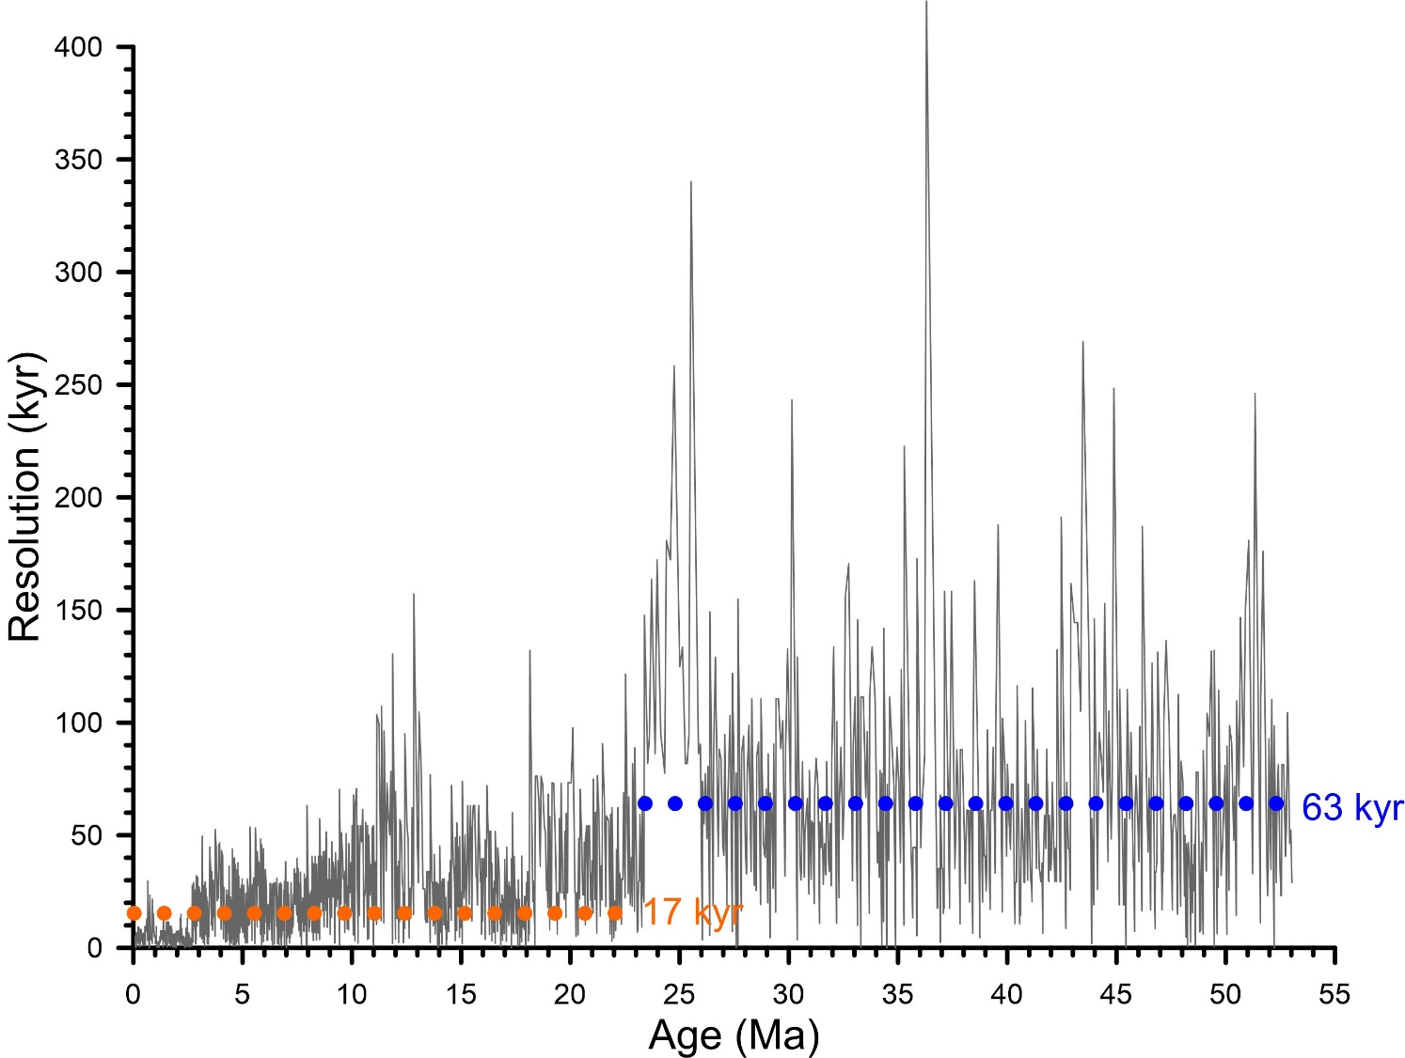
Supplementary Figure 3. Temporal resolution of the compiled (I/S mixed layer+smectite)/(illite+chlorite) records. Dotted line blue and red lines indicate the average of the data values before and after 23 Ma, respectively.

