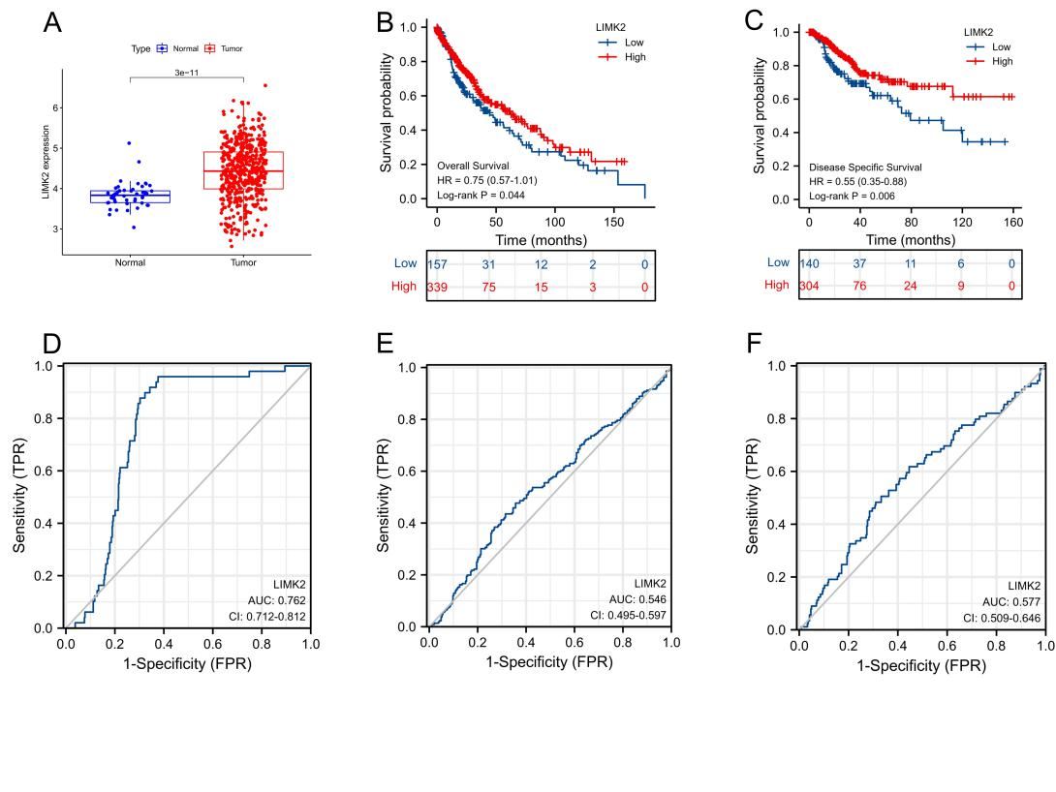
Supplementary figure 1. The expression of LIMK2 in LUSC based on the TCGA-LUSC dataset (A). The OS (B) and DFS (C) for LIMK2 in LUSC patients. ROC curve analysis for LUSC prediction (D), OS prediction (E), and DFS prediction (F).

Supplementary figure 2. RT-PCR analysis of the relative expression of miR-423-5p in lung squamous carcinoma cells (NCI-H292) transfected with miR-423-5p inhibitor or NC-inhibitor, and miR-423-5p mimic or NC-mimic (A). Determination of the LIMK2 expression level in miR-423-5p mimic and miR-423-5p inhibitor treated NCI-H292 cells (B).

Supplementary Table 1. Mimics/inhibitor sequences list
 | Sequence
mimic NC | UUCUCCGAACGUGUCACGUTT
inhibitor NC | CAGUACUUUUGUGUAGUACAA
miR-423-5p mimic | UGAGGGGCAGAGAGCGAGACUUU
miR-423-5p inhibitor | AAAGUCUCGCUCUCUGCCCCUCA
Supplementary Table 2. Primer sequences list
 | Sequence
miR-423-5p | Forward: ACGTGAGGGGCAGAGAGC  Reverse: GTGCAGGGTCCGAGGT
U6 | Forward: CAGCACATATACTAAAATTGGAACG  Reverse: ACGAATTTGCGTGTCATCC
LIMK2 | Forward: GGATTCCCTCACCAACTGGTA  Reverse: AGCCACCATAAAAGGCCCTG
GAPDH | Forward: TGCACCACCAACTGCTTAGC  Reverse: GGCATGGACTGTGGTCATGAG

Supplementary Table 3. Abbreviations are as above

BLCA | Bladder Urothelial Carcinoma
BRCA | Breast invasive carcinoma
CHOL | Cholangiocarcinoma
COAD | Colon adenocarcinoma
ESCA | Esophageal carcinoma
HNSC | Head and Neck squamous cell carcinoma
KICH | Kidney Chromophobe
KIRC | Kidney renal clear cell carcinoma
KIRP | Kidney renal papillary cell carcinoma
LIHC | Liver hepatocellular carcinoma
LUAD | Lung adenocarcinoma
LUSC | Lung squamous cell carcinoma
PRAD | Prostate adenocarcinoma
READ | Rectum adenocarcinoma
STAD | Stomach adenocarcinoma
THCA | Thyroid carcinoma
UCEC | Uterine Corpus Endometrial Carcinoma
HNSC | Head and Neck squamous cell carcinoma
TCGA | The Cancer Genome Atlas
GSEA | Gene set enrichment analysis
LASSO | Least absolute shrinkage and selection operator
ROC | Receiver operating characteristic
CTLA-4 | Cytotoxic lymphocyte associated antigen-4
PD-1 | Programmed cell death protein 1
PD-L1 | Programmed death-ligand 1

