**Additional file 1**

**Figures:**

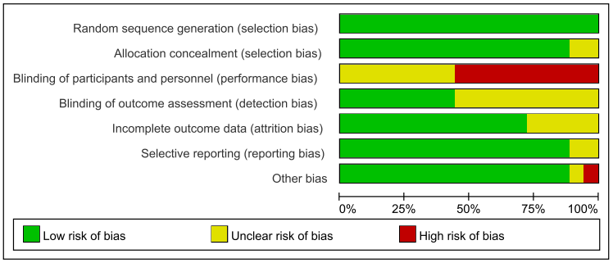

**Supplementary Figure 1.** Risk of bias graph

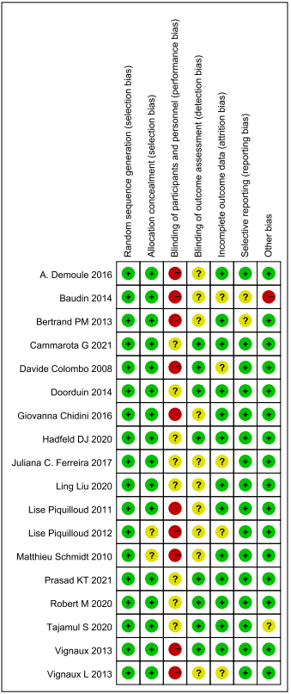

**Supplementary Figure 2.** Risk of bias summary

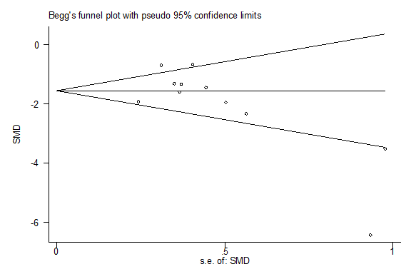

**Supplementary Figure 3.** Funnel plot of publication bias



**Supplementary Figure 4.** Sensitivity analyses for AI

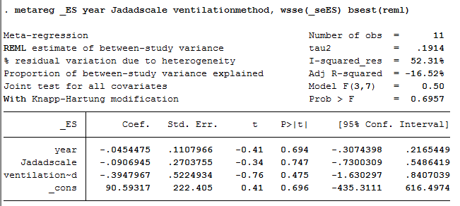

**Supplementary Figure 5.** Meta regression for AI



**Supplementary Figure 6.** Sensitivity analyses for duration of MV