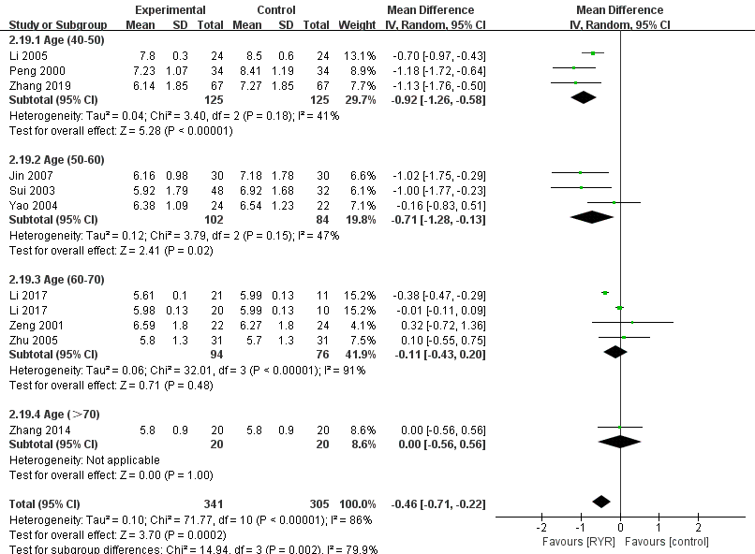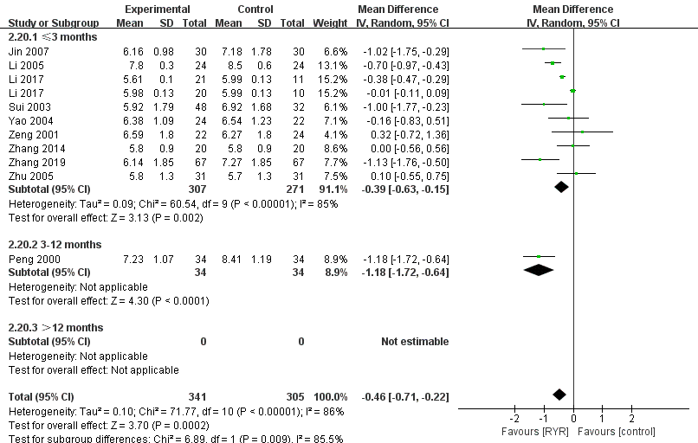
A B
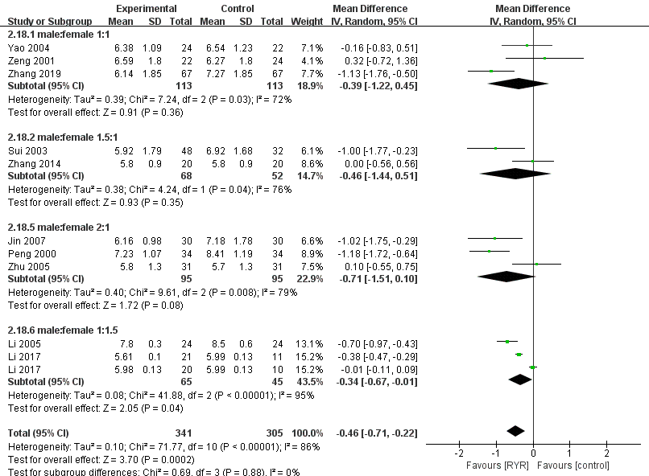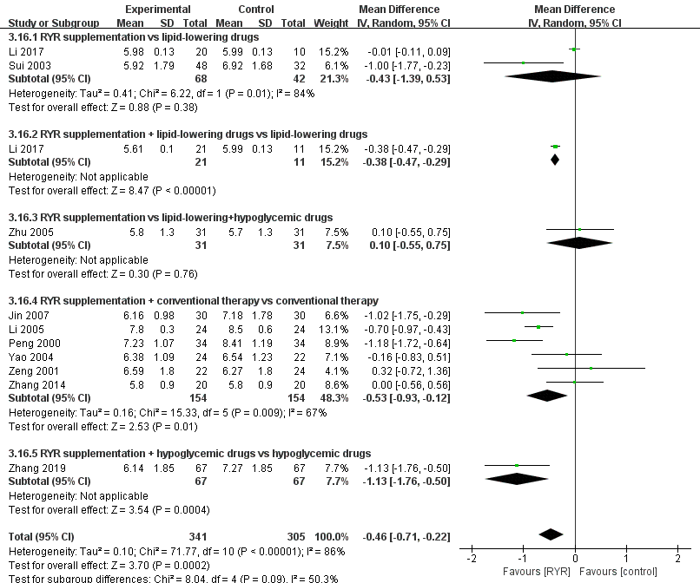
C D
Supplementary Figure S1 Forest plots of the subgroup analysis of FPG classified by (A) age, (B) intervention duration, (C) sex, and (D) intervention type
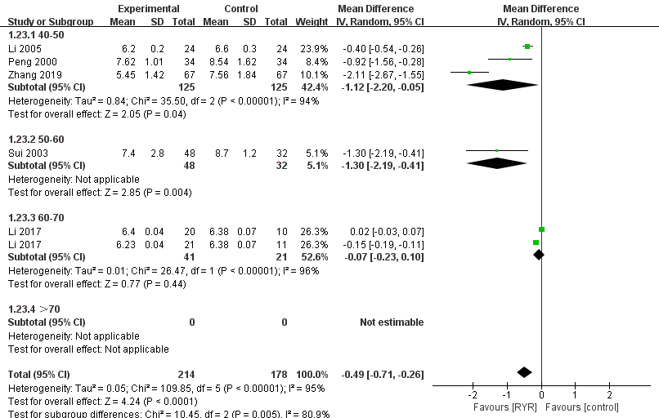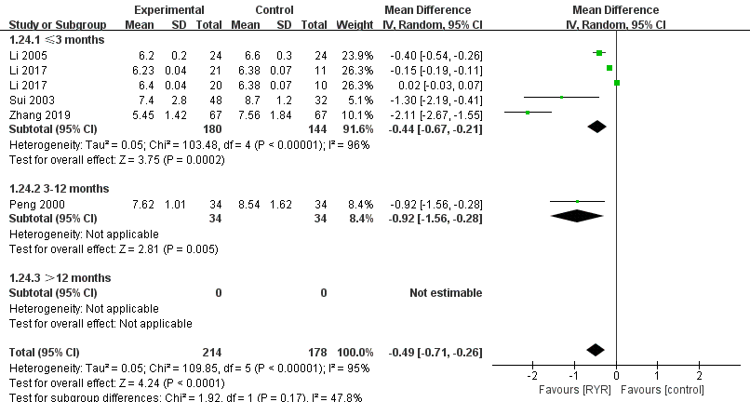
A B
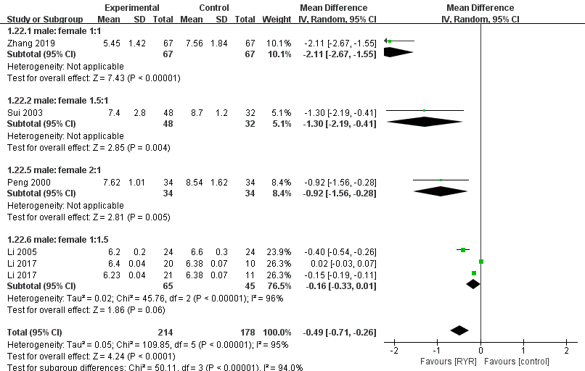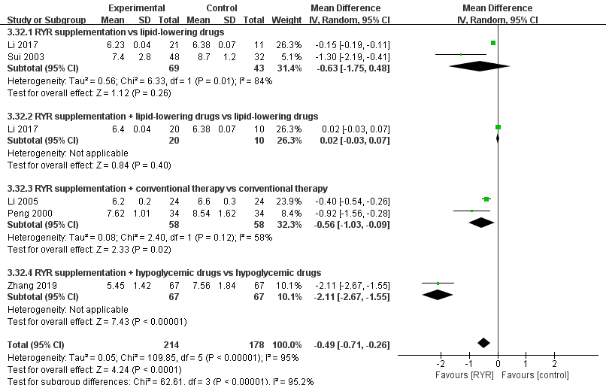
C D
Supplementary Figure S2 Forest plots of the subgroup analysis of HbA1c classified by (A) age, (B) intervention duration, (C) sex, and (D) intervention type

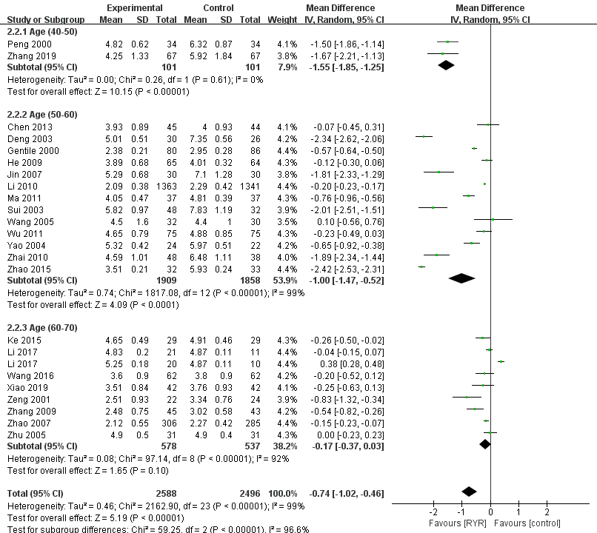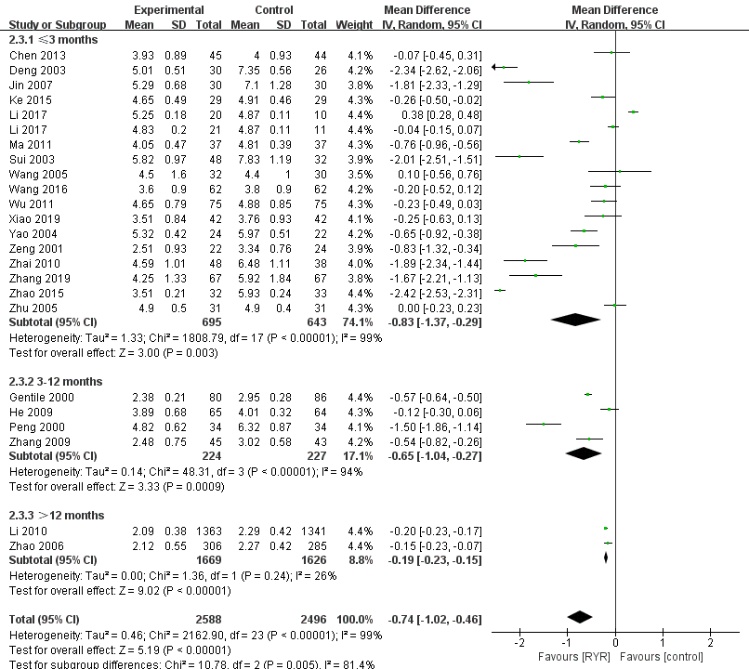
A B
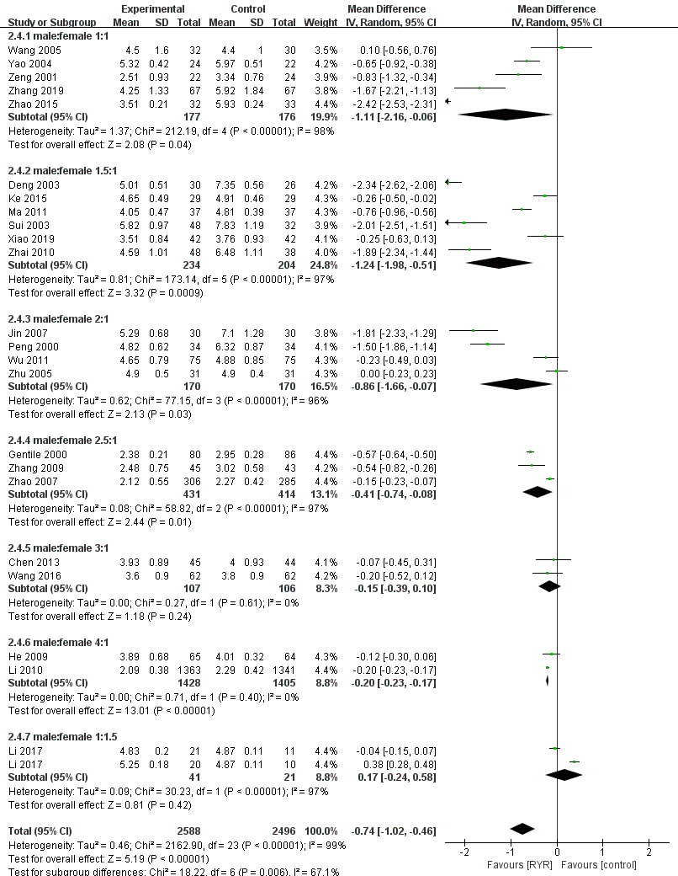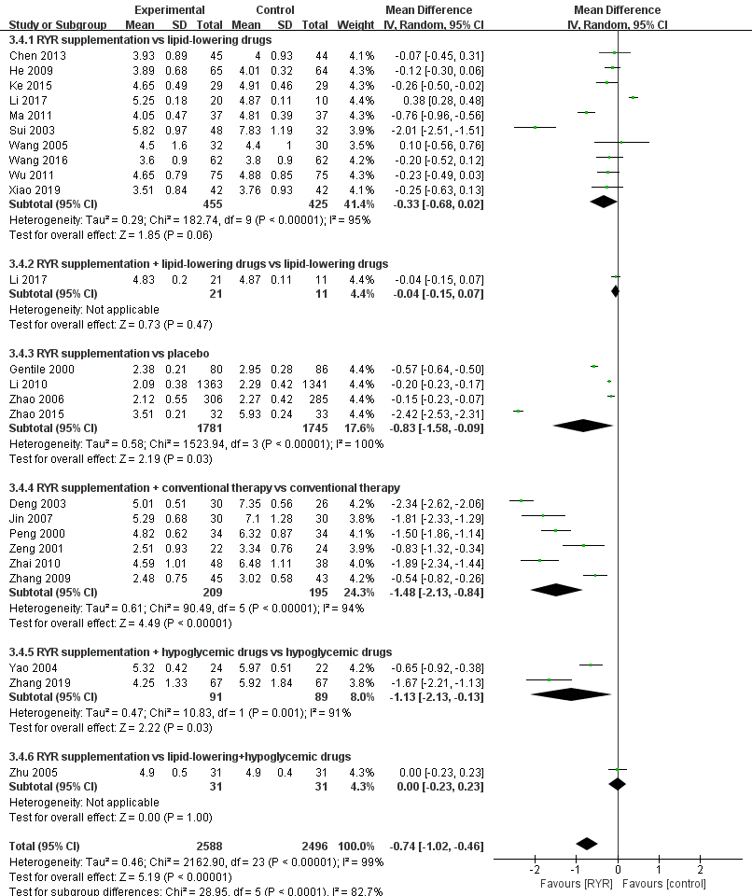
C D
Supplementary Figure S3 Forest plots of the subgroup analysis of TC classified by (A) age, (B) intervention duration, (C) sex, and (D) intervention type

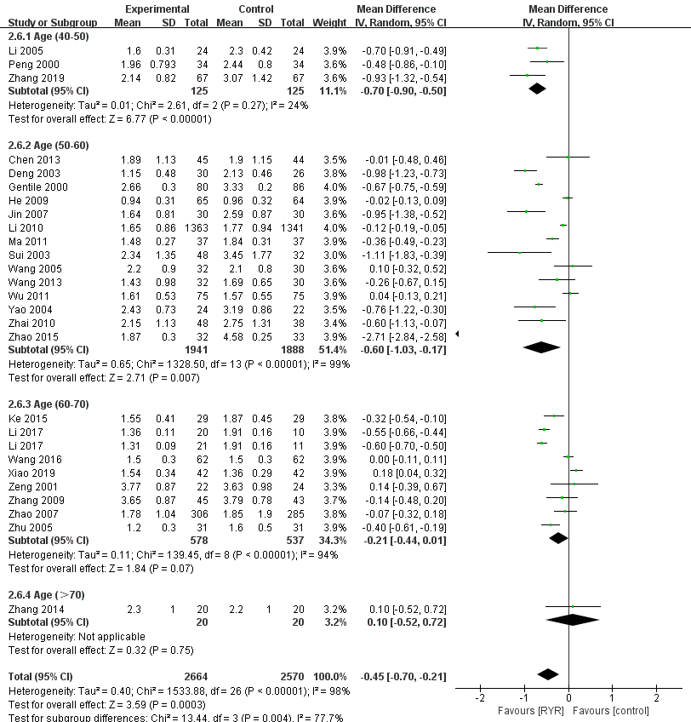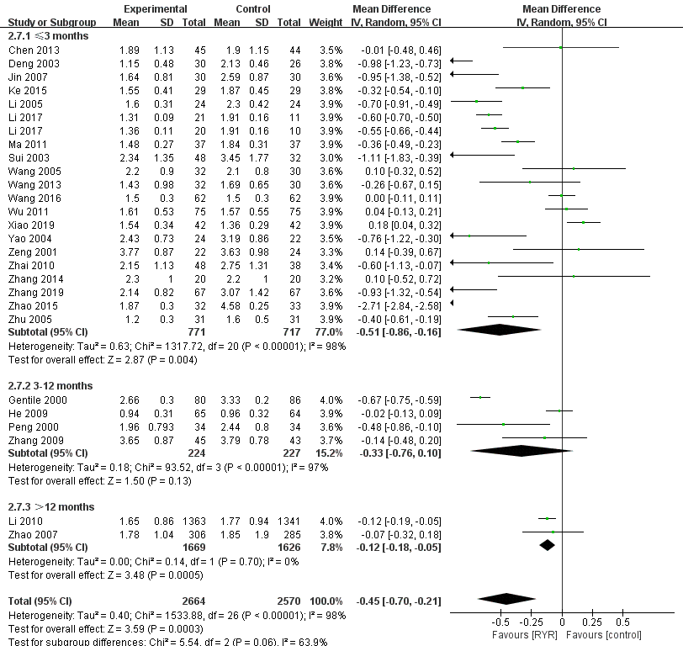
A B
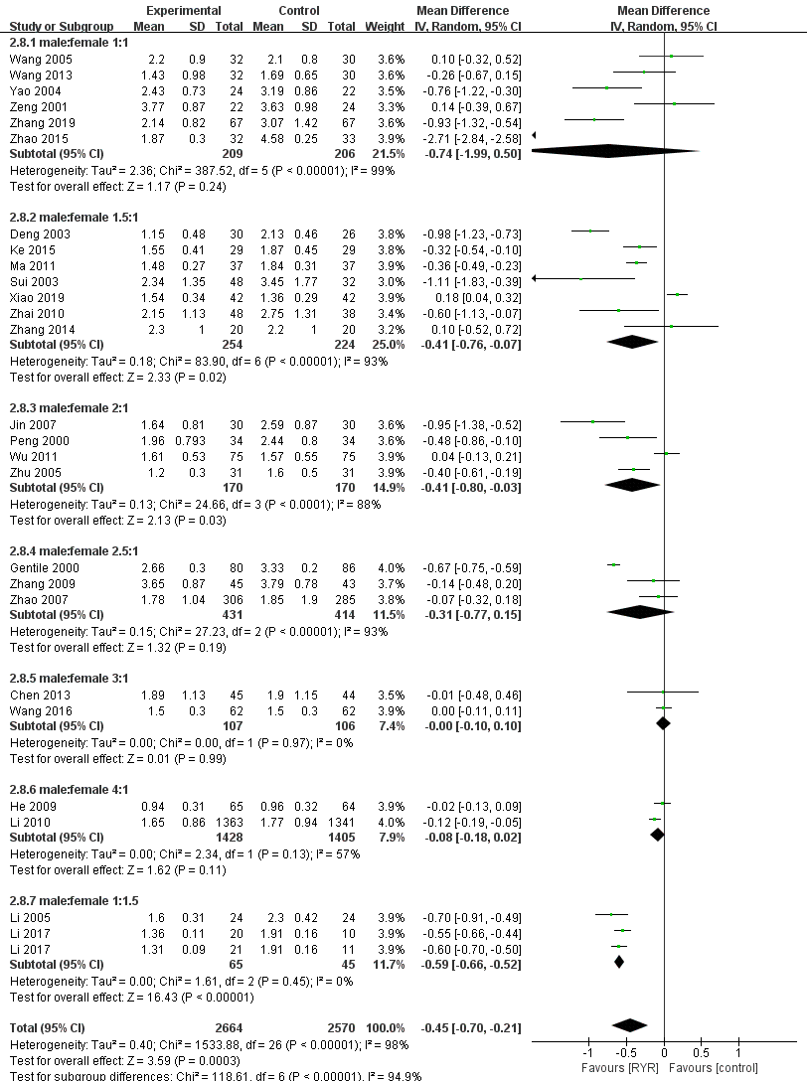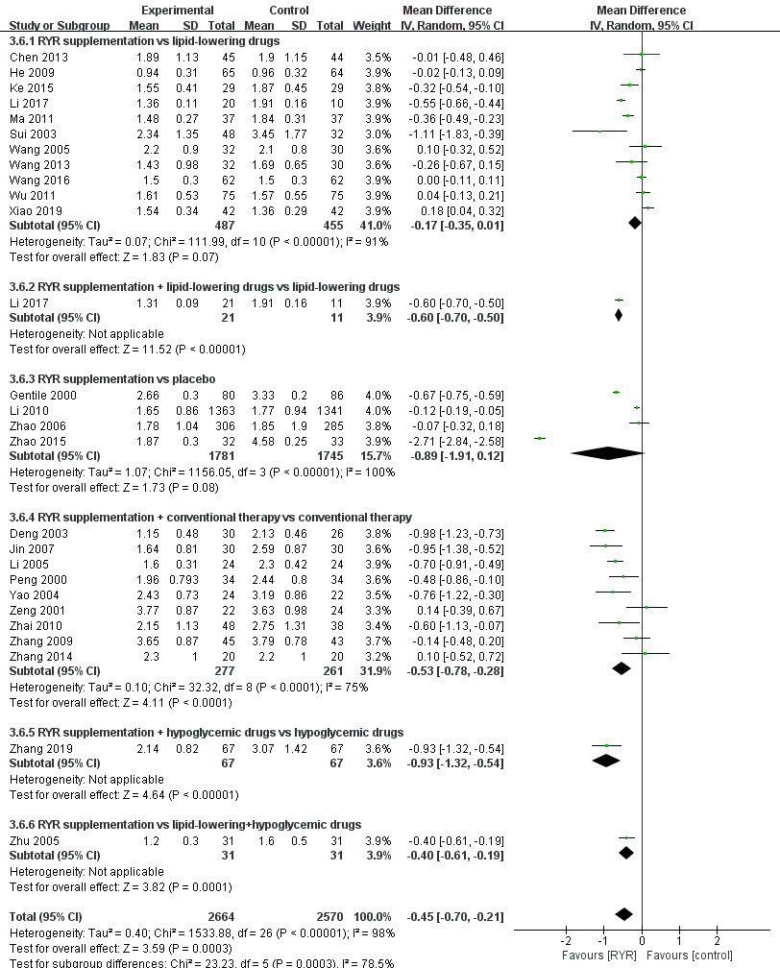
C D
Supplementary Figure S4 Forest plots of the subgroup analysis of TG classified by (A) age, (B) intervention duration, (C) sex, and (D) intervention type

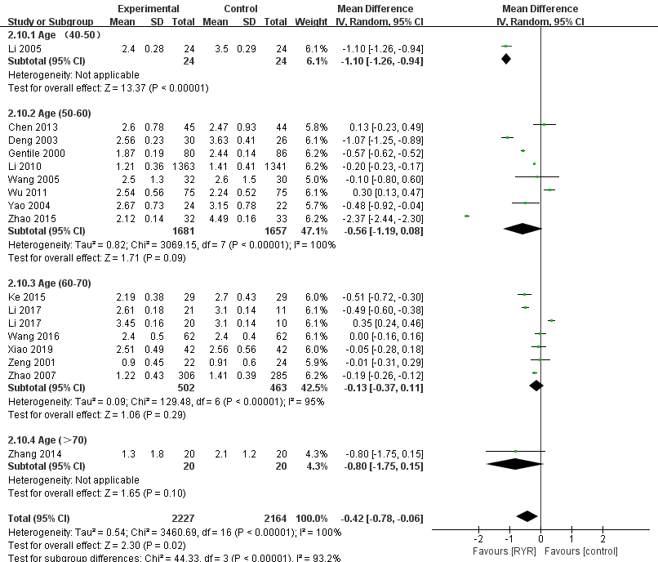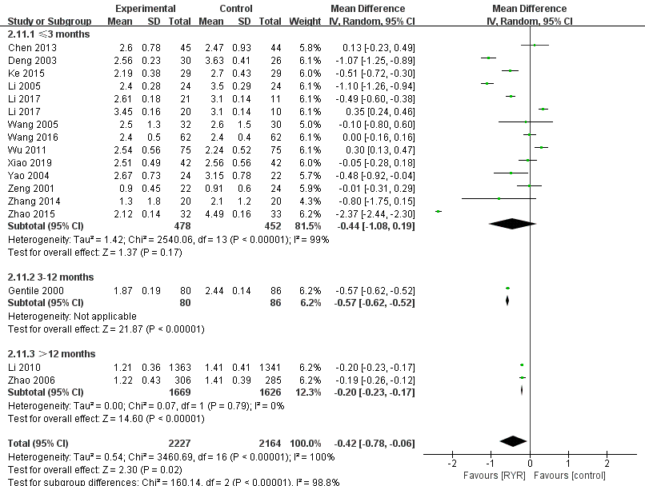
A B
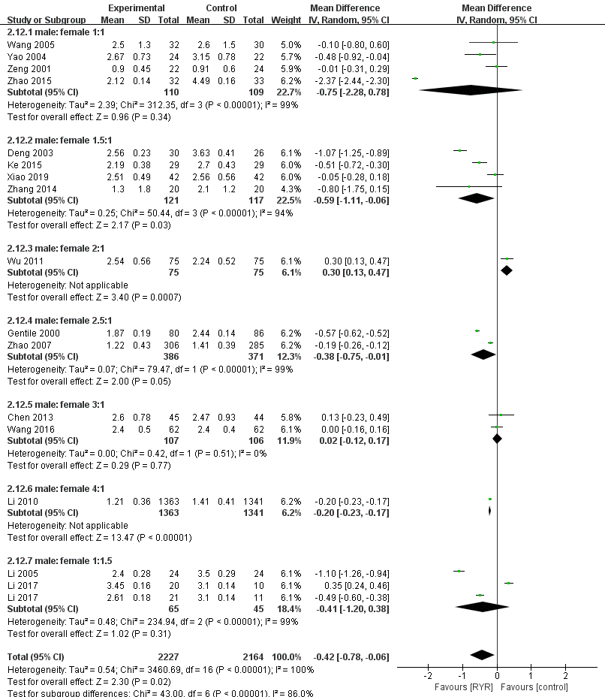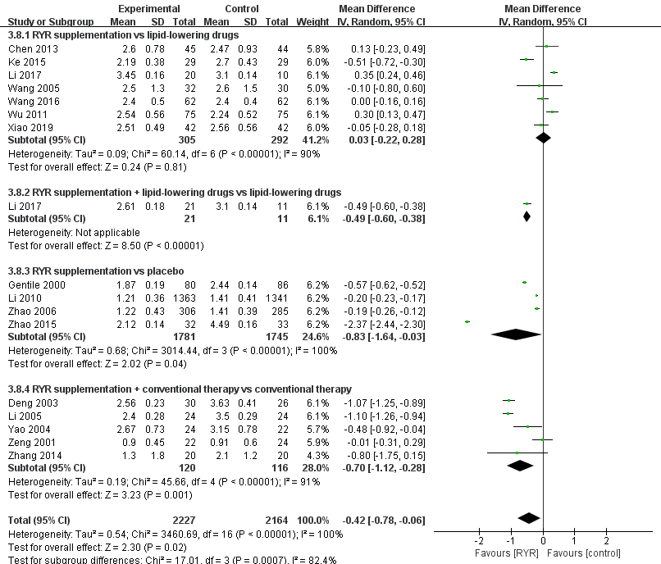
C D
Supplementary Figure S5 Forest plots of the subgroup analysis of LDL classified by (A) age, (B) intervention duration, (C) sex, and (D) intervention type

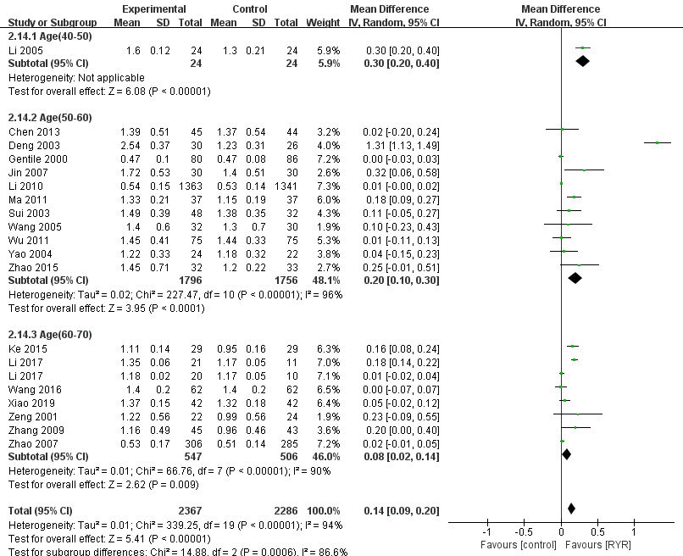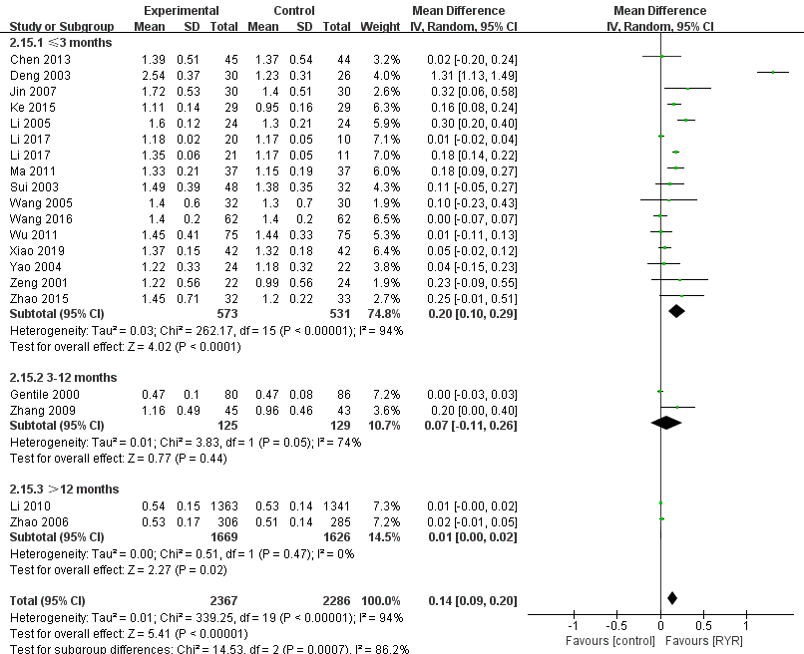

A B
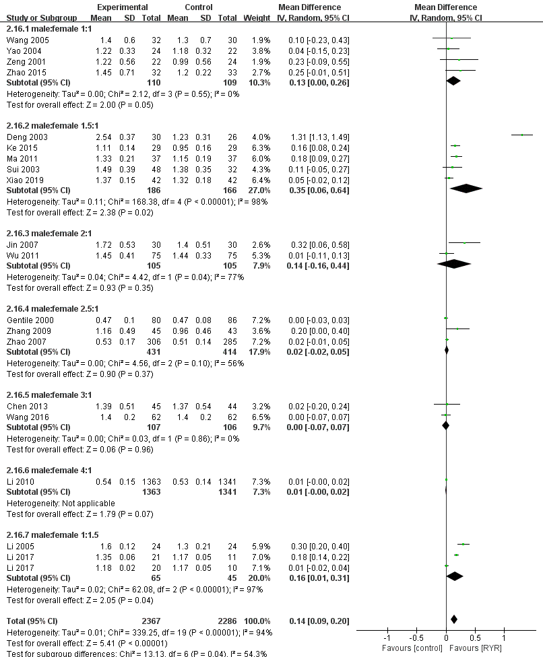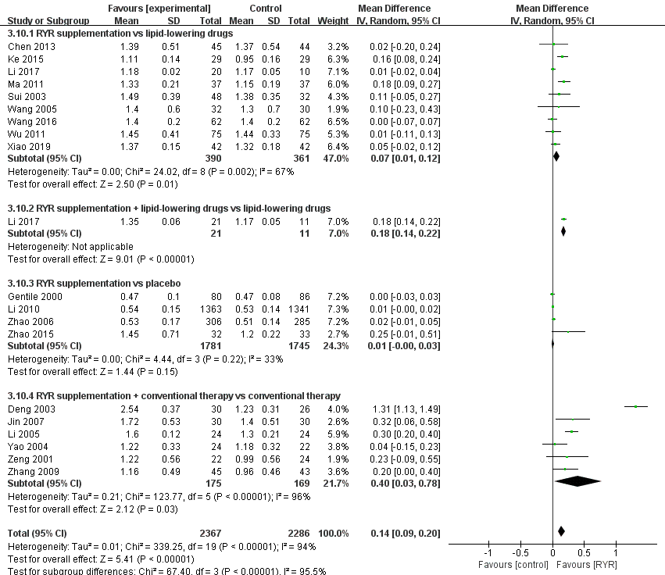
C D
Supplementary Figure S6 Forest plots of the subgroup analysis of HDL classified by (A) age, (B) intervention duration, (C) sex, and (D) intervention type

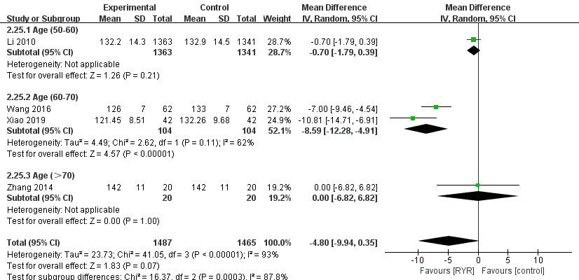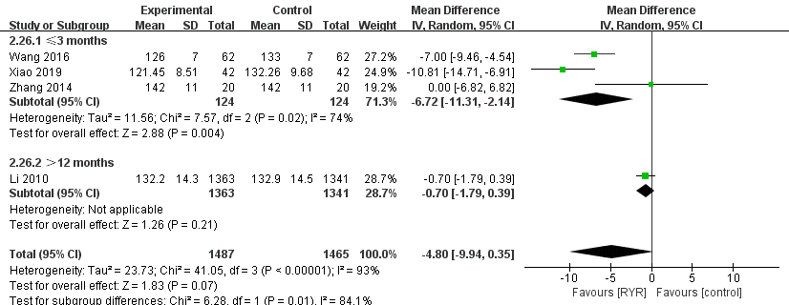
A B
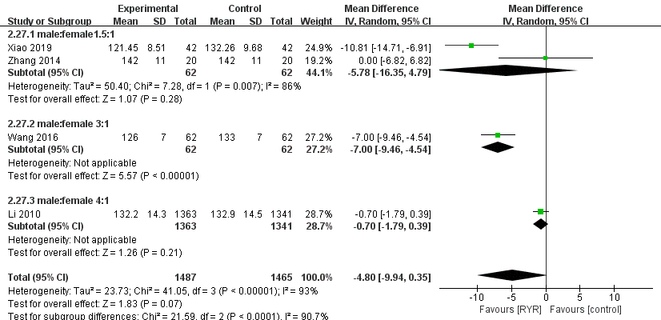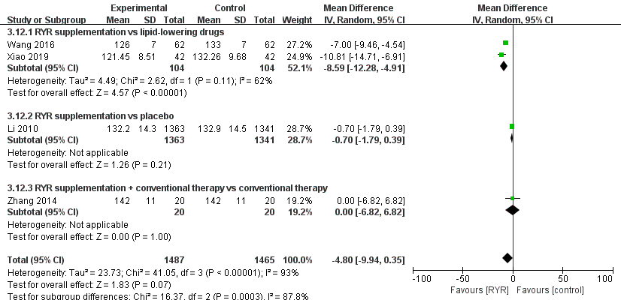
C D
Supplementary Figure S7 Forest plots of the subgroup analysis of SBP classified by (A) age, (B) intervention duration, (C) sex, and (D) intervention type

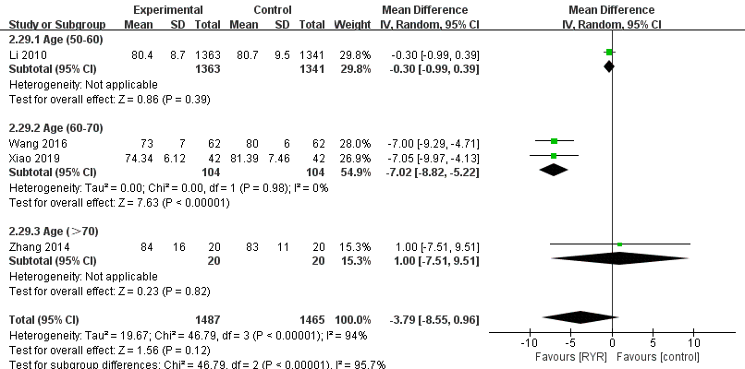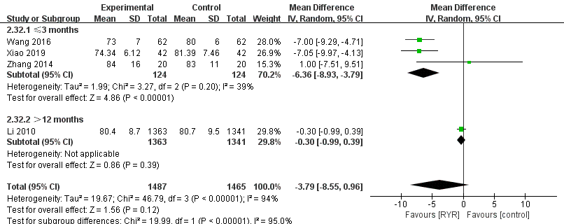
A B
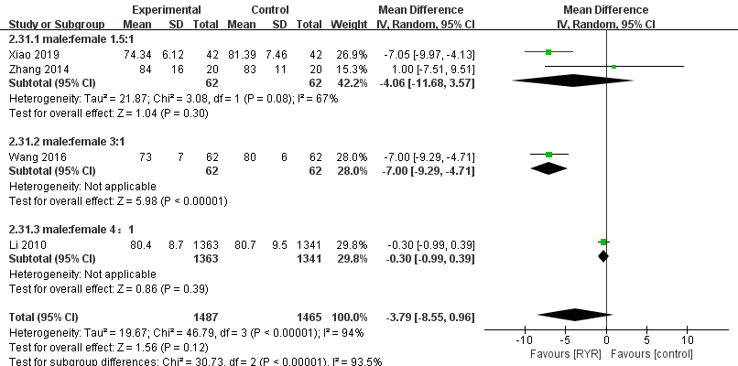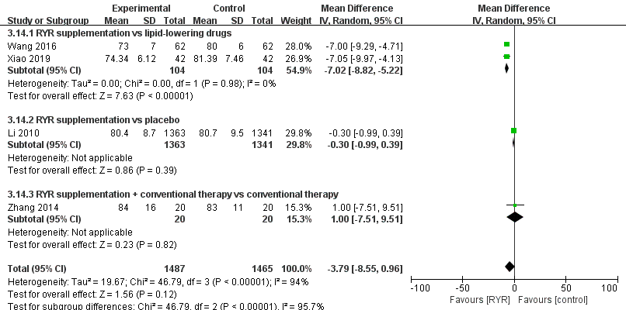
C D
Supplementary Figure S8 Forest plots of the subgroup analysis of DBP classified by (A) age, (B) intervention duration, (C) sex, and (D) intervention type

