Supplementary Table S1
Fatty acid composition of four experimental diets (μg/g).
Fatty acids |  | Experiment diets
 |  | Control | Soybean lecithin | Egg yolk lecithin | Krill oil
Fatty acids with higher relative content in soybean lecithin group
cis, cis-9,12-Linoleic Acid | C18:2 | 287.09ª | 1524.91^{c} | 493.94^{b} | 317.25ª
trans-11-Octadecenoic acid | C18:1 | 830.25^{b} | 1205.87^{d} | 1134.90^{c} | 770.11ª
cis, cis, cis-9,12,15-Linolenic Acid | C18:3 | 31.89ª | 173.72^{d} | 41.34^{b} | 69.53^{c}
Eicosanoic Acid | C20:0 | 15.30ª | 18.36^{c} | 16.53^{b} | 14.79ª
Lignoceric Acid | C24:0 | 11.08ª | 12.64^{c} | 11.74^{b} | 11.41^{ab}
Behenic Acid | C22:0 | 7.74ª | 10.54^{c} | 8.41^{b} | 8.74^{b}
Tricosanoic Acid | C23:0 | 6.03ª | 6.92^{b} | 6.23ª | 6.11ª
Fatty acids with higher relative content in egg yolk lecithin group
Stearic Acid | C18:0 | 344.36ª | 452.66^{b} | 545.20^{c} | 337.91ª
Fatty acids with higher relative content in krill oil group
all-cis-4,7,10,13,16,19-Docosahexaenoic Acid (DHA) | C22:6 | 271.94ª | 298.88^{b} | 307.39^{b} | 1165.66^{c}
all-cis-5,8,11,14,17-Eicosapentaenoic Acid | C20:5 | 144.85ª | 170.41^{b} | 167.81^{b} | 1030.38^{c}
cis-11-Octadecenoic acid | C18:1 | 67.36ª | 115.54^{c} | 95.06^{b} | 249.20^{d}
Myristic Acid | C14:0 | 109.06ª | 148.97^{b} | 147.85^{b} | 229.54^{c}
cis-15-Nervonic Acid | C24:1 | 45.92ª | 50.32^{b} | 50.74^{b} | 168.17^{c}
cis-9-Palmitoleic Acid | C16:1 | 95.84ª | 141.61^{b} | 147.52^{c} | 165.60^{d}
all-cis-7,10,13,16,19-Docosapentaenoic acid (EPA) | C22:5 | 46.62ª | 50.99^{b} | 52.39^{b} | 69.70^{c}
cis-11-Eicosenoic Acid | C20:1 | 30.32ª | 39.36^{c} | 37.91^{b} | 40.42^{d}
Pentadecanoic Acid | C15:0 | 19.47ª | 25.29^{b} | 23.77^{b} | 29.57^{c}
cis-13-Erucic Acid | C22:1 | 8.47ª | 9.57ª | 9.39ª | 17.48^{b}
cis, cis, cis-6,9,12-Linolenic Acid | C18:3 | 9.52ª | 10.24^{b} | 10.55^{b} | 12.26^{c}
cis, cis, cis-8,11,14-Linolenic Acid | C20:3 | 5.25ª | 5.55ª | 6.68^{b} | 7.98^{c}
all-cis-11,14,17-Eicosatrienoic Acid | C20:3 | 4.64ª | 5.07^{b} | 5.22^{b} | 7.98^{c}
trans-13-Docosenoic acid | C22:1 | 0.00ª | 0.00ª | 0.00ª | 5.87^{b}
Fatty acids with no significant difference in pairwise comparison
Palmitic Acid | C16:0 | 1167.74ª | 1901.81^{c} | 1867.66^{c} | 1556.67^{b}
all-cis-5,8,11,14-Eicosatetraenoic Acid (AA) | C20:4 | 32.06ª | 35.39^{b} | 66.35^{c} | 63.25^{c}
Heptadecanoic Acid | C17:0 | 23.35ª | 28.91^{c} | 28.25^{c} | 26.42^{b}
trans-9-Elaidic Acid | C18:1 | 13.76^{ab} | 13.23ª | 14.03^{b} | 14.36^{b}
cis, cis-11,14-Eicosadienoic Acid | C20:2 | 7.45ª | 9.06^{b} | 10.45^{b} | 10.26^{b}
Lauric Acid | C12:0 | 7.41ª | 8.72ª | 12.11^{b} | 9.90^{ab}
trans, trans-9,12-Linolelaidic Acid | C18:2 | 6.94^{b} | 6.85^{ab} | 6.90^{ab} | 6.65ª
tran-9-Palmitelaidic acid | C16:1 | 4.96^{ab} | 4.90^{ab} | 4.57ª | 5.08^{b}
Heneicosanoic Acid | C21:0 | 3.68ª | 3.99^{c} | 3.77^{ab} | 3.94^{bc}
cis-9-Myristoleic Acid | C14:1 | 3.61ª | 4.16^{b} | 4.43^{b} | 4.57^{b}
trans-11-Eicosenoic acid | C20:1 | 2.44^{b} | 2.54^{b} | 1.95^{b} | 0.36ª
Saturated fatty acid | SFA | 1715.21ª | 2609.29^{c} | 2488.04^{bc} | 2234.98^{b}
Monounsaturated fatty acid | MUFA | 1133.36ª | 1615.88^{d} | 1529.36^{c} | 1470.01^{b}
Polyunsaturated fatty acid | PUFA | 690.57ª | 995.44^{b} | 1971.61^{d} | 1679.64^{c}
n-3 fatty acid | n-3 FA | 495.31ª | 694.01^{c} | 568.93^{b} | 2335.27^{d}
n-6 fatty acid | n-6 FA | 335.62ª | 1577.41^{d} | 577.74^{c} | 399.4^{b}
n-9 fatty acid | n-9 FA | 106.22ª | 152.33^{b} | 158.08^{c} | 176.77^{d}
The values are the mean ± standard errors (n=4). Different superscripts (a, b, c and d) in the same row represent significant difference (P <0.05,
single factor analysis of variance and Duncan's tests).

Supplemental Figure S1︱Heatmaps for hierarchical clustering analysis of differential metabolites in ovary. Colors from dark blue to dark red indicate the contents of lipid molecules from min to max within a row. Ctrl (control group, phospholipid-devoid), SL (added 4% soybean lecithin), EL (added 4% egg yolk lecithin), KO (added 4% krill oil).

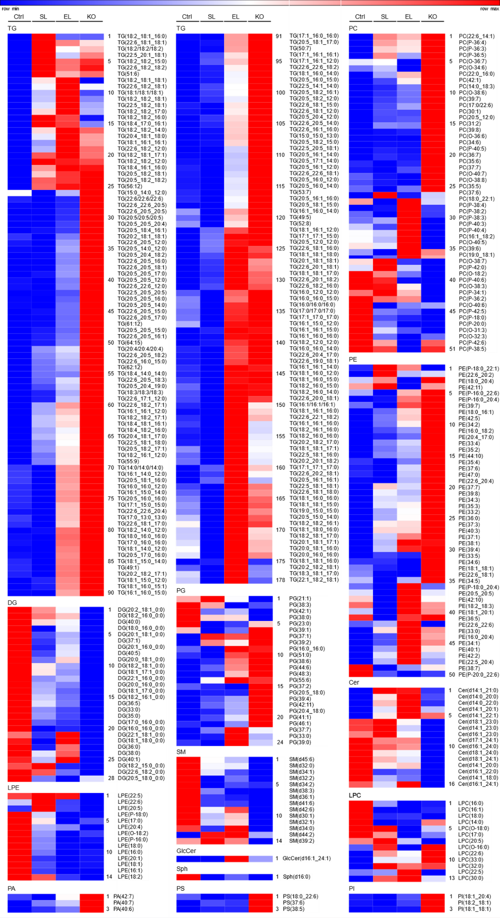
Supplemental Figure S2︱Dispersion point diagram of PCA model for ovary.
