Supplementary Material

Supplementary Figures and Tables.

Supplementary Figures

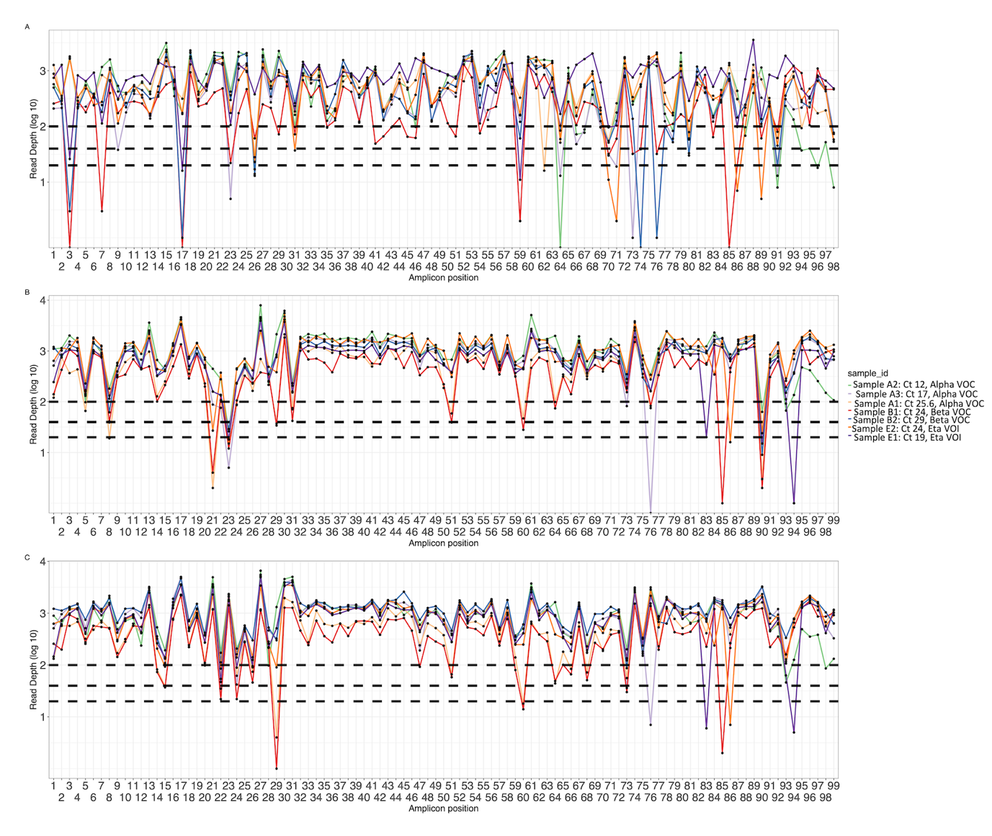
Supplementary Figure 1: Amplicon plots of seven sequences generated using (a) V3 primers, (b) V4 primers and (c) optimized V4 primers and classified as Alpha, Beta and Delta VOC. The curves show average depth in log scale (y axis) per amplicon (x axis). The horizontal dotted lines indicate amplicon depth cut-offs at 23, 50 and 100.
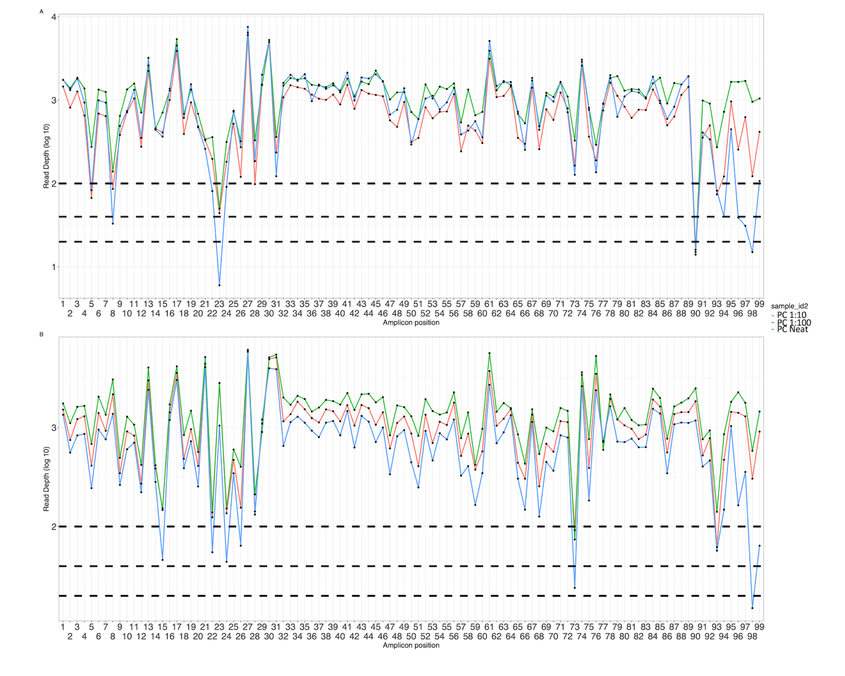
Supplementary Figure 2: Amplicon plots of serially diluted positive controls amplified using (a) V4 primers and (b) optimized V4 primers and classified as B.1. The curves show average depth in log scale (y axis) per amplicon (x axis). The horizontal dotted lines indicate amplicon depth cut-offs at 23, 50 and 100.

Supplementary tables
Supplementary Table 1: Summary table of showing lineages among the samples used during optimization
Sample id | lineage | ambiguity_score | scorpio_call | scorpio_support | scorpio_conflict | version | pangolin_version
sample_a1 | B.1.1.7 | 0.976849642 | Alpha (B.1.1.7-like) | 0.9565 | 0.0435 | PLEARN-v1.2.88 | 3.1.16
sample_a2 | B.1.1.7 | 0.96723681 | Alpha (B.1.1.7-like) | 0.913 | 0.0435 | PLEARN-v1.2.88 | 3.1.16
sample_a3 | B.1.1.7 | 0.895956734 | Alpha (B.1.1.7-like) | 0.8261 | 0.0435 | PLEARN-v1.2.88 | 3.1.16
sample_b1 | B.1.351 | 0.948491538 | Beta (B.1.351-like) | 0.6429 | 0 | PLEARN-v1.2.88 | 3.1.16
sample_b2 | B.1.351 | 0.94356826 | Beta (B.1.351-like) | 0.5714 | 0.1429 | PLEARN-v1.2.88 | 3.1.16
sample_d1 | AY.16 | 0.870355731 | Delta (B.1.617.2-like) | 0.8462 | 0 | PLEARN-v1.2.88 | 3.1.16
sample_d10 | AY.16 | 0.964492754 | Delta (B.1.617.2-like) | 0.8462 | 0 | PLEARN-v1.2.88 | 3.1.16
sample_d11 | AY.46.4 | 0.934642147 | Delta (B.1.617.2-like) | 0.9231 | 0 | PLEARN-v1.2.88 | 3.1.16
sample_d12 | AY.16 | 0.935171386 | Delta (B.1.617.2-like) | 0.9231 | 0 | PLEARN-v1.2.88 | 3.1.16
sample_d13 | AY.16 | 0.931455633 | Delta (B.1.617.2-like) | 0.9231 | 0 | PLEARN-v1.2.88 | 3.1.16
sample_d14 | AY.43 | 0.883011985 | Delta (B.1.617.2-like) | 0.9231 | 0 | PLEARN-v1.2.88 | 3.1.16
sample_d15 | AY.46 | 0.880971026 | Delta (B.1.617.2-like) | 0.9231 | 0 | PLEARN-v1.2.88 | 3.1.16
sample_d16 | AY.46.4 | 0.929855217 | Delta (B.1.617.2-like) | 0.9231 | 0 | PLEARN-v1.2.88 | 3.1.16
sample_d17 | AY.46 | 0.916055626 | Delta (B.1.617.2-like) | 0.9231 | 0 | PLEARN-v1.2.88 | 3.1.16
sample_d18 | AY.16 | 0.919062027 | Delta (B.1.617.2-like) | 0.9231 | 0 | PLEARN-v1.2.88 | 3.1.16
sample_d19 | B.1.617.2 | 0.858018114 | Delta (B.1.617.2-like) | 0.8462 | 0 | PLEARN-v1.2.88 | 3.1.16
sample_d2 | B.1.617.2 | 0.936228288 | Delta (B.1.617.2-like) | 0.9231 | 0 | PLEARN-v1.2.88 | 3.1.16
sample_d3 | AY.16 | 0.931455633 | Delta (B.1.617.2-like) | 0.9231 | 0 | PLEARN-v1.2.88 | 3.1.16
sample_d4 | AY.46 | 0.935435808 | Delta (B.1.617.2-like) | 0.9231 | 0 | PLEARN-v1.2.88 | 3.1.16
sample_d5 | AY.46 | 0.925833125 | Delta (B.1.617.2-like) | 0.9231 | 0 | PLEARN-v1.2.88 | 3.1.16
sample_d6 | AY.16 | 0.910823171 | Delta (B.1.617.2-like) | 0.7692 | 0 | PLEARN-v1.2.88 | 3.1.16
sample_d7 | AY.46.4 | 0.867969369 | Delta (B.1.617.2-like) | 0.8462 | 0 | PLEARN-v1.2.88 | 3.1.16
sample_d8 | AY.16 | 0.850362027 | Delta (B.1.617.2-like) | 0.7692 | 0 | PLEARN-v1.2.88 | 3.1.16
sample_d9 | B.1.617.2 | 0.925025075 | Delta (B.1.617.2-like) | 0.9231 | 0 | PLEARN-v1.2.88 | 3.1.16
sample_e1 | B.1.525 | 0.955154765 | Eta (B.1.525-like) | 0.9375 | 0 | PLEARN-v1.2.88 | 3.1.16
sample_e2 | B.1.525 | 0.985085227 | Eta (B.1.525-like) | 1 | 0 | PLEARN-v1.2.88 | 3.1.16
sample_nc1 | None |  |  |  |  | PANGO-v1.2.88 | 3.1.16
sample_nc10 | None |  |  |  |  | PANGO-v1.2.88 | 3.1.16
sample_nc2 | None |  |  |  |  | PANGO-v1.2.88 | 3.1.16
sample_nc3 | None |  |  |  |  | PANGO-v1.2.88 | 3.1.16
sample_nc4 | None |  |  |  |  | PANGO-v1.2.88 | 3.1.16
sample_nc5 | None |  |  |  |  | PANGO-v1.2.88 | 3.1.16
sample_nc6 | None |  |  |  |  | PANGO-v1.2.88 | 3.1.16
sample_nc7 | None |  |  |  |  | PANGO-v1.2.88 | 3.1.16
sample_nc8 | None |  |  |  |  | PANGO-v1.2.88 | 3.1.16
sample_nc9 | None |  |  |  |  | PANGO-v1.2.88 | 3.1.16
sample_nv1 | B.1.177 | 0.999766682 |  |  |  | PLEARN-v1.2.88 | 3.1.16
sample_nv2 | B.1.530 | 0.984123223 |  |  |  | PLEARN-v1.2.88 | 3.1.16
sample_nv4 | B.1 | 0.92637115 |  |  |  | PLEARN-v1.2.88 | 3.1.16
sample_nv5 | B.1 | 0.835370823 |  |  |  | PLEARN-v1.2.88 | 3.1.16
sample_nv6 | B.1 | 0.740969163 |  |  |  | PLEARN-v1.2.88 | 3.1.16
sample_nv7 | B.1.36.35 | 0.653580402 |  |  |  | PLEARN-v1.2.88 | 3.1.16
sample_nv8 | B.1 | 0.958707797 |  |  |  | PLEARN-v1.2.88 | 3.1.16

Supplementary Table 2: A table showing a summary of genome recovery when using ARTIC V3 compared to optimized V4 for 43 samples used in the optimization process
Sample_id | Lineage | Genome Coverage (%) ARTIC V3 | Genome coverage (%) Optimized V4 | Differences in Genome coverage | Ct value
sample_d8 | AY.16 | 93.8 | 96.9 | 3.1 | 18.02
sample_d1 | AY.16 | 96.2 | 99.6 | 3.4 | 16.71
sample_d10 | AY.16 | 94.8 | 98.8 | 4.0 | 24.51
sample_d12 | AY.16 | 94.8 | 99.6 | 4.7 | 22.43
sample_d13 | AY.16 | 94.6 | 99.6 | 5.0 | 21.41
sample_d3 | AY.16 | 94.1 | 99.6 | 5.5 | 22.15
sample_d18 | AY.16 | 89.9 | 99.6 | 9.7 | 24.13
sample_d6 | AY.46 | 94.8 | 97.8 | 3.0 | 24.6
sample_d14 | AY.46 | 93.8 | 98.8 | 5.0 | 18.59
sample_d15 | AY.46 | 90.2 | 95.6 | 5.4 | 27.76
sample_d5 | AY.46 | 92.3 | 99.6 | 7.2 | 18.01
sample_d7 | AY.46.4 | 94.9 | 98.0 | 3.0 | 25.42
sample_d11 | AY.46.4 | 94.3 | 98.8 | 4.6 | 20.24
sample_d4 | AY.46.4 | 88.6 | 98.8 | 10.2 | 24.23
sample_nv6 | B.1 | 96.0 | 98.7 | 2.7 | 21.05
sample_nv5 | B.1 | 93.3 | 97.0 | 3.7 | 19.8
sample_nv4 | B.1 | 81.5 | 88.5 | 7.0 | 16.32
sample_nc2 | B.1 | 40.2 | 91.6 | 51.4 | 25.88
sample_a1 | B.1.1.7 | 97.0 | 97.8 | 0.8 | 25.69
sample_a2 | B.1.1.7 | 96.0 | 99.6 | 3.5 | 12.57
sample_a3 | B.1.1.7 | 92.3 | 98.9 | 6.7 | 17.96
sample_nv1 | B.1.160 | 28.4 | 82.7 | 54.3 | 17.86
sample_nv9 | B.1.177 | 99.6 | 99.6 | 0.0 | 18.28
sample_b2 | B.1.351 | 95.1 | 97.0 | 2.0 | 29.92
sample_b1 | B.1.351 | 94.8 | 99.6 | 4.8 | 24.16
sample_nv7 | B.1.369 | 85.8 | 92.2 | 6.4 | 19.95
sample_e1 | B.1.525 | 97.7 | 98.3 | 0.6 | 19.22
sample_e2 | B.1.525 | 96.0 | 98.7 | 2.6 | 20.2
sample_nv8 | B.1.530 | 97.8 | 98.9 | 1.1 | 29.43
sample_nc1 | B.1.530 | 42.0 | 98.0 | 56.1 | 25.94
sample_nv2 | B.1.617.2 | 74.3 | 93.1 | 18.9 | 17.45
sample_d9 | B.1.617.2 | 94.9 | 98.7 | 3.7 | 19.72
sample_d2 | B.1.617.2 | 93.3 | 98.4 | 5.1 | 19.36
sample_d16 | B.1.617.2 | 91.5 | 99.6 | 8.0 | 21.38
sample_d17 | B.1.617.2 | 88.7 | 97.8 | 9.1 | 27.96
sample_d19 | B.1.617.2 | 87.7 | 98.8 | 11.2 | 22.89
sample_nc3 | None | 56.0 | 73.9 | 18.0 | 26.47
sample_nc5 | None | 27.7 | 66.9 | 39.2 | 22.62
sample_nc6 | None | 25.2 | 67.3 | 42.1 | 20.98
sample_nc7 | None | 14.7 | 62.4 | 47.7 | 29.73
sample_nc8 | None | 19.5 | 69.4 | 49.9 | 24.71
sample_nc9 | None | 18.0 | 68.1 | 50.1 | 18.11
sample_nc10 | None | 7.8 | 68.1 | 60.3 | 26.08

