SUPPLEMENTARY INFORMATION FOR:
Costa CP, Okamoto N, Orr M, Yamanaka N, Woodard SH. Convergent loss of PTTH, a canonical regulator of development, in social bee evolution.

Table S1. Gene sequences used to examine presence/absent of genes from torso-activation cassette (TAC) in social and solitary bees.
Genes | Drosophila melanogaster | Nasonia vitripennis
prothoracicotropic hormone (Ptth) | NP_001285550.1 | XP_031783445.1
Torso | NP_001097212.2 | XP_008211645.2
Trunk | NP_476767.2 | NA

Table S2. Species according to degree of social complexity. Eufriesea mexicana is communal, but its social biology is relatively unknown.
Genes | Group | Status
Apis mellifera | Apidae | Eusocial
Apis dorsata | Apidae | Eusocial
Apis florea | Apidae | Eusocial
Apis cerana | Apidae | Eusocial
Frieseomellita varia | Apidae | Eusocial
Melipona quadrifasciata | Apidae | Eusocial
Bombus impatiens | Apidae | Eusocial
Bombus ignites | Apidae | Eusocial
Bombus terrestris | Apidae | Eusocial
Bombus vosnesenkii | Apidae | Eusocial
Bombus bifarius | Apidae | Eusocial
Bombus vancouverensis | Apidae | Eusocial
Eufriesea mexicana* | Apidae | Communal
Ceratina calcarata | Apidae | Subsocial
Habropoda laboriosa | Apidae | Solitary
Megachile rotundata | Megachilidae | Solitary
Osmia bicornis | Megachilidae | Solitary
Osmia lignaria | Megachilidae | Solitary
Lasioglossum albipes | Halictidae | Facultative eusocial
Megalopta genalis | Halictidae | Facultative eusocial
Nomia melanderi | Halictidae | Solitary
Dufourea novaeanglia | Halictidae | Solitary

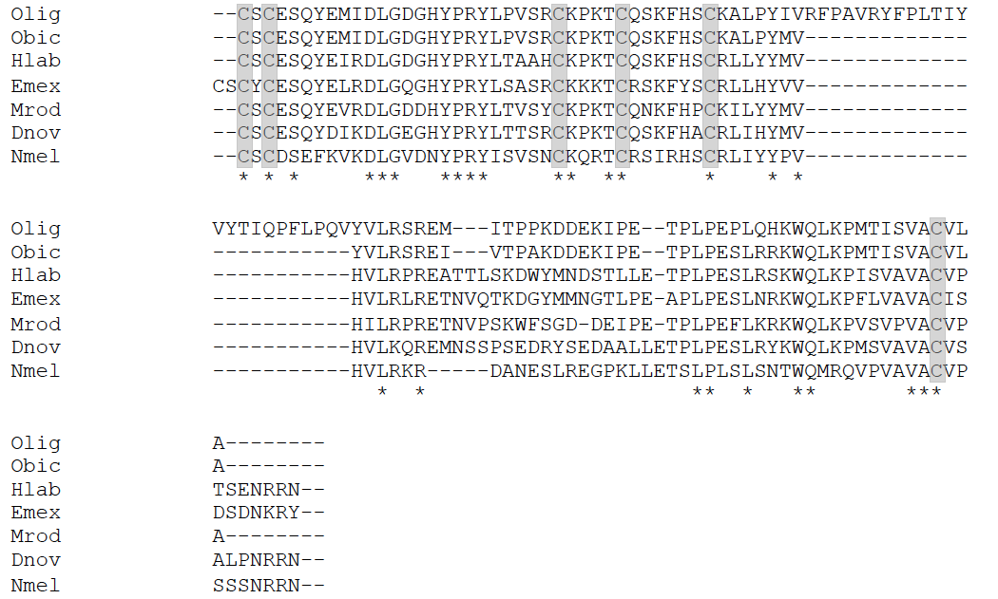
Figure S1. The alignment of partial PTTH amino acid sequences from bee species. Olig: Osmia bicornis; Obic: Osmia bicornis; Hlab: Habropoda laboriosa; Emex: Eufriesea Mexicana; Mrod: Megachile rotundata; Dnov: Dufourea novaeanglia; Nmel: Nomia melanderi. The conserved cysteine residues were highlighted in gray. *Alignment was partially modified manually to highlight the conserved cysteine residues.

