Supplementary Material

Supplementary Material
The hypergeometric test formula used in Pivot analysis:
$$p\left(k\right)=P\left(X=k\right)=1-\sum_{M-1}^{k=0}{\frac{\left({M \atop k}\right)\left({N-M \atop n-k}\right)}{\left({N \atop n}\right)}}$$
N is the total number of interaction pairs; n represents the number of interaction pairs for a TF. M is the total number of gene interaction pairs belonging to the network and TF, and k represents the gene interaction pair in the network with a particular TF.

Supplementary Figures and Tables

Supplementary Tables
Table S1. Gene Ontology analysis of DEMs.
Term |  | Gene count | P-value
UP-regulated
GOTERM_BP
GO:0007417-central nervous system development |  | 5 | 0.04981
GO:0000226-microtubule cytoskeleton organization |  | 4 | 0.02830
GOTERM_MF
GO:0001594~trace-amine receptor activity |  | 2 | 0.01036
GO:0004029~aldehyde dehydrogenase (NAD) activity |  | 2 | 0.03077
GO:0034185~apolipoprotein binding |  | 2 | 0.02207
Down-regulated
GOTERM_BP
GO:0006955~immune response |  | 9 | 0.00504
GO:0050776~regulation of immune response |  | 7 | 0.00508
GO:0002253~activation of immune response |  | 5 | 0.01633
GO:0001775~cell activation |  | 6 | 0.02202
GO:0002274~myeloid leukocyte activation |  | 3 | 0.02866
GO:0007156~homophilic cell adhesion via plasma membrane adhesion molecules |  | 3 | 0.03310
GO:0050778~positive regulation of immune response |  | 5 | 0.03315
GO:0034104~negative regulation of tissue remodeling |  | 2 | 0.03370
GO:0002682~regulation of immune system process |  | 7 | 0.03373
GO:0002252~immune effector process |  | 5 | 0.04274
GOTERM_CC
GO:0005576~extracellular region |  | 16 | 2.25E-04
GO:0070062~extracellular exosome |  | 12 | 7.17E-04
GO:0043230~extracellular organelle |  | 12 | 7.52E-04
GO:0031988~membrane-bounded vesicle |  | 13 | 0.00159
GO:0019898~extrinsic component of membrane |  | 4 | 0.00619
GO:0098590~plasma membrane region |  | 5 | 0.04258
GO: gene ontology; BP: biological process; CC: cellular component; MF: molecular function.

Table S2. KEGG pathway analysis of DEMs.
Term |  | Gene count | P-value
UP-regulated
KEGG pathway | hsa00561: Glycerolipid metabolism | 2 | 0.00486
 | hsa00010: Glycolysis / Gluconeogenesis | 2 | 0.00600
 | hsa00770: Pantothenate and CoA biosynthesis | 1 | 0.03260
 | hsa00340: Histidine metabolism | 1 | 0.03934
 | hsa04950: Maturity onset diabetes of the young | 1 | 0.04437
 | hsa00053: Ascorbate and aldarate metabolism | 1 | 0.04603
 | hsa04744: Phototransduction | 1 | 0.04770
Down-regulated
KEGG pathway | hsa04964: Proximal tubule bicarbonate reclamation | 2 | 0.00092
 | hsa05213: Endometrial cancer | 2 | 0.00575
 | hsa05100: Bacterial invasion of epithelial cells | 2 | 0.00898
 | hsa05220: Chronic myeloid leukemia | 2 | 0.00971
 | hsa04972: Pancreatic secretion | 2 | 0.01703
 | hsa04931: Insulin resistance | 2 | 0.01897
 | hsa04670: Leukocyte trans-endothelial migration | 2 | 0.02066
 | hsa04152: AMPK signaling pathway | 2 | 0.02312
 | hsa04068: FoxO signaling pathway | 2 | 0.02723
 | hsa04650: Natural killer cell mediated cytotoxicity | 2 | 0.02723
 | hsa04910: Insulin signaling pathway | 2 | 0.03038
 | hsa05226: Gastric cancer | 2 | 0.03453
KEGG: Kyoto Encyclopedia of Genes and Genomes

Table S3. Pivot analysis of TFs related to mRNA.
TFs | Connection | P value
BCL6 | 2 | 0.001181
CEBPB | 3 | 0.010076
CEBPA | 3 | 0.003335
HIF1A | 3 | 0.026603
E2F4 | 2 | 0.003511
HNF4A | 2 | 0.017261
FOS | 2 | 0.039078
GATA3 | 2 | 0.011034

TFs: transcription factors

Supplementary Figures
Supplementary Figure 1. The PPI network of 168 gene nodes based on DEMs.

Supplementary Figure 2. Scatter plots of correlation between the expression of lncRNAs ( CTD-2562J17.2, FLG-AS1, HOTTIP, RP11-131L23.1, U91319.1,ZRANB2-AS2 and OS.

Supplementary Figure 3. Scatter plots of correlation between the expression of lncRNAs (AC004231.2, CTD-2288O8.1, LINC00221, RP11.10K17.6, RP11.439C8.1, U91319.1, ZRANB2-AS2, SNAP25.AS1, RP4.529N6.1, RP11.57C13.6) and OS.

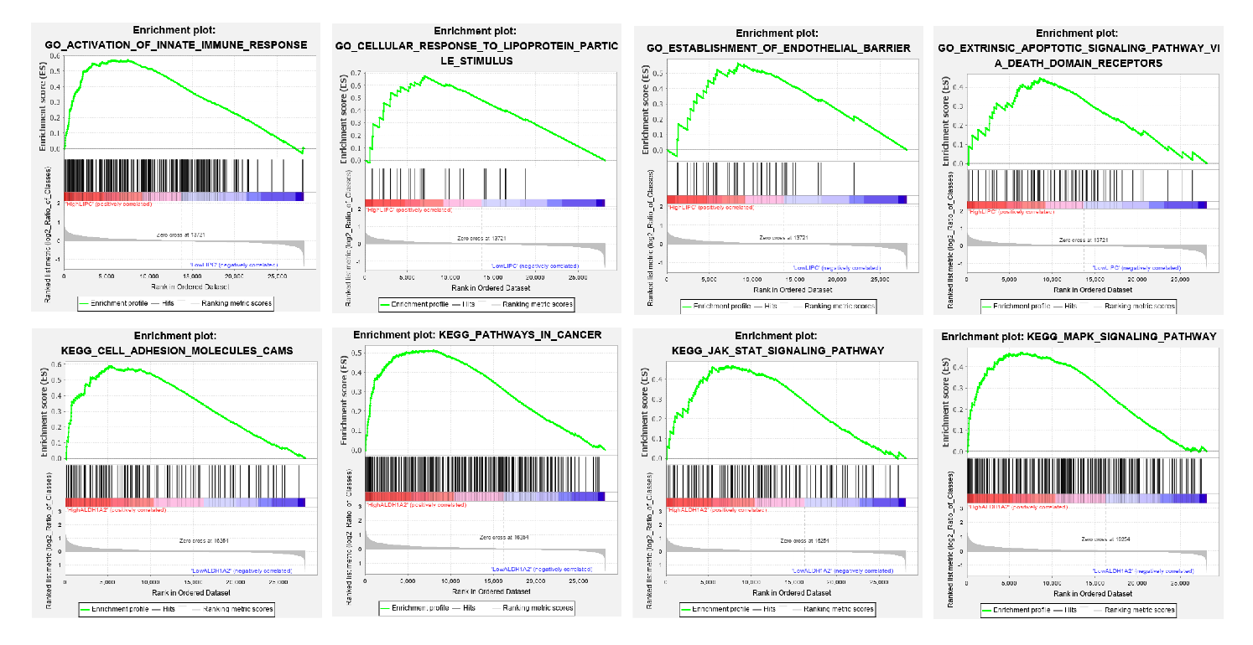
Supplementary Figure 4. Gene set enrichment analysis (GSEA) of ALDH1A2 and LIPC. 8 representative functional gene sets enriched in OC with highly expressed were listed.
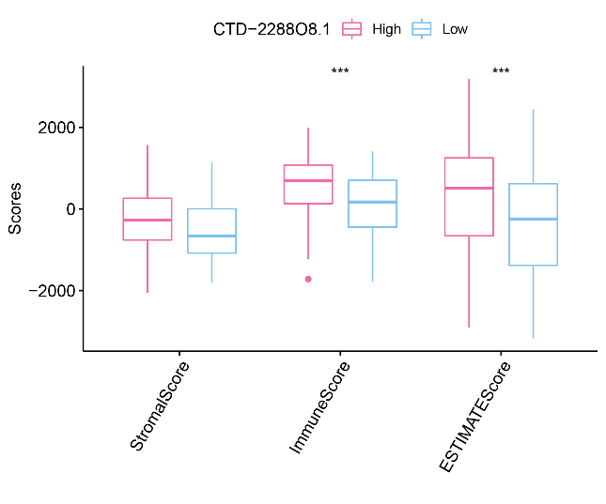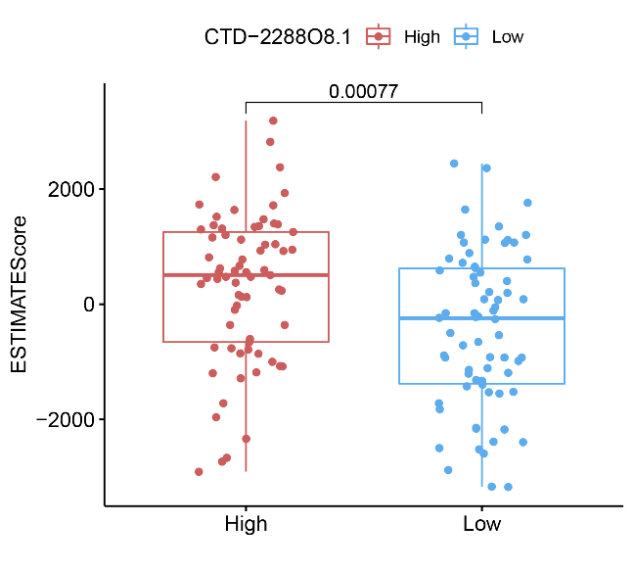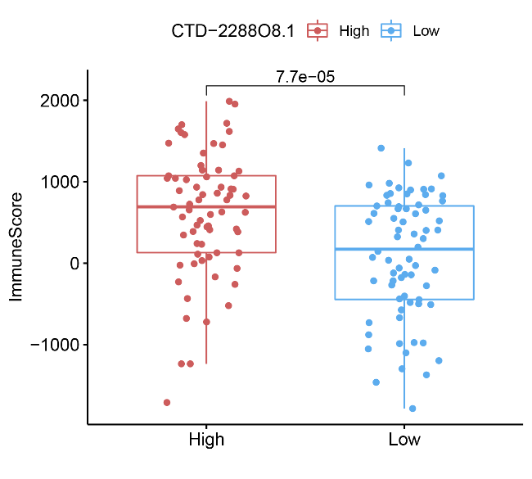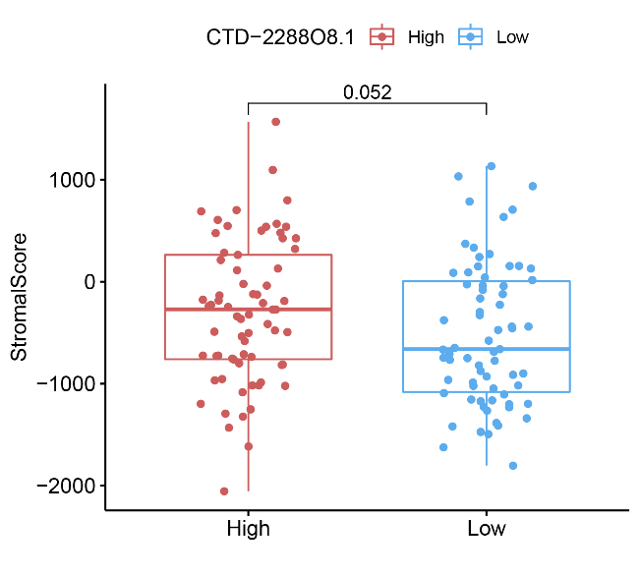
Supplementary Figure 5. Immunity analysis of CTD-2288O8.1 in 151 OC samples. The correlation of CTD-2288O8.1 with ESTIMATEScore, ImmuneScore, StromalScore, Wilcoxon rank sum was applied for the significance test.
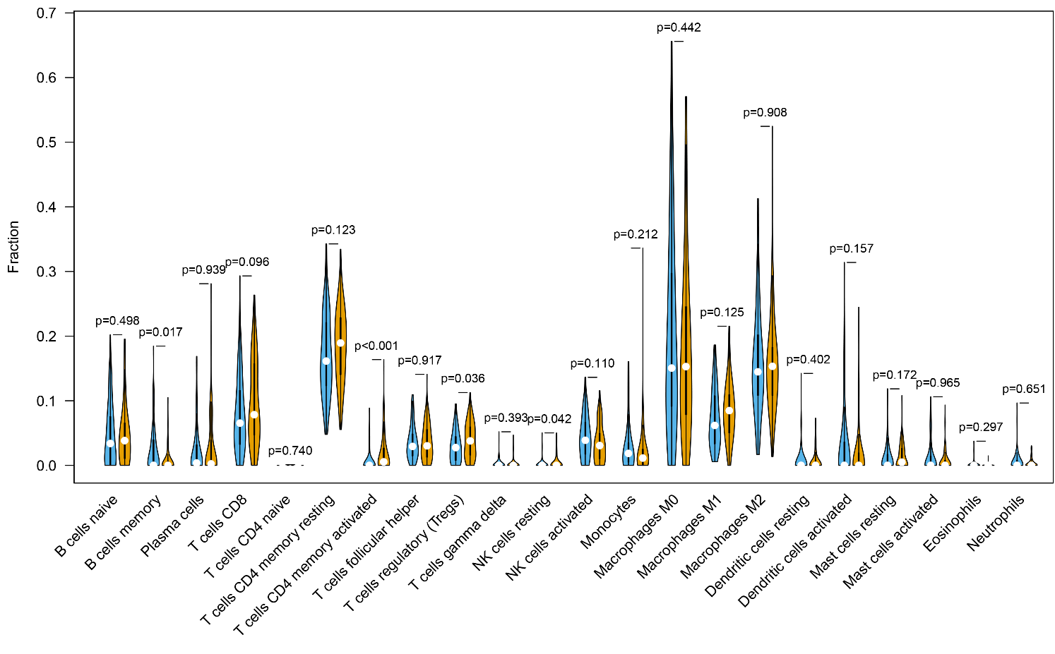
Supplementary Figure 6. Immunity analysis of CTD-2288O8.1 Violin plot showed the ratio differentiation of 22 types of immune cells between OC tumor samples with high or low-expression relative to the median of CTD-2288O8.1 expression, and Wilcoxon rank sum was applied for the significance test.

