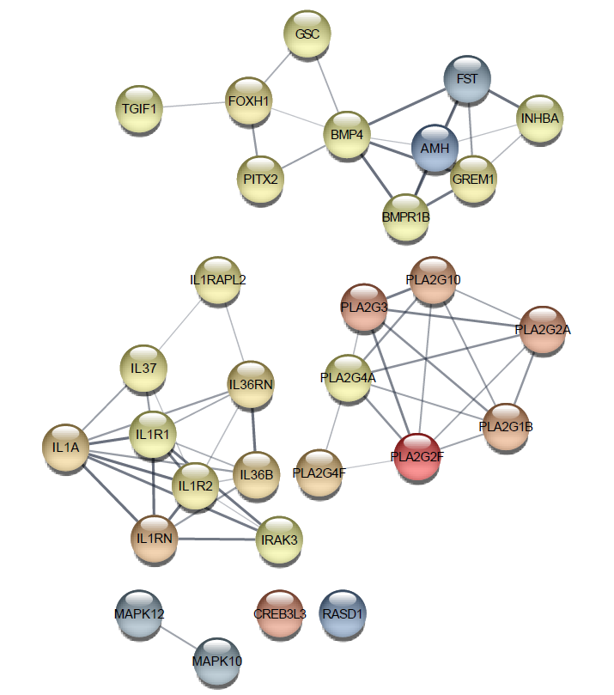
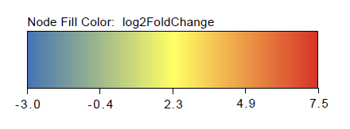
Figure S1. The Protein-protein-interaction network as determined by STRING and visualized in Cytoscape for the 30 genes in the TGF-β, MAPK and BMP4 pathways.
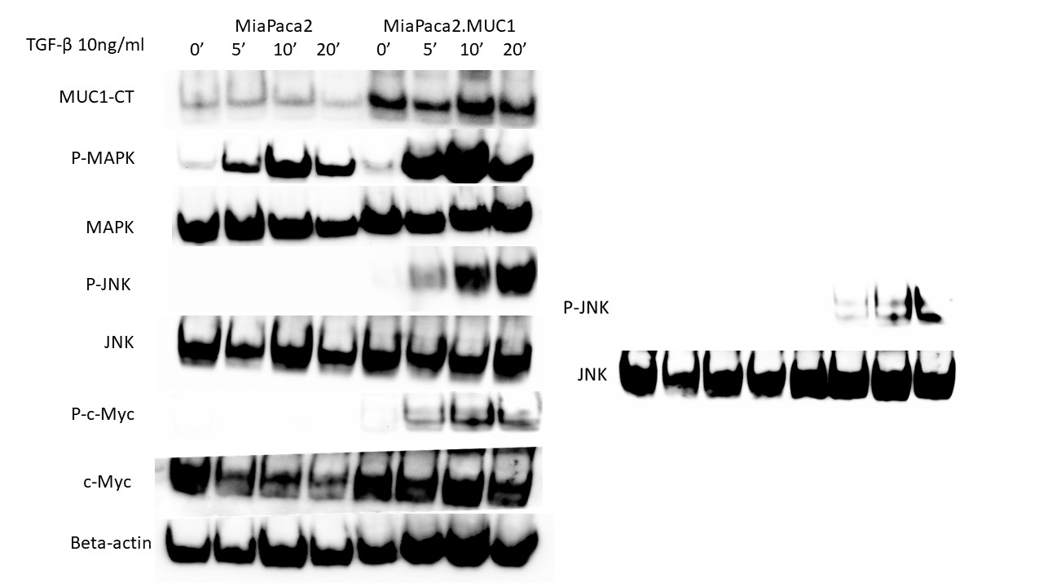
Figure S2. Overexpression of MUC1 leads to increased phosphorylation of MAPK, JNK and c-Myc. Western blot expression of phosphorylation of MAPK, JNK and c-Myc compared to total MAPK, total JNK and total c-Myc in MiaPaca2 vs MiaPaca2.MUC1 cells in response to 10ng/ml of TGF-β at 0, 5, 10 and 20 minutes. β-actin was used as endogenous loading control.
B
A
Figure S3. TGF-β exposure increases viability in cells with high MUC1. MTT cell viability assay on A. HPAFII and B MiaPaca2.MUC1 cells with 10ng/ml of TGF-β for 96 hours. All data are shown as means +/− SEM of n=3. Unpaired t-test was performed to compare between treated and untreated cells for all experiments. * p < 0.05, ** p < 0.01, *** p<0.001, **** p<0.0001.

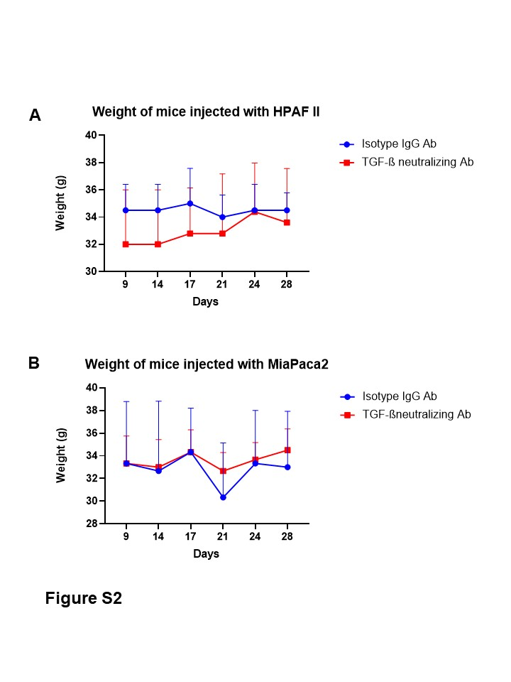
MiaPaca2
HPAFII
A
B
Figure S4. A. Immunohistochemistry for TGF-β. Top. HPAFII tumor tissues and Bottom. MiaPaca2 tumor tissues showing TGF-β expression in mice treated with neutralizing TGF-β antibody (left) and isotype control IgG (right). B. Body weights of all mice remained consistent over the period of the in vivo study. Body weights of all nude mice injected with Top. HPAFII cells and Bottom. MiaPaca2 cells and treated with IgG isotype antibody (blue) and TGF-β neutralizing antibody (red) over the period of 28 days starting from the day of treatment are shown.
Supplementary Table 1. Table showing the characteristics of the 29 PDA samples from TCGA.
