Supplementary Material

Supplementary Figures
Supplementary Figure 1. Appendix 1 Optimal parametrical models calculated by refine R algorithm for FT4 and FT3 in different sex groups.
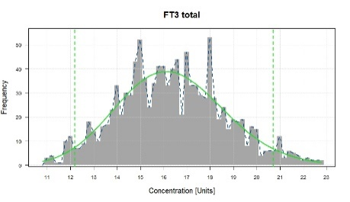
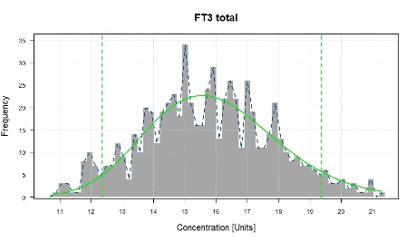
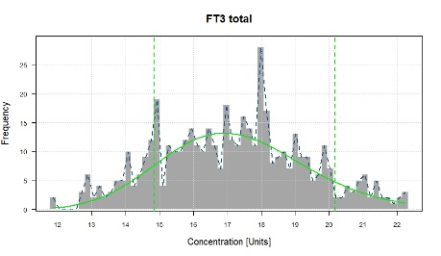
A

Total Female Male
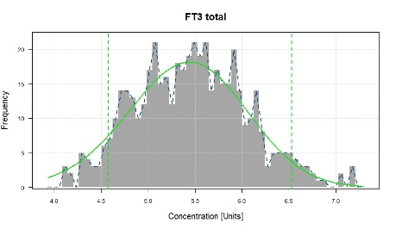
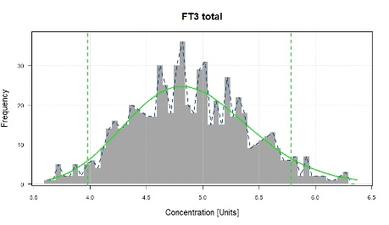
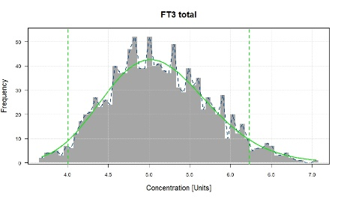
B
Total Female Male
A stands for the optimal parameter models corresponding to the FT4 RIs established for total, female and male Tibetan; B stands for the optimal parameter models corresponding to the FT3 RIs established for total, female and male Tibetan;

Supplementary Figure 2. Optimal parametrical models calculated by refine R algorithm for FT3 in different altitude groups.
A
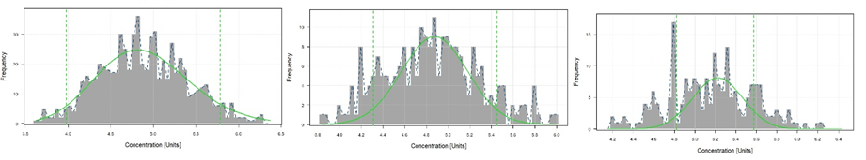AltitudeⅢ AltitudeⅡ Altitude I
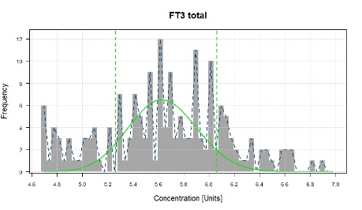
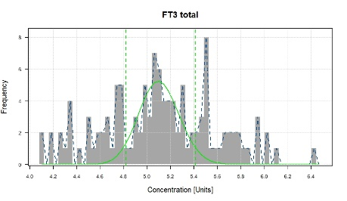
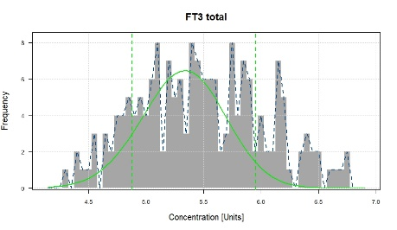
B
AltitudeⅢ AltitudeⅡ Altitude I
A and B represent, from left to right, the optimal parameter models for female and male Tibetan population when establishing FT3 RIs at Altitude III, II and I. AltitudeⅢ, Nyingchi (altitude: ~2900 m); AltitudeⅡ, Shigatse/Lhasa (altitude: 3670-3835 m); Altitude I, Ali (altitude: 4298-4352 m).

