Table S1. Primer sequences for the five genes.
Gene | mRNA | Primer Sequence |  | Product information
 |  |  | chromosomal location | Genomic Location | Product size (bp) | Strand | CpG | Relation_to_Island | UCSC_RefGene_Group
PSMC1 | NM_002802 | F- GGGGTTATTGTTTTAAGTTGTTGATAAG | Chr14 | 90722678-90722946 | 269 | + | 14 | N_Shore | TSS200
 |  | R- ACCATCTTACCTTAACCACTTAAACTACC
SPPL3 | NM_139015 | F- GTTTTAAAGTTTTYGAGGGGTTATTG | Chr12 | 121202374-121202629 | 256 | + | 6 | OpenSea | 3'UTR
 |  | R- ACCCTATTTAATTCCTTCTCTTCCTAC
CARD11 | NM_032415 | F- AGGGGTTAGGTAGGGAGTGAA | Chr7 | 3026507-3026269 | 239 | - | 14 | OpenSea | 5'UTR
 |  | R- CAACCCCTACTCACAACCTCAA
PSMB8 | NM_148919 | F- TGGAAATAGGGGTGGGTAGG | Chr6 | 32812076-32812252 | 177 | + | 6 | S_Shore | 1stExon
 |  | R- CCAAAACCTATTTCCAAAACTCTACC
NCF2 | NM_000433 | F- AAGATTTATAAGGTATAGGATTTGAAAGATAG | Chr1 | 183551907-183552128 | 222 | + | 8 | OpenSea | Body
 |  | R- CCCCCTCTATTTCCCTCTATTTTC

Table S2. Differential methylation analysis of 91 CpG cites in GEO datasets.
 |  |  |  | GSE51032 |  |  | GSE104942
Gene | CpG site | Chr | Position | t | Δβ | P value* | t | Δβ | P value*
A2ML1 | cg23546356 | 12 | 8974786 | 2.361 | -0.015 | 0.019 | 2.577 | -0.020 | 0.011
ABCC4 | cg11744861 | 13 | 95920671 | 2.464 | -0.020 | 0.014 | 2.289 | -0.029 | 0.023
ABR | cg26682335 | 17 | 945834 | 5.010 | -0.024 | <0.001 | 3.518 | -0.025 | 0.001
ADAMDEC1 | cg01759110 | 8 | 24241694 | -3.055 | 0.015 | 0.002 | -2.282 | 0.018 | 0.024
AGGF1 | cg15817406 | 5 | 76325554 | 5.393 | -0.020 | <0.001 | 3.398 | -0.021 | 0.001
APITD1 | cg07166784 | 1 | 10508703 | 4.484 | -0.033 | <0.001 | 1.983 | -0.017 | 0.049
ARL4A | cg06415087 | 7 | 12726571 | 4.023 | -0.015 | <0.001 | 3.167 | -0.017 | 0.002
ASCC3 | cg05757007 | 6 | 101053555 | 4.035 | -0.029 | <0.001 | 2.881 | -0.023 | 0.004
ASGR2 | cg04281898 | 17 | 7011140 | 4.450 | -0.030 | <0.001 | 2.407 | -0.022 | 0.017
ATM | cg19892525 | 11 | 108157498 | 7.491 | -0.041 | <0.001 | 2.357 | -0.019 | 0.020
BCL11A | cg03754165 | 2 | 60780427 | -3.512 | 0.037 | <0.001 | -2.292 | 0.022 | 0.023
BRD8 | cg12977827 | 5 | 137512548 | 3.464 | -0.016 | 0.001 | 3.321 | -0.023 | 0.001
BTN3A1 | cg22068371 | 6 | 26407505 | 2.421 | -0.016 | 0.016 | 2.370 | -0.018 | 0.019
C1QTNF9 | cg20138486 | 13 | 24884072 | 3.312 | -0.020 | 0.001 | 2.536 | -0.015 | 0.012
C2 | cg27297326 | 6 | 31894990 | 3.283 | -0.029 | 0.001 | 2.129 | -0.021 | 0.035
CARD11 | cg15658543 | 7 | 3026309 | 4.704 | -0.019 | <0.001 | 2.948 | -0.020 | 0.004
CCL13 | cg01566155 | 17 | 32685450 | 3.255 | -0.021 | 0.001 | 2.243 | -0.018 | 0.026
CHST11 | cg04737991 | 12 | 105050768 | 2.684 | -0.028 | 0.008 | 2.886 | -0.038 | 0.004
CRIM1 | cg15371815 | 2 | 36582144 | 2.451 | -0.018 | 0.015 | 2.939 | -0.029 | 0.004
DCBLD1 | cg05053978 | 6 | 117869098 | 2.339 | -0.016 | 0.020 | 2.313 | -0.030 | 0.022
EBF3 | cg09746817 | 10 | 131671265 | 3.494 | -0.029 | 0.001 | 2.620 | -0.021 | 0.010
ESRRB | cg14853964 | 14 | 76870538 | 3.904 | -0.018 | <0.001 | 3.144 | -0.017 | 0.002
ESRRG | cg00903998 | 1 | 216897293 | -6.245 | 0.027 | <0.001 | -3.007 | 0.015 | 0.003
FCHO2 | cg17829914 | 5 | 72385895 | 3.619 | -0.018 | <0.001 | 3.091 | -0.018 | 0.002
FNDC3B | cg26074575 | 3 | 171764199 | 3.255 | -0.021 | 0.001 | 3.103 | -0.025 | 0.002
GGCX | cg07143583 | 2 | 85776941 | 2.571 | -0.019 | 0.010 | 2.546 | -0.019 | 0.012
GLT25D1 | cg19414763 | 19 | 17687657 | 3.502 | -0.025 | 0.001 | 2.209 | -0.021 | 0.029
GNE | cg05844977 | 9 | 36277400 | 5.789 | -0.035 | <0.001 | 2.293 | -0.016 | 0.023
GP6 | cg20651389 | 19 | 55549842 | 3.770 | -0.017 | <0.001 | 3.097 | -0.024 | 0.002
GSTP1 | cg06841499 | 11 | 67349641 | 2.106 | -0.017 | 0.036 | 3.401 | -0.034 | 0.001
HBXIP | cg25032124 | 1 | 110946480 | 6.719 | -0.050 | <0.001 | 2.040 | -0.017 | 0.043
HCG22 | cg14119792 | 6 | 31021422 | 2.614 | -0.018 | 0.009 | 2.671 | -0.026 | 0.008
HFE2 | cg14599576 | 1 | 145413157 | 3.630 | -0.035 | <0.001 | 2.133 | -0.020 | 0.034
HLA-DMA | cg14180039 | 6 | 32919700 | 4.112 | -0.023 | <0.001 | 2.121 | -0.021 | 0.035
HLA-DPB2 | cg23376071 | 6 | 33087989 | 2.838 | -0.019 | 0.005 | 3.084 | -0.029 | 0.002
HOXA5 | cg02646423 | 7 | 27183794 | 3.880 | -0.025 | <0.001 | 2.023 | -0.020 | 0.045
HRH4 | cg26442509 | 18 | 22039496 | 2.945 | -0.016 | 0.003 | 2.978 | -0.018 | 0.003
ICA1 | cg20022118 | 7 | 8276021 | 4.692 | -0.024 | <0.001 | 2.600 | -0.015 | 0.010
IFIH1 | cg03538095 | 2 | 163139716 | 4.872 | -0.027 | <0.001 | 2.736 | -0.021 | 0.007
IGF1R | cg05110803 | 15 | 99385323 | 2.156 | -0.018 | 0.032 | 2.651 | -0.025 | 0.009
IGF2R | cg01188509 | 6 | 160509295 | 4.781 | -0.026 | <0.001 | 2.986 | -0.017 | 0.003
IGSF5 | cg24698780 | 21 | 41173950 | 3.472 | -0.022 | 0.001 | 2.154 | -0.016 | 0.033
IRAK1 | cg06334238 | X | 153284899 | -2.736 | 0.018 | 0.006 | -2.044 | 0.044 | 0.042
ITFG1 | cg05128386 | 16 | 47409367 | 4.172 | -0.026 | <0.001 | 3.157 | -0.021 | 0.002
ITGAD | cg03087622 | 16 | 31403683 | 2.999 | -0.018 | 0.003 | 2.073 | -0.015 | 0.040
KRT1 | cg02425372 | 12 | 53074023 | 6.052 | -0.027 | <0.001 | 2.964 | -0.021 | 0.003
LAMA2 | cg27120934 | 6 | 129480619 | 4.269 | -0.016 | <0.001 | 3.211 | -0.023 | 0.002
LEFTY2 | cg27179622 | 1 | 226127290 | 2.519 | -0.021 | 0.012 | 2.013 | -0.028 | 0.046
LGMN | cg21196628 | 14 | 93175350 | 4.271 | -0.017 | <0.001 | 2.437 | -0.016 | 0.016
MCF2L | cg08890338 | 13 | 113700818 | 5.830 | -0.026 | <0.001 | 2.523 | -0.018 | 0.013
MID1 | cg06448666 | X | 10645625 | 4.936 | -0.025 | <0.001 | 2.392 | -0.017 | 0.018
MIR372 | cg22462000 | 19 | 54290434 | 5.836 | -0.026 | <0.001 | 3.081 | -0.017 | 0.002
MOG | cg08725892 | 6 | 29629986 | 2.170 | -0.019 | 0.030 | 3.053 | -0.033 | 0.003
MUC1 | cg23256951 | 1 | 155163205 | 3.623 | -0.017 | <0.001 | 2.327 | -0.017 | 0.021
NCF2 | cg24045276 | 1 | 183552095 | 3.146 | -0.025 | 0.002 | 2.403 | -0.017 | 0.017
NET1 | cg01010839 | 10 | 5488225 | 2.737 | -0.023 | 0.006 | 2.841 | -0.031 | 0.005
NFATC2 | cg01334549 | 20 | 50137002 | 5.233 | -0.018 | <0.001 | 2.516 | -0.015 | 0.013
NOV | cg05020510 | 8 | 120428057 | 3.565 | -0.021 | <0.001 | 3.602 | -0.040 | 0.000
PRMT1 | cg24127106 | 19 | 50183046 | 3.747 | -0.018 | <0.001 | 2.694 | -0.021 | 0.008
PSMA1 | cg00417576 | 11 | 14535610 | 4.060 | -0.020 | <0.001 | 3.030 | -0.016 | 0.003
PSMB8 | cg21568368 | 6 | 32812167 | 2.662 | -0.015 | 0.008 | 2.860 | -0.022 | 0.005
PSMC1 | cg01760846 | 14 | 90722706 | -2.676 | 0.019 | 0.008 | -2.045 | 0.016 | 0.043
PTPRJ | cg19268720 | 11 | 48038449 | 2.072 | -0.016 | 0.039 | 3.123 | -0.024 | 0.002
PTPRS | cg00614413 | 19 | 5286594 | 3.840 | -0.016 | <0.001 | 2.865 | -0.016 | 0.005
RAB11FIP4 | cg15331096 | 17 | 29861932 | 2.813 | -0.016 | 0.005 | 3.223 | -0.017 | 0.002
RHD | cg10117171 | 1 | 25599238 | 4.750 | -0.039 | <0.001 | 2.113 | -0.022 | 0.036
RIN3 | cg16255729 | 14 | 93106394 | 2.435 | -0.016 | 0.015 | 3.089 | -0.022 | 0.002
RNF216 | cg02543993 | 7 | 5736195 | 3.383 | -0.015 | 0.001 | 2.186 | -0.018 | 0.030
RPS6KA2 | cg18495191 | 6 | 167200499 | -2.802 | 0.018 | 0.005 | -2.747 | 0.022 | 0.007
SCRN1 | cg10591077 | 7 | 30030138 | 4.064 | -0.029 | <0.001 | 2.727 | -0.020 | 0.007
SMAGP | cg10993701 | 12 | 51660035 | 2.385 | -0.016 | 0.017 | 2.706 | -0.017 | 0.008
SMARCA4 | cg08151828 | 19 | 11093828 | 5.120 | -0.017 | <0.001 | 3.574 | -0.019 | 0.000
SORL1 | cg10746778 | 11 | 121460778 | 3.683 | -0.033 | <0.001 | 2.493 | -0.019 | 0.014
SPPL3 | cg07141527 | 12 | 121202554 | 3.635 | -0.030 | <0.001 | 2.553 | -0.018 | 0.012
SYTL1 | cg12748890 | 1 | 27676205 | 2.534 | -0.015 | 0.012 | 2.618 | -0.032 | 0.010
TAP2 | cg00167916 | 6 | 32795877 | 4.100 | -0.019 | <0.001 | 3.754 | -0.018 | 0.000
TCF7L2 | cg22795218 | 10 | 114765022 | 4.952 | -0.030 | <0.001 | 3.029 | -0.020 | 0.003
TLX1 | cg20120208 | 10 | 102896869 | 3.057 | -0.023 | 0.002 | 2.620 | -0.028 | 0.010
TNFAIP8 | cg17008454 | 5 | 118724372 | 6.550 | -0.050 | <0.001 | 2.919 | -0.022 | 0.004
TNXB | cg19647111 | 6 | 32073035 | 5.068 | -0.029 | <0.001 | 2.683 | -0.016 | 0.008
TPX2 | cg26558420 | 20 | 30331315 | 4.163 | -0.024 | <0.001 | 2.282 | -0.016 | 0.024
UNC5B | cg12873350 | 10 | 72976676 | 2.893 | -0.026 | 0.004 | 2.277 | -0.020 | 0.024
VHL | cg15036157 | 3 | 10192045 | 3.819 | -0.025 | <0.001 | 2.301 | -0.020 | 0.023
VPS45 | cg05228338 | 1 | 150048339 | 3.663 | -0.021 | <0.001 | 1.997 | -0.018 | 0.048
WASF2 | cg05002165 | 1 | 27813172 | 2.600 | -0.016 | 0.010 | 2.418 | -0.018 | 0.017
WISP2 | cg04193901 | 20 | 43343736 | 3.908 | -0.015 | <0.001 | 3.116 | -0.021 | 0.002
 | cg06491405 | 6 | 31895257 | 3.495 | -0.023 | 0.001 | 2.080 | -0.015 | 0.039
 | cg12128839 | 7 | 27183436 | 2.682 | -0.024 | 0.008 | 2.184 | -0.033 | 0.030
 | cg03368099 | 7 | 27184521 | 2.394 | -0.017 | 0.017 | 2.417 | -0.026 | 0.017
 | cg05076221 | 7 | 27182637 | 2.285 | -0.016 | 0.023 | 2.197 | -0.024 | 0.029
 | cg25307665 | 7 | 27183694 | 2.035 | -0.020 | 0.042 | 2.286 | -0.039 | 0.024
*P values < 0.05 were considered statistically significant.
Table S3. Demographic characteristics of participants for PSMC1 sequencing.
Characteristics | Case (%) | Control (%) | P*
No. of participants | 409 | 495
Age (year) (Mean±SD) | 51.24±9.45 | 50.99±10.56 | 0.340
≤50 | 196 (48.64%) | 242 (49.79%) | 0.075
50- | 132 (32.75%) | 126 (25.93%)
60- | 62 (15.38%) | 99 (20.37%)
>70 | 13 (3.23%) | 19 (3.91%)
BMI (kg/m²) (Mean±SD) | 23.78±3.49 | 23.87±3.89 | 0.817
<18.5 | 10 (2.48%) | 20 (4.25%) | 0.327
18.5- | 218 (54.09%) | 239 (50.74%)
24- | 109 (27.05%) | 122 (25.90%)
≥27 | 66(16.38%) | 90 (19.11%)
Race
Han | 394 (97.77%) | 463 (95.27%) | 0.250
Other | 9 (2.23%) | 23 (4.73%)
Family history of other cancer |  |  | <0.001
No | 304 (75.25%) | 411 (84.57%)
Yes | 100 (24.75%) | 75 (15.43%)
Family history of breast cancer
No | 379 (93.81%) | 479 (98.56%) | <0.001
Yes | 25 (6.19%) | 7 (1.45%)
Missing value of age: 6 cases and 9 controls; BMI: 6 cases and 24 controls; Race: 6 cases and 9 controls. Family history of BC: 5 cases and 9 controls; Family history of other tumors: 5 cases and 9 controls.
SD, standard deviation; BMI, body mass index
*P values < 0.05 were considered statistically significant.

Table S4. Demographic characteristics of participants for SPPL3 sequencing.
Characteristics | Case (%) | Control (%) | P*
No. of participants | 373 | 434
Age (year) (Mean±SD) | 51.89±9.34 | 52.67±10.62 | 0.279
≤50 | 179 (48.77%) | 197 (46.46%) | 0.098
50- | 121 (32.97%) | 120 (28.30%)
60- | 56 (15.26%) | 88 (20.76%)
>70 | 11 (3.00%) | 19 (4.48%)
BMI (kg/m²) (Mean±SD) | 23.74±3.50 | 23.85±3.47 | 0.690
<18.5 | 10 (2.72%) | 19 (46.46%) | 0.311
18.5- | 202 (54.89%) | 203 (28.30%)
24- | 94 (25.54%) | 109 (20.76%)
≥27 | 62(16.85%) | 78 (4.48%)
Race
Han | 357 (97.28%) | 406 (95.53%) | 0.192
Other | 10 (2.72%) | 19 (4.47%)
Family history of other cancer |  |  | 0.001
No | 274 (74.46%) | 356 (83.76%)
Yes | 94 (25.54%) | 69(16.24%)
Family history of breast cancer
No | 345 (93.75%) | 418 (98.35%) | 0.001
Yes | 23 (6.25%) | 7 (1.65%)
Missing value of age: 6 cases and 9 controls; BMI: 5 cases and 15 controls; Race: 6 cases and 9 controls. Family history of BC: 5 cases and 9 controls; Family history of other tumors: 5 cases and 9 controls.
SD, standard deviation; BMI, body mass index
*P values < 0.05 were considered statistically significant.

Table S5. Demographic characteristics of participants for CARD11 sequencing.
Characteristics | Case (%) | Control (%) | P*
No. of participants | 401 | 474
Age (year) (Mean±SD) | 51.98±9.43 | 52.37±10.54 | 0.569
≤50 | 193 (48.86%) | 219 (47.10%) | 0.083
50- | 129 (32.66%) | 128 (27.52%)
60- | 60 (15.19%) | 99 (21.29%)
>70 | 13 (3.29%) | 19 (4.09%)
BMI (kg/m²) (Mean±SD) | 23.75±3.52 | 23.84±3.48 | 0.695
<18.5 | 12(3.04%) | 19 (4.23%) | 0.564
18.5- | 210 (53.16%) | 227 (50.56%)
24- | 107(27.09%) | 116 (25.83%)
≥27 | 66 (16.71%) | 87 (19.38%)
Race
Han | 386 (97.72%) | 444 (95.48%) | 0.075
Other | 9 (2.28%) | 21 (4.52%)
Family history of other cancer |  |  | 0.002
No | 299 (75.51%) | 391 (84.09%)
Yes | 97 (24.49%) | 74 (15.91%)
Family history of breast cancer
No | 372 (93.94%) | 458 (98.49%) | <0.001
Yes | 24 (6.06%) | 7 (1.51%)
Missing value of age: 6 cases and 9 controls; BMI: 5 cases and 25 controls; Race: 6 cases and 9 controls. Family history of BC: 5 cases and 9 controls; Family history of other tumors: 5 cases and 9 controls.
SD, standard deviation; BMI, body mass index
*P values < 0.05 were considered statistically significant.

Table S6. Demographic characteristics of participants for PSMB8 sequencing.
Characteristics | Case (%) | Control (%) | P*
No. of participants | 413 | 507
Age (year) (Mean±SD) | 51.90±9.49 | 50.09±10.61 | 0.776
≤50 | 201 (49.39%) | 243 (48.79%) | 0.072
50- | 131 (32.19%) | 131 (26.31%)
60- | 62 (15.23%) | 104 (20.88%)
>70 | 13 (3.19%) | 20 (4.02%)
BMI (kg/m²) (Mean±SD) | 23.77±3.49 | 23.78±3.51 | 0.968
<18.5 | 12 (2.95%) | 22 (4.57%) | 0.431
18.5- | 218 (53.56%) | 243 (50.52%)
24- | 110 (27.03%) | 125 (25.99%)
≥27 | 67 (16.46%) | 91 (18.92%)
Race
Han | 398 (97.79%) | 475 (95.38%) | 0.051
Other | 9 (2.21%) | 23 (4.62%)
Family history of other cancer |  |  | <0.001
No | 305 (74.75%) | 422 (84.74%)
Yes | 103 (25.25%) | 76 (15.26%)
Family history of breast cancer
No | 383 (93.87%) | 491 (98.59%) | <0.001
Yes | 25 (6.13%) | 7 (1.41%)
Missing value of age: 6 cases and 9 controls; BMI: 5 cases and 26 controls; Race: 6 cases and 9 controls. Family history of BC: 5 cases and 9 controls; Family history of other tumors: 5 cases and 9 controls.
SD, standard deviation; BMI, body mass index
*P values < 0.05 were considered statistically significant.

Table S7. Demographic characteristics of participants for NCF2 sequencing.
Characteristics | Case (%) | Control (%) | P*
No. of participants | 413 | 508
Age (year) (Mean±SD) | 51.95±9.49 | 52.06±10.62 | 0.872
≤50 | 201 (49.39%) | 243 (48.80%) | 0.084
50- | 131 (32.19%) | 131 (26.30%)
60- | 62 (15.23%) | 104 (20.88%)
>70 | 13 (3.19%) | 20 (4.02%)
BMI (kg/m²) (Mean±SD) | 23.75±3.50 | 23.78±3.51 | 0.895
<18.5 | 12 (2.95%) | 22 (4.56%) | 0.400
18.5- | 219 (53.81%) | 243 (50.42%)
24- | 110 (27.03%) | 126 (26.14%)
≥27 | 66 (16.21%) | 91 (18.88%)
Race
Han | 398 (97.79%) | 475 (95.38%) | 0.051
Other | 9 (2.21%) | 23 (4.62%)
Family history of other cancer |  |  | <0.001
No | 306 (75.00%) | 423 (84.77%)
Yes | 102 (25.00%) | 76 (15.23%)
Family history of breast cancer
No | 383 (93.86%) | 492 (98.60%) | <0.001
Yes | 25 (6.14%) | 7 (1.40%)
Missing value of age: 6 cases and 9 controls; BMI: 5 cases and 26 controls; Race: 6 cases and 9 controls. Family history of BC: 5 cases and 9 controls; Family history of other tumors: 5 cases and 9 controls.
SD, standard deviation; BMI, body mass index
*P values < 0.05 were considered statistically significant.

Table S8. Detail information of cut-off value of each detected CpG sites.
CpG sites | AUC | z statistic | P value | Youden | Cut-off value
PSMC1_90722706 | 0.53363 | 1.752 | 0.0797 | 0.08041 | 0.0059
PSMC1_90722716 | 0.53137 | 1.620 | 0.1052 | 0.08788 | 0.0054
PSMC1_90722782 | 0.54284 | 2.228 | 0.0259 | 0.09618 | 0.0072
PSMC1_90722795 | 0.53797 | 1.982 | 0.0475 | 0.08864 | 0.0103
PSMC1_90722799 | 0.50958 | 0.496 | 0.6200 | 0.059 | 0.0063
PSMC1_90722830 | 0.51494 | 0.775 | 0.4385 | 0.0478 | 0.0080
PSMC1_90722856 | 0.55134 | 2.690 | 0.0071 | 0.1071 | 0.0066
PSMC1_90722861 | 0.5431 | 2.245 | 0.0248 | 0.07743 | 0.0081
PSMC1_90722870 | 0.55326 | 2.785 | 0.0054 | 0.1116 | 0.0050
PSMC1_90722877 | 0.57382 | 3.897 | 0.0001 | 0.1345 | 0.0052
PSMC1_90722886 | 0.55262 | 2.751 | 0.0059 | 0.1022 | 0.0043
PSMC1_90722891 | 0.52975 | 1.548 | 0.1217 | 0.06585 | 0.0038
PSMC1_90722911 | 0.57181 | 3.780 | 0.0002 | 0.1478 | 0.0041
PSMC1_90722917 | 0.54833 | 2.516 | 0.0119 | 0.09367 | 0.0083
SPPL3_121202409 | 0.50009 | 0.00439 | 0.9965 | 0.0639 | 0.9525
SPPL3_121202464 | 0.52103 | 1.034 | 0.301 | 0.06177 | 0.9667
SPPL3_121202539 | 0.51969 | 0.966 | 0.3339 | 0.07253 | 0.9057
SPPL3_121202552 | 0.5223 | 1.094 | 0.2741 | 0.09584 | 0.9793
SPPL3_121202554 | 0.52188 | 1.078 | 0.2812 | 0.08231 | 0.9847
SPPL3_121202602 | 0.5279 | 1.371 | 0.1705 | 0.08199 | 0.9748
CARD11_3026478 | 0.52166 | 1.110 | 0.2671 | 0.06836 | 0.9762
CARD11_3026468 | 0.51345 | 0.688 | 0.4913 | 0.04582 | 0.9662
CARD11_3026460 | 0.5144 | 0.738 | 0.4605 | 0.07885 | 0.9898
CARD11_3026436 | 0.51174 | 0.601 | 0.5479 | 0.08489 | 0.9718
CARD11_3026433 | 0.50909 | 0.464 | 0.6425 | 0.06354 | 0.9554
CARD11_3026413 | 0.5109 | 0.556 | 0.5782 | 0.05218 | 0.9722
CARD11_3026389 | 0.51037 | 0.531 | 0.5952 | 0.06521 | 0.9617
CARD11_3026380 | 0.51569 | 0.801 | 0.4231 | 0.05592 | 0.9747
CARD11_3026375 | 0.50582 | 0.298 | 0.7659 | 0.06011 | 0.9681
CARD11_3026348 | 0.50247 | 0.126 | 0.900 | 0.04002 | 0.9727
CARD11_3026326 | 0.51242 | 0.635 | 0.5253 | 0.0523 | 0.9792
CARD11_3026321 | 0.50958 | 0.491 | 0.6235 | 0.05066 | 0.9660
CARD11_3026317 | 0.52074 | 1.064 | 0.2871 | 0.07784 | 0.9823
CARD11_3026310 | 0.51945 | 0.997 | 0.3189 | 0.06559 | 0.9713
PSMB8_32812098 | 0.56146 | 3.254 | 0.0011 | 0.1101 | 0.0047
PSMB8_32812113 | 0.54663 | 2.447 | 0.0144 | 0.09419 | 0.0062
PSMB8_32812165 | 0.52268 | 1.186 | 0.2358 | 0.05733 | 0.0072
PSMB8_32812167 | 0.53151 | 1.648 | 0.0993 | 0.06788 | 0.0063
PSMB8_32812213 | 0.52664 | 1.393 | 0.1636 | 0.06848 | 0.0069
PSMB8_32812221 | 0.52358 | 1.228 | 0.2193 | 0.08047 | 0.0080
NCF2_183551942 | 0.518 | 0.939 | 0.3478 | 0.07768 | 0.8450
NCF2_183551969 | 0.51891 | 0.994 | 0.3202 | 0.06911 | 0.9384
NCF2_183551986 | 0.52924 | 1.535 | 0.1247 | 0.07162 | 0.8956
NCF2_183552072 | 0.52307 | 1.210 | 0.2261 | 0.06384 | 0.9293
NCF2_183552095 | 0.50844 | 0.444 | 0.6569 | 0.06427 | 0.8763
PSMC_DMR | 0.57836 | 4.13 | <0.0001 | 0.134 | 0.0069
PSMB8_DMR | 0.55406 | 2.839 | 0.0045 | 0.1134 | 0.0059
PSMC1_Haplot | 0.55821 | 3.041 | 0.0024 | 0.1158 | 0.8153
SPPL 3_Haplot | 0.53098 | 1.520 | 0.1286 | 0.06396 | 0.6438
CARD11_Haplot | 0.50896 | 0.457 | 0.6477 | 0.04908 | 0.5410
PSMB8_Haplot | 0.54475 | 2.344 | 0.0191 | 0.09954 | 0.9141
NCF2_Haplot | 0.51226 | 0.643 | 0.5202 | 0.04899 | 0.3841

Table S9. Comparison the results from GEO datasets and case-control study.
 |  | GSE51032 |  |  |  | GSE104942 |  |  |  | Case-control study
CpG site |  | Case (%) | Control (%) | OR (95% CI) ¹ | P* | Case (%) | Control (%) | OR (95% CI) | P* | Case (%) | Control (%) | OR (95% CI)² | P*
cg01760846
 | hypo | 127 (54.51%) | 248 (72.94%) | 2.262 (1.590-3.218) | <0.001 | 34 (45.33%) | 79 (67.52%) | 2.507 (1.380-4.554) | 0.003 | 200 (40.40%) | 134 (32.68%) | 1.385 (1.048-1.831) | 0.022
 | hyper | 106 (45.49%) | 92 (27.06%) |  |  | 41 (54.67%) | 38 (32.48%) |  |  | 295 (59.60%) | 276 (67.32%)
cg07141527
 | hypo | 93 (39.91%) | 76 (22.35%) | 0.434 (0.301-0.626) | <0.001 | 65 (86.67%) | 77 (65.81%) | 0.296 (0.137-0.638) | 0.002 | 295 (67.97%) | 283 (75.87%) | 0.660 (0.479-0.909) | 0.011
 | hyper | 140 (40.09%) | 264 (77.65%) |  |  | 10(13.33%) | 40 (34.19%) |  |  | 139 (32.03%) | 90 (24.13%)
cg15658543
 | hypo | 153 (65.67%) | 161 (47.35%) | 0.470 (0.333-0.663) | <0.001 | 61 (81.33%) | 71 (60.68%) | 0.354 (0.178-0.706) | 0.003 | 325 (68.57%) | 302 (75.12%) | 0.749 (0.552-1.017) | 0.064
 | hyper | 80 (34.33%) | 179 (52.65%) |  |  | 14 (18.67%) | 46 (39.32%) |  |  | 149 (31.43%) | 100 (24.88%)
cg21568368
 | hypo | 158 (67.81%) | 188 (55.29%) | 0.586 (0.414-0.830) | 0.003 | 42 (56.00%) | 31 (26.50%) | 0.283 (0.153-0.523) | <0.001 | 331 (65.29%) | 243 (58.70%) | 1.311 (0.997-1.725) | 0.053
 | hyper | 75 (32.19%) | 152 (44.71%) |  |  | 33 (44.00%) | 86 (73.50%) |  |  | 176 (34.71%) | 171 (41.30%)
cg24045276
 | hypo | 92 (39.48%) | 86 (25.29%) | 0.513 (0.358-0.736) | <0.001 | 47 (62.67%) | 46 (39.32%) | 0.386 (0.212-0.701) | 0.002 | 414 (81.5%) | 362 (87.44%) | 0.600 (0.410-0.878) | 0.008
 | hyper | 141 (60.52%) | 254 (74.71%) |  |  | 28 (37.33%) | 71 (60.68%) |  |  | 94 (18.5%) | 52 (12.56%)
¹ ORs adjusted for age. ² ORs adjusted for age, family history of other cancers and breast cancer. *P values < 0.05 were considered statistically significant
Table S10. The association between methylation levels of the CpG sites in five genes and the risk of breast cancer in the subgroup analysis of age.
 |  | ≤60 years |  |  |  |  |  | >60 years
CpG sites¹ |  |  |  | Univariate analysis |  | Multivariate analysis |  |  |  | Univariate analysis |  | Multivariate analysis
 |  | Cases (%) | Controls (%) | OR (95%CI) | P* | OR (95%CI)¹ | P* | Cases (%) | Controls (%) | OR (95%CI) | P* |  | OR (95%CI)¹ | P*
PSMC1_DMR | hypo | 179(54.57%) | 262(71.20%) |  |  |  |  | 43(57.33%) | 70(59.32%)
 | hyper | 149(45.43%) | 106(28.80%) | 2.057(1.504-2.814) | <0.001 | 1.975(1.438-2.712) | <0.001 | 32(42.67%) | 48(40.68%) | 1.085(0.604-1.951) | 0.785 |  | 1.122(0.614-2.048) | 0.708
SPPL3_121202552 | hypo | 116(36.59%) | 144(48.00%) |  |  |  |  | 26(37.14%) | 36(33.33%)
 | hyper | 201(63.41%) | 156(52.00%) | 0.625(0.453-0.863) | 0.004 | 0.683(0.460-1.014) | 0.058 | 44(62.86%) | 72(66.67%) | 0.846(0.451-1.586) | 0.271 |  | 0.880(0.457-1.697) | 0.703
SPPL3_121202554 | hypo | 219(69.09%) | 230(76.67%) |  |  |  |  | 52(74.29%) | 70(64.81%)
 | hyper | 98(30.91%) | 70(23.33%) | 0.680(0.475-0.973) | 0.035 | 0.690(0.465-1.024) | 0.065 | 18(25.71%) | 38(35.19%) | 0.638(0.328-1.241) | 0.185 |  | 0.611(0.301-1.241) | 0.173
SPPL3_121202602 | hypo | 219(69.09%) | 183(61.00%) |  |  |  |  | 40(57.14%) | 69(63.89%)
 | hyper | 98(30.91%) | 117(39.00%) | 1.429(1.025-1.992) | 0.035 | 1.424(1.017-1.995) | 0.040 | 30(42.86%) | 39(36.11%) | 1.327(0.717-2.454) | 0.367 |  | 1.290(0.678-2.456) | 0.297
CARD11_3026460 | hypo | 294(91.30%) | 289(83.29%) |  |  |  |  | 63(86.30%) | 96(81.36%)
 | hyper | 28(8.70%) | 58(16.71%) | 0.475(0.294-0.766) | 0.002 | 0.459(0.281-0.749) | 0.002 | 10(13.70%) | 22(18.64%) | 0.693(0.307-1.56) | 0.376 |  | 0.684(0.298-1.570) | 0.370
CARD11_3026436 | hypo | 70(21.74%) | 105(30.26%) |  |  |  |  | 15(20.55%) | 31(26.27%)
 | hyper | 252(78.26%) | 242(69.74%) | 1.562(1.101-2.217) | 0.013 | 1.579(1.108-2.251) | 0.012 | 58(79.45%) | 87(73.73%) | 1.378(0.684-2.775) | 0.370 |  | 1.408(0.684-2.897) | 0.353
CARD11_3026433 | hypo | 86(26.71%) | 130(37.46%) |  |  |  |  | 23(31.51%) | 29(24.58%)
 | hyper | 236(73.29%) | 217(62.54%) | 1.644(1.183-2.284) | 0.003 | 1.658(1.188-2.313) | 0.003 | 50(68.49%) | 89(75.42%) | 0.708(0.371-1.354) | 0.297 |  | 0.710(0.366-1.377) | 0.311
CARD11_3026389 | hypo | 26(8.07%) | 55(15.85%) |  |  |  |  | 8(10.96%) | 13(11.02%)
 | hyper | 296(91.93%) | 292(84.15%) | 2.144(1.309-3.513) | 0.002 | 2.166(1.314-3.572) | 0.002 | 65(89.04%) | 105(88.98%) | 1.006(0.396-2.558) | 0.990 |  | 1.148(0.438-3.008) | 0.778
CARD11_3026375 | hypo | 61(18.94%) | 88(25.36%) |  |  |  |  | 18(24.66%) | 36(30.51%)
 | hyper | 261(81.06%) | 259(74.64%) | 1.454(1.005-2.103) | 0.047 | 1.468(1.009-2.135) | 0.045 | 55(75.34%) | 82(69.49%) | 1.341(0.693-2.598) | 0.384 |  | 1.526(0.768-3.034) | 0.228
CARD11_3026321 | hypo | 33(10.25%) | 55(15.85%) |  |  |  |  | 6(8.22.00%) | 14(11.86%)
 | hyper | 289(89.75%) | 292(84.15%) | 1.650(1.040-2.616) | 0.033 | 1.707(1.067-2.731) | 0.026 | 67(91.78%) | 104(88.14%) | 1.503(0.551-4.104) | 0.426 |  | 1.589(0.563-4.486) | 0.382
CARD11_3026317 | hypo | 272(84.47%) | 267(76.95%) |  |  |  |  | 61(83.56%) | 91(77.12%)
 | hyper | 50(15.53%) | 80(23.05%) | 0.614(0.415-0.908) | 0.009 | 0.603(0.405-0.896) | 0.012 | 12(16.44%) | 27(22.88%) | 0.663(0.312-1.408) | 0.285 |  | 0.665(0.307-1.440) | 0.301
PSMB8_DMR | hypo | 132(39.76%) | 185(49.47%) |  |  |  |  | 27(36.00%) | 60(48.39%)
 | hyper | 200(60.24%) | 189(50.53%) | 1.483(1.100-2.000) | 0.010 | 1.490(1.100-2.018) | 0.010 | 48(64.00%) | 64(51.61%) | 1.667(0.925-3.002) | 0.089 |  | 1.803(0.979-3.323) | 0.059
NCF2_183551942 | hypo | 117(35.35%) | 109(29.07%) |  |  |  |  | 51(57.95%) | 53(39.26%)
 | hyper | 214(64.65%) | 266(70.93%) | 0.750(0.546-1.029) | 0.075 | 0.750(0.546-1.029) | 0.054 | 37(42.05%) | 82(60.74%) | 0.469(0.272-0.810) | 0.007 |  | 0.495(0.283-0.866) | 0.014
NCF2_183551969 | hypo | 271(81.87%) | 288(76.80%) |  |  |  |  | 75(85.23%) | 98(72.59%)
 | hyper | 60(18.13%) | 87(23.20%) | 0.733(0.507-1.059) | 0.098 | 0.733(0.507-1.059) | 0.101 | 13(14.77%) | 37(27.41%) | 0.459(0.228-0.924) | 0.029 |  | 0.386(0.185-0.806) | 0.011
NCF2_183551986 | hypo | 261(78.85%) | 282(75.20%) |  |  |  |  | 74(84.09%) | 89(65.93%)
 | hyper | 70(21.15%) | 93(24.80%) | 0.813(0.571-1.157) | 0.251 | 0.813(0.571-1.157) | 0.206 | 14(15.91%) | 46(34.07%) | 0.366(0.187-0.718) | 0.003 |  | 0.379(0.191-0.751) | 0.005
NCF2_183552095 | hypo | 292(88.22%) | 313(83.47%) |  |  |  |  | 75(85.23%) | 101(74.81%)
 | hyper | 39(11.78%) | 62(16.53%) | 0.674(0.438-1.038) | 0.073 | 0.674(0.438-1.038) | 0.073 | 13(14.77%) | 34(25.19%) | 0.515(0.254-1.043) | 0.065 |  | 0.530(0.257-1.091) | 0.085
CI, confidence interval; OR, odds ratio;¹ ORs adjusted for age, family history of other cancers and breast cancer. *P values < 0.025 were considered statistically significant.

Table S11. The association between methylation level of the CpG sites in five genes and the risk of breast cancer in the subgroup analysis of BC molecular type.
CpG sites¹ |  | Basal like |  |  |  |  |  | Her2
 |  |  |  | Univariate analysis |  | Multivariate analysis |  |  |  | Univariate analysis |  | Multivariate analysis
 |  | Cases (%) | Controls (%) | OR (95%CI) | P* | OR (95%CI)¹ | P* | Cases (%) | Controls (%) | OR (95%CI) | P* | OR (95%CI)¹ | P*
PSMC1_DMR | hypo | 15(44.12%) | 337(68.08%) |  |  |  |  | 33(67.35%) | 337(68.08%)
 | hyper | 19(55.88%) | 158(31.92%) | 2.702(1.338-5.456) | 0.006 | 2.721(1.339-5.527) | 0.006 | 16(32.65%) | 158(31.92%) | 1.034(0.553-1.934) | 0.916 | 0.984(0.521-1.861) | 0.961
SPPL3_121202552 | hypo | 15(44.12%) | 158(36.41%) |  |  |  |  | 19(46.34%) | 158(36.41%)
 | hyper | 19(55.88%) | 276(63.59%) | 0.725(0.358-1.467) | 0.371 | 0.702(0.345-1.429) | 0.330 | 22(53.66%) | 276(63.59%) | 0.663(0.348-1.262) | 0.211 | 0.612(0.318-1.179) | 0.142
SPPL3_121202554 | hypo | 29(85.29%) | 295(67.97%) |  |  |  |  | 35(85.37%) | 295(67.97%)
 | hyper | 5(14.71%) | 139(32.03%) | 0.366(0.139-0.966) | 0.042 | 0.376(0.142-0.999) | 0.050 | 6(14.63%) | 139(32.03%) | 0.364(0.150-0.885) | 0.026 | 0.348(0.141-0.859) | 0.022
SPPL3_121202602 | hypo | 20(58.82%) | 297(68.43%) |  |  |  |  | 24(58.54%) | 297(68.43%)
 | hyper | 14(41.18%) | 137(31.57%) | 1.518(0.744-3.094) | 0.251 | 1.503(0.730-3.092) | 0.269 | 17(41.46%) | 137(31.57%) | 1.536(0.799-2.952) | 0.198 | 1.451(0.747-2.817) | 0.272
CARD11_3026460 | hypo | 29(82.86%) | 393(82.91%) |  |  |  |  | 43(93.48%) | 393(82.91%)
 | hyper | 6(17.14%) | 81(17.09%) | 1.004(0.404-2.496) | 0.993 | 1.010(0.403-2.531) | 0.984 | 3(6.52%) | 81(17.09%) | 0.339(0.103-1.118) | 0.076 | 0.349(0.105-1.157) | 0.085
CARD11_3026436 | hypo | 9(25.71%) | 142(29.96%) |  |  |  |  | 9(19.57%) | 142(29.96%)
 | hyper | 26(74.29%) | 332(70.04%) | 1.236(0.565-2.704) | 0.596 | 1.195(0.541-2.639) | 0.659 | 37(80.43%) | 332(70.04%) | 1.758(0.827-3.739) | 0.143 | 1.672(0.783-3.570) | 0.184
CARD11_3026433 | hypo | 12(34.29%) | 161(33.97%) |  |  |  |  | 17(36.96%) | 161(33.97%)
 | hyper | 23(65.71%) | 313(66.03%) | 0.986(0.478-2.032) | 0.969 | 0.978(0.472-2.027) | 0.952 | 29(63.04%) | 313(66.03%) | 0.877(0.468-1.644) | 0.683 | 0.881(0.468-1.660) | 0.696
CARD11_3026389 | hypo | 2(5.71%) | 70(14.77%) |  |  |  |  | 5(10.87%) | 70(14.77%)
 | hyper | 33(94.29%) | 404(85.23%) | 2.859(0.671-12.184) | 0.156 | 2.994(0.697-12.873) | 0.140 | 41(89.13%) | 404(85.23%) | 1.421(0.543-3.720) | 1.421 | 1.345(0.510-3.544) | 0.549
CARD11_3026375 | hypo | 6(17.14%) | 124(26.16%) |  |  |  |  | 8(17.39%) | 124(26.16%)
 | hyper | 29(82.86%) | 350(73.84%) | 1.712(0.694-4.223) | 0.243 | 1.804(0.725-4.487) | 0.205 | 38(82.61%) | 350(73.84%) | 1.683(0.764-3.706) | 0.196 | 1.751(0.791-3.877) | 0.167
CARD11_3026321 | hypo | 4(11.43%) | 70(14.77%) |  |  |  |  | 5(10.87%) | 70(14.77%)
 | hyper | 31(88.57%) | 404(85.23%) | 1.343(0.460-3.922) | 0.590 | 1.393(0.472-4.107) | 0.548 | 41(89.13%) | 404(85.23%) | 1.421(0.543-3.720) | 0.474 | 1.404(0.534-3.692) | 0.492
CARD11_3026317 | hypo | 30(85.71%) | 364(76.79%) |  |  |  |  | 40(86.96%) | 364(76.79%)
 | hyper | 5(14.29%) | 110(23.21%) | 0.552(0.209-1.456) | 0.229 | 0.556(0.210-1.473) | 0.238 | 6(13.04%) | 110(23.21%) | 0.496(0.205-1.202) | 0.120 | 0.471(0.191-1.156) | 0.100
PSMB8_DMR | hypo | 13(37.14%) | 251(49.51%) |  |  |  |  | 21(43.75%) | 251(49.51%)
 | hyper | 22(62.86%) | 256(50.49%) | 1.659(0.818-3.366) | 0.161 | 1.674(0.820-3.416) | 0.157 | 27(56.25%) | 256(50.49%) | 1.261(0.694-2.288) | 0.446 | 1.245(0.681-2.276) | 0.476
NCF2_183551942 | hypo | 7(20.00%) | 163(32.09%) |  |  |  |  | 27(55.10%) | 163(32.09%)
 | hyper | 28(80.00%) | 345(67.91%) | 1.890(0.809-4.417) | 0.142 | 0.750(0.546-1.029) | 0.146 | 22(44.90%) | 345(67.91%) | 0.385(0.213-0.697) | 0.002 | 0.382(0.209-0.696) | 0.002
NCF2_183551969 | hypo | 28(80.00%) | 387(76.18%) |  |  |  |  | 38(77.55%) | 387(76.18%)
 | hyper | 7(20.00%) | 121(23.82%) | 0.800(0.341-1.876) | 0.607 | 0.733(0.507-1.059) | 0.630 | 11(22.45%) | 121(23.82%) | 0.926(0.459-1.867) | 0.830 | 0.882(0.432-1.802) | 0.731
NCF2_183551986 | hypo | 22(62.86%) | 371(73.03%) |  |  |  |  | 41(83.67%) | 371(73.03%)
 | hyper | 13(37.14%) | 137(26.97%) | 1.600(0.784-3.265) | 0.196 | 0.813(0.571-1.157) | 0.181 | 8(16.33%) | 137(26.97%) | 0.528(0.242-1.156) | 0.110 | 0.502(0.226-1.113) | 0.090
NCF2_183552095 | hypo | 32(91.43%) | 414(81.50%) |  |  |  |  | 38(77.55%) | 414(81.50%)
 | hyper | 3(8.57%) | 94(18.5%) | 0.413(0.124-1.377) | 0.150 | 0.674(0.438-1.038) | 0.160 | 11(22.45%) | 94(18.50%) | 1.275(0.628-2.587) | 0.501 | 1.266(0.620-2.586) | 0.518
CI, confidence interval; OR, odds ratio;¹ ORs adjusted for age, family history of other cancer and breast cancer. *P values < 0.0125 were considered statistically significant.

Table S12. The association between methylation level of the CpG sites in 5 genes and the risk of breast cancer in the subgroup analysis of BC molecular type.
 |  | Luminal_A |  |  |  |  |  |  | Luminal_B
CpG sites¹ |  |  |  | Univariate analysis |  |  | Multivariate analysis |  |  |  | Univariate analysis |  | Multivariate analysis
 |  | Cases (%) | Controls (%) |  | OR (95%CI) | P* | OR (95%CI)¹ | P* | Cases (%) | Controls (%) | OR (95%CI) | P* | OR (95%CI)¹ | P*
PSMC1_DMR | hypo | 83(58.04%) | 337(68.08%) |  |  |  |  |  | 80(55.60%) | 337(68.08%)
 | hyper | 60(41.96%) | 158(31.92%) |  | 1.542(1.052-2.259) | 0.026 | 1.517(1.032-2.228) | 0.034 | 64(44.40%) | 158(31.92%) | 2.133(1.484-3.066) | <0.001 | 2.128(1.466-3.090) | <0.001
SPPL3_121202552 | hypo | 60(45.8%) | 158(36.41%) |  |  |  |  |  | 69(47.92%) | 158(36.41%)
 | hyper | 71(54.2%) | 276(63.59%) |  | 0.677(0.456-1.006) | 0.054 | 0.660(0.442-0.986) | 0.042 | 75(52.08%) | 276(63.59%) | 0.622(0.425-0.911) | 0.015 | 0.619(0.418-0.916) | 0.016
SPPL3_121202554 | hypo | 102(77.86%) | 295(67.97%) |  |  |  |  |  | 104(72.22%) | 295(67.97%)
 | hyper | 29(22.14%) | 139(32.03%) |  | 0.603(0.381-0.955) | 0.031 | 0.606(0.380-0.968) | 0.036 | 40(27.78%) | 139(32.03%) | 0.816(0.538-1.238) | 0.340 | 0.813(0.530-1.248) | 0.344
SPPL3_121202602 | hypo | 86(65.65%) | 297(68.43%) |  |  |  |  |  | 83(57.64%) | 297(68.43%)
 | hyper | 45(34.35%) | 137(31.57%) |  | 1.134(0.750-1.715) | 0.550 | 1.102(0.725-1.676) | 0.649 | 61(42.36%) | 137(31.57%) | 1.593(1.081-2.348) | 0.019 | 1.58(1.061-2.352) | 0.024
CARD11_3026460 | hypo | 126(88.73%) | 393(82.91%) |  |  |  |  |  | 140(91.50%) | 393(82.91%)
 | hyper | 16(11.27%) | 81(17.09%) |  | 0.616(0.348-1.092) | 0.097 | 0.625(0.352-1.112) | 0.110 | 13(8.50%) | 81(17.09%) | 0.451(0.243-0.835) | 0.011 | 0.409(0.214-0.781) | 0.007
CARD11_3026436 | hypo | 26(18.31%) | 142(29.96%) |  |  |  |  |  | 39(25.49%) | 142(29.96%)
 | hyper | 116(81.69%) | 332(70.04%) |  | 1.908(1.194-3.049) | 0.007 | 1.885(1.168-3.044) | 0.009 | 114(74.51%) | 332(70.04%) | 1.250(0.827-1.890) | 0.290 | 1.159(0.760-1.769) | 0.494
CARD11_3026433 | hypo | 39(27.46%) | 161(33.97%) |  |  |  |  |  | 34(22.22%) | 161(33.97%)
 | hyper | 103(72.54%) | 313(66.03%) |  | 1.358(0.897-2.057) | 0.148 | 1.331(0.876-2.021) | 0.180 | 119(77.78%) | 313(66.03%) | 1.800(1.176-2.756) | 0.007 | 1.858(1.200-2.876) | 0.005
CARD11_3026389 | hypo | 15(10.56%) | 70(14.77%) |  |  |  |  |  | 10(6.54%) | 70(14.77%)
 | hyper | 127(89.44%) | 404(85.23%) |  | 1.467(0.811-2.652) | 0.205 | 1.462(0.804-2.656) | 0.213 | 143(93.46%) | 404(85.23%) | 2.478(1.243-4.937) | 0.010 | 2.549(1.258-5.166) | 0.009
CARD11_3026375 | hypo | 30(21.13%) | 124(26.16%) |  |  |  |  |  | 32(20.92%) | 124(26.16%)
 | hyper | 112(78.87%) | 350(73.84%) |  | 1.323(0.842-2.079) | 0.225 | 1.378(0.871-2.182) | 0.171 | 121(79.08%) | 350(73.84%) | 1.340(0.863-2.080) | 0.193 | 1.462(0.928-2.305) | 0.102
CARD11_3026321 | hypo | 14(9.86%) | 70(14.77%) |  |  |  |  |  | 11(7.19%) | 70(14.77%)
 | hyper | 128(90.14%) | 404(85.23%) |  | 1.584(0.863-2.908) | 0.138 | 1.596(0.866-2.944) | 0.134 | 142(92.81%) | 404(85.23%) | 2.237(1.152-4.344) | 0.017 | 2.352(1.188-4.658) | 0.014
CARD11_3026317 | hypo | 123(86.62%) | 364(76.79%) |  |  |  |  |  | 124(81.05%) | 364(76.79%)
 | hyper | 19(13.38%) | 110(23.21%) |  | 0.511(0.301-0.867) | 0.013 | 0.531(0.312-0.903) | 0.019 | 29(18.95%) | 110(23.21%) | 0.774(0.490-1.222) | 0.272 | 0.768(0.480-1.228) | 0.270
PSMB8_DMR | hypo | 64(44.14%) | 251(49.51%) |  |  |  |  |  | 51(31.88%) | 251(49.51%)
 | hyper | 81(55.86%) | 256(50.49%) |  | 1.241(0.856-1.799) | 0.254 | 1.258(0.866-1.827) | 0.229 | 109(68.13%) | 256(50.49%) | 2.096(1.440-3.050) | 0.000 | 2.208(1.496-3.257) | <0.001
NCF2_183551942 | hypo | 63(43.75%) | 163(32.09%) |  |  |  |  |  | 58(36.25%) | 163(32.09%)
 | hyper | 81(56.25%) | 345(67.91%) |  | 0.607(0.416-0.887) | 0.010 | 0.602(0.412-0.881) | 0.009 | 102(63.75%) | 345(67.91%) | 0.831(0.573-1.206) | 0.329 | 0.867(0.591-1.274) | 0.468
NCF2_183551969 | hypo | 122(84.72%) | 387(76.18%) |  |  |  |  |  | 135(84.38%) | 387(76.18%)
 | hyper | 22(15.28%) | 121(23.82%) |  | 0.577(0.351-0.949) | 0.030 | 0.570(0.345-0.941) | 0.028 | 25(15.63%) | 121(23.82%) | 0.592(0.369-0.951) | 0.030 | 0.610(0.376-0.990) | 0.045
NCF2_183551986 | hypo | 125(86.81%) | 371(73.03%) |  |  |  |  |  | 127(79.38%) | 371(73.03%)
 | hyper | 19(13.19%) | 137(26.97%) |  | 0.412(0.245-0.693) | 0.001 | 0.396(0.234-0.672) | 0.001 | 33(20.63%) | 137(26.97%) | 0.704(0.458-1.082) | 0.109 | 0.679(0.435-1.059) | 0.088
NCF2_183552095 | hypo | 130(90.28%) | 414(81.5%) |  |  |  |  |  | 141(88.13%) | 414(81.50%)
 | hyper | 14(9.72%) | 94(18.5%) |  | 0.474(0.262-0.860) | 0.014 | 0.484(0.267-0.879) | 0.017 | 19(11.88%) | 94(18.50%) | 0.593(0.35-1.007) | 0.053 | 0.567(0.327-0.981) | 0.043
CI, confidence interval; OR, odds ratio;¹ ORs adjusted for age, family history of other cancers and breast cancer. *P values < 0.0125 were considered statistically significant.
Table S13. The association between methylation level of the CpG sites in 5 genes and the risk of breast cancer in the subgroup analysis of ER expression.
 |  | ER_negative |  |  |  |  |  |  | ER_positive
CpG sites¹ |  |  |  | Univariate analysis |  |  | Multivariate analysis |  |  |  | Univariate analysis |  | Multivariate analysis
 |  | Cases (%) | Controls (%) |  | OR (95%CI) | P* | OR (95%CI)¹ | P* | Cases (%) | Controls (%) | OR (95%CI) | P* | OR (95%CI)¹ | P*
PSMC1_DMR | hypo | 51(56.04%) | 337(68.08%) |  |  |  |  |  | 173(54.75%) | 337(68.08%)
 | hyper | 40(43.96%) | 158(31.92%) |  | 1.673(1.061-2.637) | 0.027 | 1.647(1.039-2.611) | 0.034 | 143(45.25%) | 158(31.92%) | 1.763(1.318-2.359) | 0.000 | 1.717(1.278-2.308) | <0.001
SPPL3_121202552 | hypo | 37(44.05%) | 158(36.41%) |  |  |  |  |  | 135(47.04%) | 158(36.41%)
 | hyper | 47(55.95%) | 276(63.59%) |  | 0.727(0.453-1.167) | 0.187 | 0.693(0.429-1.119) | 0.134 | 152(52.96%) | 276(63.59%) | 0.645(0.476-0.873) | 0.005 | 0.639(0.468-0.871) | 0.005
SPPL3_121202554 | hypo | 68(80.95%) | 295(67.97%) |  |  |  |  |  | 214(74.56%) | 295(67.97%)
 | hyper | 16(19.05%) | 139(32.03%) |  | 0.499(0.279-0.893) | 0.019 | 0.504(0.280-0.907) | 0.022 | 73(25.44%) | 139(32.03%) | 0.724(0.519-1.011) | 0.058 | 0.715(0.508-1.006) | 0.054
SPPL3_121202602 | hypo | 47(55.95%) | 297(68.43%) |  |  |  |  |  | 177(61.67%) | 297(68.43%)
 | hyper | 37(44.05%) | 137(31.57%) |  | 1.707(1.06-2.747) | 0.028 | 1.639(1.012-2.654) | 0.066 | 110(38.33%) | 137(31.57%) | 1.347(0.986-1.841) | 0.061 | 1.323(0.963-1.819) | 0.085
CARD11_3026460 | hypo | 80(88.89%) | 393(82.91%) |  |  |  |  |  | 280(90.61%) | 393(82.91%)
 | hyper | 10(11.11%) | 81(17.09%) |  | 0.606(0.301-1.221) | 0.161 | 0.606(0.299-1.228) | 0.164 | 29(9.39%) | 81(17.09%) | 0.503(0.32-0.789) | 0.003 | 0.480(0.302-0.763) | 0.002
CARD11_3026436 | hypo | 18(20.00%) | 142(29.96%) |  |  |  |  |  | 68(22.01%) | 142(29.96%)
 | hyper | 72(80.00%) | 332(70.04%) |  | 1.711(0.984-2.973) | 0.057 | 1.639(0.939-2.861) | 0.082 | 241(77.99%) | 332(70.04%) | 1.516(1.086-2.115) | 0.014 | 1.455(1.035-2.045) | 0.031
CARD11_3026433 | hypo | 32(35.56%) | 161(33.97%) |  |  |  |  |  | 78(25.24%) | 161(33.97%)
 | hyper | 58(64.44%) | 313(66.03%) |  | 0.932(0.582-1.494) | 0.771 | 0.938(0.583-1.510) | 0.793 | 231(74.76%) | 313(66.03%) | 1.523(1.107-2.097) | 0.010 | 1.544(1.114-2.139) | 0.009
CARD11_3026389 | hypo | 9(10.00%) | 70(14.77%) |  |  |  |  |  | 25(8.09%) | 70(14.77%)
 | hyper | 81(90.00%) | 404(85.23%) |  | 1.559(0.749-3.249) | 0.235 | 1.521(0.726-3.189) | 0.267 | 284(91.91%) | 404(85.23%) | 1.968(1.216-3.185) | 0.006 | 2.023(1.237-3.309) | 0.005
CARD11_3026375 | hypo | 15(16.67%) | 124(26.16%) |  |  |  |  |  | 66(21.36%) | 124(26.16%)
 | hyper | 75(83.33%) | 350(73.84%) |  | 1.771(0.981-3.199) | 0.058 | 1.874(1.031-3.406) | 0.040 | 243(78.64%) | 350(73.84%) | 1.304(0.928-1.834) | 0.126 | 1.404(0.990-1.991) | 0.057
CARD11_3026321 | hypo | 11(12.22%) | 70(14.77%) |  |  |  |  |  | 28(9.06%) | 70(14.77%)
 | hyper | 79(87.78%) | 404(85.23%) |  | 1.244(0.630-2.456) | 0.529 | 1.274(0.641-2.533) | 0.490 | 281(90.94%) | 404(85.23%) | 1.739(1.093-2.765) | 0.019 | 1.784(1.111-2.866) | 0.017
CARD11_3026317 | hypo | 78(86.67%) | 364(76.79%) |  |  |  |  |  | 259(83.82%) | 364(76.79%)
 | hyper | 12(13.33%) | 110(23.21%) |  | 0.509(0.267-0.969) | 0.040 | 0.502(0.262-0.964) | 0.038 | 50(16.18%) | 110(23.21%) | 0.639(0.441-0.925) | 0.018 | 0.653(0.448-0.952) | 0.027
PSMB8_DMR | hypo | 37(40.22%) | 251(49.51%) |  |  |  |  |  | 124(38.87%) | 251(49.51%)
 | hyper | 55(59.78%) | 256(50.49%) |  | 1.457(0.928-2.289) | 0.102 | 1.469(0.929-2.321) | 0.100 | 195(61.13%) | 256(50.49%) | 1.542(1.16-2.049) | 0.003 | 1.587(1.187-2.121) | 0.002
NCF2_183551942 | hypo | 38(40.86%) | 163(32.09%) |  |  |  |  |  | 125(39.31%) | 163(32.09%)
 | hyper | 55(59.14%) | 345(67.91%) |  | 0.684(0.435-1.076) | 0.100 | 0.750(0.546-1.029) | 0.099 | 193(60.69%) | 345(67.91%) | 0.729(0.545-0.977) | 0.034 | 0.734(0.546-0.988) | 0.041
NCF2_183551969 | hypo | 70(75.27%) | 387(76.18%) |  |  |  |  |  | 269(84.59%) | 387(76.18%)
 | hyper | 23(24.73%) | 121(23.82%) |  | 1.051(0.629-1.756) | 0.850 | 0.733(0.507-1.059) | 0.885 | 49(15.41%) | 121(23.82%) | 0.583(0.404-0.841) | 0.004 | 0.584(0.402-0.849) | 0.005
NCF2_183551986 | hypo | 67(72.04%) | 371(73.03%) |  |  |  |  |  | 262(82.39%) | 371(73.03%)
 | hyper | 26(27.96%) | 137(26.97%) |  | 1.051(0.642-1.721) | 0.742 | 0.813(0.571-1.157) | 0.817 | 56(17.61%) | 137(26.97%) | 0.579(0.408-0.82) | 0.002 | 0.555(0.388-0.794) | 0.001
NCF2_183552095 | hypo | 76(81.72%) | 414(81.50%) |  |  |  |  |  | 284(89.31%) | 414(81.50%)
 | hyper | 17(18.28%) | 94(18.50%) |  | 0.985(0.556-1.745) | 0.959 | 0.674(0.438-1.038) | 0.965 | 34(10.69%) | 94(18.50%) | 0.527(0.346-0.803) | 0.003 | 0.523(0.340-0.803) | 0.003
CI, confidence interval; OR, odds ratio;¹ ORs adjusted for age, family history of other cancers and breast cancer. *P values < 0.025 were considered statistically significant.

Table S14. The association between five CpGs of immune-related genes and the risk of breast cancer after adjusting the distribution of six cells.
CpG site |  | OR (95% CI) | P value | OR (95% CI)¹ | P value
cg01760846
 | hypo | 2.250(1.583-3.198) | <0.001 | 2.241(1.567-3.205) | <0.001
 | hyper
cg07141527
 | hypo | 0.433(0.301-0.625) | <0.001 | 0.435(0.301-0.629) | <0.001
 | hyper
cg15658543
 | hypo | 0.470(0.333-0.663) | <0.001 | 0.476(0.337-0.672) | <0.001
 | hyper
cg21568368
 | hypo | 0.587(0.414-0.832) | 0.003 | 0.588(0.414-0.834) | 0.003
 | hyper
cg24045276
 | hypo | 0.519(0.362-0.743) | <0.001 | 0.503(0.350-0.724) | <0.001
 | hyper
CI, confidence interval; OR, odds ratio;¹ ORs adjusted for age and proportion of cell types.
*P values < 0.05 were considered statistically significant.

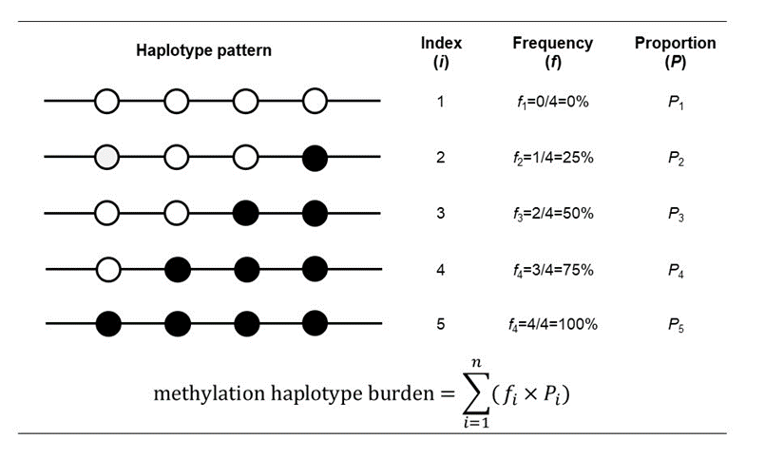
Figure S1. ﻿Schematic representation of methylation haplotype burden.
The diagram is an example for a genome region with 4 CpG sites and 5 patterns of methylation haplotypes in a sequencing sample. The black circles represent the methylated CpGs, and white circles represent the unmethylated CpGs. fi is the frequency of DNA methylation at the CpG sites in the targeted region; Pi is the number of reads of the haplotype divided by the total number of reads in the targeted region. Based on the formula shown below the figure, which is weighted by the frequency of methylation in the targeted sequencing region, we can calculate the methylation haplotype burden.

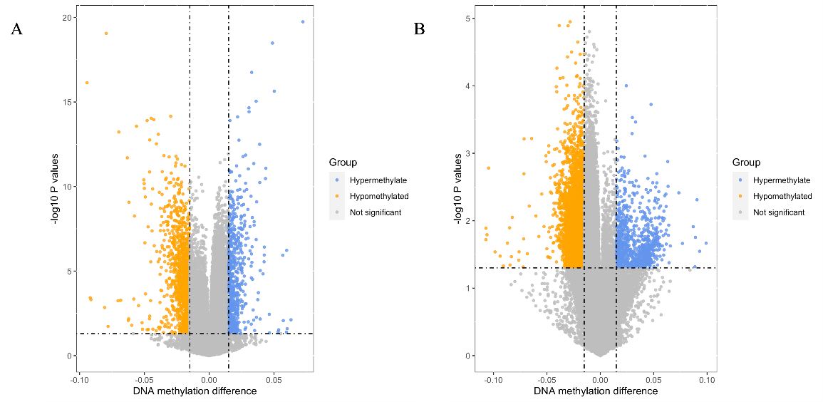

Figure S2. Volcano plots of differential methylation analysis in the samples from GSE51032 and GSE104942.
A represents the volcano plot of the sample from GSE51032; B represents the volcano plot of the samples from GSE104942.
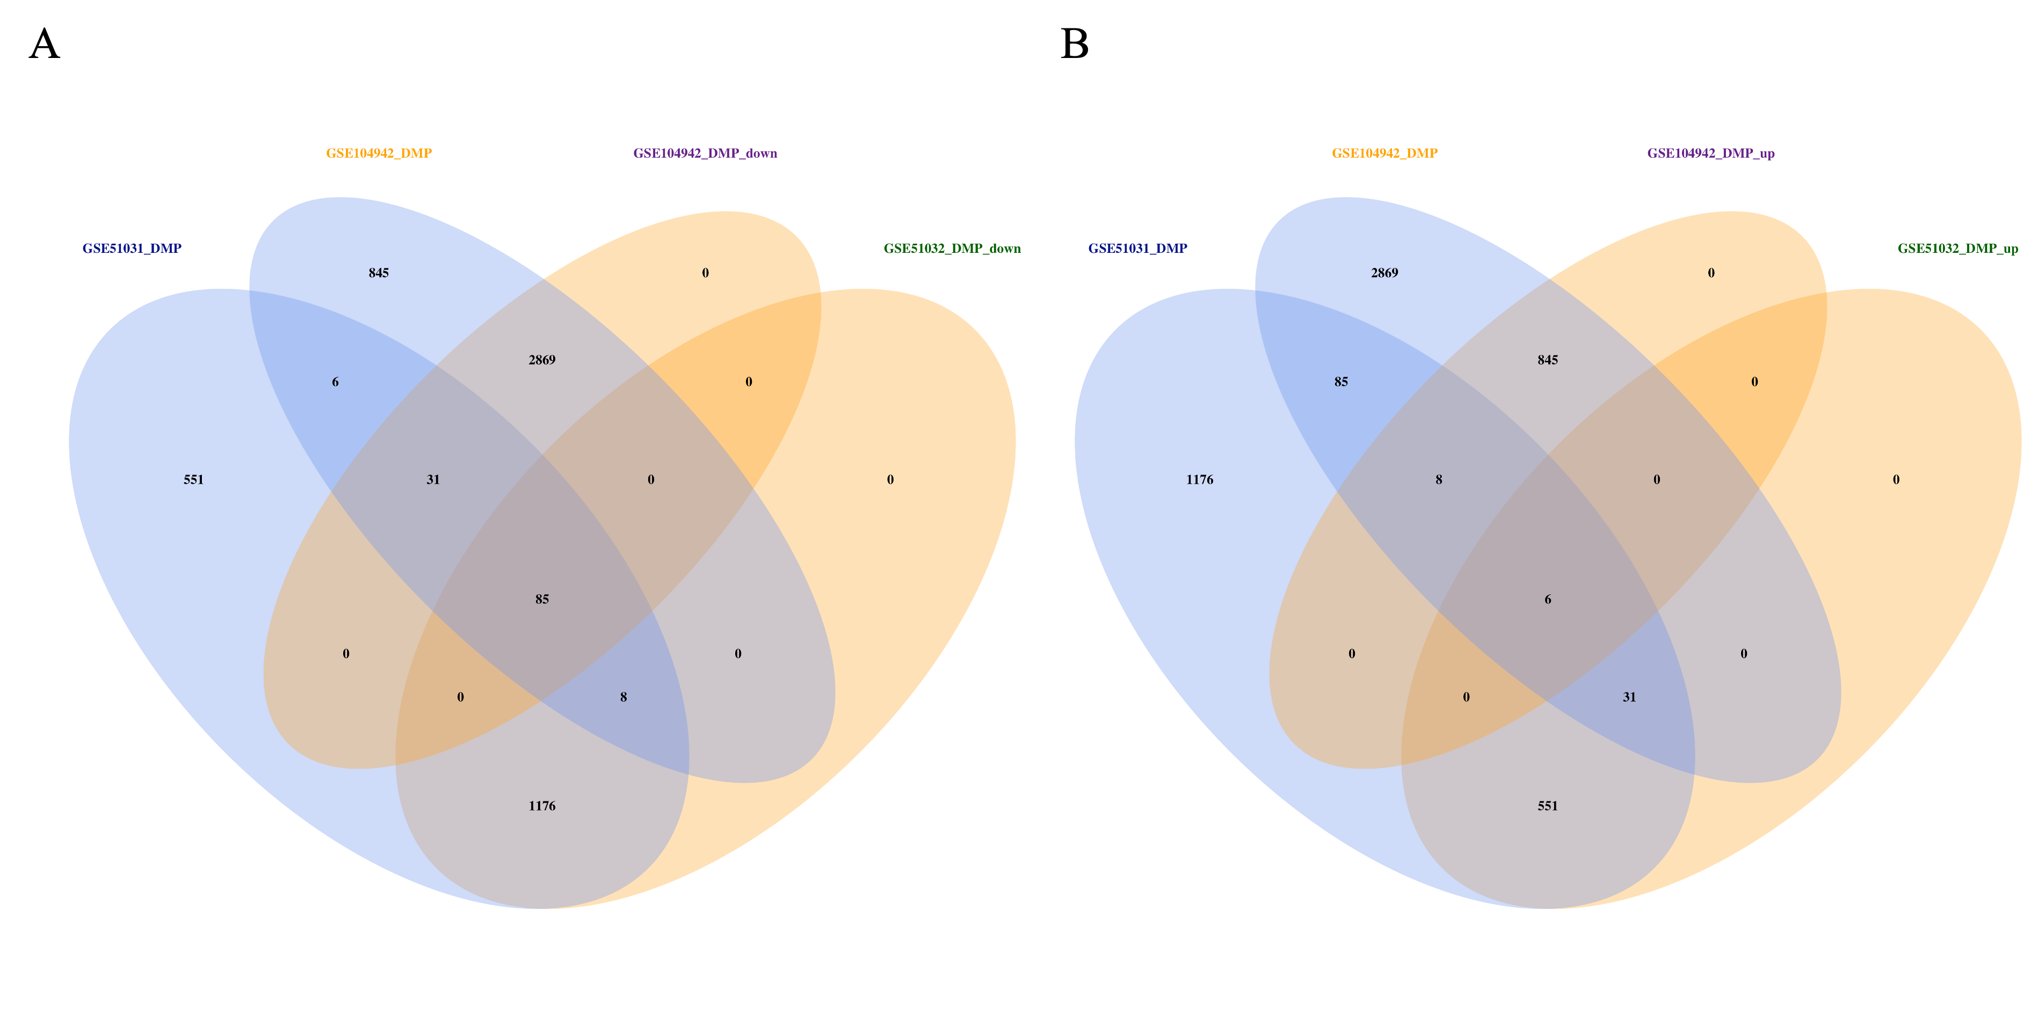
Figure S3. ﻿Integrative analysis of DNA methylation.
﻿A four-way venn diagram shows intersection of genes containing differentially methylated. A represents the venn diagram of hypomethylation of CpG sites associated to immune; B represents the venn diagram of hypermethylation of CpG sites associated to immune.

Figure S4. A dotplot of Go enrichment analysis.
The X-axis represents the gene ratio, which means the ratio of genes to the total genes in a term. The Y-axis rest represents the functional terms. The color represents the P value. The size of the dot represents the number of the enriched genes

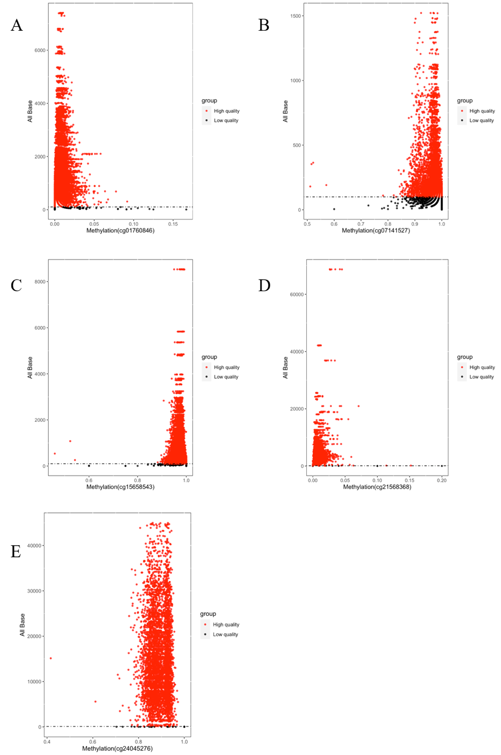

Figure S5. Quality control of samples based on different target regions.
(A), (B), (C), (D) ,(E),represent the sequencing depth of cg01760846, cg07141527, cg15658543, cg21568368 cg24045276 in targeted sequencing, respectively. The red points represent the samples that the sequencing depth are greater than 100X.

Figure S6. Distribution of PSMC1_DMR methylation among sorted leukocyte fractions
Figure S7. Distribution of the methylation of 3 CpG sites in SPPL3 region among sorted leukocyte fractions.
Figure S8. Distribution of the methylation of 7 CpG sites in CARD11 region among sorted leukocyte fractions.

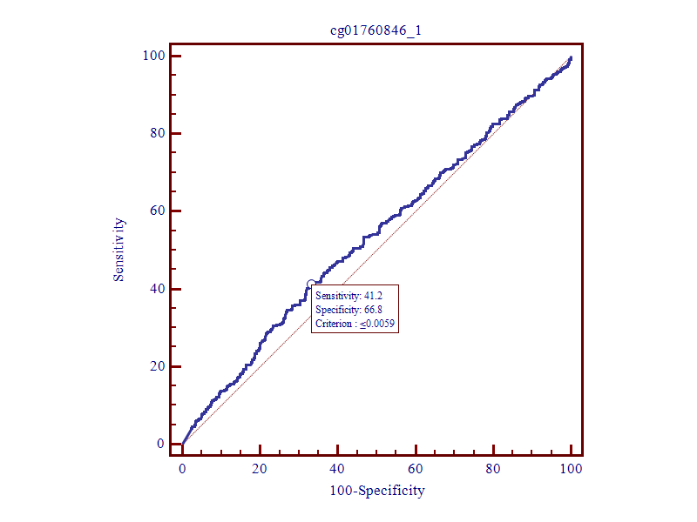
Figure S9. ROC curves of PSMC1_90722706.
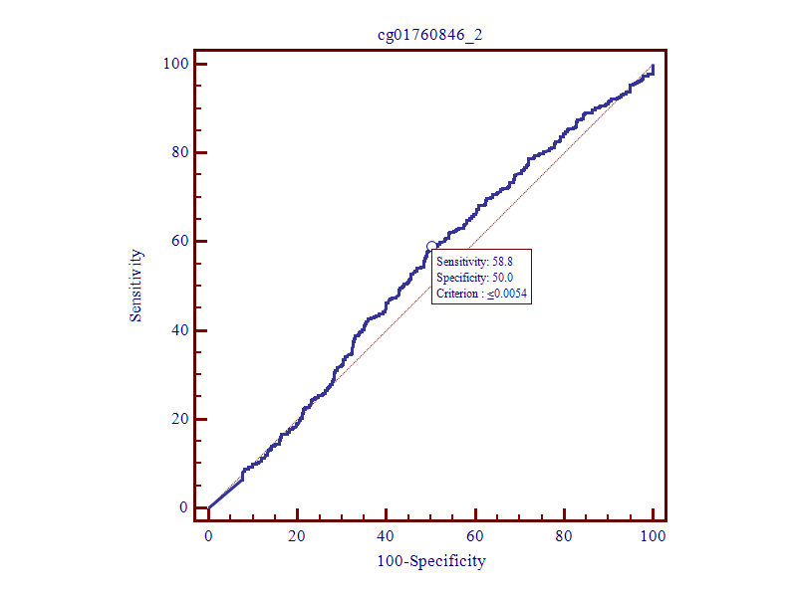
Figure S10. ROC curves of PSMC1_90722716.
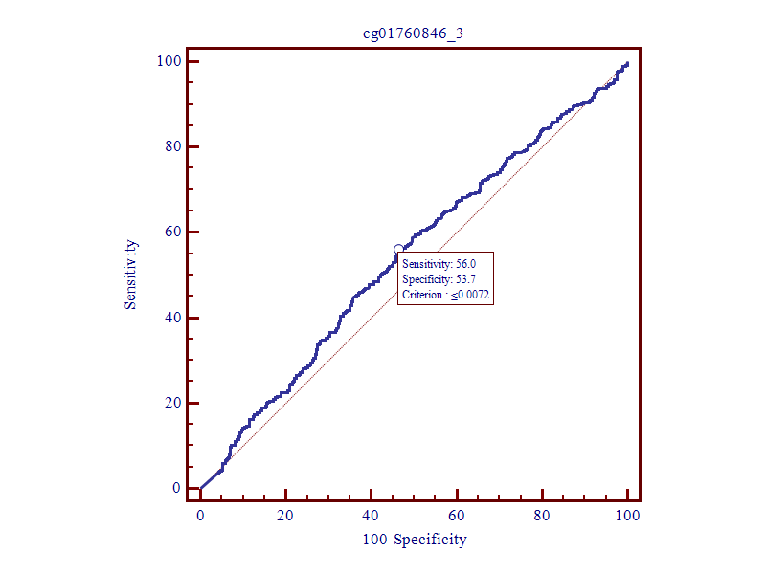
Figure S11. ROC curves of PSMC1_90722782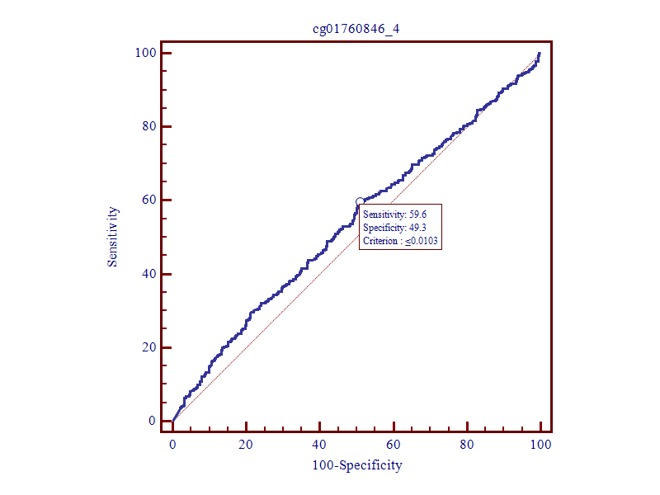 Figure S12. ROC curves of PSMC1_90722795.
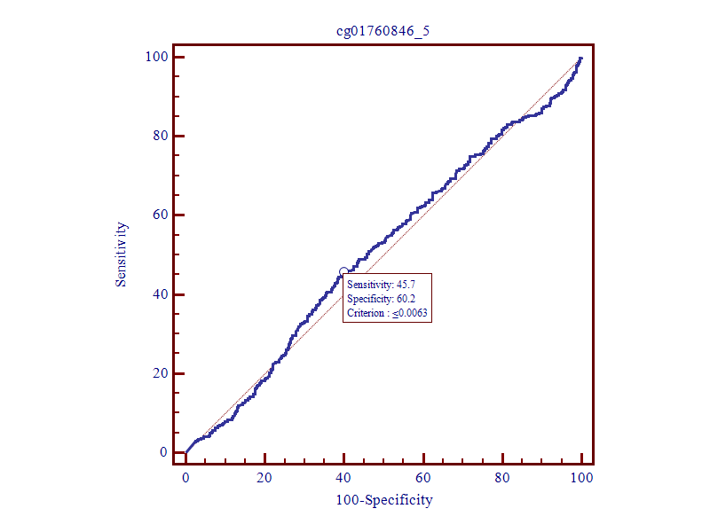
Figure S13. ROC curves of PSMC1_90722799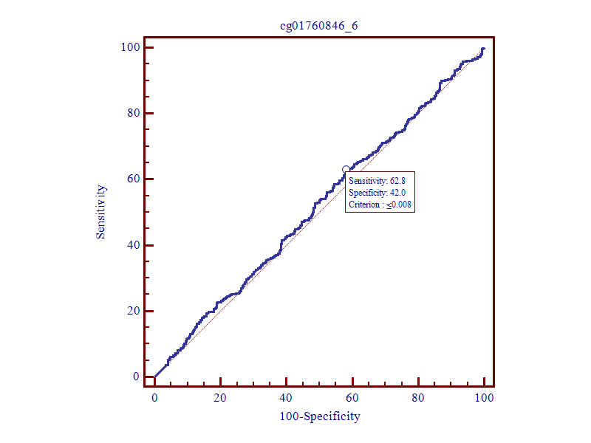 Figure S14. ROC curves of PSMC1_90722830.
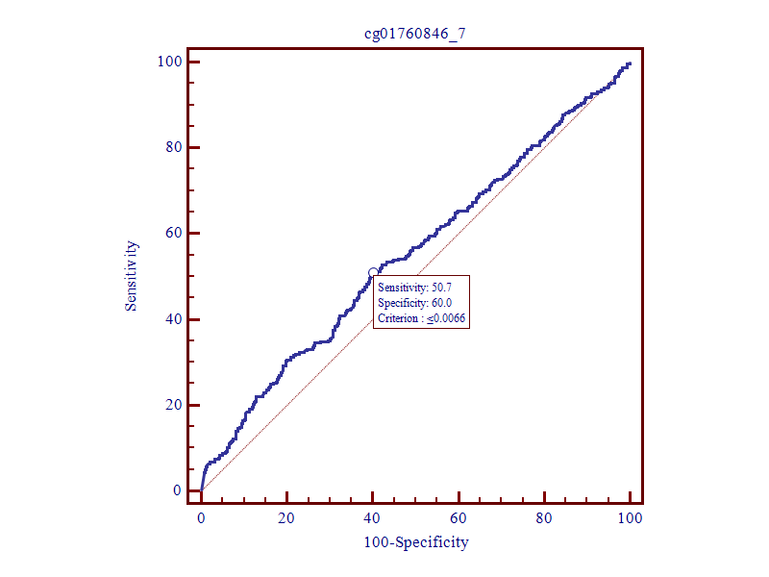
Figure S15. ROC curves of PSMC1_90722856.
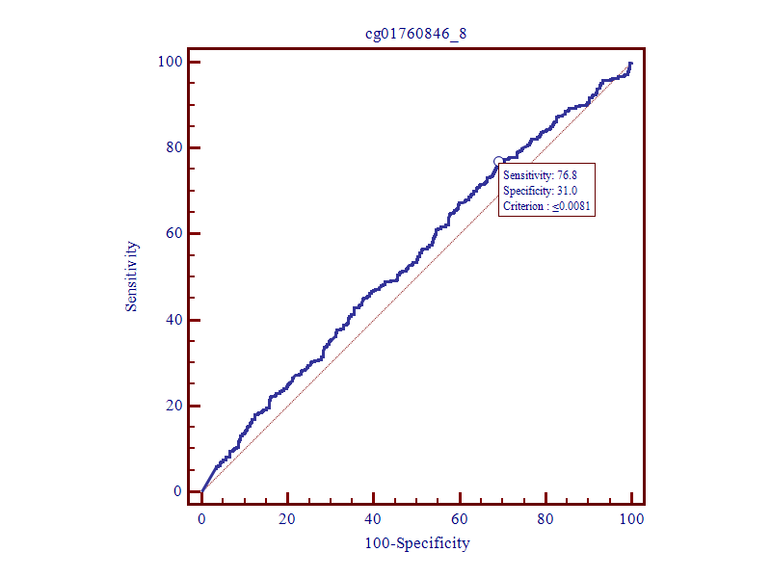
Figure S16. ROC curves of PSMC1_90722861.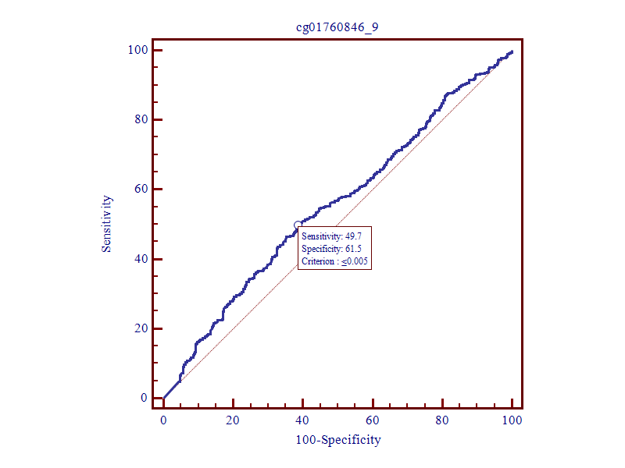

Figure S17. ROC curves of PSMC1_90722870.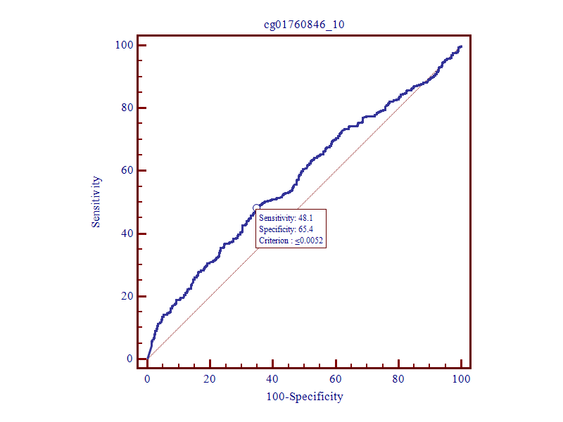
Figure S18. ROC curves of PSMC1_90722877.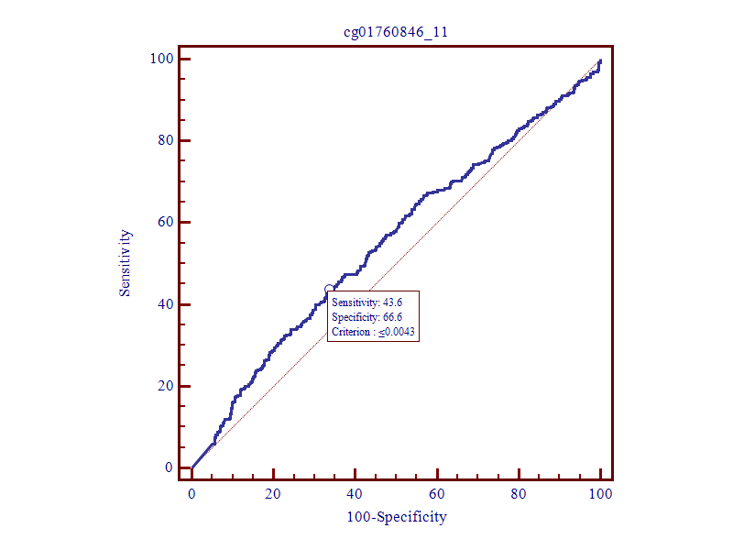
Figure S19. ROC curves of PSMC1_90722886.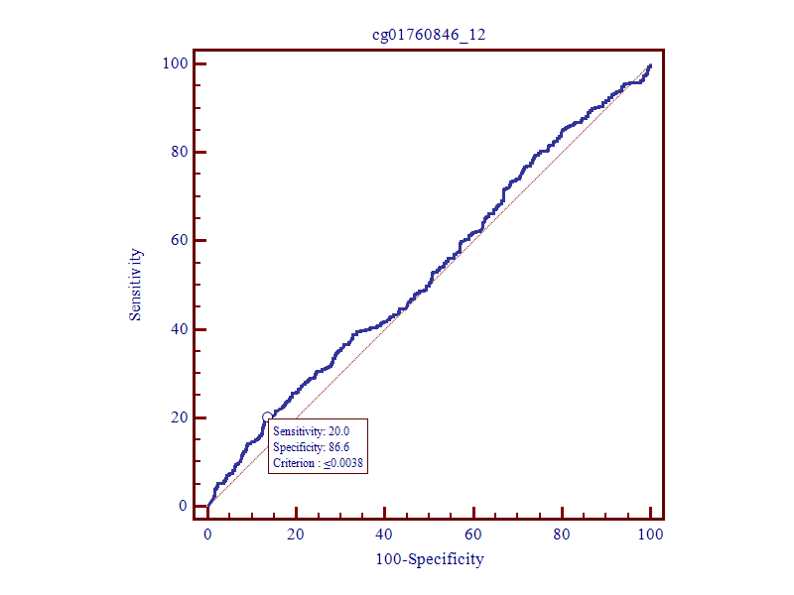
Figure S20. ROC curves of PSMC1_90722891.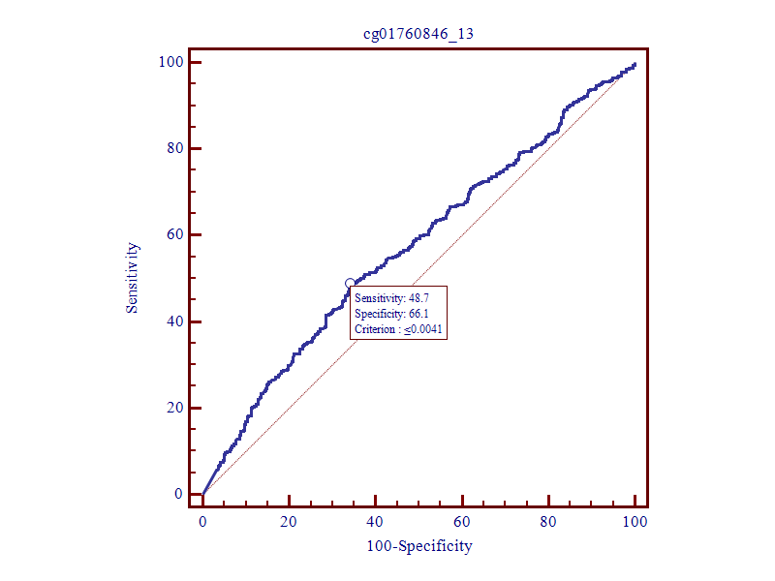
Figure S21. ROC curves of PSMC1_90722911.
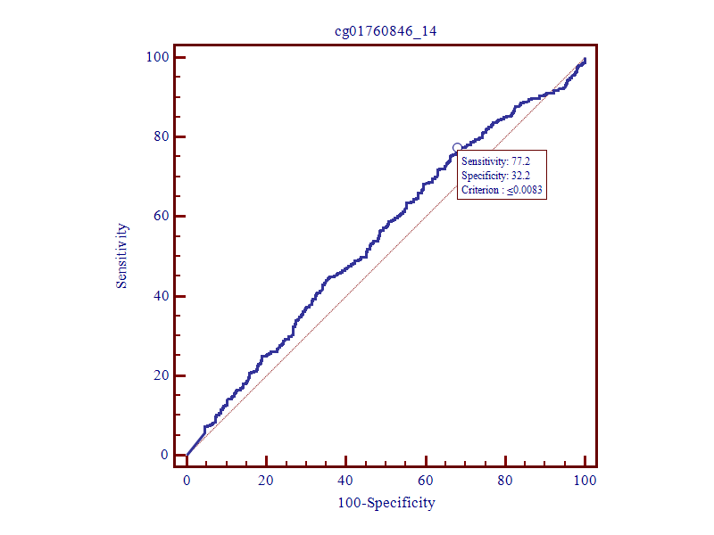
Figure S22. ROC curves of PSMC1_90722917.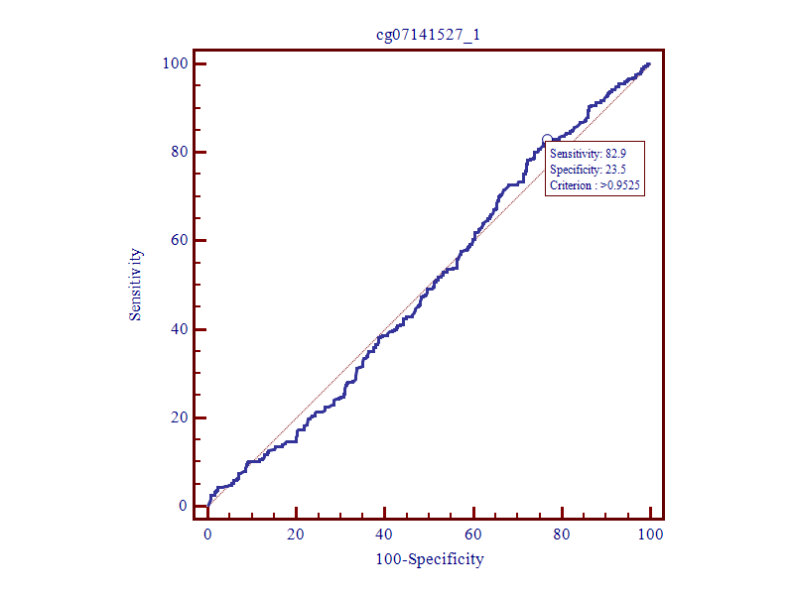
Figure S23. ROC curves of SPPL3_121202409
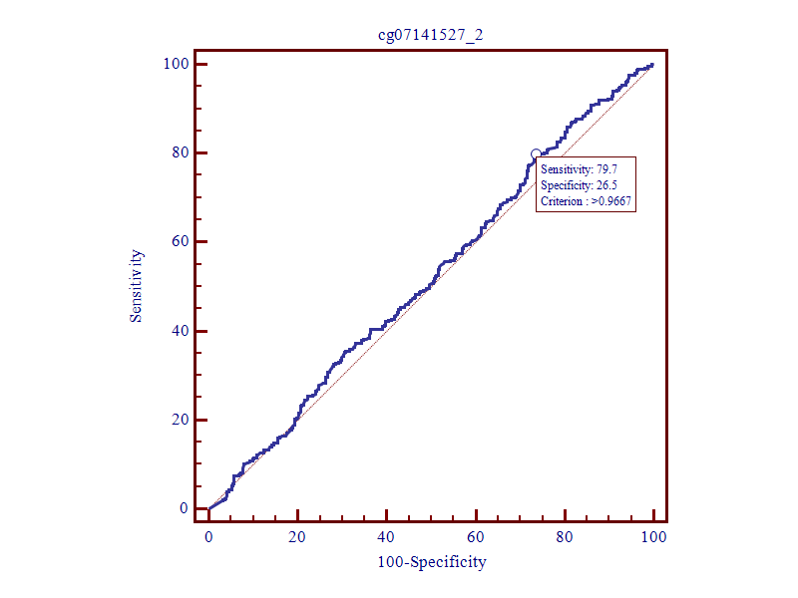 Figure S24. ROC curves of SPPL3_121202464
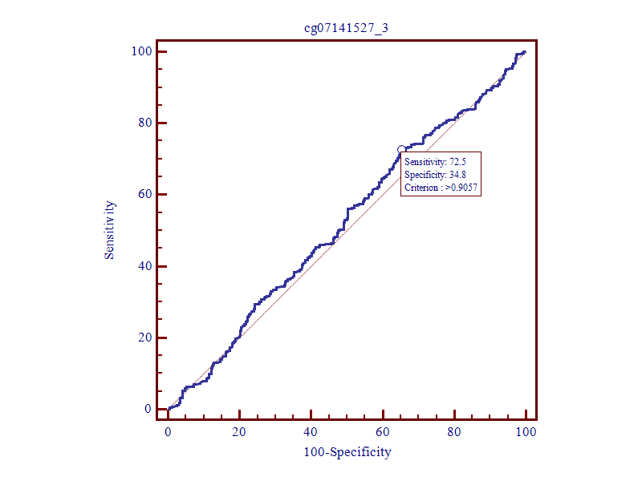
Figure S25. ROC curves of SPPL3_121202539.
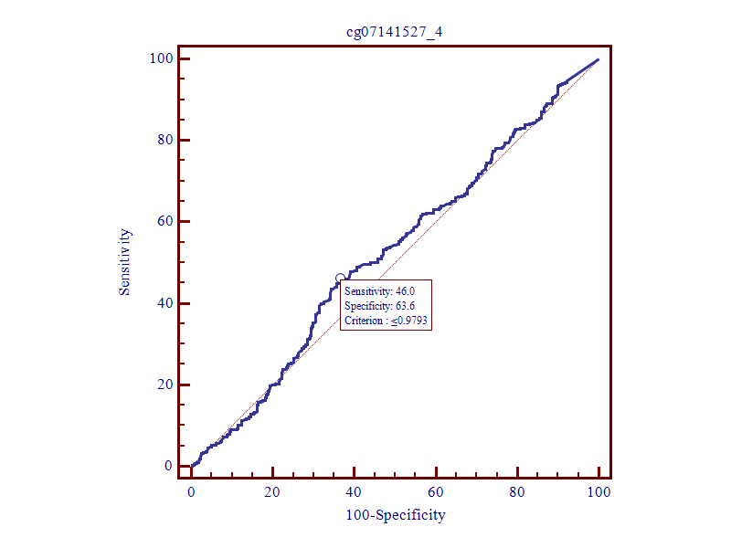
Figure S26. ROC curves of SPPL3_121202552.
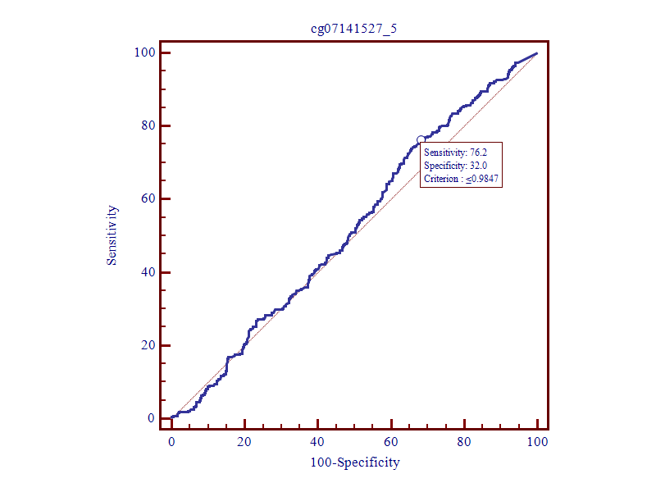
Figure S27. ROC curves of SPPL3_121202554.
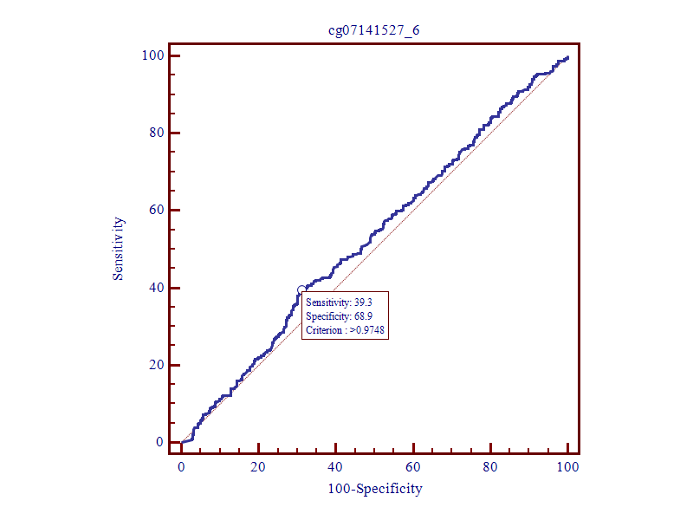
Figure S28. ROC curves of SPPL3_121202602.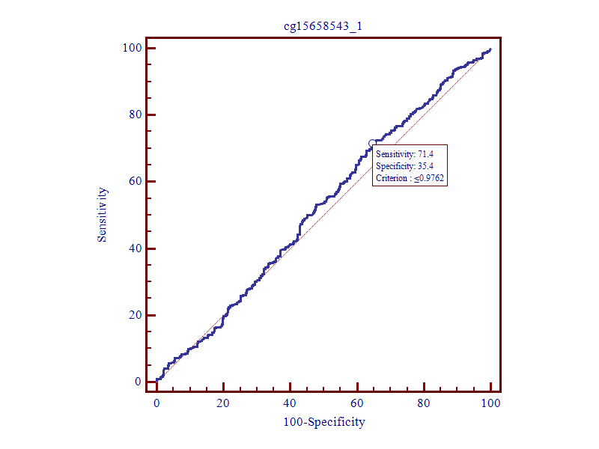
Figure S29. ROC curves of CARD11_3026478.
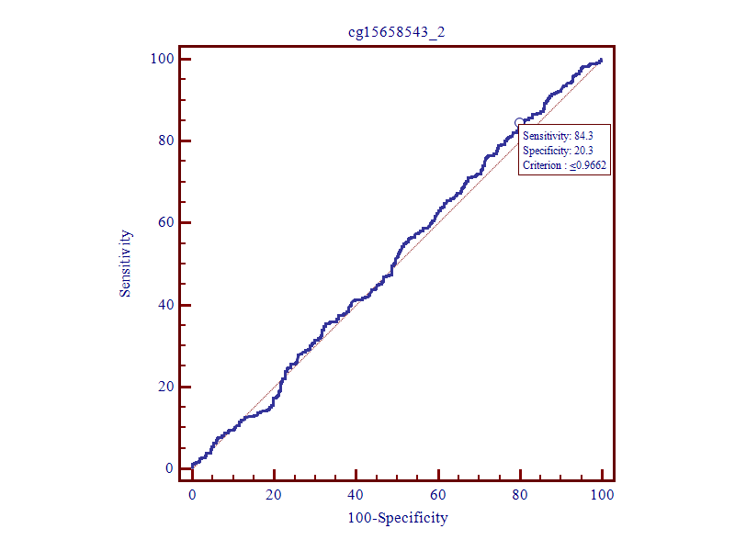
Figure S30. ROC curves of CARD11_3026468
.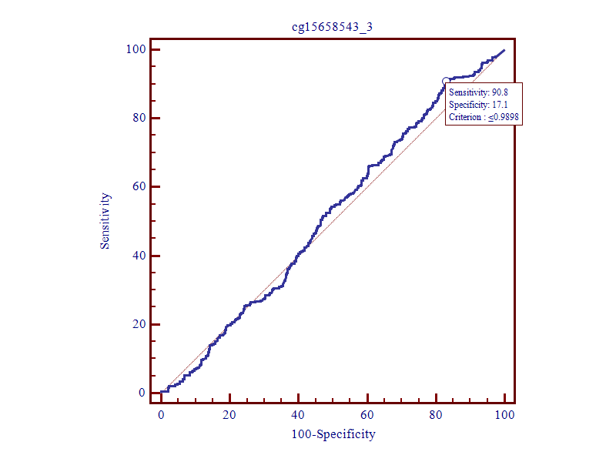
Figure S31. ROC curves of CARD11_3026460.
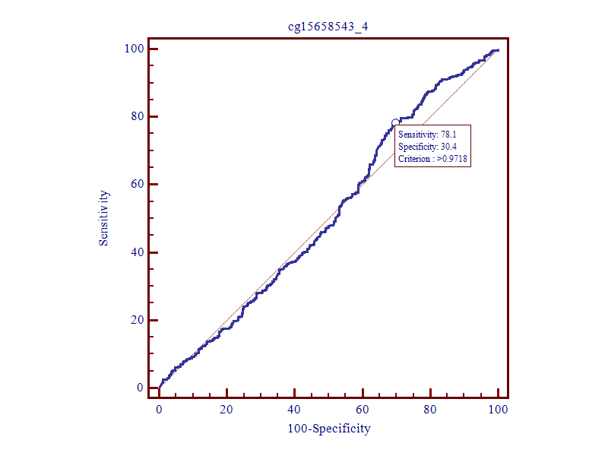
Figure S32. ROC curves of CARD11_3026436.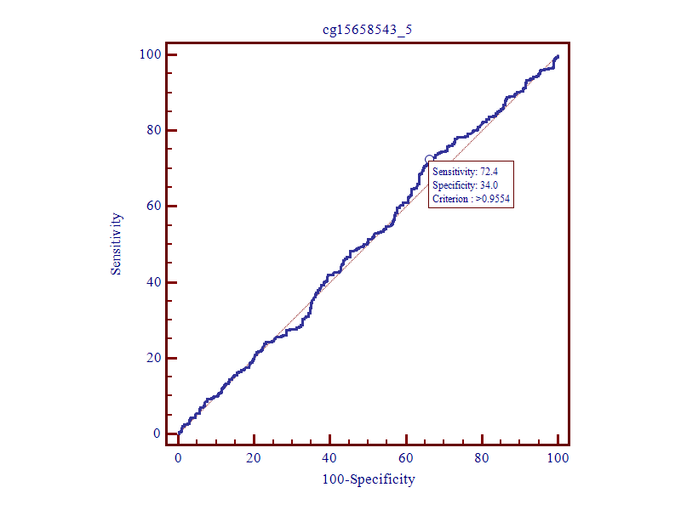
Figure S33. ROC curves of CARD11_3026433.
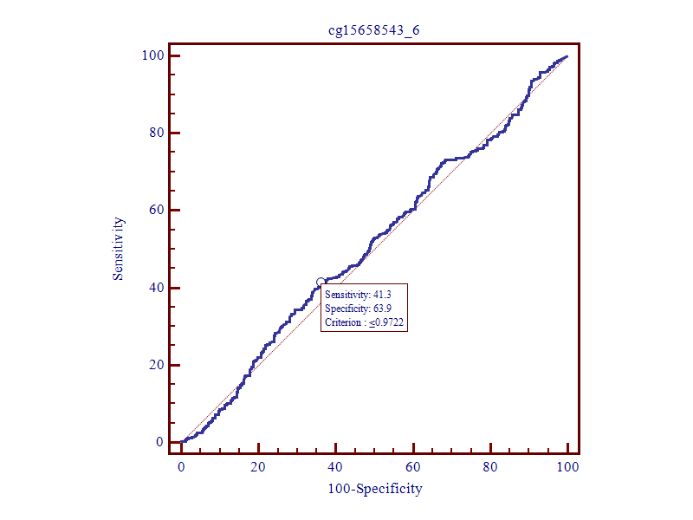
Figure S34. ROC curves of CARD11_3026413.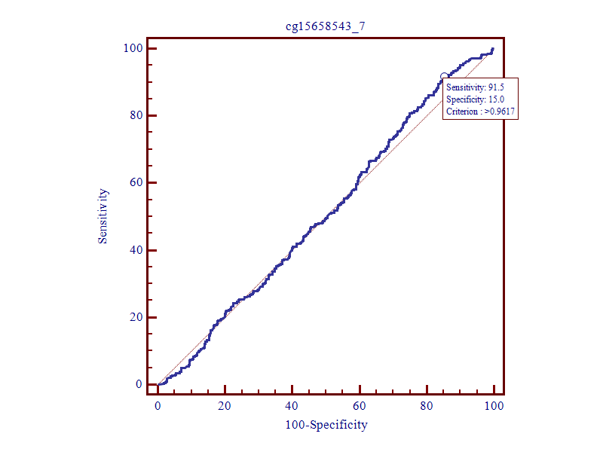
Figure S35. ROC curves of CARD11_3026389.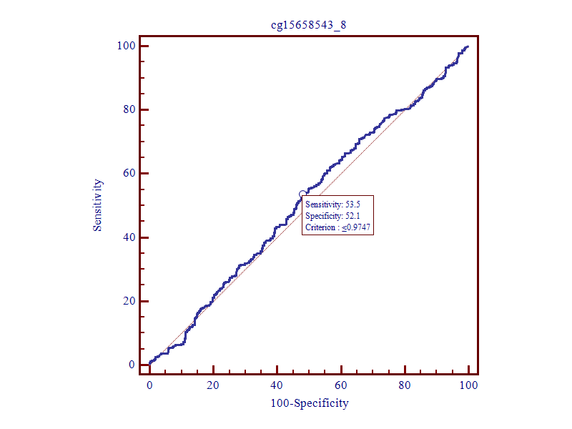 Figure S36. ROC curves of CARD11_3026380.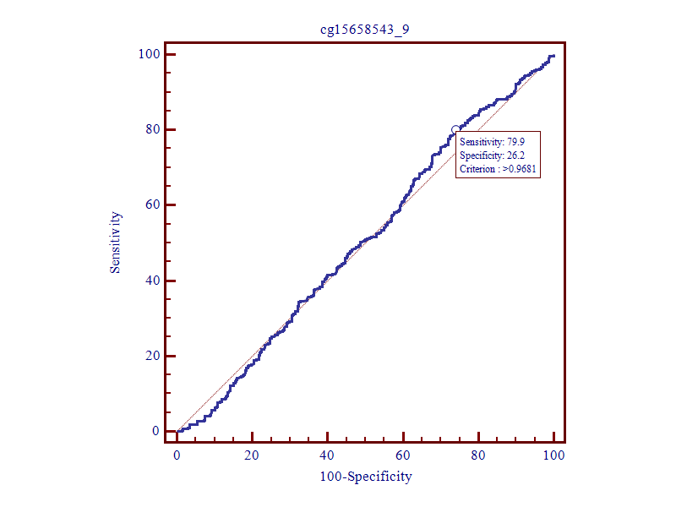 Figure S37. ROC curves of CARD11_3026375.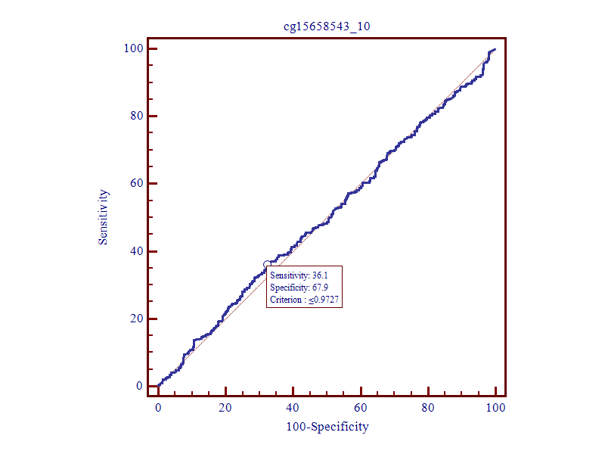 Figure S38. ROC curves of CARD11_3026348.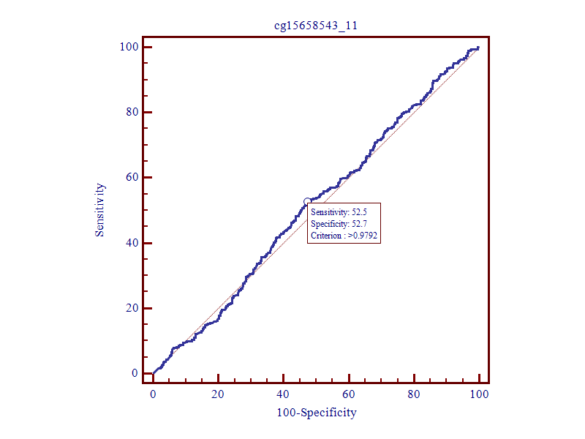
Figure S39. ROC curves of CARD11_3026326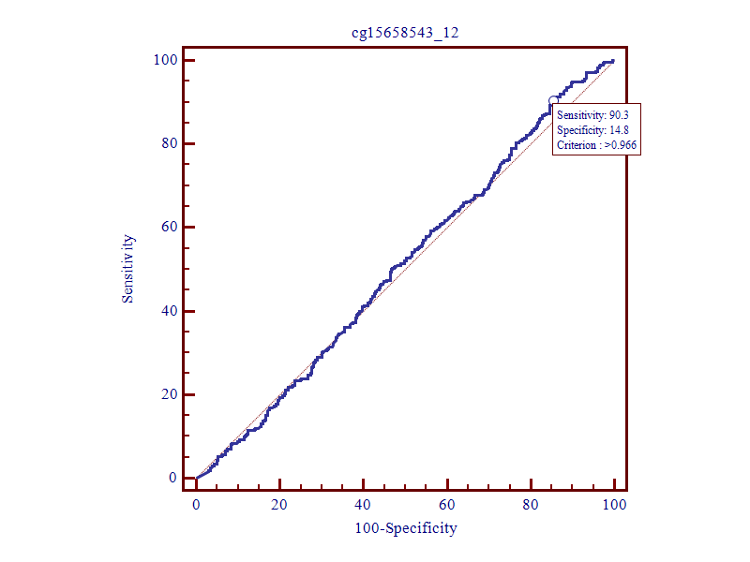 Figure S40. ROC curves of CARD11_3026321.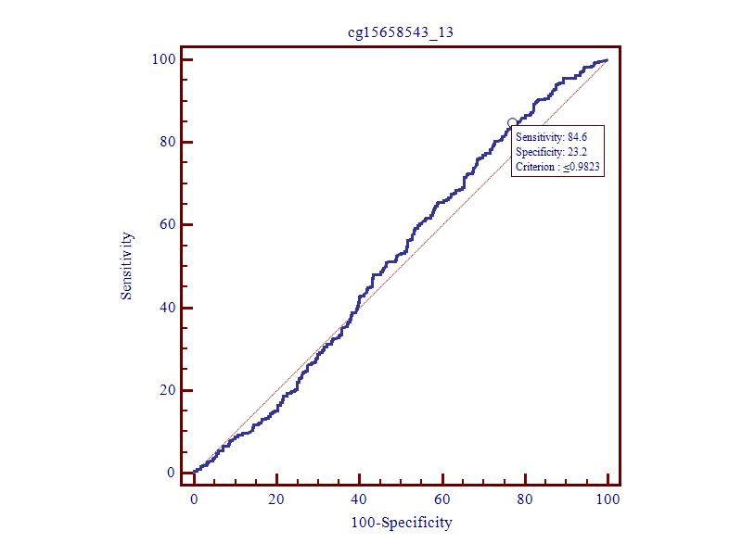 Figure S41. ROC curves of CARD11_3026317.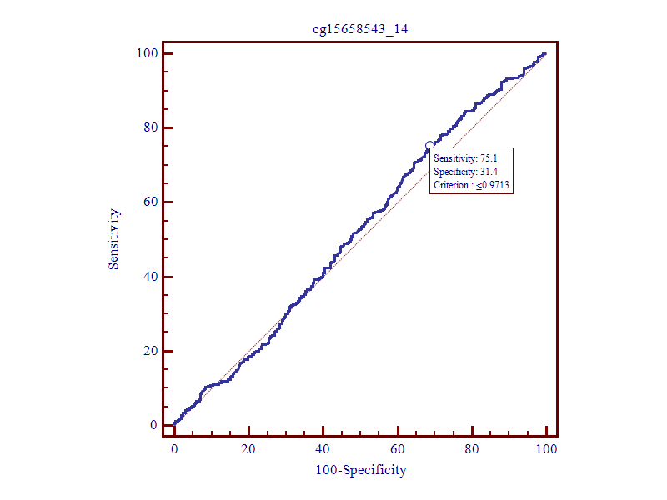 Figure S42. ROC curves of CARD11_3026310.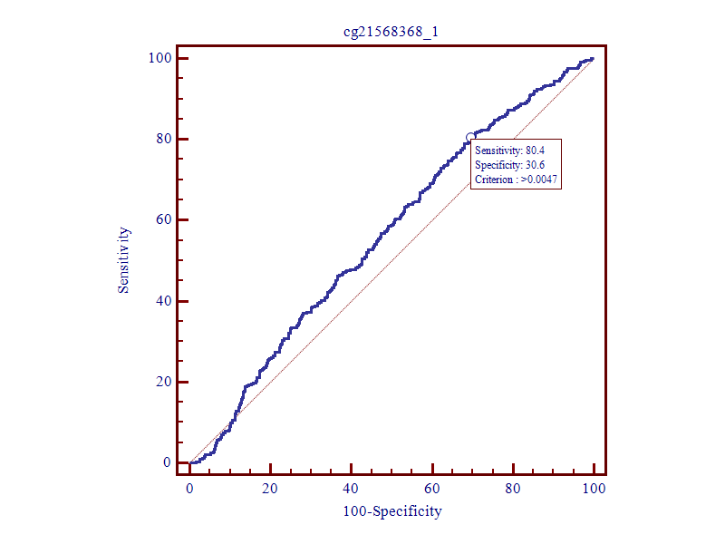
Figure S43. ROC curves of PSMB8_32812098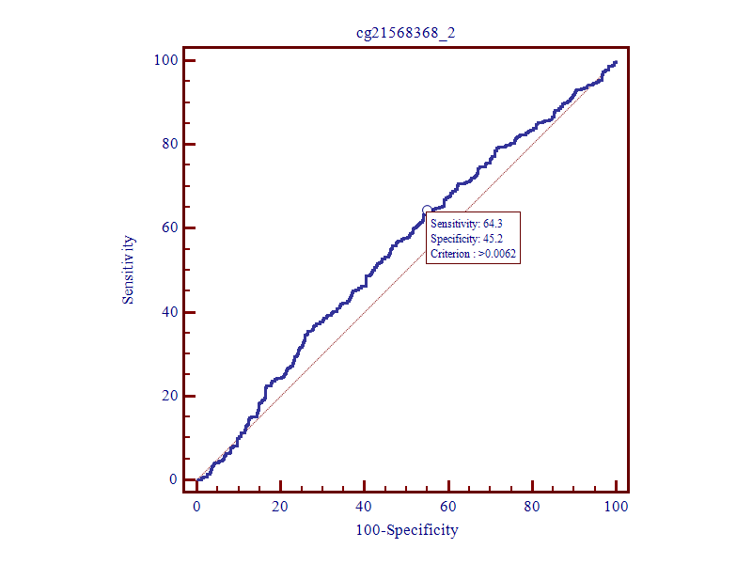 Figure S44. ROC curves of PSMB8_32812113.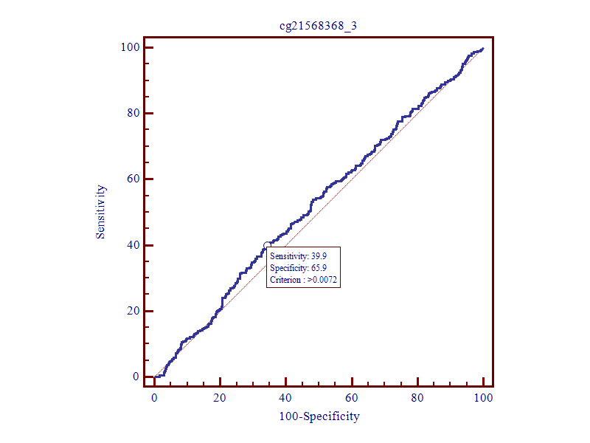
Figure S45. ROC curves of PSMB8_32812165.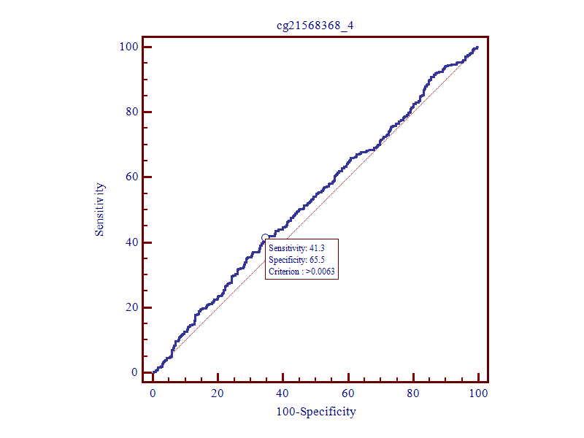 Figure S46. ROC curves of PSMB8_32812167.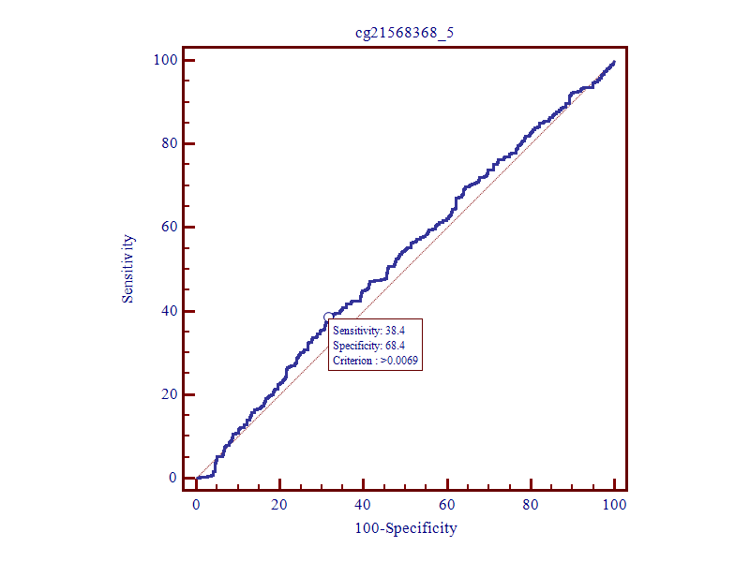
Figure S47. ROC curves of PSMB8_32812213.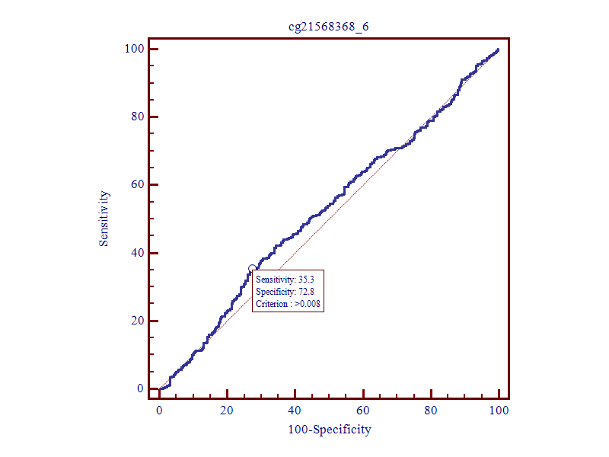 Figure S48. ROC curves of PSMB8_32812221.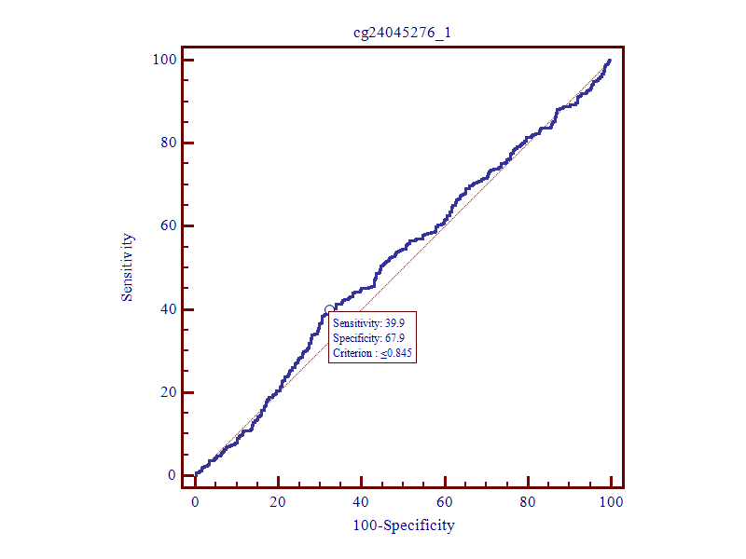 Figure S49. ROC curves of NCF2_183551942.
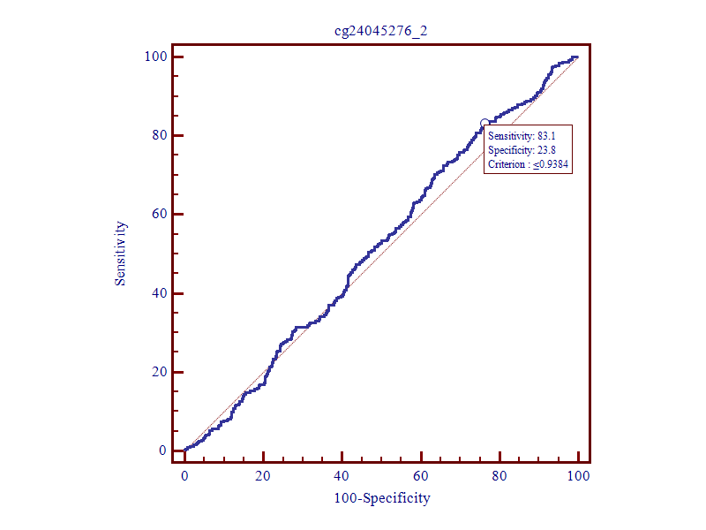
Figure S50. ROC curves of NCF2_183551969.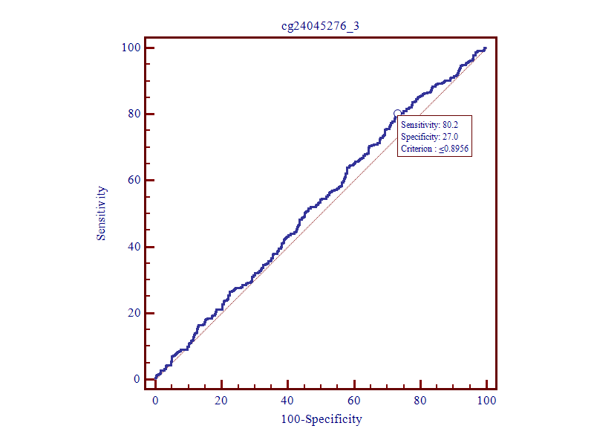
Figure S51. ROC curves of NCF2_183551986.
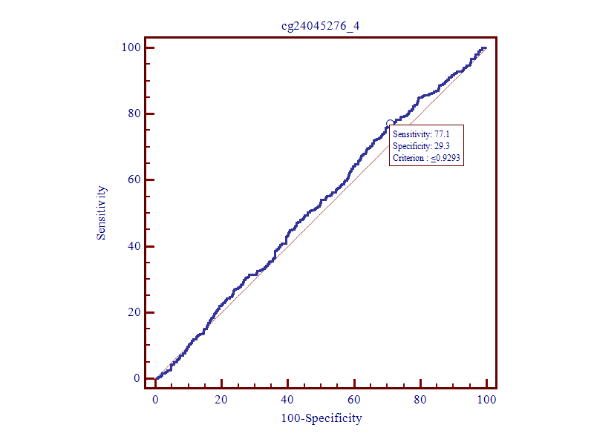 Figure S52. ROC curves of NCF2_183552072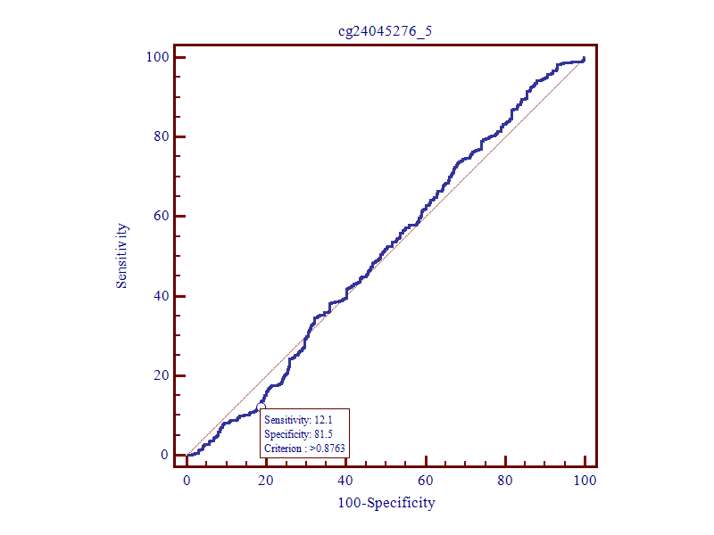
Figure S53. ROC curves of NCF2_183552095.
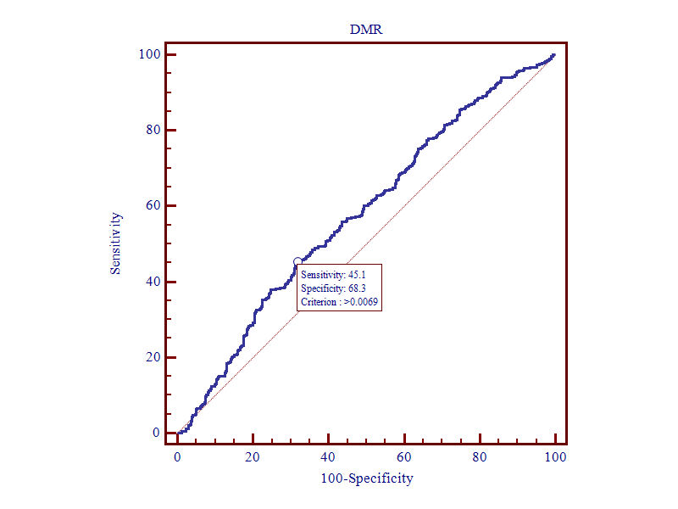 Figure S54. ROC curves of PSMC1_DMR. 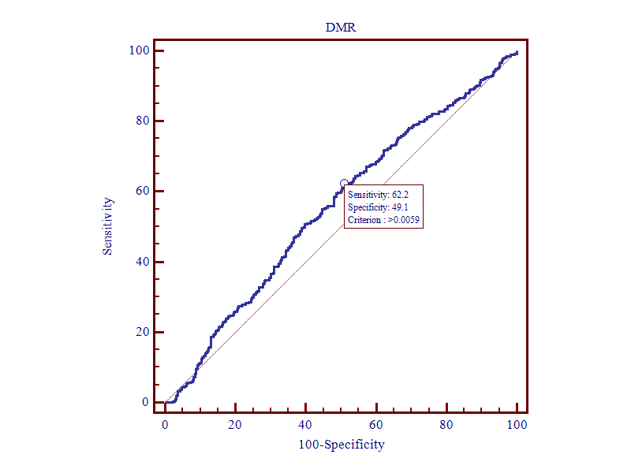 Figure S55. ROC curves of PSMB8_DMR.
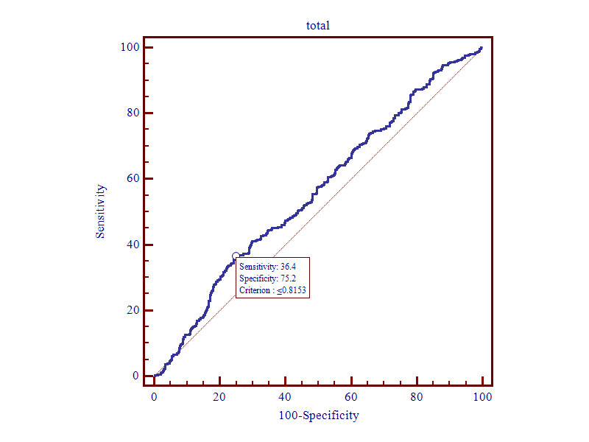
Figure S56. ROC curves of PSMC1_Haplot.
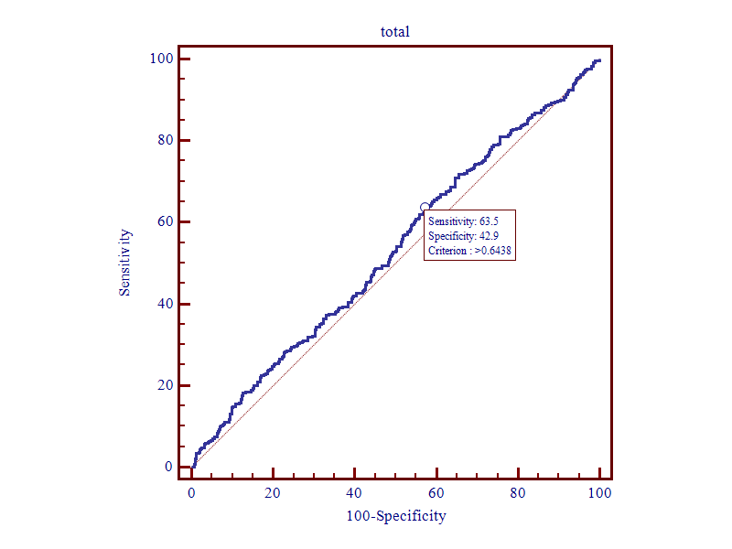 Figure S57. ROC curves of SPPL 3_Haplot.
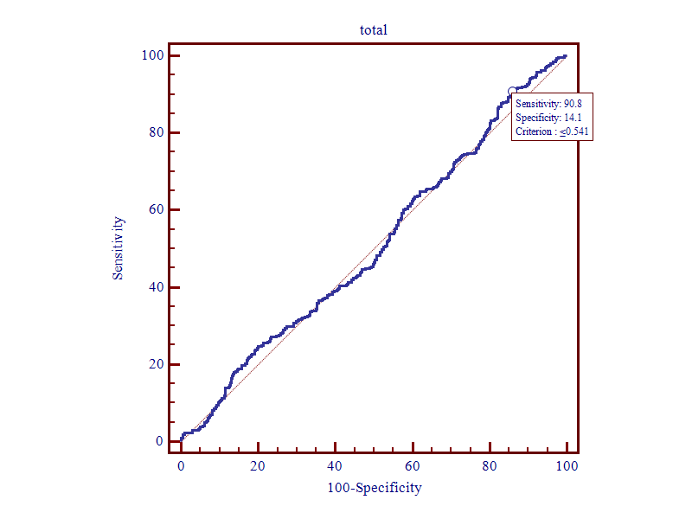
Figure S58. ROC curves of CARD11_Haplot.
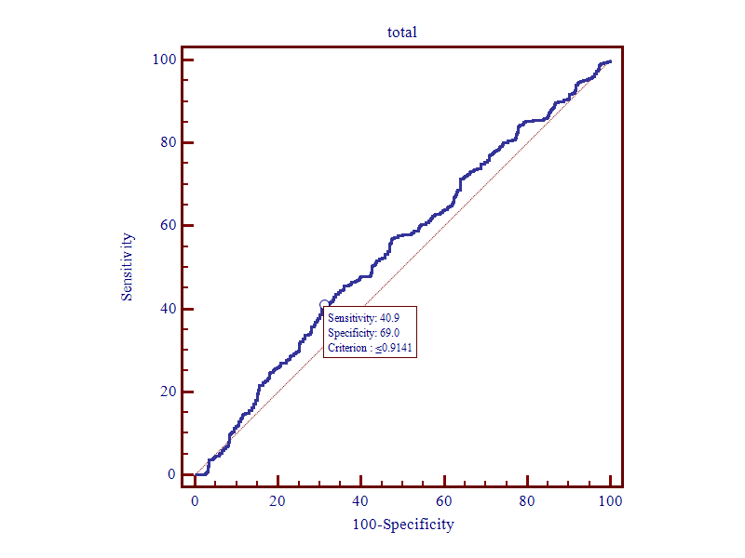
Figure S59. ROC curves of PSMB8_Haplot.
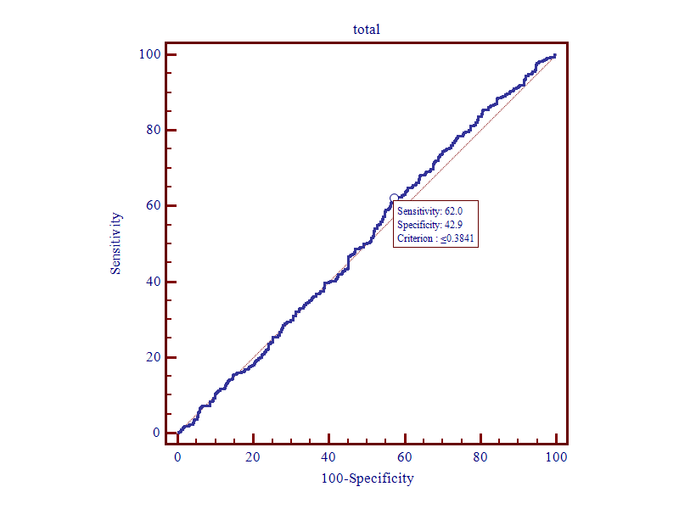 Figure S60. ROC curves of NCF2_Haplot.

