Supplementary Material
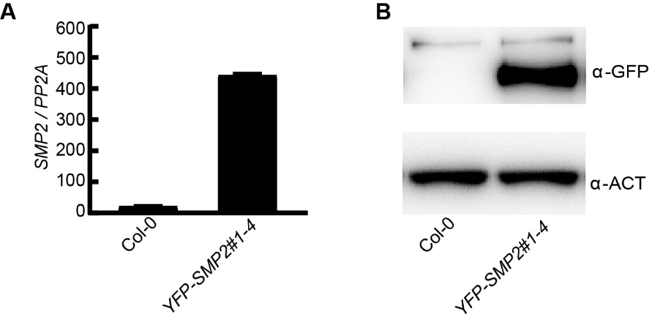
Supplementary Figure 1. Identification of YFP-SMP2 transgenic plant. (A) SMP2 expression level in Col-0 and YFP-SMP2 plants. Total RNA was extracted from 5-day-old seedlings of Col-0, YFP-SMP2 grown under constant white light condition. PP2A was used as the internal control. Error bars represent SD, n = 3. The experiments are performed three times with similar results. (B) Protein abundance of YFP-SMP2 in YFP-SMP2 plants. Total proteins were extracted from 5-day-old seedlings of Col-0, YFP-SMP2 grown under constant white light condition. YFP-SMP2 proteins were detected by immunoblot analysis with anti-GFP antibody. α-ACT, anti-Actin antibody, was used as a loading control.
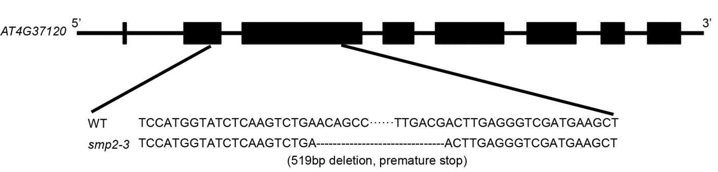
Supplementary Figure 2. The smp2-3 mutant allele generated by CRISPR/Cas9. Black boxes in the gene body indicated the exon regions, horizontal lines indicated the intron regions.

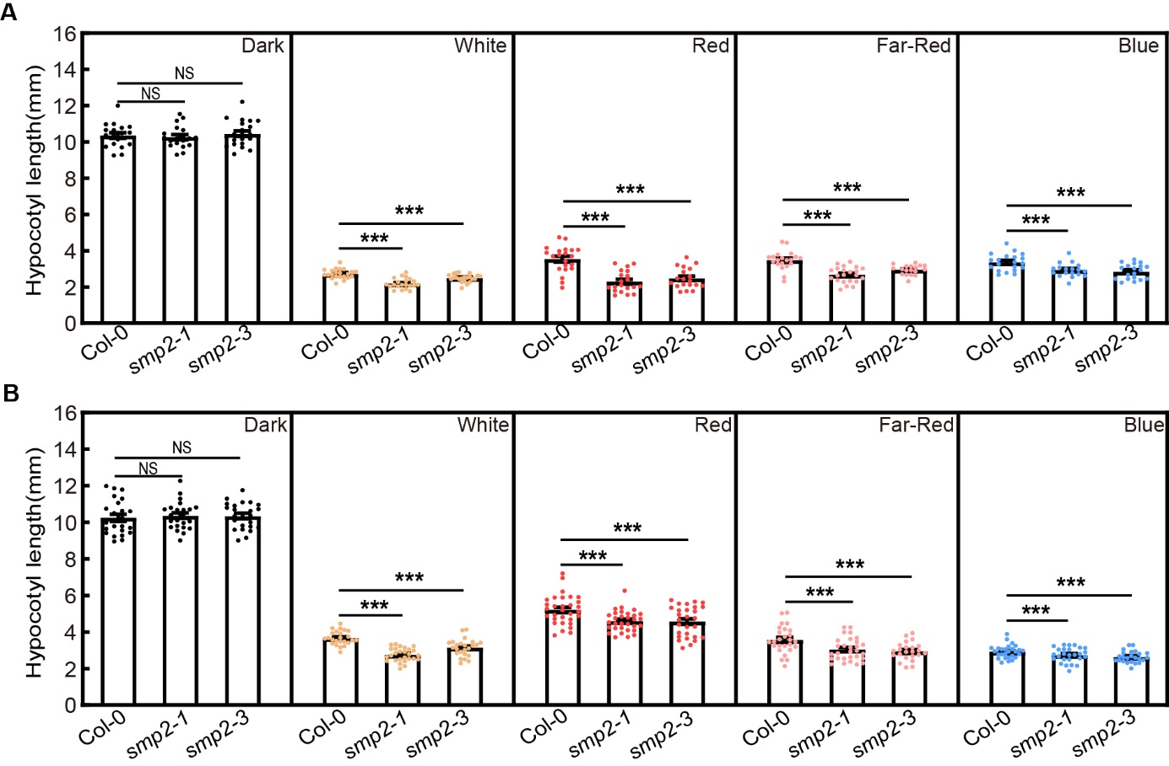
Supplementary Figure 3. Biological replicates of hypocotyl phenotypes of smp2 mutants. Error bars represent standard deviation (SD), n ≥20; ***, P<0.001 (t-test); NS, not significant (t-test).

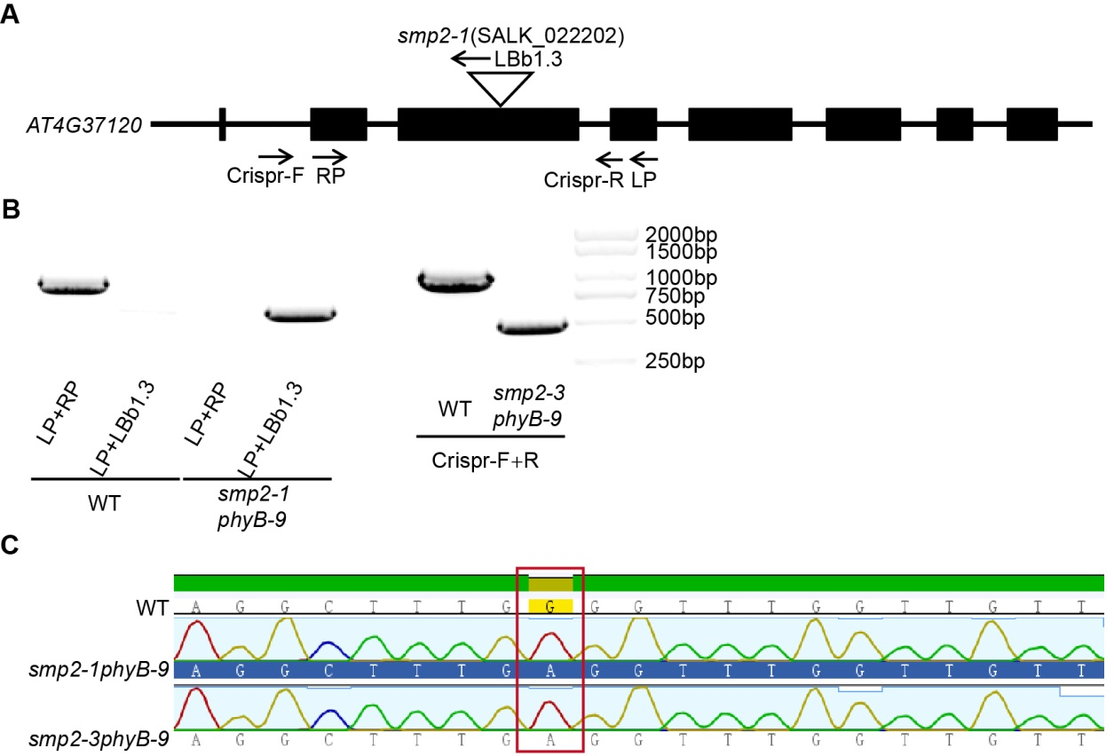
Supplementary Figure 4. Identification of homozygous smp2-1 phyB-9 and smp2-3 phyB-9 mutants. (A) The schematic diagram of primers used for genotyping smp2-1 and smp2-3. (B) Identification of homozygous smp2-1 and smp2-3 by PCR with the indicated primers. (C) Identification of homozygous phyB-9 allele by DNA sequencing. The red box indicated the G-to-A mutation in phyB-9.
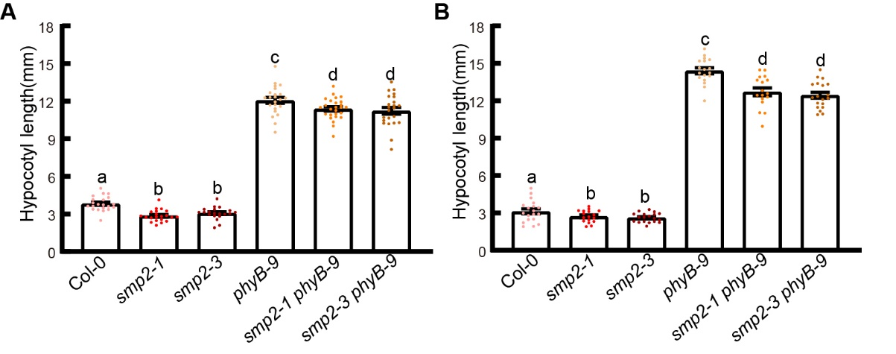
Supplementary Figure 5. Biological replicates of hypocotyl phenotypes of the mutants as indicated. Error bars represent SD, n ≥ 20. Letters above the bars indicate significant differences (P < 0.05), as determined by one-way analysis of variance (ANOVA) with Duncan’s post-hoc analysis.
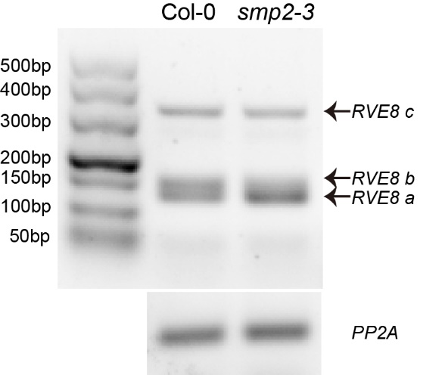
Supplementary Figure 6. RVE8 splicing patterns in Col-0 and smp2-3 by RT-PCR. Total RNA was extracted from Col-0 and smp2-3 seedlings treated as described in Figure 4A. Sequences of related primers RVE8-RT-F1 and RVE8-PCR-R were listed in Supplemental Table 1.
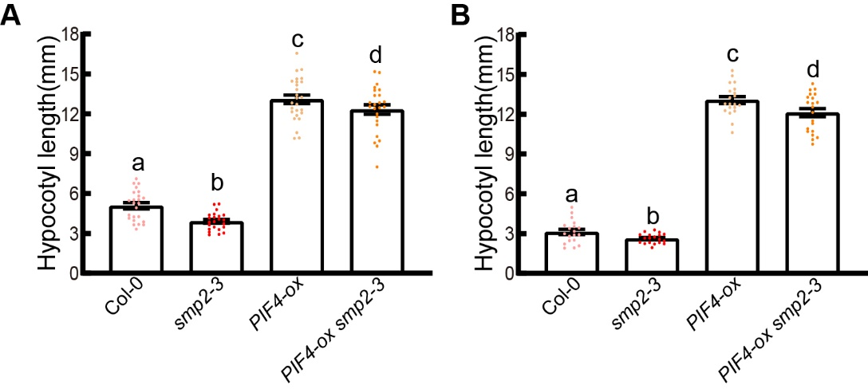
Supplementary Figure 7. Biological replicates of the hypocotyl phenotypes of the mutants as indicated. Error bars represent SD, n ≥ 20. Letters above bars indicate significant differences (P < 0.05), as determined by one-way analysis of variance (ANOVA) with Duncan’s post-hoc analysis.

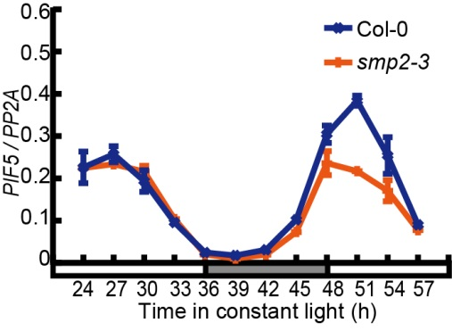
Supplementary Figure 8. Relative expression level of PIF5 in Col-0 and smp2-3 mutant. Seedlings were entrained in the diurnal cycles (12 h light / 12 h dark) for 6 days and then transferred to continuous white light (145 μmol·m⁻²·sec⁻¹). Seedlings were harvested as described in Figure 4A. PP2A was used as an internal control. Error bars represent SD, n = 3.
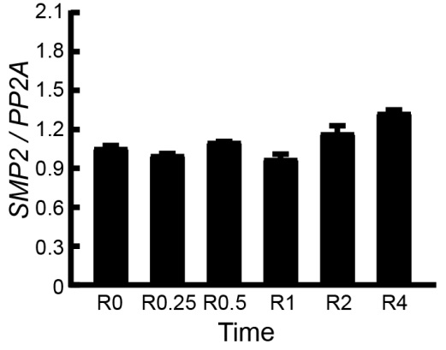
Supplementary Figure 9. SMP2 expression is not regulated by red light. Seedlings were grown in the dark for 5 days and then transferred to red light (145 μmol·m⁻²·sec⁻¹) for indicated times (hours). PP2A was used as the internal control. Error bars represent SD, n = 3. The experiments were performed three times with similar results.

Supplemental Table 1. Primers used in this study.
Primer name | Primer sequences (5’→3’)
Genotyping primers
smp2-1 LP | CACGATGATCACAAACTAACCAAATAG
smp2-1 RP | TCTGAACAGCCGGTATATGCGAA
smp2-3 Crispr-F | TGCTATTGGCTAGATTCATTTTGG
smp2-3 Crispr-R | GTCTTCTCTGATACGCAGATTCC
phyB-9 seq-F | TGCTGTTCAATCGCAGAAAC
phyB-9 seq-R | TCGCAGTGTGAGATCGAAAC
Real-time qPCR
PP2A-RT-F | TATCGGATGACGATTCTTCGTGCAG
PP2A-RT-R | GCTTGGTCGACTATCGGAATGAGAG
SMP2-RT-F | TAAAGCTGGTCTCGCTCCTG
SMP2-RT-R | GCTTCAAACTCGGCTGTTCA
RVE8-RT-F1 | CCTCACAGTTAACTTATCAAACCCTG
RVE8-RT-F2 | GGATCCTATAAATTTCGAAACTGTTCT
RVE8 a-RT-R1 | TCATATGATAAGAGGACTTTCCTAGTGG
RVE8 b-RT-R2 | GCATCATTACAATCCGAAGTGGA
RVE8 c-RT-R3 | ACAATCCGACTAGCTGAGGT
RVE8-PCR-R | GCTGATTTGTCGCTTGTTGAGTTC
PRR5-RT-F | GCCGGGACAGAGTTCATACC
PRR5-RT-R | CTTGGGGAGAGTGAAGCAGG
TOC1-RT-F | AATAGTAATCCAGCGCAATTTTCTTC
TOC1-RT-R | CTTCAATCTACTTTTCTTCGGTGCT
ELF4-RT-F | CAAAGCAACGTTCTTCGACA
ELF4-RT-R | CGACAATCACCAATCGAGAA
GI-RT-F | ACTAGCAGTGGTCGACGGTTTATC
GI-RT-R | GCTGGTAGACGACACTTCAATAGATT
PIF4-RT-F | TGCATCACAACCGACCGTAA
PIF4-RT-R | AACTTCAGCTGCTCGACTCC
PIF1-RT-F | ACTGAATCCCGTAGCGAGGAAA
PIF1-RT-R | CTTGTTGCAGCGAGGTATAAGT
PIF3-RT-F | AGACAGGAACCCTTCTCCACC
PIF3-RT-R | GTGATGGCACTGACATAGGGA
PIF5-RT-F | GTGGAACAAGTGTAACCATTGACC
PIF5-RT-R | GATCCGATCTCTCCTCCTCCTT

