Supplementary Material

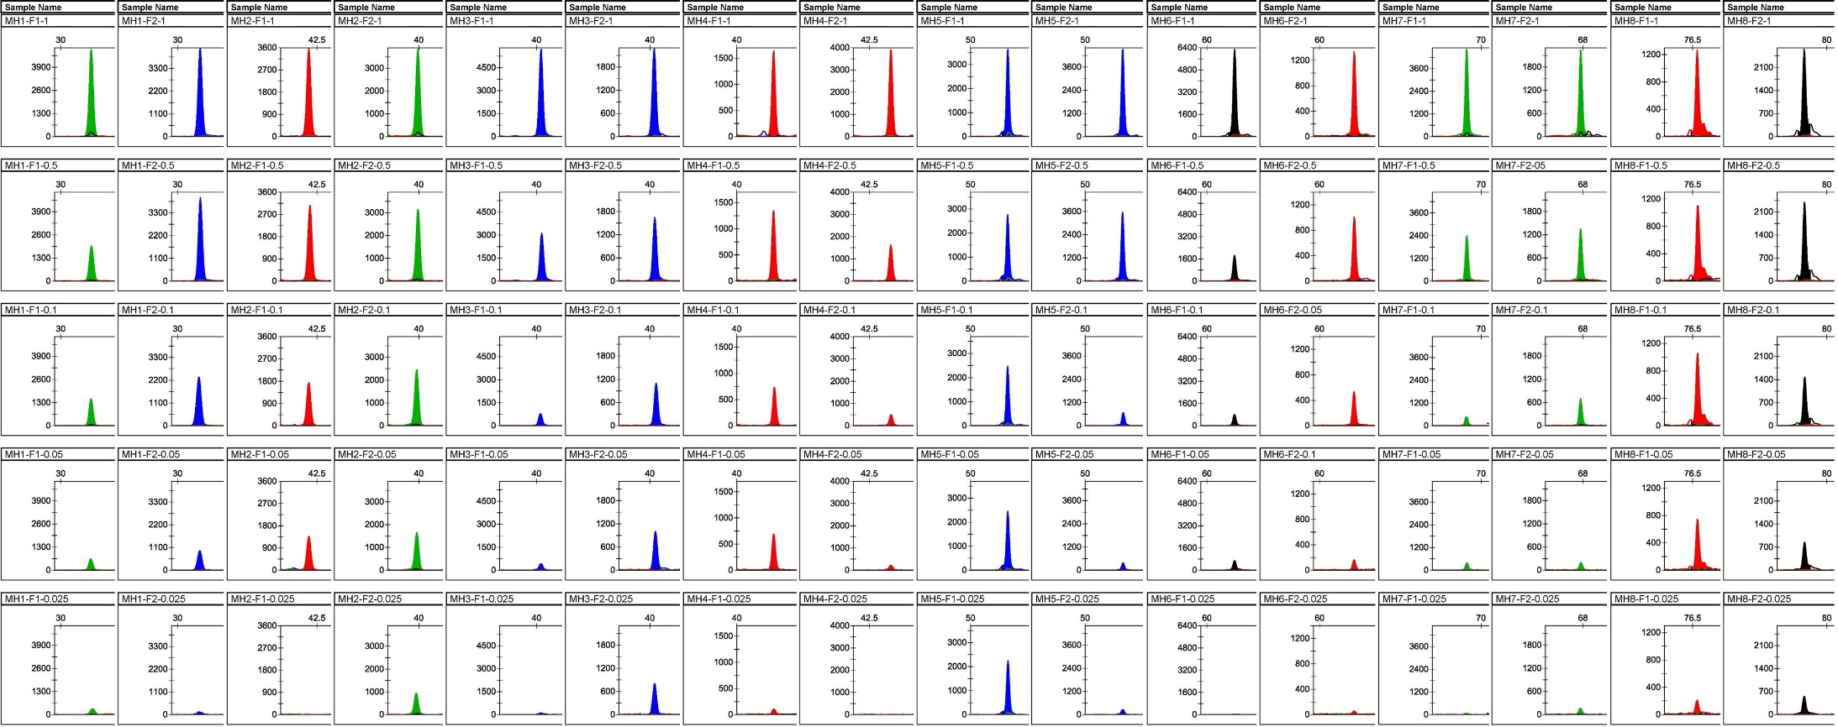
(A)
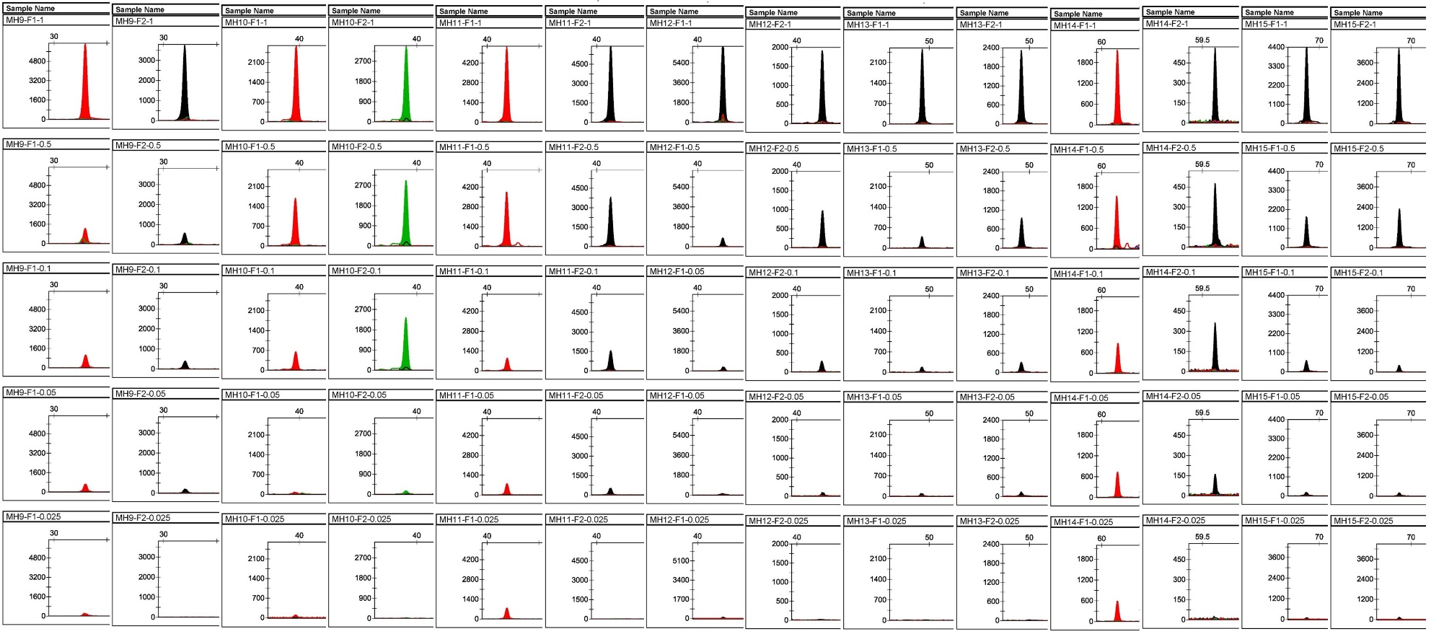
(B)
Supplementary Figure 1. Sensitivity profiles of a single allele-specific primer. (A) and (B) represent the two panels constructed previously, containing 8 (MH1~MH8) and 7 (MH9~MH15) loci respectively (see our previous study (Zhang et al., 2020) for more details). Each locus had two allele-specific primers, F1 and F2. All 30 primers showed a positive result of 0.025 ng, except MH2-F1, MH4-F2, MH7-F1, MH9-F2, MH10-F2, MH11-F2, MH12-F2, MH13-F1/F2, and MH14-F2, which had a detection sensitivity of 0.05 ng.

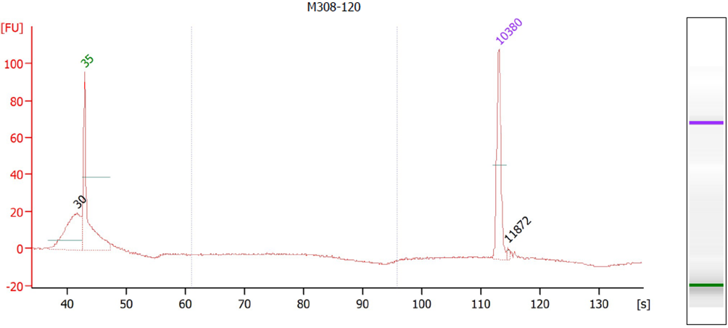
（A）

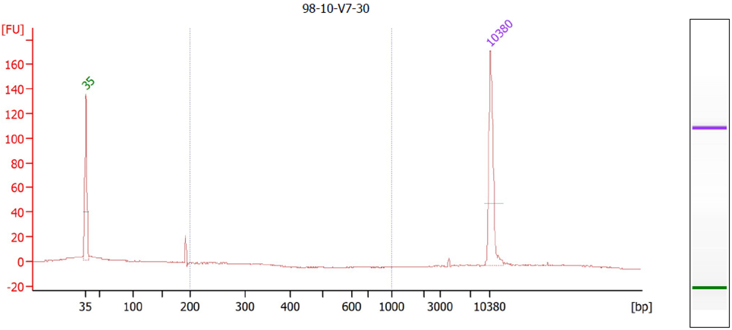
（B）

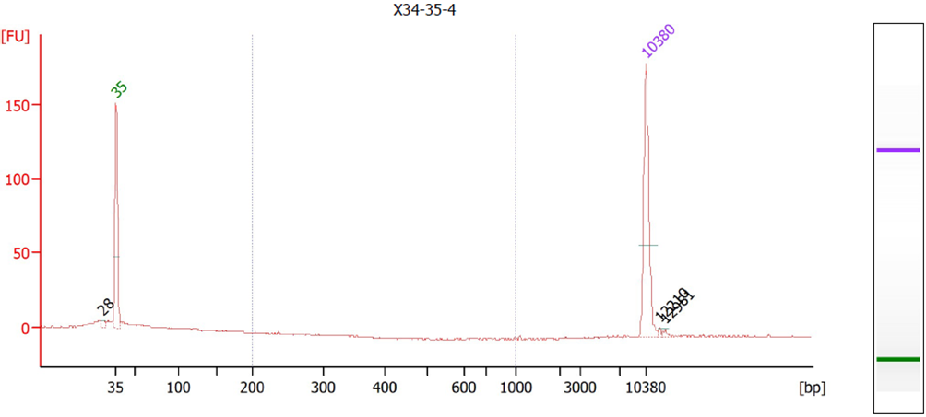
（C）
Supplementary Figure 2. Evaluation of the degree of fragmentation of degraded samples. A High Sensitivity DNA Kit was used on the Agilent 2100 Bioanalyzer. (A) The fragment range of the standard DNA M308 concentrated at approximately 30bp after incubation at 98°C for 120 min. (B) The fragment range of sample V7 concentrated at approximately 200bp after incubation at 98°C for 30 min. (C) The fragment range of sample X34 concentrated at approximately 28bp after incubation at 98°C for 35 min. The input concentration of the DNA was 5 ng/uL.

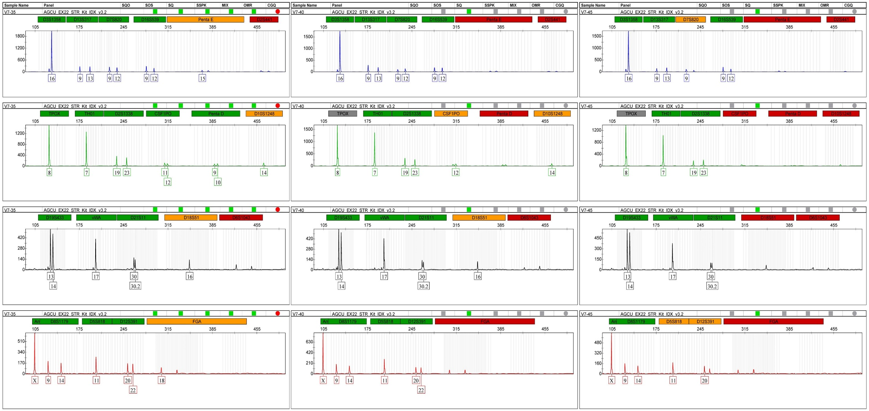
（A）
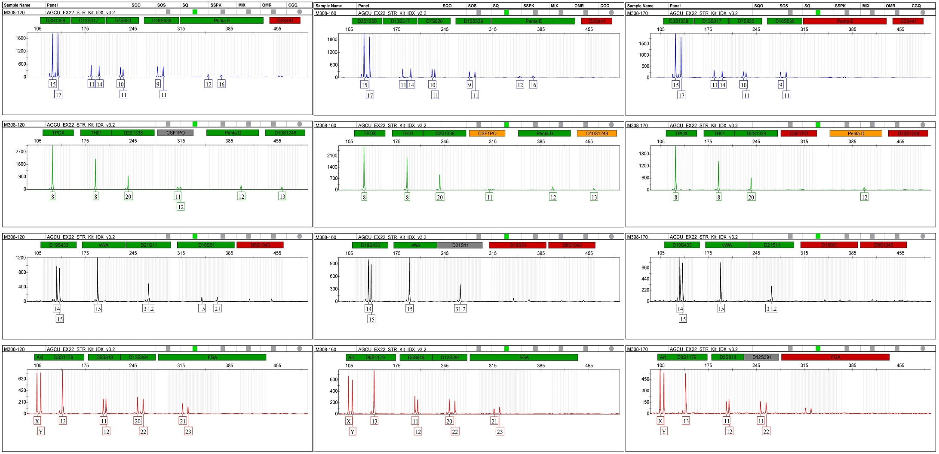
（B）
（C）

（D）
Supplementary Figure 3. Profiles of degraded single-source DNA. DNA V7 obtained from a randomly selected individual was processed at 98°C for 35, 40, 45 min. Standard DNA M308 was processed at 98°C for 120, 160, 170 min. (A and B) Profiles obtained using the commercial STR kit at 35, 40, and 45 min from left to right. (A) For V7, drop-out of the STR Kit began at approximately 385bp at 35 min and 280bp at 40 and 45min. (B) For M308, drop-out of the STR Kit began at approximately 385bp at 120 min and 280bp at 160 and 170 min. Only a subset of the loci of the two samples were genotyped at different degradation times. (C and D) Profiles obtained using the SNP-SNP multiplex system at 35, 40, and 45 min from top to bottom. All loci of the two samples were successfully genotyped at the different degradation times.

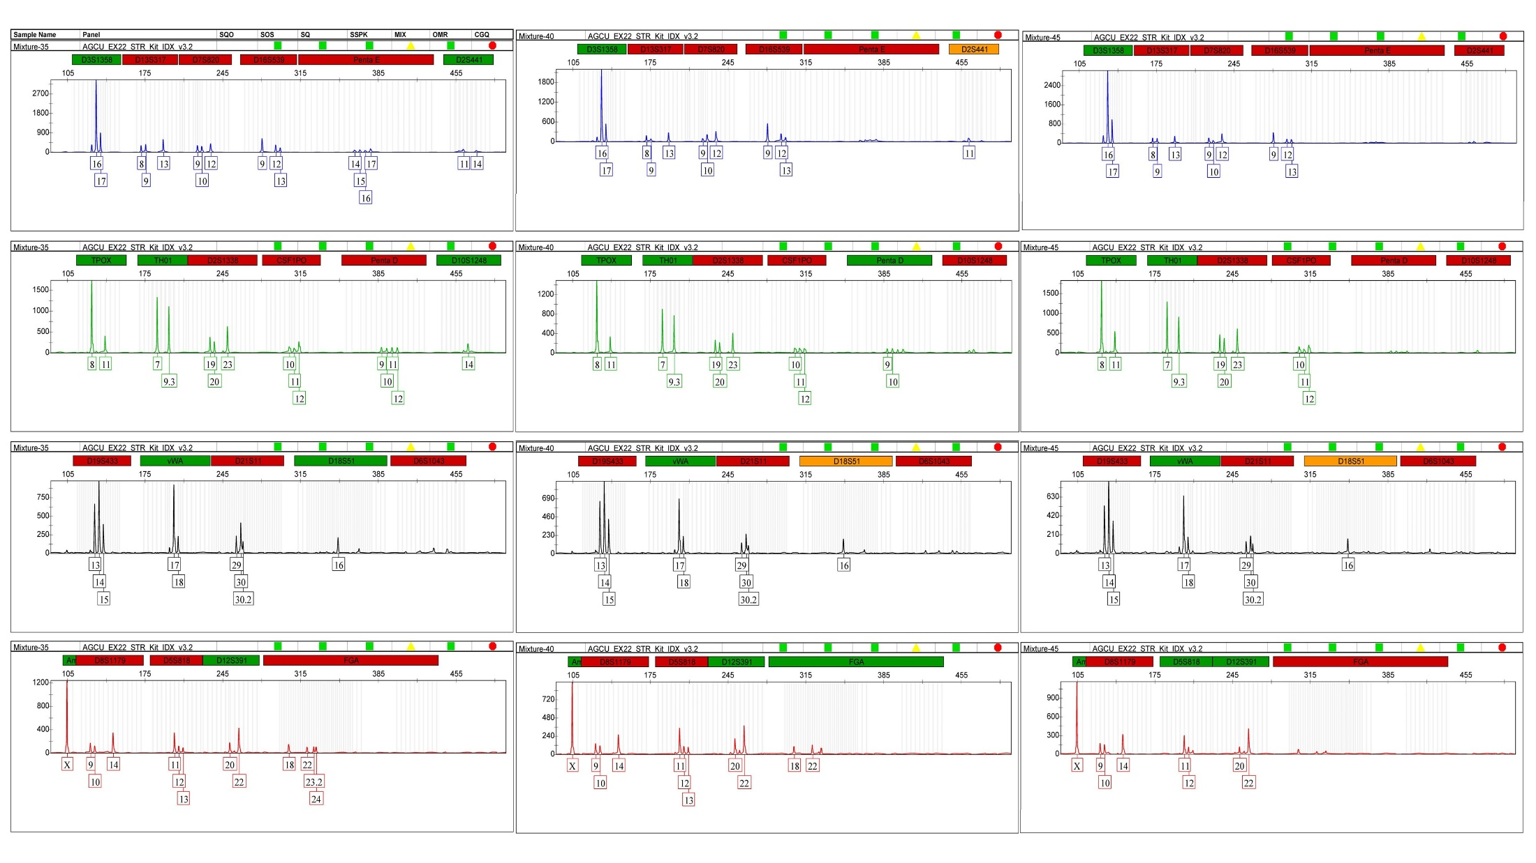
（A）
（B）
Supplementary Figure 4. Profiles of the degraded mixture. The mixture was processed at 98°C for 35, 40, and 45 min. (A) Profiles obtained at 30, 40, and 45 min from left to right using the commercial STR kit. The drop-out of the STR Kit began at approximately 310bp at 35 min, 280bp at 40 min, and 180bp at 45 min. (B) Profiles obtained at 30, 40, and 45 min from top to bottom using the SNP-SNP multiplex system. All loci in the sample were successfully genotyped at the different degradation times. The black arrows indicated informative markers in the mixture.

Supplement Table 1. Description of SNP-SNPs included in this study¹.
ID | SNP-SNP | SNP1 | Chr | Location（GRCh37/hg19) | Extent in bp
MH1 | rs10445426-rs57907290 | G/T | 18 | 12195773-12195803 | 30
MH2 | rs12101725-rs55649144 | A/G | 15 | 92575365-92575386 | 21
MH3 | rs3843625-rs12422436 | C/T | 12 | 58858690-58858715 | 25
MH4 | rs9938522-rs9940690 | A/T | 16 | 13552242-13552251 | 9
MH5 | rs3109851-rs6848611 | C/T | 4 | 26473621-26473631 | 10
MH6 | rs468851-rs468852 | C/T | 22 | 29956137-29956156 | 19
MH7 | rs2527748-rs2527749 | G/T | 8 | 5396199-5396225 | 26
MH8 | rs35443929-rs6462431 | A/C | 7 | 32935434-32935439 | 5
MH9 | rs12950438-rs12950190 | C/T | 17 | 59846353-59846363 | 10
MH10 | rs10119697-rs10961215 | C/G | 9 | 13741227-13741252 | 24
MH11 | rs59588112-rs8018285 | C/T | 14 | 25768631-25768641 | 10
MH12 | rs6663660-rs9426355 | C/T | 1 | 29774262-29774287 | 25
MH13 | rs2012094-rs220181 | C/T | 21 | 43561440-43561468 | 28
MH14 | rs7724803-rs6554864 | C/T | 5 | 14950999-14951005 | 6
MH15 | rs68012481-rs2498233 | C/T | 6 | 23007491-23007496 | 5
1 More details of the 15 SNP-SNPs are available in our previous study (Zhang et al., 2020)

Supplementary Table 2. Characteristics of the donors.
Family ID | Sample ID | Origin | Gestation Week | Concentration¹ | Clinical state
No.1 | K181203-9102 | Mother’s peripheral blood | ＞18 | 15.96 | No special
 | K181203-9103 | Father’s peripheral blood |  | 5.58
 | K181119-7023 | Amniotic fluid |  | 29.6
 | K181203-9102 | Maternal plasma |  | 0.388
No.2 | K181203-9104 | Mother’s peripheral blood | ＞18 | 3.6 | No special
 | K181203-9105 | Father’s peripheral blood |  | 5.3
 | K181119-7046 | Amniotic fluid |  | 12.4
 | K181203-9104 | Maternal plasma |  | Out of range
No.3 | K181225-9126 | Mother’s peripheral blood | ＞18 | 16.96 | No special
 | K181225-9127 | Father’s peripheral blood |  | 5.86
 | K181207-7512 | Amniotic fluid |  | 8
 | K181225-9126 | Maternal plasma |  | 0.754
No.4 | K190312-9162 | Mother’s peripheral blood | ＞18 | 51.24 | No special
 | K190312-9163 | Father’s peripheral blood |  | 16.21
 | K190225-0520 | Amniotic fluid |  | 2.92
 | K190312-9162 | Maternal plasma |  | 0.204
No.5 | K190312-9164 | Mother’s peripheral blood | ＞18 | 43.87 | No special
 | K190312-9165 | Father’s peripheral blood |  | 5.13
 | K190226-0534 | Amniotic fluid |  | 37
 | K190312-9164 | Maternal plasma |  | 0.266
No.6 | K190312-9166 | Mother’s peripheral blood | ＞18 | 63.24 | No special
 | K190312-9167 | Father’s peripheral blood |  | 40.59
 | K190226-0537 | Amniotic fluid |  | 9.86
 | K190312-9166 | Maternal plasma |  | 0.414
No.7 | K190312-9168 | Mother’s peripheral blood | ＞18 | 8.83 | No special
 | K190312-9169 | Father’s peripheral blood |  | 10.54
 | K190226-0387 | Amniotic fluid |  | 11.8
 | K190312-9168 | Maternal plasma |  | 0.716
No.8 | K190312-9170 | Mother’s peripheral blood | ＞18 | 37.78 | No special
 | K190312-9171 | Father’s peripheral blood |  | 13.14
 | K190226-0609 | Amniotic fluid |  | 5.2
 | K190312-9170 | Maternal plasma |  | 0.63
No.9 | K190312-9180 | Mother’s peripheral blood | ＞18 | 12.64 | No special
 | K190312-9181 | Father’s peripheral blood |  | 21.98
 | K190226-0762 | Amniotic fluid |  | 5.94
 | K190312-9180 | Maternal plasma |  | 0.2
No.10 | K190312-9189 | Mother’s peripheral blood | ＞18 | 28.04 | No special
 | K190312-9190 | Father’s peripheral blood |  | 35.45
 | K190226-0872 | Amniotic fluid |  | 5.58
 | K190312-9189 | Maternal plasma |  | 0.696
No.11 | K190312-9191 | Mother’s peripheral blood | ＞18 | 23.66 | No special
 | K190312-9192 | Father’s peripheral blood |  | 13.06
 | K190226-0930 | Amniotic fluid |  | 7.58
 | K190312-9191 | Maternal plasma |  | 0.632
No.12 | K190312-9193 | Mother’s peripheral blood | ＞18 | 18.72 | No special
 | K190312-9194 | Father’s peripheral blood |  | 32.66
 | K190226-0956 | Amniotic fluid |  | 31.2
 | K190312-9193 | Maternal plasma |  | 0.538
No.13 | K190102-9130 | Mother’s peripheral blood | ＞18 | 40.48 | No special
 | K190102-9131 | Father’s peripheral blood |  | 12.38
 | K181217-7600 | Amniotic fluid |  | 14.8
 | K190102-9130 | Maternal plasma |  | 1.03
No.14 | K190102-9138 | Mother’s peripheral blood | ＞18 | 29.86 | No special
 | K190102-9139 | Father’s peripheral blood |  | 23.92
 | K190117-0161 | Amniotic fluid |  | 3.3
 | K190102-9138 | Maternal plasma |  | 1.03
No.15 | K190305-9152 | Mother’s peripheral blood | ＞18 | 33.51 | No special
 | K190305-9153 | Father’s peripheral blood |  | 31.18
 | K190211-0307 | Amniotic fluid |  | 27.19
 | K190305-9152 | Maternal plasma |  | 1.12
No.16 | K190305-9154 | Mother’s peripheral blood | ＞18 | 39.75 | No special
 | K190305-9155 | Father’s peripheral blood |  | 28.11
 | K190214-0364 | Amniotic fluid |  | 19.39
 | K190305-9154 | Maternal plasma |  | 0.82
No.17 | K190305-9156 | Mother’s peripheral blood | ＞18 | 17.06 | No special
 | K190305-9157 | Father’s peripheral blood |  | 10.93
 | K190212-0326 | Amniotic fluid |  | 7.12
 | K190305-9156 | Maternal plasma |  | 1.115
No.18 | K190306-9158 | Mother’s peripheral blood | ＞18 | 45.84 | No special
 | K190306-9159 | Father’s peripheral blood |  | 53.99
 | K190219-0426 | Amniotic fluid |  | 7.98
 | K190306-9158 | Maternal plasma |  | 1.43
No.19 | K190306-9160 | Mother’s peripheral blood | ＞18 | 43 | No special
 | K190306-9161 | Father’s peripheral blood |  | 22.11
 | K190219-0431 | Amniotic fluid |  | 14.3
 | K190306-9160 | Maternal plasma |  | 1.14
No.20 | K190416-9210 | Mother’s peripheral blood | ＞18 | 22.61 | No special
 | K190416-9211 | Father’s peripheral blood |  | 36.39
 | K190328-1128 | Amniotic fluid |  | 8.57
 | K190416-9210 | Maternal plasma |  | 0.764
No.21 | K90416-9212 | Mother’s peripheral blood | ＞18 | 23.23 | No special
 | K90416-9213 | Father’s peripheral blood |  | 21.53
 | K190329-1159 | Amniotic fluid |  | 15.9
 | K90416-9212 | Maternal plasma |  | 0.606
No.22 | K190416-9214 | Mother’s peripheral blood | ＞18 | 17.48 | No special
 | K190416-9217 | Father’s peripheral blood |  | 43.64
 | K190401-1169 | Amniotic fluid |  | 7.42
 | K190416-9214 | Maternal plasma |  | 0.224
No.23 | K190416-9215 | Mother’s peripheral blood | ＞18 | 23.85 | No special
 | K190416-9216 | Father’s peripheral blood |  | 74.66
 | K190315-0880 | Amniotic fluid |  | 34.8
 | K190417-9215 | Maternal plasma |  | 0.54
No.24 | K1904239220 | Mother’s peripheral blood | ＞18 | 19.55 | No special
 | K1904239221 | Father’s peripheral blood |  | 25.56
 | K190408-1320 | Amniotic fluid |  | 7.76
 | K1904239220 | Maternal plasma |  | 0.392
No.25 | K1904239224 | Mother’s peripheral blood | ＞18 | 50.14 | No special
 | K1904239225 | Father’s peripheral blood |  | 20.51
 | K190410-1412 | Amniotic fluid |  | 14.91
 | K1904239224 | Maternal plasma |  | 0.156
No.26 | K181203-ZGR-B | Mother’s peripheral blood | ＞18 | 45.8 | No special
 | K181203-LL | Father’s peripheral blood |  | 79.4
 | K181126-7222 | Amniotic fluid |  | 36
 | K181203-ZGR | Maternal plasma |  | 0.884
1 Peripheral blood from the mother and father and amniotic fluid from the mother were quantified using a NanoDrop™ 1000 spectrophotometer. Maternal plasma was quantified using a Qubit 3.0 fluorometer.
Supplementary Table 3. Informative markers' details of each family.
Family ID | rs10445426-rs57907290 |  | rs12101725-rs55649144 |  | rs3843625-rs12422436 |  | rs9938522-rs9940690 |  | rs3109851-rs6848611 |  | rs468851-rs468852 |  | rs2527748-rs2527749 |  | rs35443929-rs6462431
 | (G-)¹ | (T-)² | (A-) | (G-) | (C-) | (T-) | (A-) | (T-) | (C-) | (T-) | (C-) | (T-) | (G-) | (T-) | (A-) | (C-)
No.1 |  |  |  |  |  |  |  |  |  |  |  |  |  |  | A
No.2 |  |  |  |  | T
No.3 |  |  |  |  |  |  |  |  |  |  |  |  |  |  | A
No.4 | A³ |  | T |  |  | C
No.5 |  |  |  |  |  | C |  |  | C |  |  |  |  | T | A
No.6 |  |  | T |  |  |  |  |  | C
No.7 |  |  |  |  |  |  | T |  |  | C | C |  |  |  | A
No.8 |  |  |  |  |  |  |  |  |  |  | C
No.9 |  |  | T |  |  |  |  |  |  |  |  |  |  |  | A
No.10 |  |  |  |  |  |  |  | T |  |  |  |  |  |  | A
No.11 |  |  |  | T |  |  |  |  |  |  | C
No.12 |  |  |  |  |  |  |  |  | C |  | C |  |  |  | A
No.13 |  |  |  |  |  |  | T
No.14
No.15
No.16
No.17 |  |  |  |  | T
No.18 |  |  |  |  |  |  |  |  |  |  |  |  |  | T |  | A
No.19 |  |  | T |  |  |  |  |  |  |  |  |  | T
No.20
No.21 |  |  |  |  |  |  | T |  |  |  |  |  |  | T |  | A
No.22 |  |  |  |  |  |  | T |  |  |  | C
No.23 |  |  |  |  |  |  |  |  |  |  |  | CT |  |  |  | G
No.24
No.25 |  |  |  |  |  |  | T
No.26 |  |  |  |  |  | C |  |  | C |  |  |  |  | T
Number of informative markers per primer | 1 | 0 | 4 | 1 | 2 | 3 | 5 | 1 | 4 | 1 | 5 | 1 | 1 | 4 | 7 | 3

Continued:
Supplementary Table 3. Informative markers' details of each family.
Family ID | rs12950438-rs12950190 |  | rs10119697-rs10961215 |  | rs59588112-rs8018285 |  | rs6663660-rs9426355 |  | rs2012094-rs220181 |  | rs7724803-rs12521912 |  | rs68012481-rs2498233
 | (C-)¹ | (T-)² | (C-) | (G-) | (C-) | (T-) | (C-) | (T-) | (C-) | (T-) | (C-) | (T-) | (C-) | (T-)
No.1 | A³ |  |  |  |  |  |  |  |  |  |  | G |  | G
No.2 |  |  |  |  |  |  |  |  |  |  |  | G
No.3 |  |  | T
No.4 |  |  |  |  |  |  |  |  |  |  |  | G
No.5 |  |  |  |  |  |  |  | G | G
No.6 |  |  |  | A |  | G |  |  | G |  |  | G
No.7 |  | G |  |  |  |  |  |  | G
No.8 |  |  |  | A |  | G
No.9 |  |  |  |  |  |  |  |  |  |  |  |  | A
No.10
No.11 |  |  |  |  |  | G |  |  |  |  |  | G
No.12
No.13 |  |  |  | A |  |  |  | G | G
No.14 |  |  |  |  |  | G |  |  |  |  |  | G
No.15 |  |  |  |  | A
No.16 |  |  |  |  |  |  |  |  | G
No.17 |  |  | T
No.18 |  |  |  |  |  |  |  |  | G
No.19
No.20 |  |  |  | T
No.21 |  |  |  |  |  | G |  |  |  |  |  | G
No.22 |  |  |  |  |  | G |  |  |  |  |  | G
No.23
No.24
No.25
No.26 |  |  |  | T
Number of informative markers per primer | 1 | 1 | 2 | 5 | 1 | 6 | 0 | 2 | 6 | 0 | 0 | 8 | 1 | 1
1 and 2 represent the two alleles of SNP1 at each locus; 3 represents the SNP2 genotype at each locus. Note that only when SNP1 has an ARMS-PCR amplification product does SNP2 have a corresponding SBE extension product. At this time, the corresponding SNP1-SNP2 is a single-stranded haplotype.

