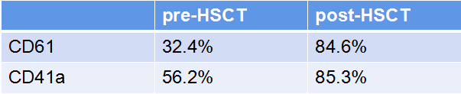

Table 1

Expression rate of platelet membrane glycoprotein before and after transplantation