FIGURES
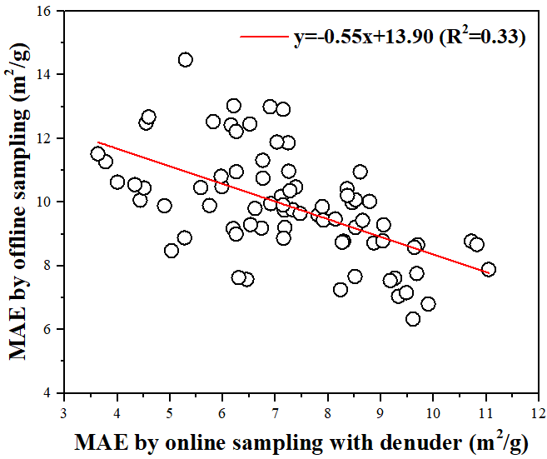 | 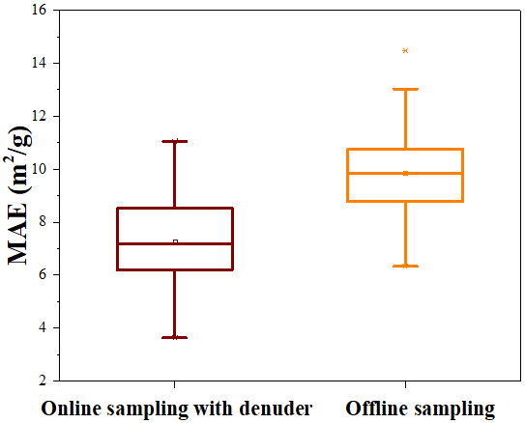
(a) | (b)
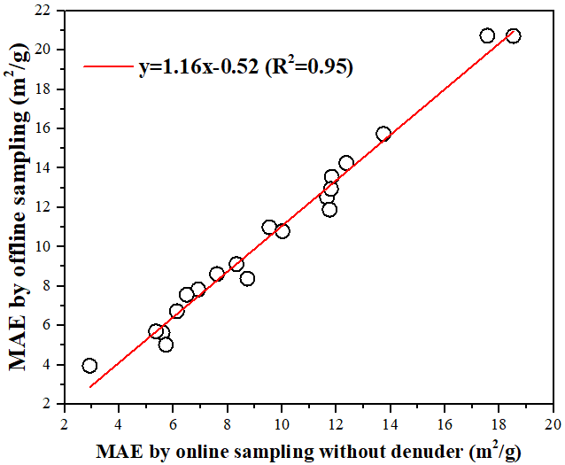 | 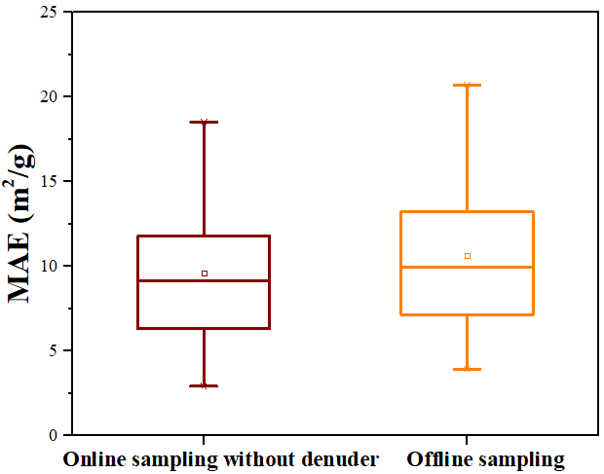
(c) | (d)

Figure 1. Comparison of mass absorption efficiency (MAE) values between offline and online samplings. (a) The correlation between MAE by offline sampling and that by online sampling with denuder. (b) Box plots of MAE by offline sampling and that by online sampling with denuder. (c) The correlation between MAE by offline sampling and that by online sampling without denuder. (d) Box plots of MAE by offline sampling and that by online sampling without denuder.

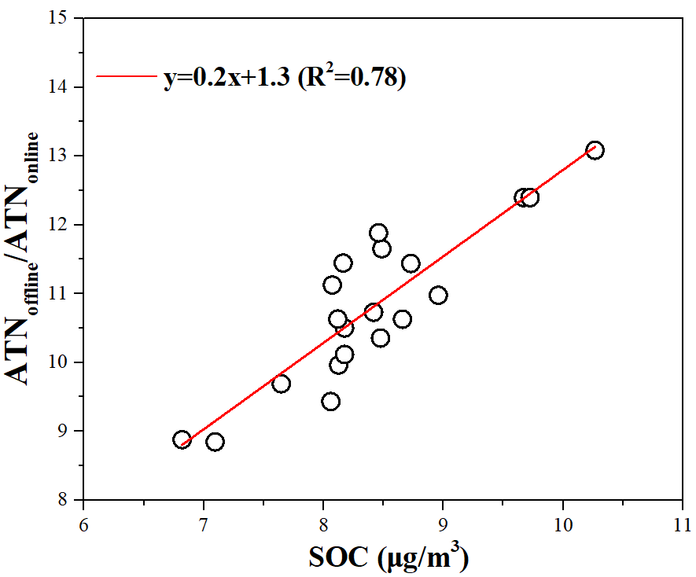

Figure 2. The relationship between secondary organic carbon (SOC) and the ratio of light attenuation (ATN) by offline sampling to that by online sampling without denuder (ATN_{offline}/ATN_{online}).

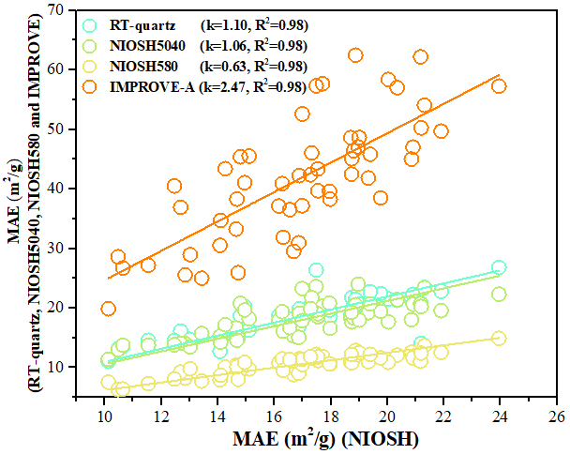 | 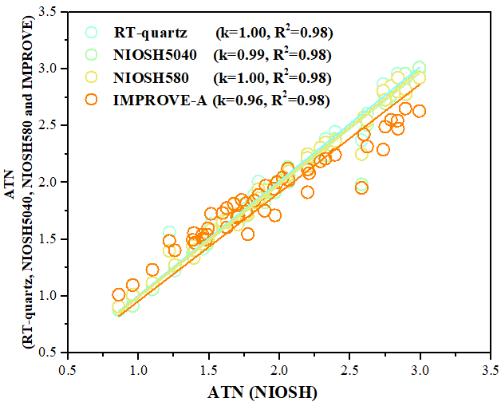
(a) | (b)
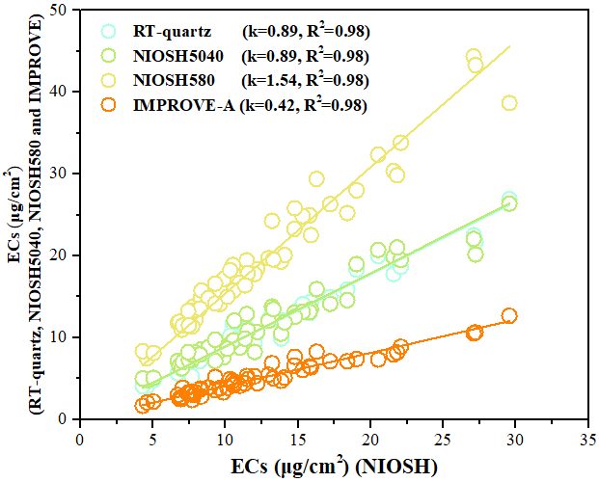
(c)

Figure 3. Mass absorption efficiency (MAE), optical attenuation (ATN) and elemental carbon (EC) mass by NIOSH protocol compared with those by RT-quartz, NIOSH5040, NIOSH580 and IMPROVE-A protocols. (a) Comparison of MAE by different temperature protocols. (b) Comparison of light attenuation (ATN) by different temperature protocols. (c) Comparison of EC mass by different temperature protocols.

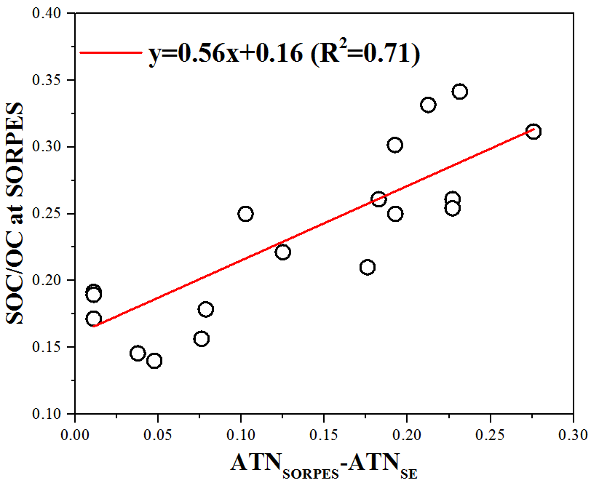

Figure 4. Correlation between the changes of light attenuation (ATN_{SORPES}-ATN_{SE}) and the ratios of secondary organic carbon (SOC) to organic carbon (OC) (SOC/OC) at SORPES.

