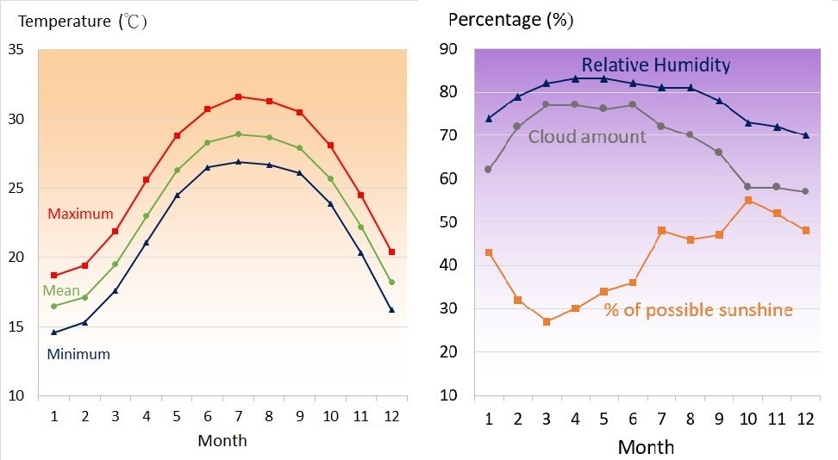

Supplementary figure 1. Monthly means of daily maximum, mean and minimum temperature (left), relative humidity, cloud amount and percentage of possible sunshine (right) in Hong Kong between 1991-2020.

