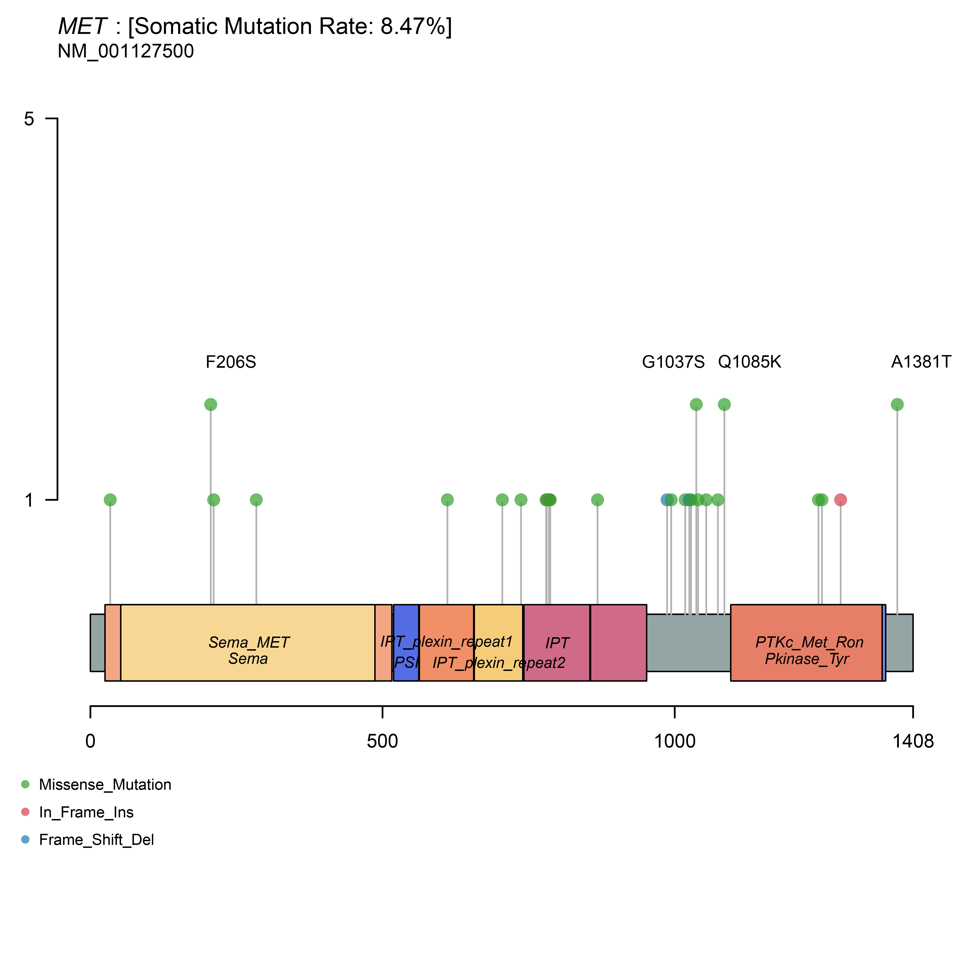
Supplementary Figure 1. Schematic locations of mutations in MET.

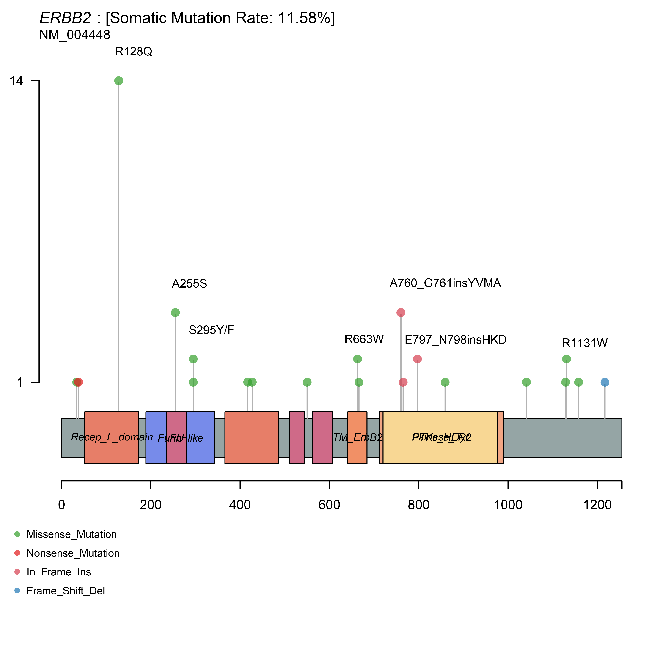
Supplementary Figure 2. Schematic locations of mutations in ERBB2.

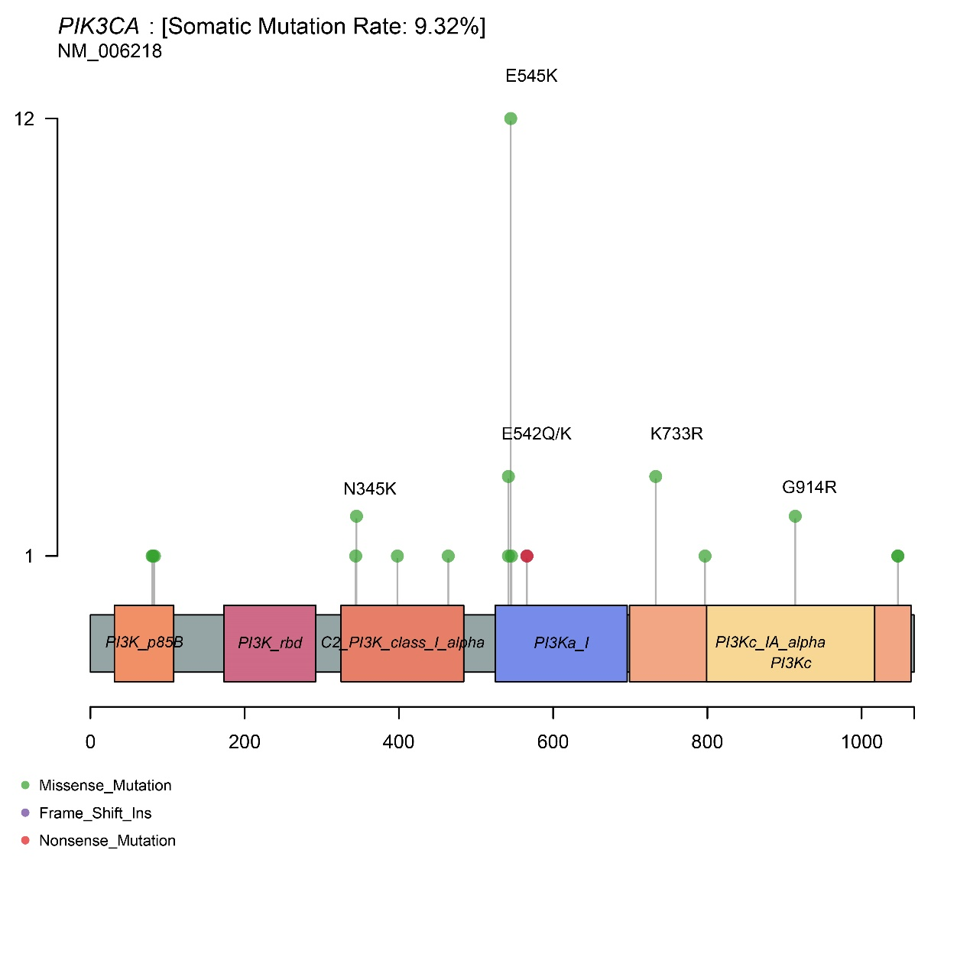
Supplementary Figure 3. Schematic locations of mutations in PIK3CA.

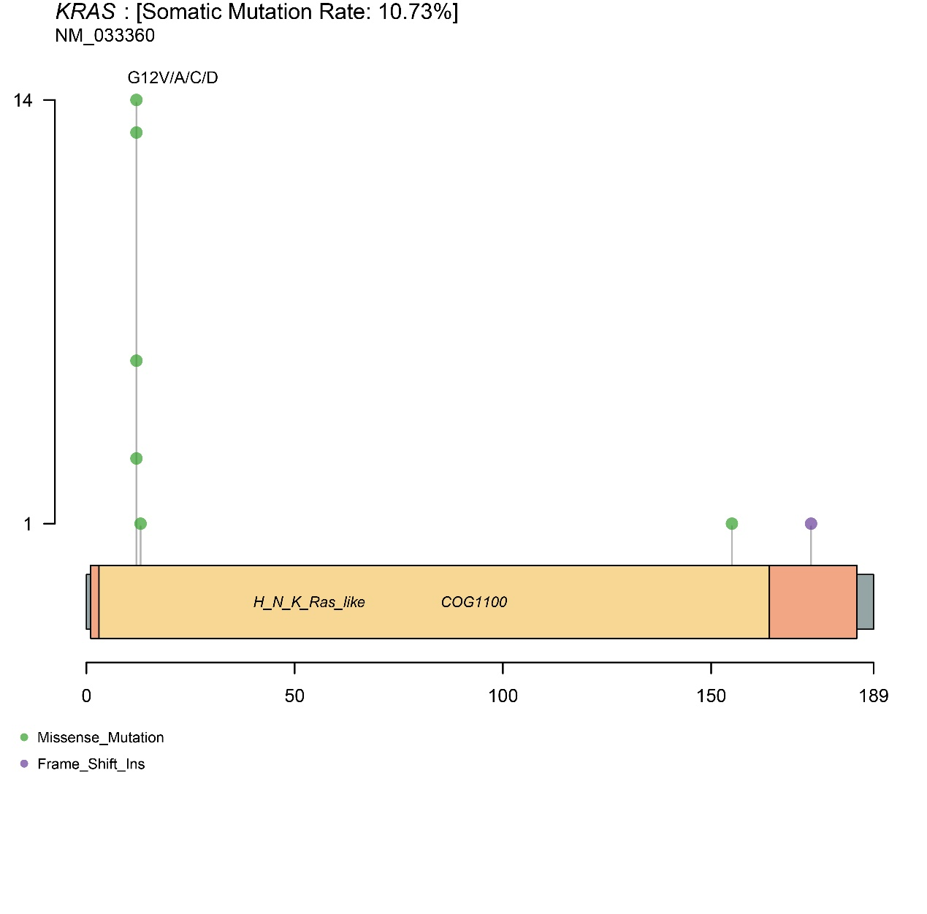
Supplementary Figure 4. Schematic locations of mutations in KRAS.

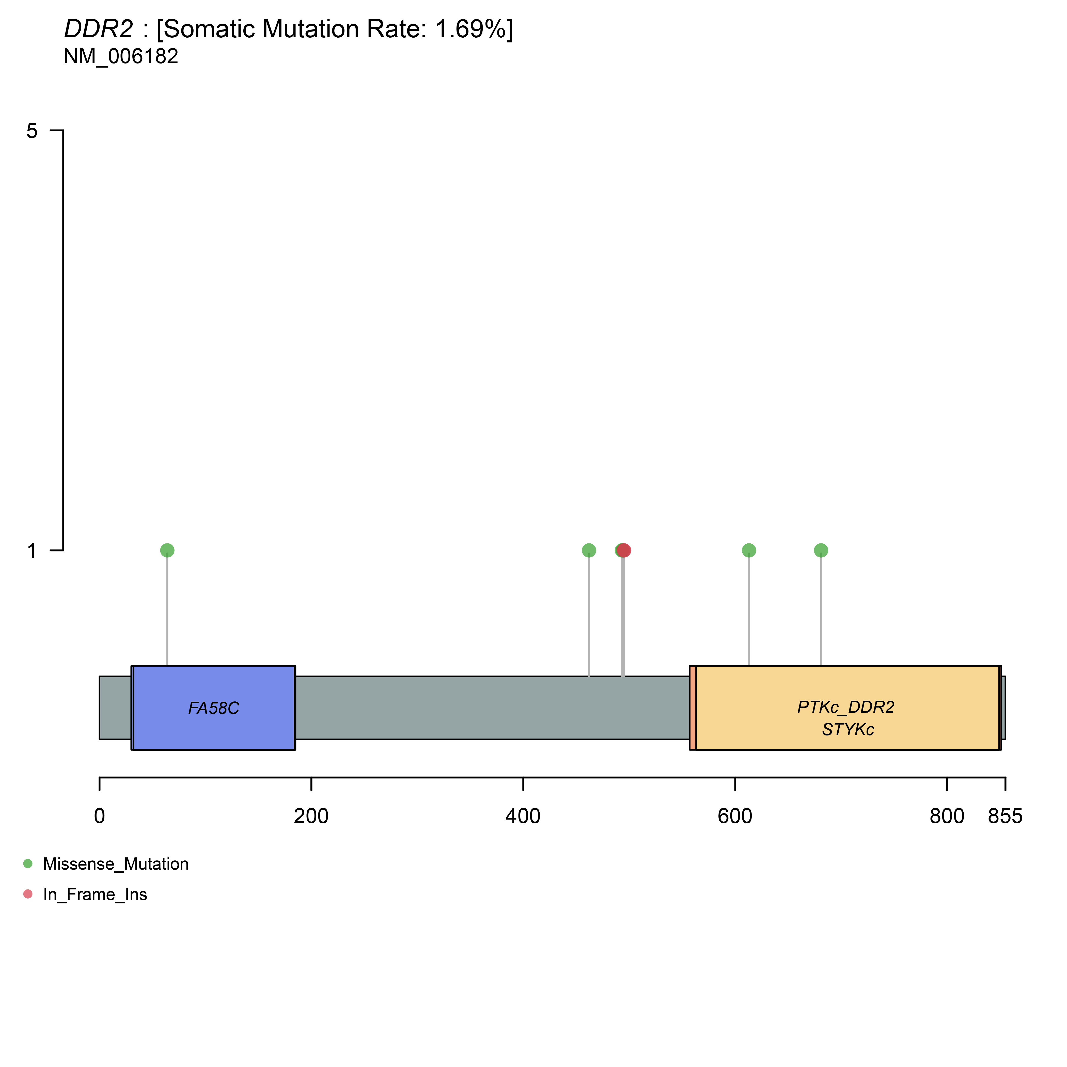
Supplementary Figure 5. Schematic locations of mutations in DDR2.

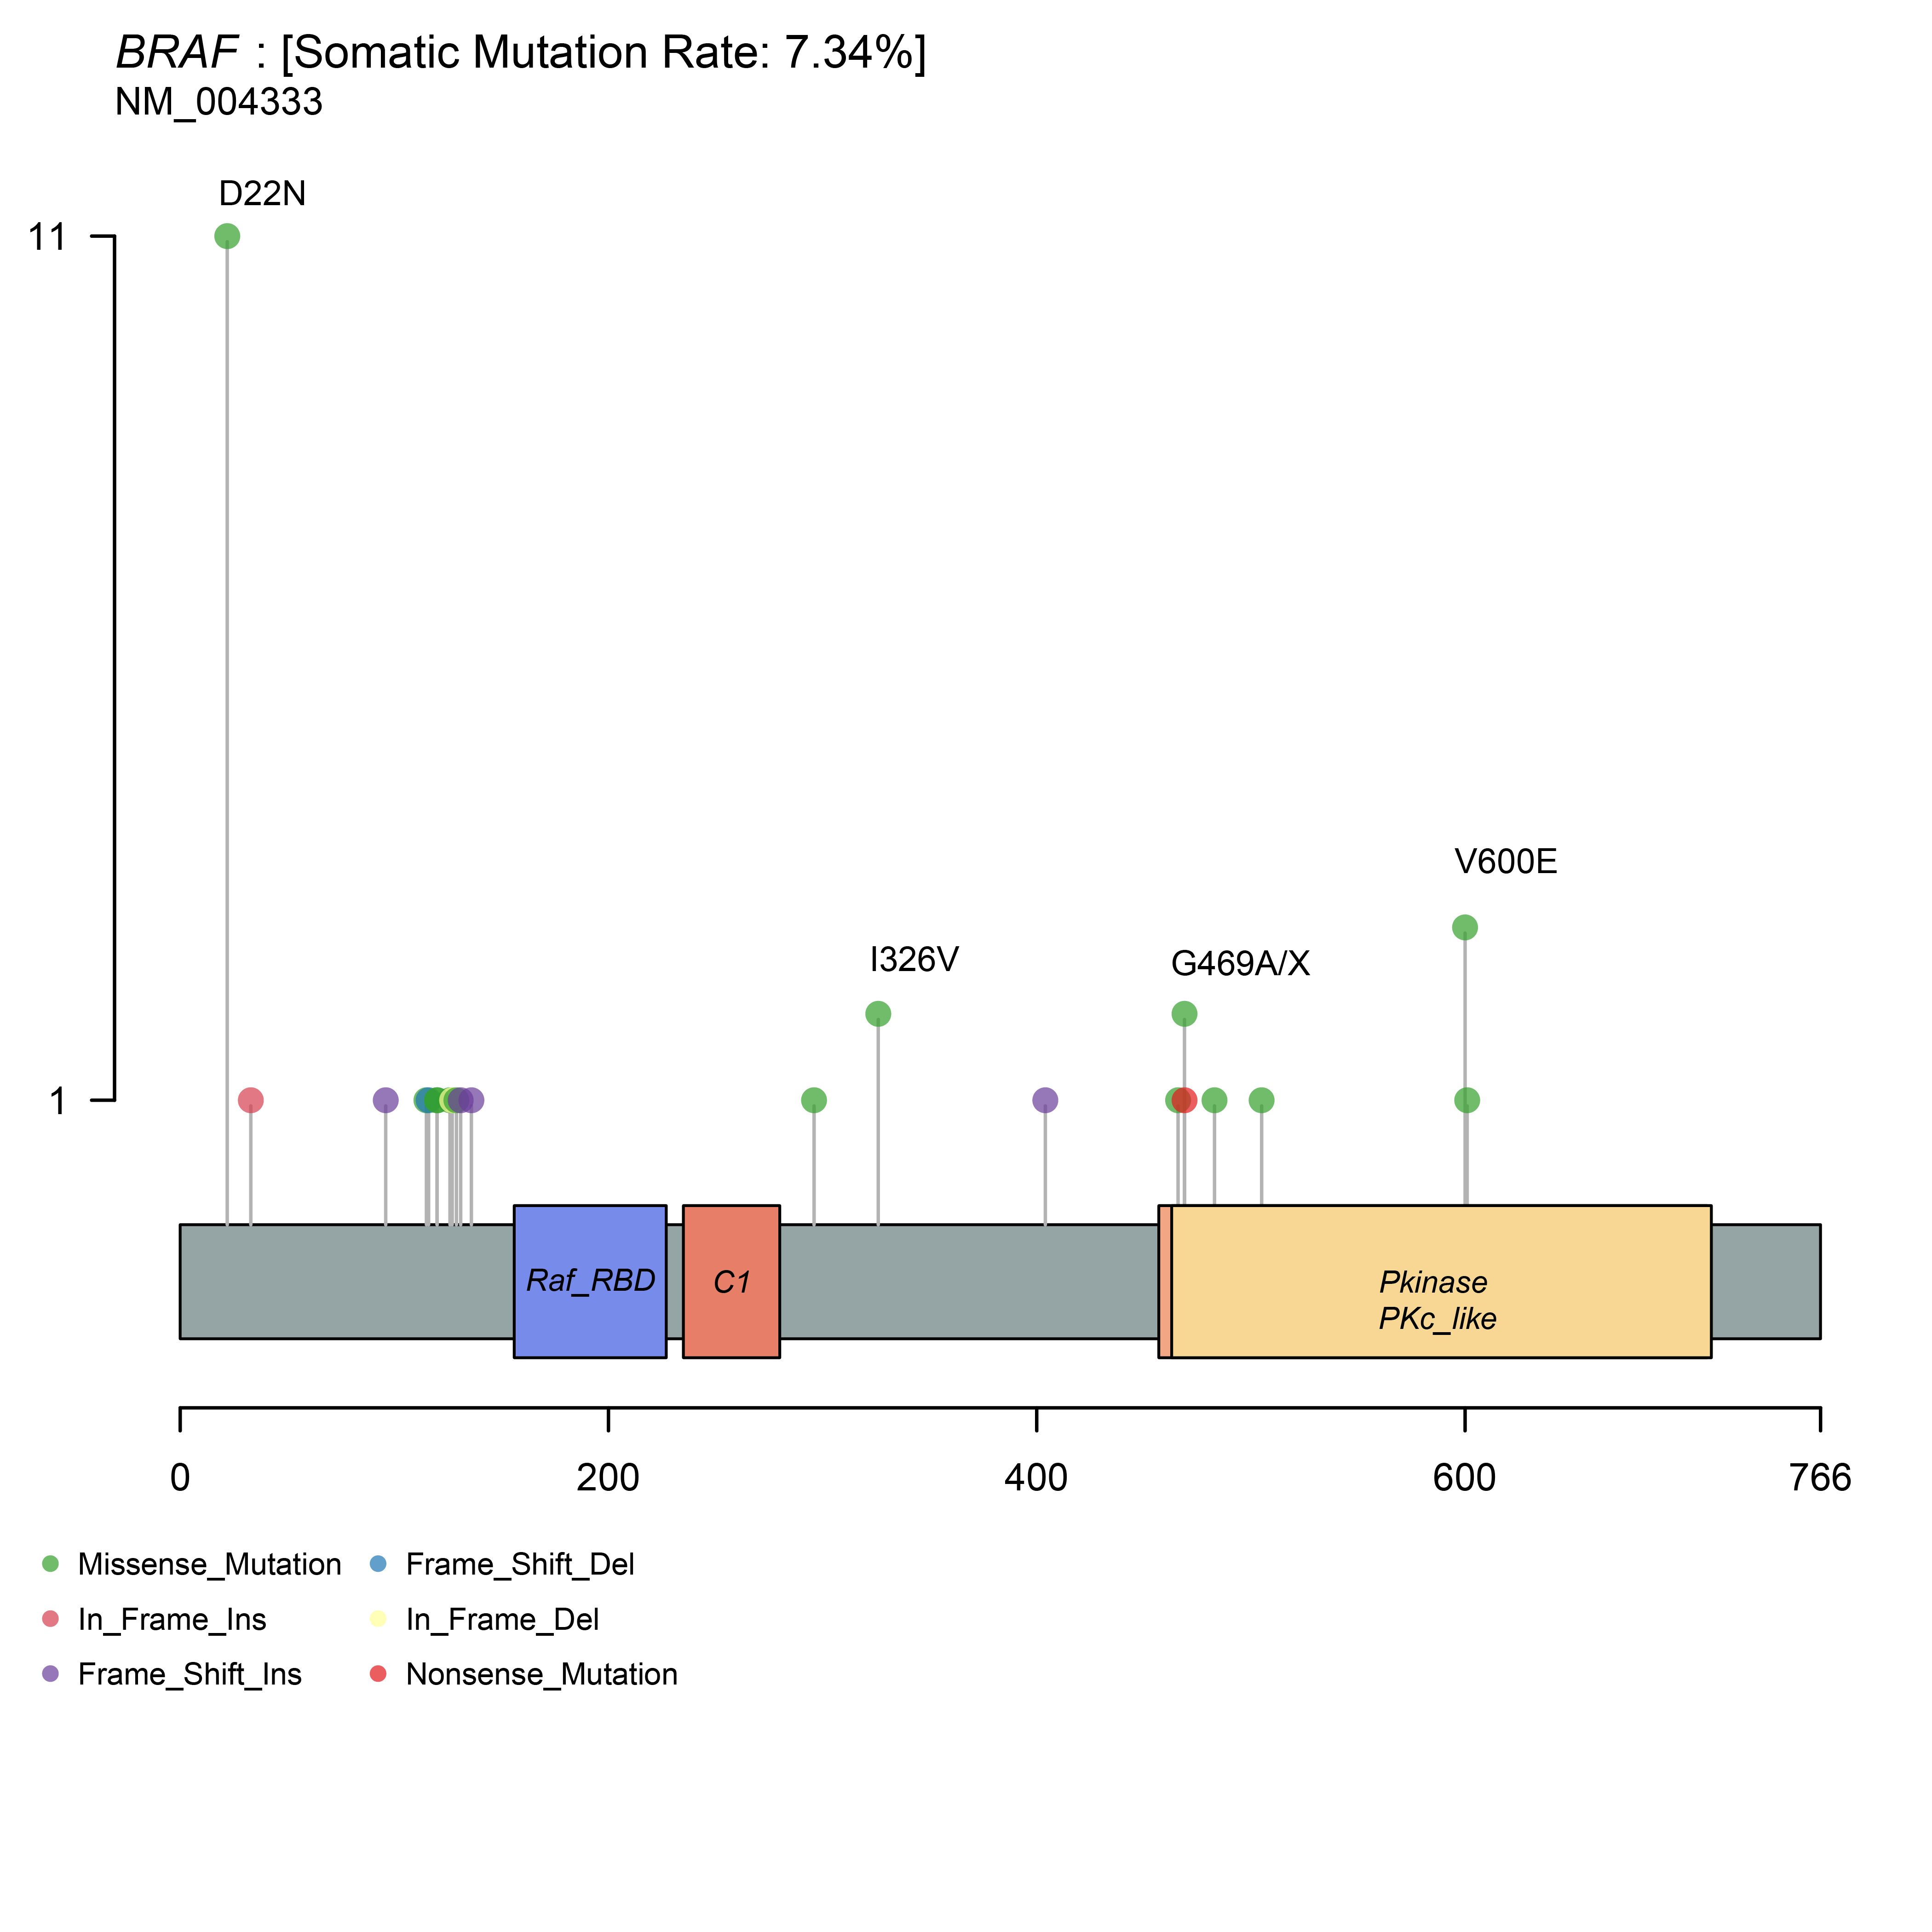Supplementary Figure 6. Schematic locations of mutations in BRAF.

