Genome sequences of two strains of Prototheca wickerhamii provide insight into the protothecosis evolution
Jian Guo ^{1#}, Jianbo Jian^{2#}, Lili Wang^{1#}, Lijuan Xiong³, Huiping Lin¹, Ziyi Zhou¹, Eva C. Sonnenschein ^{2*}, Wenjuan Wu^{1*}

Supplementary materials
Outline

Supplementary section: Plastid, mitochondrion and nuclear genomes assemblies 2
Figure S1 The cultured phenotype of P. wickerhamii strain S1 and S931. 3
Figure S2 Genome characteristics estimation of P. wickerhamii strain S1 using GenomeScope. 4
Figure S3 Genome characteristics estimation of P. wickerhamii strain S931 using GenomeScope. 5
Figure S4 Circular map of genomic features of mitochondria and plastid of P. wickerhamii genomes. 6
Figure S5 The Gene Ontology (GO) enrichment annotation of P.wickerhamii strain S1 7
Figure S6 Kyoto Encyclopedia of Genes and Genomes (KEGG) enrichment annotation of P. wickerhamii strain S1 8
Figure S7 The Gene Ontology (GO) enrichment annotation of P. wickerhamii strain S931 9
Figure S8 Kyoto Encyclopedia of Genes and Genomes (KEGG) enrichment annotation of P. wickerhamii strain S931 10
Figure S9 Genomic comparison of the three P. wickerhamii strains S1, S931, and ATCC 16529. 10
Figure S10 Differences in gene expression between P. wickerhamii strains S1 and S931. 11
Table S1 Sequencing data statistics of two types of P. wickerhamii genomes with Illumina platform. 11
Table S2 Sequencing data statistics of two types of P. wickerhamii genomes with Nanopore platform. 11
Table S3. The assembly statistics of P. wickerhamii genomes. 12
Table S4. BUSCO evaluation of P. wickerhamii genome assembly. 12
Table S5 General features of the mitochondrion and plastid genomes of P. wickerhamii 13
Table S6 The statistics of Prototheca wickerhamii strain S1 assembled nuclear genome. 13
Table S7. The statistics of Prototheca wickerhamii strain S931 assembled nuclear genome. 13
Table S8 Repeat content in the assembled nuclear genomes. 14
Table S9 BUSCO analysis result for different P. wickerhamii including the genome and gene evaluation. 15
Table S10 Gene function annotation 15
Table S11 Gene family statistics 16
Table S12 KEGG pathway enrichment annotation in expansion of P.wickerhamii species 16
Table S13 The SNP information in P.wickerhamii genomes. 23

Supplementary section: Plastid, mitochondrion and nuclear genomes assemblies
The clean Nanopore long reads were used to obtain two primary genome sequences with Canu and Necat, respectively. The assembled genomes were self-corrected and polished with Nanopore long reads and Illumina short reads. Finally, the assembled S1 genome size is 19,936,577 bp with Contig N50=1,648,552 and 84 contigs using the Canu-based pipeline. A total of 17,674,137 bp were assembled with Contig N50=1,639,047 and 21 contigs using Necat. Similar assembly results were generated for S931: the assembled genome size is respectively 19,980,883 bp (Contig N50=1,082,058 bp; 79 Contigs) with Canu and 17,651,439 bp (Contig N50=1,406,360 bp; 31 Contigs) with Necat (Table S3). The GC content of all the assembled genome is approximately 64 %, being slightly higher with Necat than Canu (Table S3). The mean length of the assembled genome in Necat is significantly longer than that of Canu revealing the better assembly in Necat. The assembled genome size in Canu is about 20 Mb, which is larger than the estimated genome size (18.65 Mb and 17.97 Mb) suggesting redundant assembly. The assembled genome sequences were further evaluated with BUSCO. The complete BUSCOs (C) of the genomes were 87.1% and 88.8% for S1 and S931, respectively. However, the complete and duplicated BUSCOs (D) are 7.6% in S1 and 8.2% in S931 for the Canu assembly (Table S4). The complete and duplicated BUSCOs (D) are 1.3 % in S1 and 2.4 % in S931 for the Necat assembly (Table S4). The significantly higher number of duplicated genes in Canu than in Necat means that it is true that there are redundant sequences in Canu-based assembly. Therefore, the Necat-based genome was used for downstream analyses.
According to the previous reported mitochondrial (mtDNA) and plastid (ptDNA) genomes of the P. wickerhamii type strain ATCC 16529 (Bakula et al., 2021), the assembled genome sequences were blasted to identify the mtDNA and ptDNA in S1 and S931. In S1, only contig 19 (52,657) and contig 21 (47,502 bp) could be blasted with >1 kb with ATCC 16529 mtDNA (MN794237.1, 53.8 kb) and ATCC 16529 ptDNA (MN794236.1, 48 kb kb), respectively. A similar result was found for S931, with the contigs matching ATCC 16529 mtDNA and ptDNA being 57,870 bp and 47,464 bp in length (Figure 2). The number of CDSs, rRNAs, tRNAs in the mitochondrion and plastid genomes were similar across the three P. wickerhamii strains. The GC content of the mitochondrion genomes ranges from 25.63% to 25.81% and the GC content of the plastid genomes is about 28.2% (Table S5).

Figure S1 The cultured phenotype of P. wickerhamii strain S1 and S931.

Left：Prototheca wickerhamii S931 (rough colony)；
Right：Prototheca wickerhamii S1 (mucoid colony)

Figure S2 Genome characteristics estimation of P. wickerhamii strain S1 using GenomeScope.
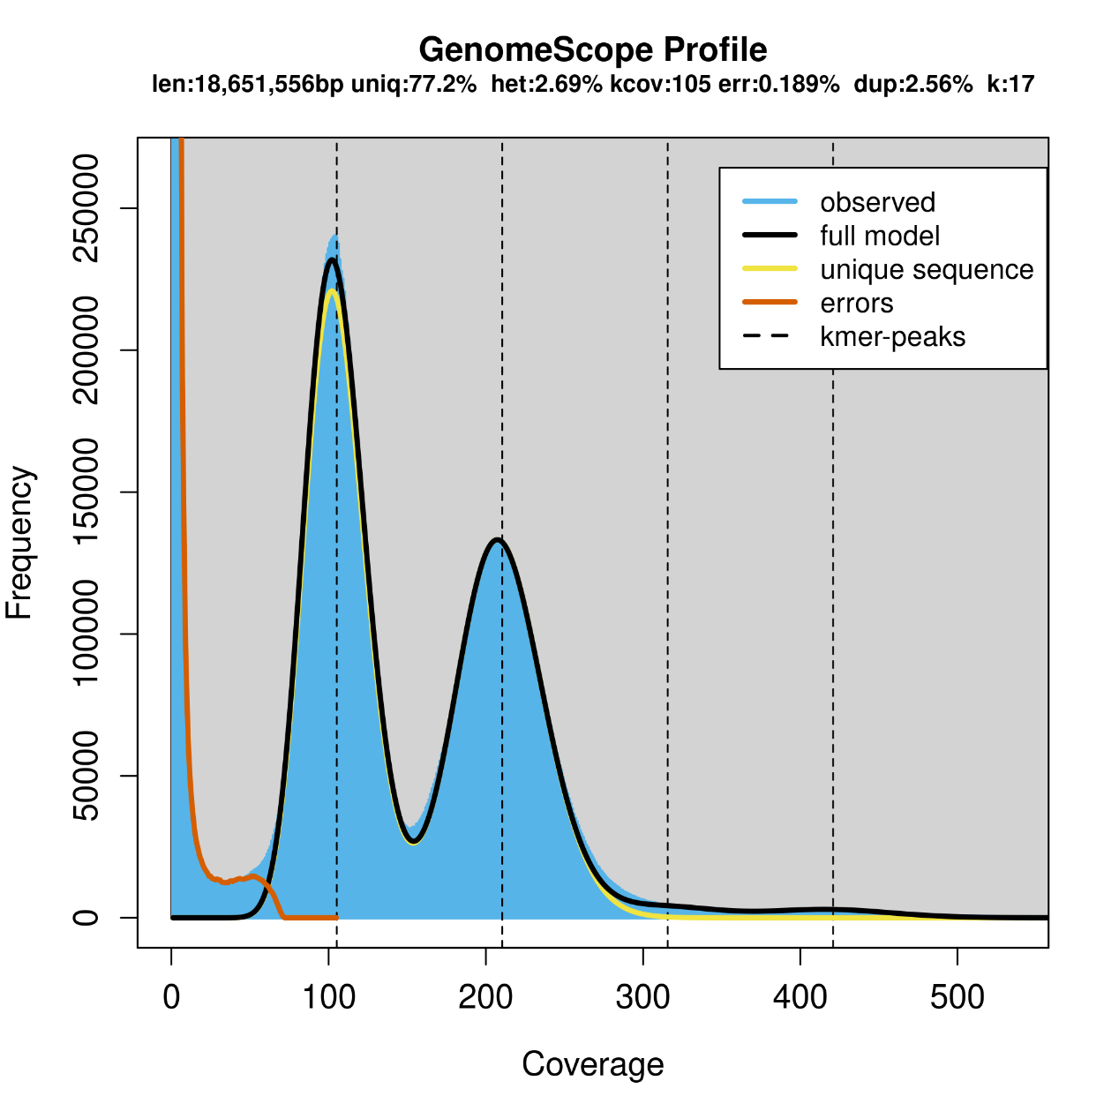
Figure S2 Genome characteristics estimation of P. wickerhamii strain S1 using GenomeScope. X axes is the coverage (X), y axes is the frequency of 17-mer.
Note: het: heterozygosity; kcov: kmer mean peak; uniq: non-repetitive kmer; observed: the kmer actual distribution by jellyfish analysis; full model: theoretical kmer distribution; unique sequence: non-repetitive kmer; errors: wrong kmer, usually the lower kmer；kmer-peaks: the position of the kmer peak.

Figure S3 Genome characteristics estimation of P. wickerhamii strain S931 using GenomeScope.
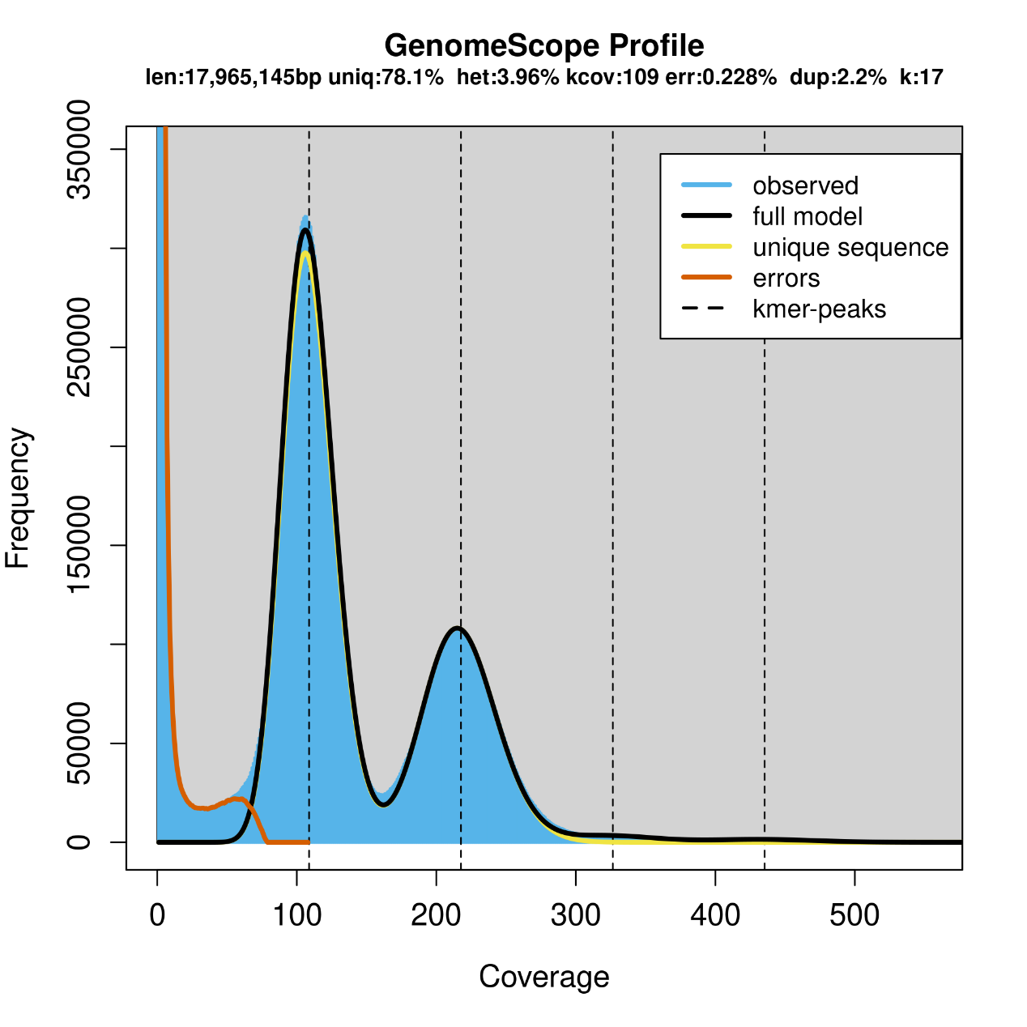
Figure S3 Genome characteristics estimation of P. wickerhamii strain S1 using GenomeScope. X axes is the coverage (X), y axes is the frequency of 17-mer.
Note: het: heterozygosity; kcov: kmer mean peak; uniq: non-repetitive kmer; observed: the kmer actual distribution by jellyfish analysis; full model: theoretical kmer distribution; unique sequence: non-repetitive kmer; errors: wrong kmer, usually the lower kmer；kmer-peaks: the position of the kmer peak.

Figure S4 Circular map of genomic features of mitochondria and plastid of P. wickerhamii genomes.
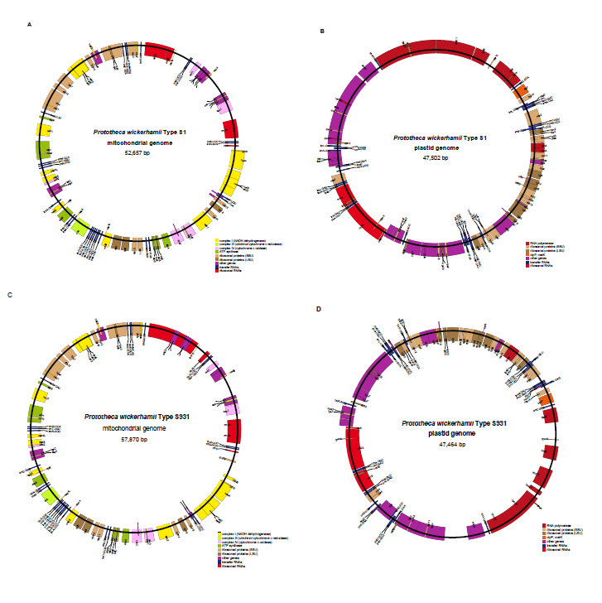

Figure S4 Circular map of genomic features of mitochondria and plastid of P. wickerhamii genomes. A: Strain S1 mitochondrial genome. B: Strain S1 plastid genome. C: Strain S931 mitochondrial genome. D: Strain S931 plastid genome.

Figure S5 The Gene Ontology (GO) enrichment annotation of P.wickerhamii strain S1
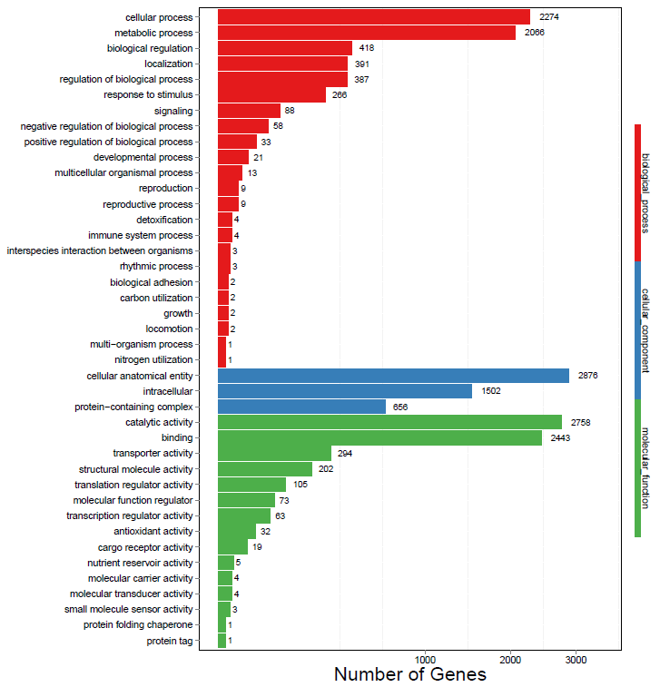

Figure S6 Kyoto Encyclopedia of Genes and Genomes (KEGG) enrichment annotation of P. wickerhamii strain S1
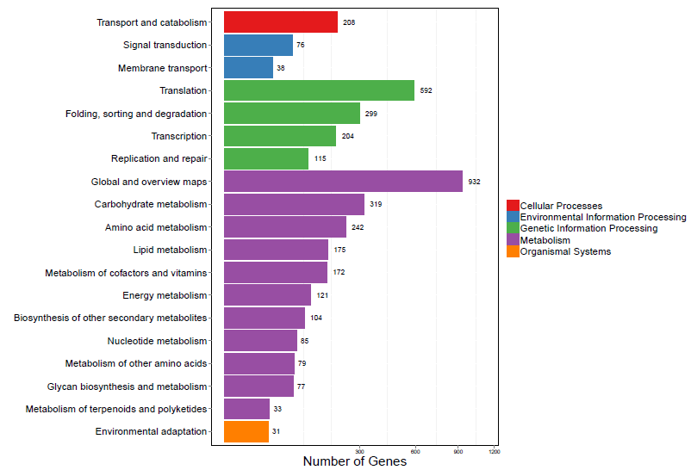

Figure S7 The Gene Ontology (GO) enrichment annotation of P. wickerhamii strain S931
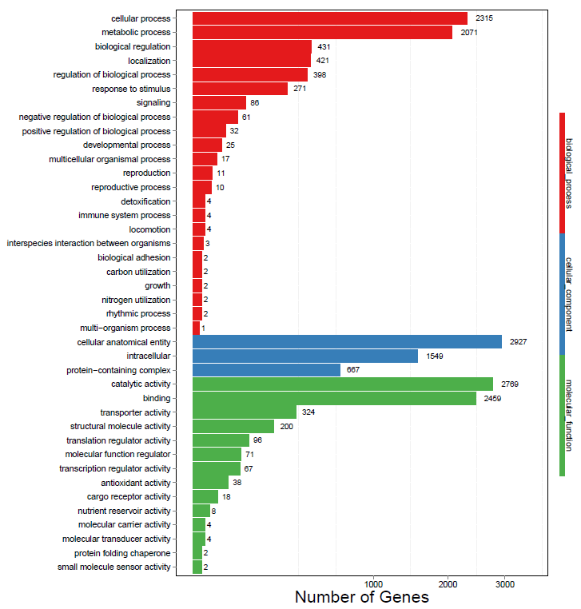

Figure S8 Kyoto Encyclopedia of Genes and Genomes (KEGG) enrichment annotation of P. wickerhamii strain S931
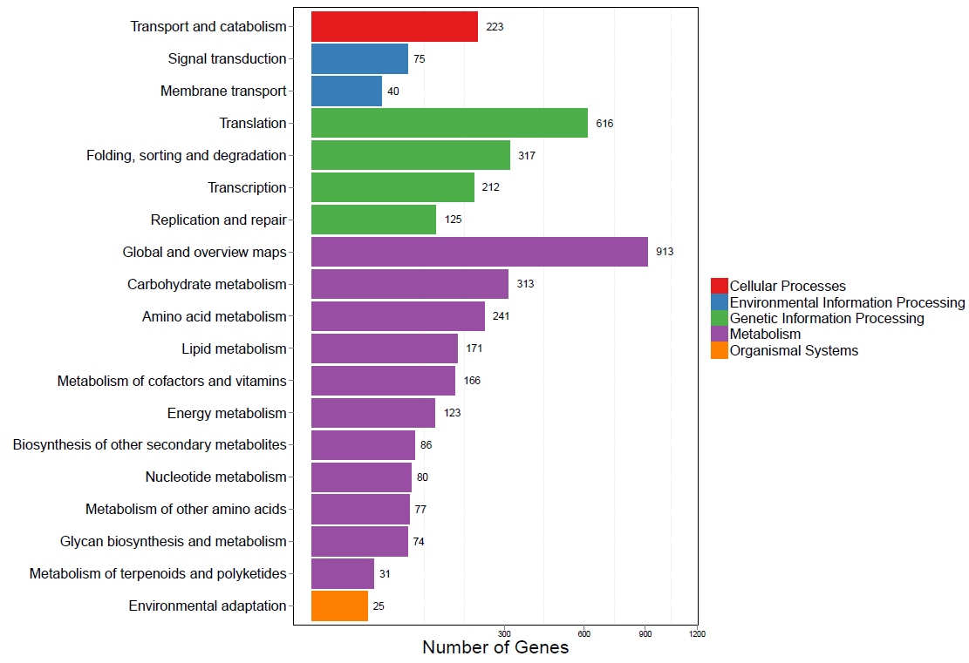

Figure S9 Genomic comparison of the three P. wickerhamii strains S1, S931, and ATCC 16529.
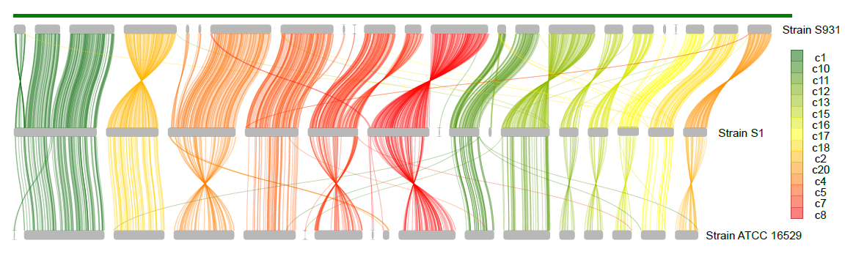

Figure S10 Differences in gene expression between P. wickerhamii strains S1 and S931.
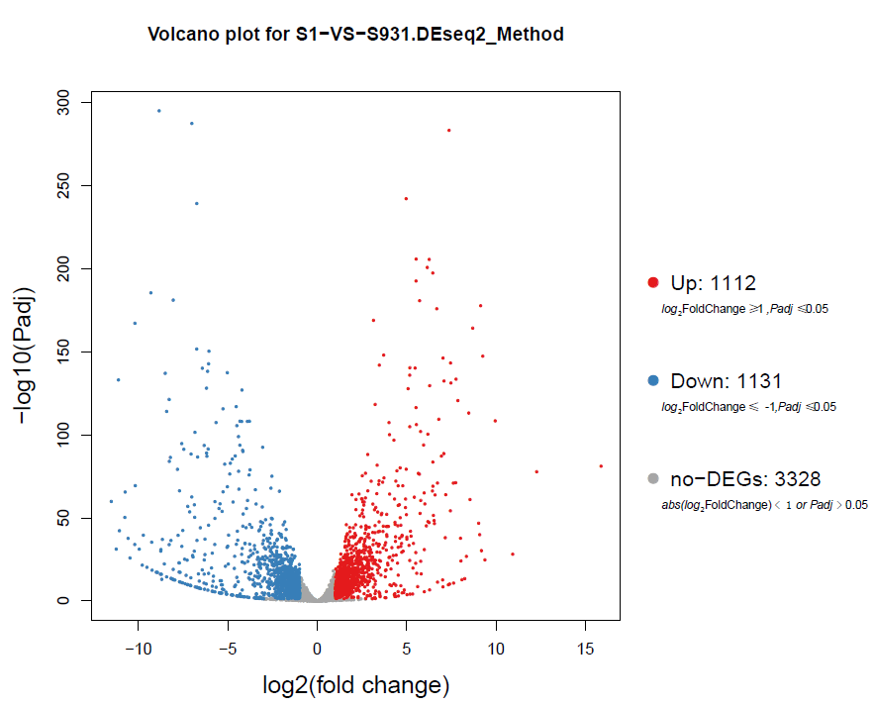

Table S1 Sequencing data statistics of two types of P. wickerhamii genomes with Illumina platform.
Table S1 Sequencing data statistics of two types of P.wickerhamii genomes with Illumina platform.
Sample | Clean Reads | Clean Data (bp) | Q20 (%) | Q30 (%) | GC (%)
S1 | 30,294,638 | 4,538,051,122 | 98.16 | 95.02 | 58.30
S931 | 30,400,388 | 4,551,834,050 | 98.09 | 94.92 | 58.99

Table S2 Sequencing data statistics of two types of P. wickerhamii genomes with Nanopore platform.
Table S2 Sequencing data statistics of two types of P.wickerhamii genomes with Nanopore platform.
Sample | Total reads | Total bases (bp) | Average length (bp) | Max length (bp)
S1 raw data | 1,328,625 | 4,945,169,571 | 3,722 | 153,066
S1 clean data | 551,989 | 4,545,371,048 | 8,235 | 153,066
S931 raw data | 681,088 | 4,984,644,056 | 7,319 | 149,724
S931 clean data | 542,630 | 4,902,398,079 | 9,035 | 149,724

Table S3. The assembly statistics of P. wickerhamii genomes.
Table S3. The assembly statistics of P.wickerhamii genomes.
 | S1 |  | S931
 | Canu | Necat | Canu | Necat
Assembled genome size (bp) | 19,936,577 | 17,674,137 | 19,980,883 | 17,651,439
Contig Number | 84 | 21 | 79 | 31
Contig N50 | 1,648,552 | 1,639,047 | 1,082,058 | 1,406,360
Max length | 2,551,560 | 2,552,045 | 2,083,189 | 1,845,983
Mean length | 237,340 | 841,625 | 252,922 | 569,401
GC% | 63.54% | 64.00% | 63.73% | 64.04%
Note: the assembled genomes contained the nuclear genomes, mitochondrion and plastid genomes.

Table S4. BUSCO evaluation of P. wickerhamii genome assembly.
Table S4 BUSCO evaluation of P.wickerhamii genome assembly
Type | S1_Necat |  | S1_Canu |  | S931_Necat |  | S931_Canu
 | Number | Percentage (%) | Number | Percentage (%) | Number | Percentage (%) | Number | Percentage (%)
Complete BUSCOs (C) | 1348 | 88.8 | 1347 | 88.7 | 1336 | 87.1 | 1336 | 87.9
Complete and single-copy BUSCOs (S) | 1329 | 87.5 | 1232 | 81.1 | 1211 | 84.7 | 1211 | 79.7
Complete and duplicated BUSCOs (D) | 19 | 1.3 | 115 | 7.6 | 125 | 2.4 | 125 | 8.2
Fragmented BUSCOs (F) | 11 | 0.7 | 10 | 0.7 | 37 | 1.2 | 14 | 0.9
Missing BUSCOs (M) | 160 | 10.5 | 162 | 10.6 | 169 | 11.7 | 169 | 11.2
Total BUSCO groups searched | 1519 | 100 | 1519 | 100 | 1519 | 100 | 1519 | 100

Table S5 General features of the mitochondrion and plastid genomes of P. wickerhamii
Genome | Type strain | Size (bp) | CDS | rRNA | tRNA | GC %
Mitochondrion | S931 | 57,870 | 42 | 5 | 26 | 25.66
 | S1 | 52,657 | 41 | 4 | 26 | 25.63
 | ATCC 16529 | 53,822 | 38 | 3 | 27 | 25.81
Plastid | S931 | 47,464 | 36 | 3 | 29 | 28.26
 | S1 | 47,502 | 36 | 3 | 29 | 28.22
 | ATCC 16529 | 47,997 | 35 | 3 | 30 | 28.20

Table S6 The statistics of Prototheca wickerhamii strain S1 assembled nuclear genome.
S1 | Length | GC | GC content (%)
Contig1 | 2,552,045 | 1,648,168 | 64.58%
Contig4 | 2,086,090 | 1,348,001 | 64.62%
Contig8 | 1,901,190 | 1,230,371 | 64.72%
Contig5 | 1,660,611 | 1,075,347 | 64.76%
Contig2 | 1,639,047 | 1,044,207 | 63.71%
Contig7 | 1,560,028 | 998,295 | 63.99%
Contig13 | 1,491,610 | 957,776 | 64.21%
Contig11 | 928,735 | 589,869 | 63.51%
Contig18 | 793,799 | 504,738 | 63.59%
Contig20 | 744,247 | 476,778 | 64.06%
Contig17 | 659,570 | 426,089 | 64.60%
Contig16 | 648,131 | 410,554 | 63.34%
Contig15 | 601,769 | 381,193 | 63.35%
Contig12 | 110,109 | 66,155 | 60.08%
Contig6 | 62,121 | 44,436 | 71.53%
Contig14 | 59,188 | 33,109 | 55.94%
Contig3 | 43,908 | 28,574 | 65.08%
Contig10 | 30,119 | 19,390 | 64.38%
Contig9 | 1,661 | 1,203 | 72.43%
Total | 17,573,978 |  | 64.21%

Table S7. The statistics of Prototheca wickerhamii strain S931 assembled nuclear genome.
Table S7. The statistics of Prototheca wickerhamii strain S931 assembled nuclear genome.
S931 | Length | GC | GC content (%)
Contig4 | 1,845,983 | 1,198,075 | 64.90%
Contig2 | 1,774,155 | 1,153,826 | 65.04%
Contig13 | 1,614,017 | 1,044,597 | 64.72%
Contig1 | 1,611,696 | 1,031,548 | 64.00%
Contig5 | 1,423,260 | 921,827 | 64.77%
Contig24 | 1,406,360 | 909,518 | 64.67%
Contig17 | 1,013,720 | 650,845 | 64.20%
Contig23 | 849,189 | 553,389 | 65.17%
Contig25 | 785,291 | 501,028 | 63.80%
Contig26 | 767,406 | 492,227 | 64.14%
Contig21 | 737,940 | 475,517 | 64.44%
Contig30 | 693,932 | 437,042 | 62.98%
Contig8 | 621,843 | 394,370 | 63.42%
Contig16 | 600,272 | 395,626 | 65.91%
Contig19 | 569,196 | 365,004 | 64.13%
Contig20 | 360,942 | 230,944 | 63.98%
Contig22 | 266,955 | 165,438 | 61.97%
Contig3 | 138,771 | 91,063 | 65.62%
Contig15 | 109,235 | 69,332 | 63.47%
Contig31 | 78,238 | 51,109 | 65.33%
Contig9 | 76,185 | 49,359 | 64.79%
Contig6 | 61,514 | 36,597 | 59.49%
Contig12 | 23,214 | 15,006 | 64.64%
Contig18 | 13,174 | 8,937 | 67.84%
Contig14 | 5,433 | 3,095 | 56.97%
Contig7 | 5,268 | 3,423 | 64.98%
Total | 17,453,189 |  | 64.45%

Table S8 Repeat content in the assembled nuclear genomes.
Table S8 Repeat content in the assembled nuclear genomes.
Type | S1 |  | S931
 | Repeat Size | % of genome | Repeat Size | % of genome
Trf | 432,804 | 2.46 | 331,641 | 1.90
Repeatmasker | 96,782 | 0.55 | 74,804 | 0.43
Proteinmask | 70,688 | 0.40 | 57,776 | 0.33
De novo | 2,016 | 0.01 | 4,215 | 0.02
Total | 546,360 | 3.11 | 434,225 | 2.49
Note: Repbase TEs: the result of RepeatMasker based on Repbase; TE proteins: the result of RepeatProteinMask based on Repbase; De novo: Result of RepeatMasker by using library predicted through De novo; Total: combine the results of Repbase TEs, TE proteins and De novo with removing the over-lap.

Table S9 BUSCO analysis result for different P. wickerhamii including the genome and gene evaluation.
Table S9 BUSCO analysis result for P. wickerhamii including the genome and gene evaluation.
P. wickerhamii | Type | Complete BUSCOs (C) | Complete and single-copy BUSCOs (S) | Complete and duplicated BUSCOs (D) | Fragmented BUSCOs (F) | Missing BUSCOs (M) | Total BUSCO groups searched
Strain S1 | Genome BUSCO (number) | 1314 | 1297 | 17 | 25 | 180 | 1519
 | Genome BUSCO (percentage %) | 86.5 | 85.4 | 1.1 | 1.6 | 11.9 | 100
 | Gene BUSCO (number) | 1343 | 1325 | 18 | 18 | 171 | 1519
 | Gene BUSCO (percentage %) | 88.4 | 87.2 | 1.2 | 0.3 | 11.3 | 100
Strain S931 | Genome BUSCO (number) | 1289 | 1258 | 31 | 29 | 201 | 1519
 | Genome BUSCO (percentage %) | 8.8 | 8.8 | 2 | 1.9 | 13.3 | 100
 | Gene BUSCO (number) | 1319 | 1277 | 42 | 14 | 186 | 1519
 | Gene BUSCO (percentage %) | 86.9 | 84.1 | 2.8 | 0.9 | 12.2 | 100
Strain ATCC 16529 | Genome BUSCO (number) | 1260 | 1255 | 5 | 44 | 215 | 1519
 | Genome BUSCO (percentage %) | 82.9 | 82.6 | 0.3 | 2.9 | 14.2 | 100
 | Gene BUSCO (number) | 1211 | 1199 | 12 | 54 | 254 | 1519
 | Gene BUSCO (percentage %) | 79.7 | 78.9 | 0.8 | 3.6 | 16.7 | 100

Table S10 Gene function annotation
Table S10 Gene function annotation in P. wickerhamii strain S1 and S931.
P. wickerhamii | Values | Total | Nr | Swissprot | KEGG | KOG | TrEMBL | GO | Interpro | Overall
Strain S1 | Number | 5,694 | 5,508 | 4,093 | 5,050 | 3,856 | 5,259 | 4,566 | 4,756 | 5,512
 | Percentage | 100% | 96.73% | 71.88% | 88.69% | 70.72% | 92.36% | 80.19% | 83.53% | 96.80%
Strain S931 | Number | 5,704 | 5,548 | 4,108 | 5,067 | 3,881 | 5,307 | 4,622 | 4,313 | 5,554
 | Percentage | 100% | 97.27% | 72.02% | 88.83% | 68.04% | 93.04% | 81.03% | 75.61% | 97.37%

Table S11 Gene family statistics
Table S11. Statistics of gene families in different species
Species | Genes number | Genes in families | Unclustered genes | Family number | Unique families | Average genes per family
P. stagnorum | 4,050 | 3,931 | 119 | 3,662 | 2 | 1.07
P. cutis | 5,038 | 4,915 | 123 | 4,596 | 2 | 1.07
M. conductrix | 10,041 | 9,018 | 1,023 | 6,875 | 226 | 1.31
C. subellipsoidae | 9,815 | 7,781 | 2,034 | 6,253 | 223 | 1.24
C. variabilis | 9,723 | 8,344 | 1,379 | 7,003 | 116 | 1.19
A. protothecoides | 5,710 | 5,245 | 465 | 4,916 | 18 | 1.07
C. reinhardtii | 19,528 | 14,984 | 4,544 | 8,012 | 1,348 | 1.87
M. commoda | 9,954 | 7,713 | 2,241 | 6,882 | 108 | 1.12
O. tauri | 7,709 | 6,522 | 1,187 | 6,017 | 64 | 1.08
P. coloniale | 7,133 | 5,891 | 1,242 | 5,351 | 50 | 1.1
P.wickerhamii strain ATCC 16529 | 6,079 | 5,798 | 281 | 5,361 | 3 | 1.08
P.wickerhamii strain S1 | 5,694 | 5,441 | 253 | 5,151 | 8 | 1.06
P.wickerhamii strain S931 | 5,704 | 5,493 | 211 | 5,113 | 5 | 1.07

Table S12 KEGG pathway enrichment annotation in expansion of P.wickerhamii species
Table S12. KEGG pathway enrichment annotation in expansion of P.wickerhamii species

Genes | Pathway_level1 | Pathway_level2 | Pathway | PathwayID
Maker00001096 | Environmental Information Processing | Membrane transport | ABC transporters | ko02010
Maker00000018 | Metabolism | Amino acid metabolism | Alanine, aspartate and glutamate metabolism | ko00250
Maker00001552 | Metabolism | Carbohydrate metabolism | Amino sugar and nucleotide sugar metabolism | ko00520
Maker00001068 | Genetic Information Processing | Translation | Aminoacyl-tRNA biosynthesis | ko00970
Maker00004812 | Genetic Information Processing | Translation | Aminoacyl-tRNA biosynthesis | ko00970
Maker00002802 | Metabolism | Amino acid metabolism | Arginine biosynthesis | ko00220
Maker00001552 | Metabolism | Carbohydrate metabolism | Ascorbate and aldarate metabolism | ko00053
Maker00003246 | Genetic Information Processing | Transcription | Basal transcription factors | ko03022
Maker00003958 | Genetic Information Processing | Replication and repair | Base excision repair | ko03410
Maker00000383 | Metabolism | Global and overview maps | Biosynthesis of amino acids | ko01230
Maker00002537 | Metabolism | Global and overview maps | Biosynthesis of amino acids | ko01230
Maker00002802 | Metabolism | Global and overview maps | Biosynthesis of amino acids | ko01230
Maker00005452 | Metabolism | Global and overview maps | Biosynthesis of amino acids | ko01230
Maker00000244 | Metabolism | Global and overview maps | Biosynthesis of secondary metabolites | ko01110
Maker00000383 | Metabolism | Global and overview maps | Biosynthesis of secondary metabolites | ko01110
Maker00001354 | Metabolism | Global and overview maps | Biosynthesis of secondary metabolites | ko01110
Maker00002180 | Metabolism | Global and overview maps | Biosynthesis of secondary metabolites | ko01110
Maker00002537 | Metabolism | Global and overview maps | Biosynthesis of secondary metabolites | ko01110
Maker00002779 | Metabolism | Global and overview maps | Biosynthesis of secondary metabolites | ko01110
Maker00002802 | Metabolism | Global and overview maps | Biosynthesis of secondary metabolites | ko01110
Maker00003996 | Metabolism | Global and overview maps | Biosynthesis of secondary metabolites | ko01110
Maker00004816 | Metabolism | Global and overview maps | Biosynthesis of secondary metabolites | ko01110
Maker00005396 | Metabolism | Global and overview maps | Biosynthesis of secondary metabolites | ko01110
Maker00005452 | Metabolism | Global and overview maps | Biosynthesis of secondary metabolites | ko01110
Maker00005396 | Metabolism | Energy metabolism | Carbon fixation in photosynthetic organisms | ko00710
Maker00002180 | Metabolism | Global and overview maps | Carbon metabolism | ko01200
Maker00002779 | Metabolism | Global and overview maps | Carbon metabolism | ko01200
Maker00005396 | Metabolism | Global and overview maps | Carbon metabolism | ko01200
Maker00005396 | Metabolism | Carbohydrate metabolism | Citrate cycle (TCA cycle) | ko00020
Maker00000244 | Metabolism | Amino acid metabolism | Cysteine and methionine metabolism | ko00270
Maker00002537 | Metabolism | Amino acid metabolism | Cysteine and methionine metabolism | ko00270
Maker00005396 | Metabolism | Amino acid metabolism | Cysteine and methionine metabolism | ko00270
Maker00005452 | Metabolism | Amino acid metabolism | Cysteine and methionine metabolism | ko00270
Maker00004462 | Genetic Information Processing | Replication and repair | DNA replication | ko03030
Maker00003454 | Cellular Processes | Transport and catabolism | Endocytosis | ko04144
Maker00004027 | Cellular Processes | Transport and catabolism | Endocytosis | ko04144
Maker00003689 | Metabolism | Metabolism of cofactors and vitamins | Folate biosynthesis | ko00790
Maker00004921 | Metabolism | Metabolism of cofactors and vitamins | Folate biosynthesis | ko00790
Maker00004298 | Metabolism | Carbohydrate metabolism | Fructose and mannose metabolism | ko00051
Maker00002552 | Metabolism | Metabolism of other amino acids | Glutathione metabolism | ko00480
Maker00004312 | Metabolism | Metabolism of other amino acids | Glutathione metabolism | ko00480
Maker00002779 | Metabolism | Amino acid metabolism | Glycine, serine and threonine metabolism | ko00260
Maker00003343 | Metabolism | Amino acid metabolism | Glycine, serine and threonine metabolism | ko00260
Maker00005452 | Metabolism | Amino acid metabolism | Glycine, serine and threonine metabolism | ko00260
Maker00002180 | Metabolism | Carbohydrate metabolism | Glycolysis / Gluconeogenesis | ko00010
Maker00002180 | Metabolism | Carbohydrate metabolism | Glyoxylate and dicarboxylate metabolism | ko00630
Maker00002779 | Metabolism | Carbohydrate metabolism | Glyoxylate and dicarboxylate metabolism | ko00630
Maker00005396 | Metabolism | Carbohydrate metabolism | Glyoxylate and dicarboxylate metabolism | ko00630
Maker00002537 | Metabolism | Biosynthesis of other secondary metabolites | Isoquinoline alkaloid biosynthesis | ko00950
Maker00005452 | Metabolism | Amino acid metabolism | Lysine biosynthesis | ko00300
Maker00003565 | Environmental Information Processing | Signal transduction | MAPK signaling pathway - plant | ko04016
Maker00000244 | Metabolism | Global and overview maps | Metabolic pathways | ko01100
Maker00000383 | Metabolism | Global and overview maps | Metabolic pathways | ko01100
Maker00000604 | Metabolism | Global and overview maps | Metabolic pathways | ko01100
Maker00001332 | Metabolism | Global and overview maps | Metabolic pathways | ko01100
Maker00001552 | Metabolism | Global and overview maps | Metabolic pathways | ko01100
Maker00002091 | Metabolism | Global and overview maps | Metabolic pathways | ko01100
Maker00002180 | Metabolism | Global and overview maps | Metabolic pathways | ko01100
Maker00002537 | Metabolism | Global and overview maps | Metabolic pathways | ko01100
Maker00002779 | Metabolism | Global and overview maps | Metabolic pathways | ko01100
Maker00002802 | Metabolism | Global and overview maps | Metabolic pathways | ko01100
Maker00003343 | Metabolism | Global and overview maps | Metabolic pathways | ko01100
Maker00003689 | Metabolism | Global and overview maps | Metabolic pathways | ko01100
Maker00003996 | Metabolism | Global and overview maps | Metabolic pathways | ko01100
Maker00004171 | Metabolism | Global and overview maps | Metabolic pathways | ko01100
Maker00004426 | Metabolism | Global and overview maps | Metabolic pathways | ko01100
Maker00004816 | Metabolism | Global and overview maps | Metabolic pathways | ko01100
Maker00004921 | Metabolism | Global and overview maps | Metabolic pathways | ko01100
Maker00005396 | Metabolism | Global and overview maps | Metabolic pathways | ko01100
Maker00005452 | Metabolism | Global and overview maps | Metabolic pathways | ko01100
Maker00004462 | Genetic Information Processing | Replication and repair | Mismatch repair | ko03430
Maker00005452 | Metabolism | Biosynthesis of other secondary metabolites | Monobactam biosynthesis | ko00261
Maker00000476 | Genetic Information Processing | Translation | mRNA surveillance pathway | ko03015
Maker00000769 | Genetic Information Processing | Translation | mRNA surveillance pathway | ko03015
Maker00000960 | Genetic Information Processing | Translation | mRNA surveillance pathway | ko03015
Maker00004645 | Genetic Information Processing | Translation | mRNA surveillance pathway | ko03015
Maker00004662 | Genetic Information Processing | Translation | mRNA surveillance pathway | ko03015
Maker00004816 | Genetic Information Processing | Translation | mRNA surveillance pathway | ko03015
Maker00003246 | Genetic Information Processing | Replication and repair | Nucleotide excision repair | ko03420
Maker00004418 | Genetic Information Processing | Replication and repair | Nucleotide excision repair | ko03420
Maker00004462 | Genetic Information Processing | Replication and repair | Nucleotide excision repair | ko03420
Maker00003689 | Metabolism | Metabolism of cofactors and vitamins | One carbon pool by folate | ko00670
Maker00002091 | Metabolism | Energy metabolism | Oxidative phosphorylation | ko00190
Maker00004171 | Metabolism | Energy metabolism | Oxidative phosphorylation | ko00190
Maker00001552 | Metabolism | Carbohydrate metabolism | Pentose and glucuronate interconversions | ko00040
Maker00001450 | Cellular Processes | Transport and catabolism | Peroxisome | ko04146
Maker00001815 | Cellular Processes | Transport and catabolism | Phagosome | ko04145
Maker00004171 | Cellular Processes | Transport and catabolism | Phagosome | ko04145
Maker00002537 | Metabolism | Amino acid metabolism | Phenylalanine metabolism | ko00360
Maker00000383 | Metabolism | Amino acid metabolism | Phenylalanine, tyrosine and tryptophan biosynthesis | ko00400
Maker00002537 | Metabolism | Amino acid metabolism | Phenylalanine, tyrosine and tryptophan biosynthesis | ko00400
Maker00004816 | Metabolism | Biosynthesis of other secondary metabolites | Phenylpropanoid biosynthesis | ko00940
Maker00004738 | Genetic Information Processing | Folding, sorting and degradation | Protein export | ko03060
Maker00001815 | Genetic Information Processing | Folding, sorting and degradation | Protein processing in endoplasmic reticulum | ko04141
Maker00002858 | Genetic Information Processing | Folding, sorting and degradation | Protein processing in endoplasmic reticulum | ko04141
Maker00004738 | Genetic Information Processing | Folding, sorting and degradation | Protein processing in endoplasmic reticulum | ko04141
Maker00000604 | Metabolism | Nucleotide metabolism | Purine metabolism | ko00230
Maker00000635 | Metabolism | Nucleotide metabolism | Pyrimidine metabolism | ko00240
Maker00001332 | Metabolism | Nucleotide metabolism | Pyrimidine metabolism | ko00240
Maker00003689 | Metabolism | Nucleotide metabolism | Pyrimidine metabolism | ko00240
Maker00000029 | Metabolism | Carbohydrate metabolism | Pyruvate metabolism | ko00620
Maker00002180 | Metabolism | Carbohydrate metabolism | Pyruvate metabolism | ko00620
Maker00005396 | Metabolism | Carbohydrate metabolism | Pyruvate metabolism | ko00620
Maker00002693 | Genetic Information Processing | Translation | Ribosome | ko03010
Maker00003577 | Genetic Information Processing | Translation | Ribosome | ko03010
Maker00003927 | Genetic Information Processing | Translation | Ribosome | ko03010
Maker00003955 | Genetic Information Processing | Translation | Ribosome | ko03010
Maker00004552 | Genetic Information Processing | Translation | Ribosome | ko03010
Maker00004733 | Genetic Information Processing | Translation | Ribosome | ko03010
Maker00000265 | Genetic Information Processing | Translation | Ribosome biogenesis in eukaryotes | ko03008
Maker00003482 | Genetic Information Processing | Translation | Ribosome biogenesis in eukaryotes | ko03008
Maker00005333 | Genetic Information Processing | Translation | Ribosome biogenesis in eukaryotes | ko03008
Maker00000767 | Genetic Information Processing | Folding, sorting and degradation | RNA degradation | ko03018
Maker00000769 | Genetic Information Processing | Translation | RNA transport | ko03013
Maker00000960 | Genetic Information Processing | Translation | RNA transport | ko03013
Maker00001065 | Genetic Information Processing | Translation | RNA transport | ko03013
Maker00002769 | Genetic Information Processing | Translation | RNA transport | ko03013
Maker00002924 | Genetic Information Processing | Translation | RNA transport | ko03013
Maker00004645 | Genetic Information Processing | Translation | RNA transport | ko03013
Maker00004662 | Genetic Information Processing | Translation | RNA transport | ko03013
Maker00004816 | Genetic Information Processing | Translation | RNA transport | ko03013
Maker00000540 | Genetic Information Processing | Transcription | Spliceosome | ko03040
Maker00004914 | Genetic Information Processing | Transcription | Spliceosome | ko03040
Maker00003996 | Metabolism | Carbohydrate metabolism | Starch and sucrose metabolism | ko00500
Maker00001354 | Metabolism | Lipid metabolism | Steroid biosynthesis | ko00100
Maker00002537 | Metabolism | Biosynthesis of other secondary metabolites | Tropane, piperidine and pyridine alkaloid biosynthesis | ko00960
Maker00002537 | Metabolism | Amino acid metabolism | Tryptophan metabolism | ko00380
Maker00002537 | Metabolism | Amino acid metabolism | Tyrosine metabolism | ko00350
Maker00004426 | Metabolism | Amino acid metabolism | Tyrosine metabolism | ko00350
Maker00002537 | Metabolism | Metabolism of cofactors and vitamins | Ubiquinone and other terpenoid-quinone biosynthesis | ko00130
Maker00000634 | Genetic Information Processing | Folding, sorting and degradation | Ubiquitin mediated proteolysis | ko04120
Maker00003970 | Genetic Information Processing | Folding, sorting and degradation | Ubiquitin mediated proteolysis | ko04120
Maker00004418 | Genetic Information Processing | Folding, sorting and degradation | Ubiquitin mediated proteolysis | ko04120

Table S13 The SNP information in P.wickerhamii genomes.
Table S13. The SNP information in P. wickerhamii genomes.

SNP type | S1 vs S931 |  | S1 vs ATCC 16529 |  | ATCC 16529 vs S931
 | Number | Percent | Number | Percent | Number | Percent
A<->G | 28,022 | 29.74% | 66,385 | 30.82% | 98,667 | 29.25%
C<->T | 28,394 | 30.13% | 66,959 | 31.09% | 98,977 | 29.35%
Transitions | 56,416 | 59.87% | 133,344 | 61.91% | 197,644 | 58.60%
A<->C | 9,453 | 10.03% | 20,441 | 9.49% | 34,677 | 10.28%
A<->T | 6,611 | 7.02% | 12,506 | 5.81% | 24,561 | 7.28%
C<->G | 12,527 | 13.29% | 29,031 | 13.48% | 46,190 | 13.69%
G<->T | 9,229 | 9.79% | 20,066 | 9.32% | 34,210 | 10.14%
Transversions | 37,820 | 40.13% | 82,044 | 38.09% | 139,638 | 41.40%
Transition/Transversion | 1.492 |  | 1.625 |  | 1.415
Total | 94,236 |  | 215,388 |  | 337,282

