Supplementary Material

Supplementary Figures
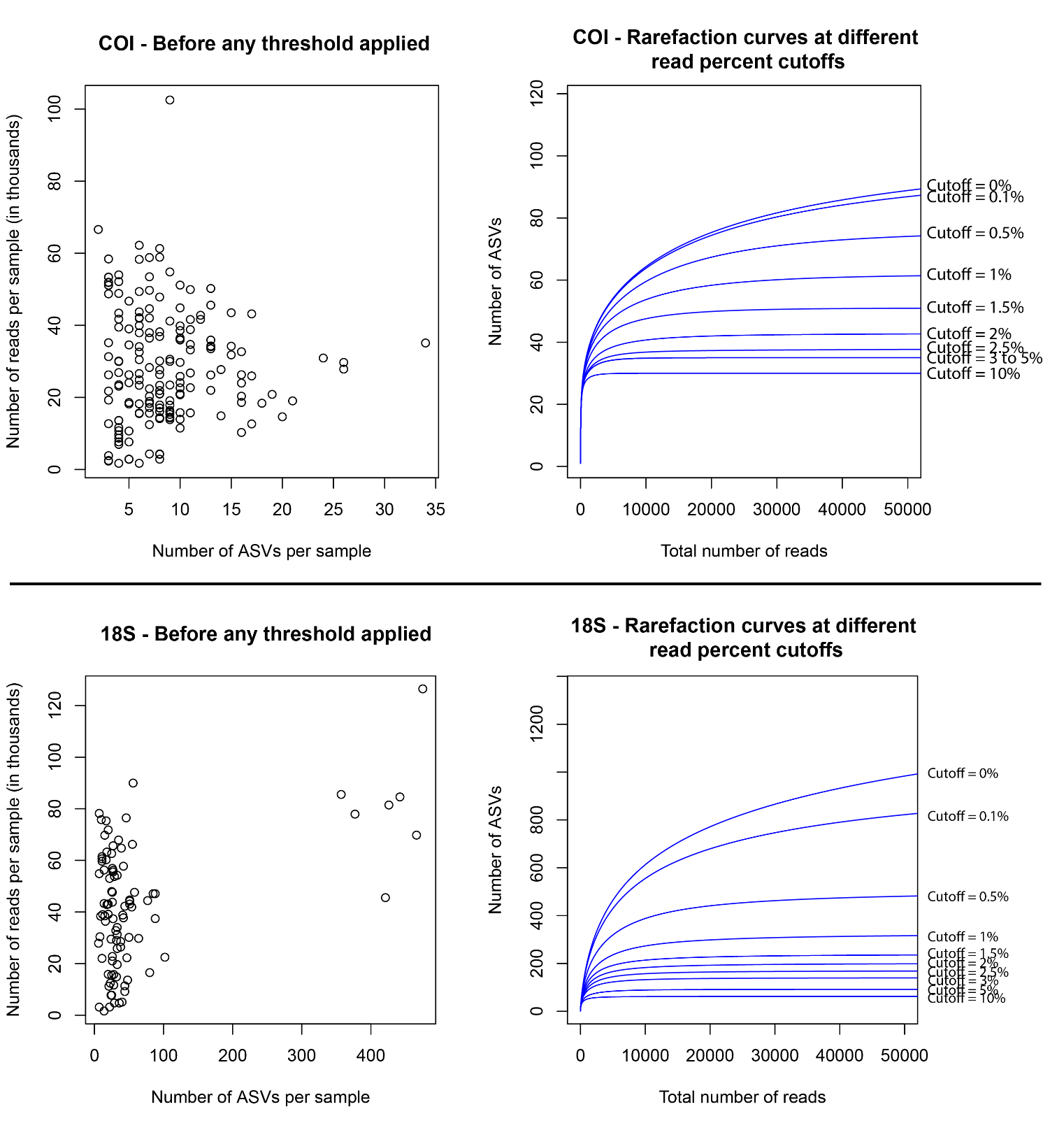
Supplementary Figure 1. Distribution of the total number of ASVs per total number of reads in each sample (left). Threshold applied (right) to the ASV table to see how many AVS are remove by increasing the threshold (cutoff). The cutoff varied between none (0%) and 10% of the total read number. By cutoff, we mean that e.g., if a ASV has a read number equal or below 10% of the total read number in a sample, it’s value is then set to zero. Top: for COI marker; bottom: for 18S marker.

Supplementary Tables
Supplementary Table S1. Metadata file on the all samples: location, date, extraction method, amplification master mix, species and successful sequencing.
Supplementary Table S2. Levene’s test and Fligner-Killeen test results, used to assess homogeneity of variances between genetic variability of both markers.
Supplementary Table S3. Flagged ASVs.
Supplementary Table S4. Detailed read numbers for all samples at three different step on the filtering process: 1) raw reads from the sequencer, 2) number of reads after filtering but before cutoff and 3) number of reads after cutoff. Samples that have less than 1000 raw reads or less than 10% of the raw reads left after quality filter were not analyzed (abbreviation: NA).

