Supplementary Material

Supplementary Table 1. Multinomial logistic regression showing independent factors associated with probability of receive TACE compared to potentially curative treatments (LT, LR and ABL) and palliative therapies (SOR and BSC) in BCLC B patients.
Variable |  | Curative treatment (LT, LR and ABL) |  | Palliative treatment (SOR and BSC) |  | Curative treatment (LT, LR and ABL) |  | Palliative treatment (SOR and BSC)
 |  | First treatment |  |  |  | Main treatment
 |  | aOR (95% CI) | p | aOR (95% CI) | p | aOR (95% CI) | p | aOR (95% CI) | p
Sex | Females  Males | Ref  1.17 (0.69-1.99) | -  0.56 | Ref  0.87 (0.44-1.74) | -  0.69 | Ref  1.07 (0.64-1.80) | -  0.80 | Ref  0.84 (0.42-1.70) | -  0.63
Age (per 10-year increase) |  | 0.78 (0.65-0.93) | 0.005 | 1.05 (0.81-1.35) | 0.73 | 0.73 (0.61-0.88) | 0.001 | 1.03 (0.79-1.34) | 0.83
Period of diagnosis | P1  P2  P3  P4  P5  P6 | Ref  0.28 (0.06-1.35)  3.16 (0.98-10.18)  2.37 (0.77-7.29)  1.98 (0.66-5.91)  1.82 (0.60-5.53) | -  0.11  0.05  0.13  0.22  0.29 | Ref  1.06 (0.23-4.77)  3.57 (0.89-14.31)  1.02 (0.25-4.23)  1.26 (0.33-4.82)  0.76 (0.19-3.04) | -  0.94  0.07  0.97  0.73  0.70 | Ref  0.26 (0.05-1.26)  3.83 (1.19-12.30)  3.48 (1.14-10.67)  3.06 (1.03-9.11)  3.11 (1.03-9.36) | -  0.09  0.02  0.03  0.04  0.04 | Ref  1.03 (0.23-4.64)  3.89 (0.97-15.67)  1.21 (0.29-5.01)  1.42 (0.37-5.44)  0.92 (0.23-3.70) | -  0.97  0.06  0.80  0.61  0.91
Surveillance | No  Yes | Ref  1.39 (0.95-2.03) | -  0.09 | Ref  0.72 (0.43-1.20) | -  0.21 | Ref  1.14 (0.78-1.65) | -  0.50 | Ref  0.65 (0.38-1.10) | -  0.11
CRPH | No  Yes | Ref  0.44 (0.30-0.66) | -  <0.0001 | Ref  0.89 (0.51-1.56) | -  0.68 | Ref  0.57 (0.39-0.84) | -  0.004 | Ref  0.92 (0.52-1.63) | -  0.77
MELD |  | 0.94 (0.88-1.02) | 0.12 | 1.10 (1.01-1.20) | 0.04 | 0.91 (0.85-0.98) | 0.01 | 1.08 (0.98-1.18) | 0.11
Number |  | 0.87 (0.76-0.99) | 0.04 | 1.09 (0.99-1.19) | 0.07 | 0.88 (0.78-0.99) | 0.04 | 1.08 (0.99-1.18) | 0.09
Diameter (cm) |  | 0.95 (0.86-1.05) | 0.29 | 1.13 (1.03-1.23) | 0.01 | 0.91 (0.83-0.99) | 0.04 | 1.10 (1.01-1.21) | 0.03
AFP (ng/mL) | ≤20  20-200  >200 | Ref  1.01 (0.63-1.62)  0.82 (0.53-1.26) | -  0.96  0.36 | Ref  0.73 (0.36-1.48)  1.19 (0.67-2.10) | -  0.38  0.56 | Ref  0.89 (0.56-1.42)  0.81 (0.53-1.23) | -  0.63  0.32 | Ref  0.72 (0.35-1.48)  1.22 (0.68-2.18) | -  0.37  0.51
TACE treatment is the reference category of the multinomial logistic regression. OR<1 indicates that the variable is associated with higher probability of being treated with TACE rather than the comparison category (curative treatments or palliative treatments). OR>1 indicates that the variable is associated with higher probability to be treated with potentially curative treatments (or palliative treatments) rather than TACE.
Abbreviations: LT, liver transplantation; LR, liver resection; ABL, ablation; SOR, systemic therapy; BSC, best supportive care; aOR, adjusted odds ratio; CI, confidence interval; CSPH, clinically relevant portal hypertension; MELD, Model for End-Stage Liver Disease; MVI, macrovascular invasion; EHS, extrahepatic spread; AFP, alpha-fetoprotein.

Supplementary Table 2. Survival analysis according to the period of diagnosis in BCLC B patients.
Period of diagnosis | Median OS (months) | 5-year survival (%) | aHR (95% CI) ª | p
All patients
P1  P2  P3  P4  P5  P6 | 16.0 (12.2-19.8)  25.0 (20.3-29.7)  30.0 (24.0-36.0)  35.0 (29.1-40.9)  35.0 (30.0-40.0)  NE (NE-NE) | 15.4  13.6  23.7  26.5  33.8  51.5 | Ref  0.75 (0.53-1.07)  0.75 (0.55-1.03)  0.60 (0.44-0.81)  0.54 (0.40-0.74)  0.40 (0.28-0.57) | -  0.12  0.07  0.001  0.0001  <0.0001
Patients treated with TACE as first therapy
P1  P2  P3  P4  P5  P6 | 16.0 (11.2-20.8)  25.0 (21.8-28.2)  34.0 (25.8-42.2)  34.0 (27.6-40.4)  36.0 (30.7-41.3)  NE (NE-NE) | 6.6  8.2  23.7  25.9  33.5  50.2 | Ref  0.85 (0.56-1.30)  0.60 (0.39-0.90)  0.53 (0.36-0.79)  0.52 (0.35-0.77)  0.38 (0.24-0.61) | -  0.46  0.02  0.002  0.001  <0.0001
Patients treated with TACE as main therapy
P1  P2  P3  P4  P5  P6 | 15.0 (10.9-19.1)  25.0 (21.9-28.1)  30.0 (18.6-41.4)  29.0 (23.8-34.2)  31.0 (22.7-39.3)  47.4 (NE-NE) | 9.3  6.2  17.5  13.4  23.9  53.8 | Ref  0.84 (0.55-1.29)  0.66 (0.44-1.01)  0.60 (0.40-0.91)  0.65 (0.43-0.98)  0.39 (0.24-0.65) | -  0.44  0.06  0.02  0.04  0.0003
a) Adjusted for: age, etiology, surveillance, CRPH, MELD, AFP level and main treatment (this latter only in the group including all patients).
Abbreviations: OS, overall survival; aHR, adjusted hazard ratio; NE, not estimable; TACE, trans-arterial chemoembolization.

Supplementary Table 3. Univariate and multivariate Cox regression analysis in BCLC B patients.
Variable | Univariate |  | Multivariate
 | HR (95% CI) | p | aHR (95% CI) | p
Period
P1  P2  P3  P4  P5  P6 | Ref  0.86 (0.63-1.17)  0.76 (0.58-1.00)  0.60 (0.46-0.79)  0.52 (0.40-0.68)  0.41 (0.30-0.56) | -  0.34  0.05  0.0003  <0.0001  <0.0001 | Ref  0.75 (0.53-1.07)  0.75 (0.55-1.03)  0.60 (0.44-0.81)  0.54 (0.40-0.74)  0.40 (0.28-0.57) | -  0.12  0.07  0.001  0.0001  <0.0001
Sex
Female  Male | Ref  0.87 (0.73-1.05) | -  0.14 | - | -
Age – 10 years increase | 1.06 (1.00-1.13) | 0.05 | 1.03 (0.95-1.12) | 0.48
Surveillance
No  Yes | Ref  0.81 (0.71-0.94) | -  0.005 | Ref  0.83 (0.71-0.98) | -  0.03
Etiology
Viral  Not viral  Viral + other | Ref  0.83 (0.71-0.97)  1.12 (0.91-1.38) | -  0.02  0.30 | Ref  0.95 (0.78-1.15)  1.15 (0.90-1.48) | -  0.59  0.25
CRPH
No  Yes | Ref  1.42 (1.23-1.65) | -  <0.0001 | Ref  1.21 (1.02-1.45) | -  0.03
Number | 1.02 (1.00-1.04) | 0.09 | -ª | - ª
Diameter (cm) | 1.02 (1.00-1.04) | 0.09 | - ª | - ª
Child-Pugh
A  B7  B8-9 | Ref  1.56 (1.29-1.90)  2.24 (1.83-2.73) | -  <0.0001  <0.0001 | -^{b} | - ^{b}
MELD | 1.06 (1.04-1.08) | <0.0001 | 1.04 (1.01-1.07) | 0.006
AFP (ng/mL)
≤20  20-200  >200 | Ref  1.03 (0.87-1.23)  1.27 (1.08-1.49) | -  0.72  0.003 | Ref  1.00 (0.81-1.23)  1.35 (1.12-1.63) | -  0.99  0.002
Main treatment
BSC  LT  LR  ABL  TACE  SOR  Other | Ref  0.07 (0.04-0.12)  0.18 (0.12-0.26)  0.23 (0.16-0.33)  0.35 (0.25-0.50)  0.46 (0.30-0.70)  0.57 (0.38-0.87) | -  <0.0001  <0.0001  <0.0001  <0.0001  0.0003  0.009 | Ref  0.06 (0.03-0.11)  0.17 (0.10-0.26)  0.23 (0.15-0.34)  0.31 (0.22-0.46)  0.52 (0.32-0.86)  0.46 (0.28-0.75) | -  <0.0001  <0.0001  <0.0001  <0.0001  0.01  0.002
a) Not included in multivariate analysis to avoid collinearity with stage.
b) Not included in multivariate analysis to avoid collinearity with MELD
Abbreviations: HR. hazard ratio; CI, confidence interval; aHR, adjusted hazard ratio; CRPH, clinically relevant portal hypertension; MELD, Model for End-stage Liver Disease; AFP, alpha-fetoprotein; BSC, best supportive care; LT, liver transplantation; LR, liver resection; ABL, ablation; TACE, transarterial chemoembolization; SOR, systemic therapies.

Supplementary Figure 1. Flow chart of patient selection.

Supplementary Figure 2. Kaplan-Meier curves showing overall survival according to the period of diagnosis in BCLC B patients (A), in BCLC B patients treated with TACE as first treatment (B) and in those treated with TACE as main treatment (C) (all p<0.0001).

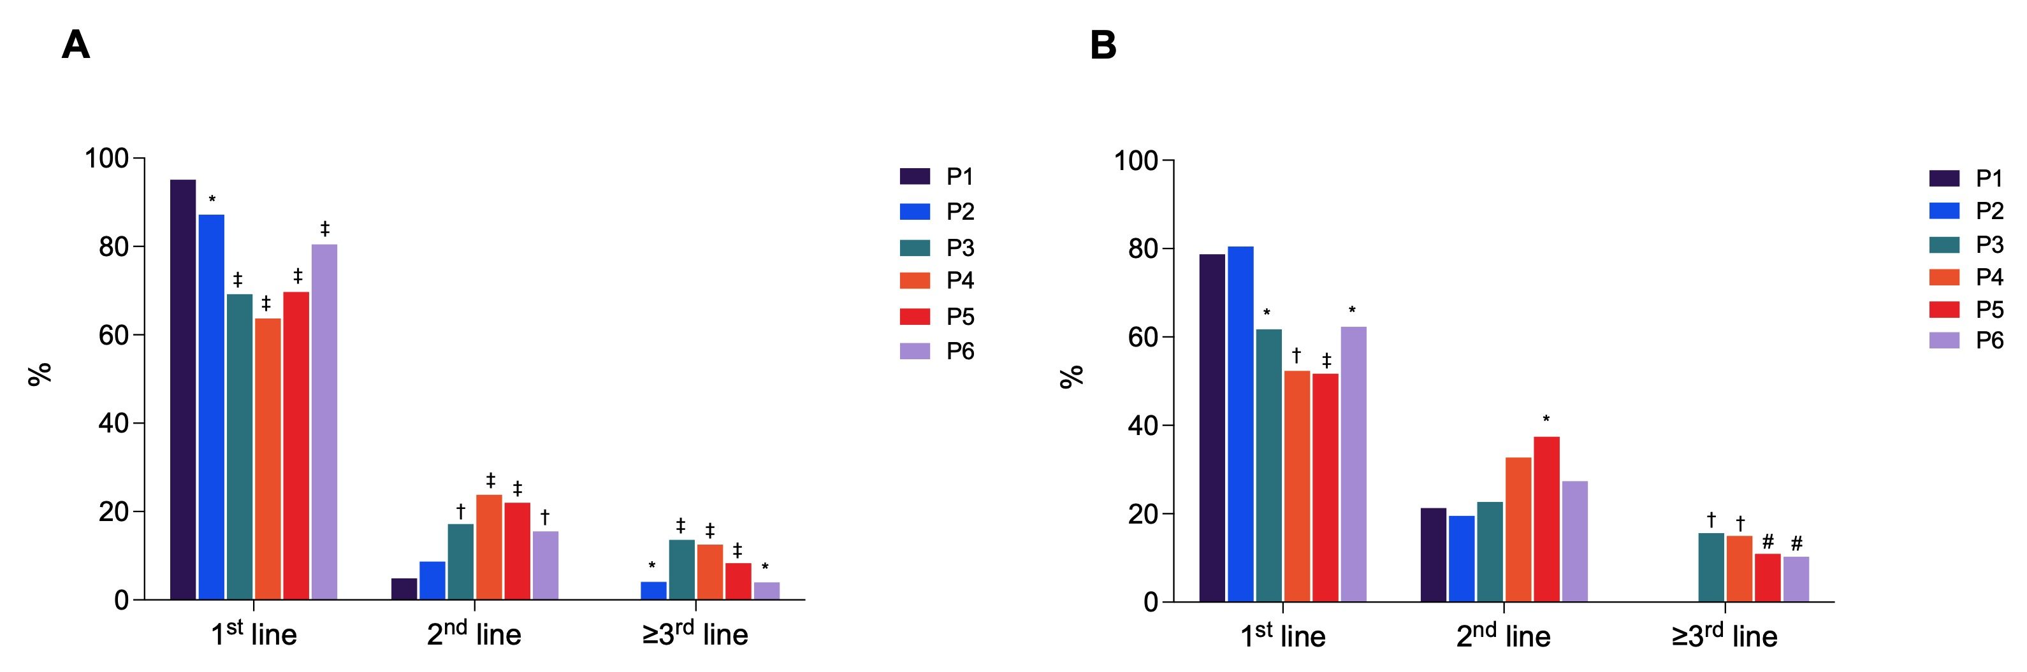
Supplementary Figure 3. Proportion of patients treated with TACE overall (A) and in BCLC B stage (B) in 1st, 2nd and ≥3rd line divided according to the period of diagnosis (* p<0.05 and ≥0.01; # p<0.01 and ≥0.001; † p<0.001 and ≥0.0001; ‡ p<0.0001).

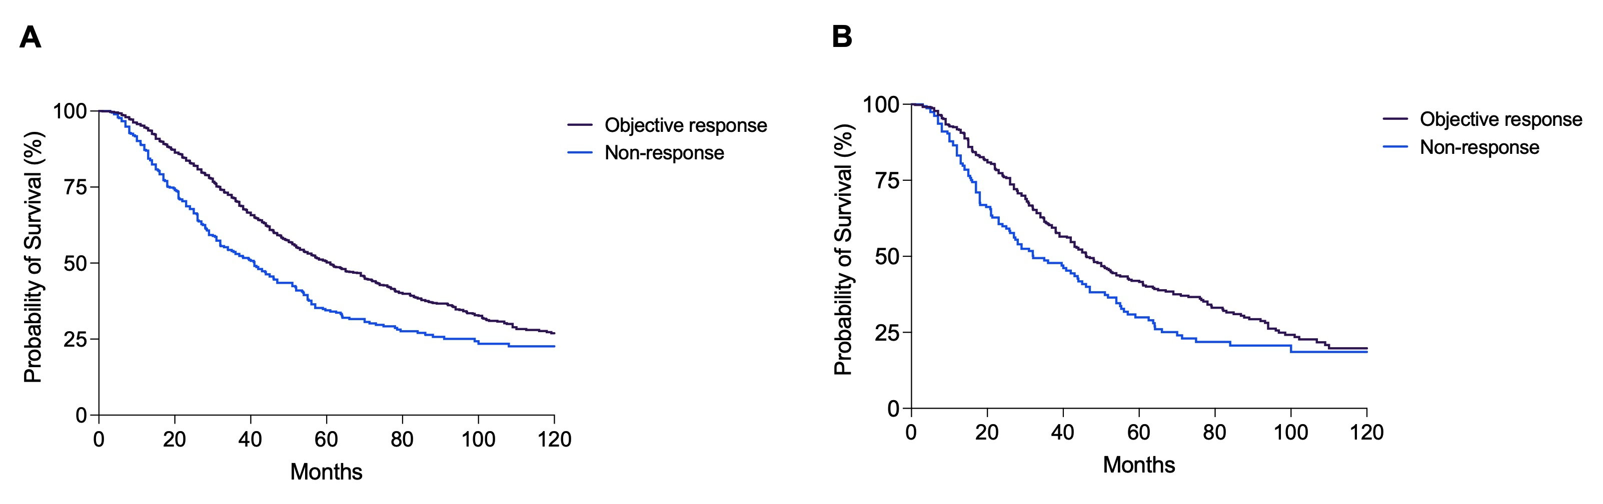
Supplementary Figure 4. Kaplan-Meier curves showing overall survival according to the response to the first TACE in the whole patient population (A) and in BCLC B patients (B). Patients with objective response demonstrated a statistically significant longer survival compared to non-responders (p<0.0001 in the whole population and p=0.004 in BCLC B).

