Suppl. TABLE 1 Logistic regression analysis for associations of serum metabolites with frailty by continuous variables.
Model | variables | β | SE | OR(95%CI) | P value
MODLE1 | A6 | -0.0964 | 0.0453 | 0.908(0.831,0.992) | 0.0334
 | A9 | 0.0175 | 0.0104 | 1.018(0.997,1.039) | 0.0942
 | C5 | -41.1544 | 15.4761 | <0.001(<0.001,<0.001) | 0.0078
 | C8 | 3.7098 | 4.0191 | 40.844(0.015,>999.999) | 0.356
 | C10 | 2.3957 | 2.6606 | 10.976(0.06,>999.999) | 0.3679
 | C12 | 20.8263 | 11.5274 | >999.999(0.171,>999.999) | 0.0708
 | C14 | 82.7088 | 36.8895 | >999.999(>999.999,>999.999) | 0.025
 | L1 | -0.0105 | 0.00421 | 0.99(0.981,0.998) | 0.0125
 | L4 | -0.0319 | 0.0121 | 0.969(0.946,0.992) | 0.0085
MODLE2 | A6 | -0.0562 | 0.0509 | 0.945(0.856,1.045) | 0.2699
 | A9 | 0.0111 | 0.0113 | 1.011(0.989,1.034) | 0.3259
 | C5 | -40.6207 | 17.1374 | <0.001(<0.001,<0.001) | 0.0178
 | C8 | 2.1202 | 4.1564 | 8.332(0.002,>999.999) | 0.61
 | C10 | 1.0423 | 2.7807 | 2.836(0.012,660.028) | 0.7078
 | C12 | 12.2235 | 12.6589 | >999.999(<0.001,>999.999) | 0.3342
 | C14 | 60.5092 | 40.3777 | >999.999(<0.001,>999.999) | 0.134
 | L1 | -0.0109 | 0.00463 | 0.989(0.98,0.998) | 0.0189
 | L4 | -0.0311 | 0.0135 | 0.969(0.944,0.995) | 0.0212
MODLE3 | A6 | -0.0612 | 0.0524 | 0.941(0.849,1.042) | 0.2423
 | A9 | 0.011 | 0.0117 | 1.011(0.988,1.034) | 0.3484
 | C5 | -46.9208 | 17.807 | <0.001(<0.001,<0.001) | 0.0084
 | C8 | 2.6977 | 4.3693 | 14.846(0.003,>999.999) | 0.5369
 | C10 | 1.685 | 2.9465 | 5.392(0.017,>999.999) | 0.5674
 | C12 | 16.1633 | 13.6027 | >999.999(<0.001,>999.999) | 0.2347
 | C14 | 69.2991 | 42.9713 | >999.999(<0.001,>999.999) | 0.1068
 | L1 | -0.0143 | 0.00493 | 0.986(0.976,0.995) | 0.0038
 | L4 | -0.0437 | 0.0147 | 0.957(0.93,0.985) | 0.003

Note: Model1: age, body mass index, smoking status; Model2: further controlled for malnutrition, cognitive decline, activities of daily living, polypharmacy, comorbidities; Model3: further controlled for red blood cell and hemoglobin, alanine aminotransferase and uric acid; C5,valeryl-L-carnitine;C8,octanoyl-L-carnitine;C10,decanoyl-L-carnitin;C12,dodecanoy-L-carnitine;C14,tetradecanoyl-L-car-nitine; LPC16:0,1-palmitoyl-2-hydroxy-sn-glycero-3-phosphocholine; LPC18:2,1-linoleoyl-2-hydroxy-sn-glycero-3-phosphocholine.

Suppl. TABLE 2 Logistic regression analysis for associations of serum metabolites with frailty by categorical variables.
Variables | Model1 |  |  |  |  | Model 2 |  |  |  |  | Model 3
 | β | SE | OR(95%CI) | P |  | β | SE | OR(95%CI) | P |  | β | SE | OR(95%CI) | P
Glycine -M3 | 0.663 | 0.380 | 1.941(0.921,4.091) | 0.081 |  | 0.355 | 0.413 | 1.426(0.635,3.203) | 0.390 |  | 0.314 | 0.424 | 1.368(0.596,3.142) | 0.460
-M2 | 0.584 | 0.361 | 1.793(0.883,3.638) | 0.106 |  | 0.380 | 0.386 | 1.462(0.685,3.118) | 0.326 |  | 0.324 | 0.398 | 1.382(0.634,3.015) | 0.416
-M1 | 0.827 | 0.373 | 2.286(1.101,4.747) | 0.027 |  | 0.613 | 0.397 | 1.846(0.847,4.022) | 0.123 |  | 0.566 | 0.409 | 1.76(0.789,3.927) | 0.170
C5-M3 | -0.777 | 0.409 | 0.46(0.206,1.024) | 0.057 |  | -0.659 | 0.452 | 0.518(0.214,1.254) | 0.145 |  | -0.841 | 0.470 | 0.431(0.172,1.083) | 0.073
-M2 | -0.568 | 0.403 | 0.567(0.257,1.249) | 0.159 |  | -0.292 | 0.441 | 0.747(0.314,1.772) | 0.507 |  | -0.453 | 0.459 | 0.636(0.258,1.564) | 0.324
-M1 | 0.021 | 0.410 | 1.021(0.457,2.283) | 0.959 |  | 0.133 | 0.449 | 1.142(0.474,2.755) | 0.767 |  | 0.023 | 0.463 | 1.023(0.413,2.536) | 0.961
C10-M3 | 0.795 | 0.389 | 2.213(1.033,4.742) | 0.041 |  | 0.648 | 0.423 | 1.911(0.834,4.38) | 0.126 |  | 0.741 | 0.442 | 2.097(0.882,4.986) | 0.094
-M2 | 0.628 | 0.368 | 1.875(0.912,3.854) | 0.088 |  | 0.507 | 0.405 | 1.661(0.750,3.676) | 0.211 |  | 0.567 | 0.417 | 1.762(0.778,3.989) | 0.174
-M1 | 0.803 | 0.375 | 2.232(1.070,4.653) | 0.032 |  | 0.744 | 0.400 | 2.105(0.962,4.608) | 0.063 |  | 0.738 | 0.408 | 2.091(0.939,4.655) | 0.071
C14-M3 | 0.873 | 0.382 | 2.394(1.132,5.064) | 0.022 |  | 0.695 | 0.415 | 2.003(0.888,4.517) | 0.094 |  | 0.784 | 0.432 | 2.19(0.939,5.108) | 0.070
-M2 | 0.397 | 0.356 | 1.487(0.739,2.99) | 0.266 |  | 0.222 | 0.387 | 1.249(0.585,2.667) | 0.566 |  | 0.380 | 0.398 | 1.462(0.670,3.190) | 0.340
-M1 | 0.203 | 0.389 | 1.225(0.572,2.624) | 0.601 |  | 0.197 | 0.423 | 1.218(0.532,2.79) | 0.641 |  | 0.220 | 0.432 | 1.246(0.534,2.908) | 0.610
Note: Model1: age, body mass index, smoking status; Model2: further controlled for malnutrition, cognitive decline, activities of daily living, polypharmacy, comorbidities; Model3: further controlled for red blood cell and hemoglobin, alanine aminotransferase and uric acid; Measured metabolites were used as categorical variables: lower quartile (M1), median (M2), upper quartile (M3) versus lowest quartile.C5,valeryl-L-carnitine; C10,decanoyl-L-carnitin; C14,tetradecanoyl-L-car-nitine

Suppl. Figure1
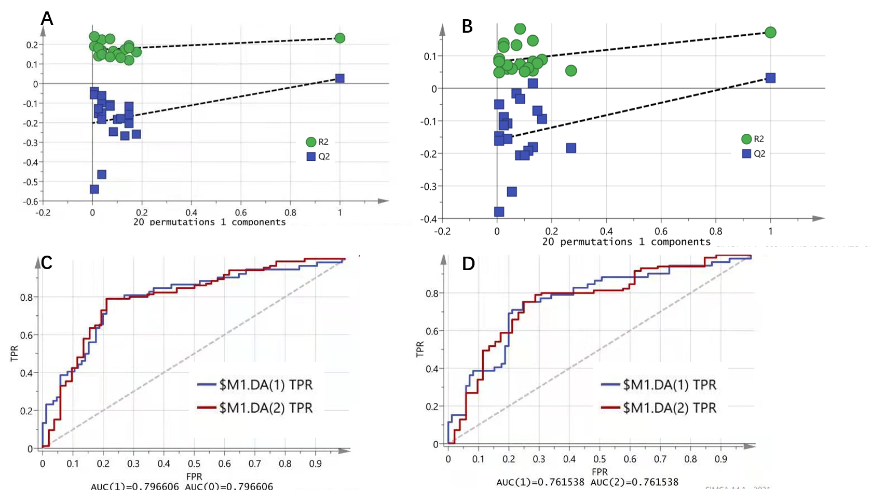

FIGURE 1 Validation of OPLS-DA analysis. (A) Permutation tests of OPLS-DA model analysis for frailty versus nonfrailty groups. (B) Permutation tests of OPLS-DA model analysis for frailty and sarcopenia (F&S) versus nonfrail and nonsarcopenic control. (C) The area under the curve (AUC) for separation of frailty and nonfrailty groups. (D) The area under the curve (AUC) for separation of frailty and sarcopenia (F&S) versus nonfrail and nonsarcopenic control.

