Supplementary material
- Figure S1
- Figure S2
- Figure S3
- Figure S4
- Supplementary method

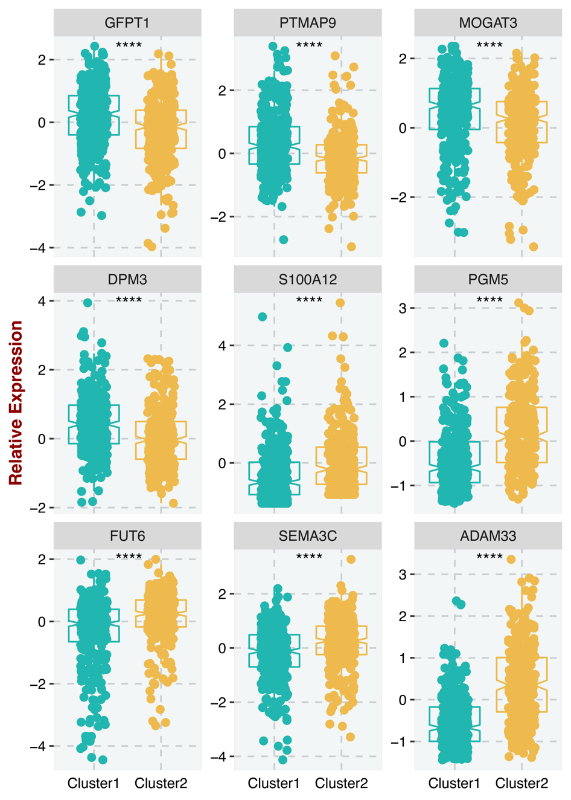
Figure S1. Distribution of nine key stemness predictor genes between two stemness clusters. ****P <0.0001.
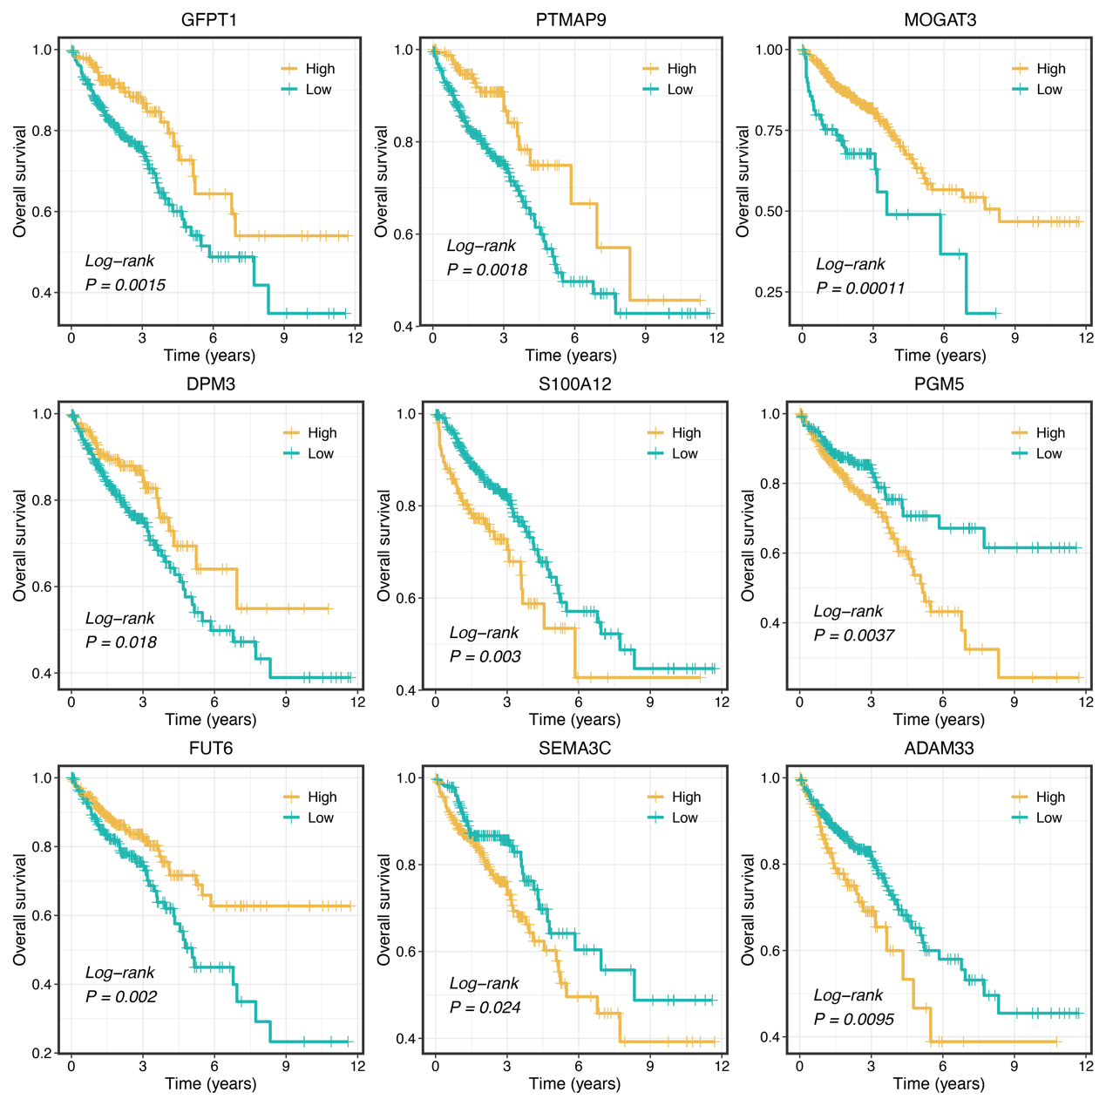
Figure S2. Kaplan-Meier curves of OS according to the nine key stemness predictor genes.

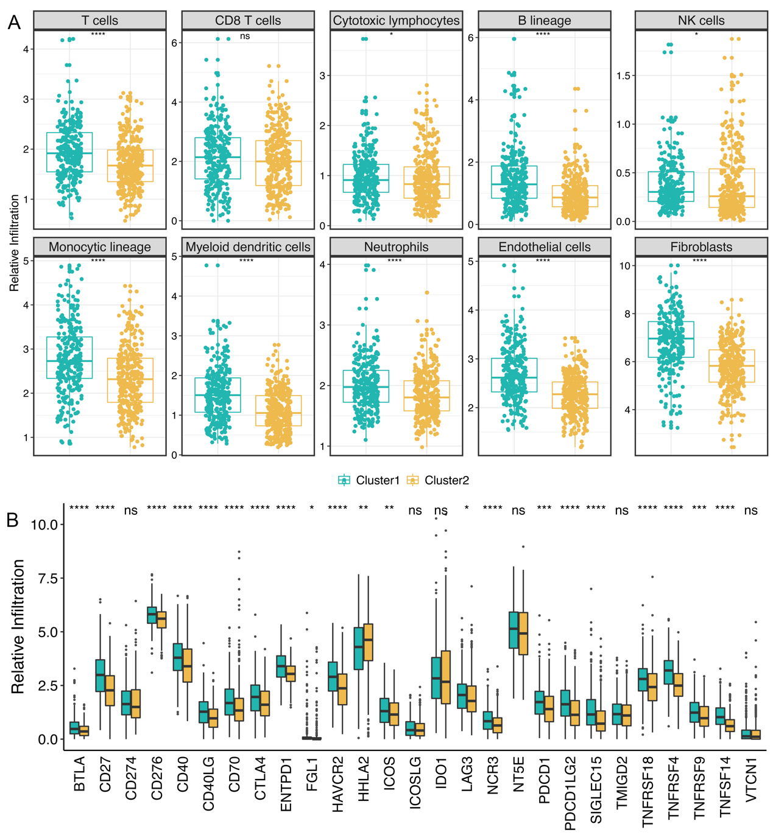
Figure S3. Distinct microenvironment patterns between two stemness clusters. A. Distributions of 12 immune and stromal cells between two clusters. B. Distributions of 27 immune checkpoint molecules between two clusters. ^{ns}P >0.05, *P <0.05, **P <0.01, ***P <0.001, ****P <0.0001.

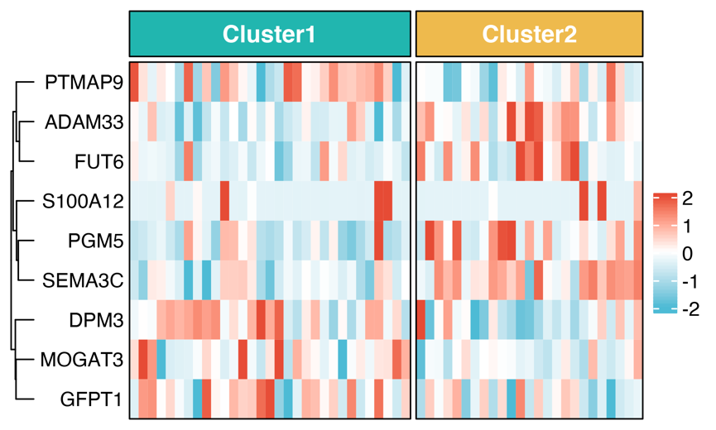
Figure S4. Using the stemness cluster predictor, CRC patients from GSE35640 were categorized into C1 or C2.

Supplementary method
Quantitative Real-Time PCR (qRT-PCR)
Total RNA was isolated from CRC tissues using RNAiso Plus reagent RNA quality was evaluated using a NanoDrop One C (Waltham, MA, USA), and RNA integrity was assessed using agarose gel electrophoresis. An aliquot of 1 μg of total RNA was reverse transcribed into complementary DNA (cDNA) according to the manufacturer's protocol using a High-Capacity cDNA Reverse Transcription kit (TaKaRa BIO, Japan). qRT-PCR was performed using SYBR Assay I Low ROX (Eurogentec, USA) and SYBR® Green PCR Master Mix (Yeason, Shanghai, China) to detect the expression of 16 lncRNAs expression. The expression value was normalized to GAPDH, and then log2 transformed for subsequent analysis. The primer sequences of the included nine genes and GAPDH were shown in Table S2.

