Supplementary Materials

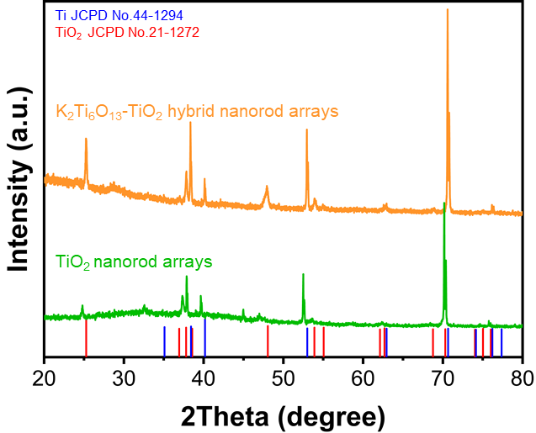

Supplementary Fig. 1 XRD pattern of K₂Ti₆O₁₃-TiO₂ hybrid nanorod arrays and TiO₂ nanotube arrays.

XRD was employed to characterize the crystalline structures of the resultant samples. All the diffraction peaks of the sample can be easily indexed to anatase TiO₂ and Ti, corresponding to JCPD cards #21-1272 and #44-1294, respectively. After hydrothermal treatment, although almost all of the peaks in the XRD image still belonged to TiO₂ and titanium, a very broad peak could be found at approximately 28°, which is the peak of K₂Ti₆O_{13.}

Supplementary Fig. 2 Immunofluorescence cell staining of stemness marker Nestin and DAPI. The mNSCs were cultured on culture plate.

Nestin immunofluorescence staining was used to assess the quality of NSCs. Almost all of the NSCs cultured on the culture plate were nestin-positive, indicating the high multi-differential potential of the isolated NSCs.

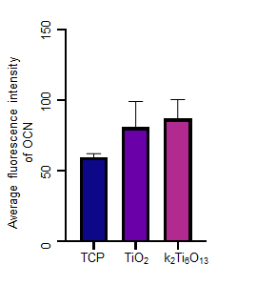
Supplementary Fig. 3 Statistical analysis of the average OCN fluorescence intensity using ImageJ software.

Supplementary Fig. 4 SEM image of mNSCs cultured on tissue culture plate for 7 d. The scale bar represents 15 μm. The cells cultured on tissue culture plates exhibited less extended axons and protrusions of dendritic filopodia.

Supplementary Table 1: Sequences of RT-PCR primers.
Gene | Forward primers (5’-3’) | Reverse primers (5’-3’)
β-actin | GGCTGTATTCCCCTCCATCG | CCAGTTGGTAACAATGCCATGT
Nestin | TGCCCTAGAGACGGTGTCTCA | AATCGCTTGACCTTCCTCCC
Tuj1 | TATGAAGATGATGACGAGGAATCG | TACAGAGGTGGCTAAAATGGGG
GFAP | CCAAGCCAAACACGAAGCTAA | CATTTGCCGCTCTAGGGACTC
MAP2 | GCCAGCCTCAGAACAAACAG | AAGGTCTTGGGAGGGAAGAAC

Gene | Forward primers (5’-3’) | Reverse primers (5’-3’)
GAPDH | GCCTCGTCTCATAGACAAGATGGT | GAAGGCAGCCCTGGTAACC
Runx2 | AATGCCTCCGCTGTTATG | TTCTGTCTGTGCCTTCTTG
OPN | TCCTGTCTCCCGGTGAAAGT | GGCTACAGCATCTGAGTGTTTGC
OCN | AAGCCCAGCGACTCTGAGTCT | CCGGAGTCTATTCACCACCTTACT
Supplementary Table 2: Sequences of RT-PCR primers.

Supplementary Movie 1. The NSCs, seeded on K₂Ti₆O₁₃-TiO₂ hybrid nanorod arrays for 7 days, are labeled with Fluo-4 AM, stimulated by GABA, and visualized using a confocal microscope.

Supplementary Movie 2. The NSCs, seeded on TCPs for 7 days, are labeled with Fluo-4 AM, stimulated by GABA, and visualized using a confocal microscope.

