Dynamic upper and lower airway microbiotas in paediatric bronchiectasis exacerbations: a pilot study
Online Supplement

Figure S1: Taxa plot of nasal samples showing the 15 ASVs with the highest average relative abundance across all samples
Figure S2: Taxa plot of sputum samples showing the 15 ASVs with the highest average relative abundance across all samples

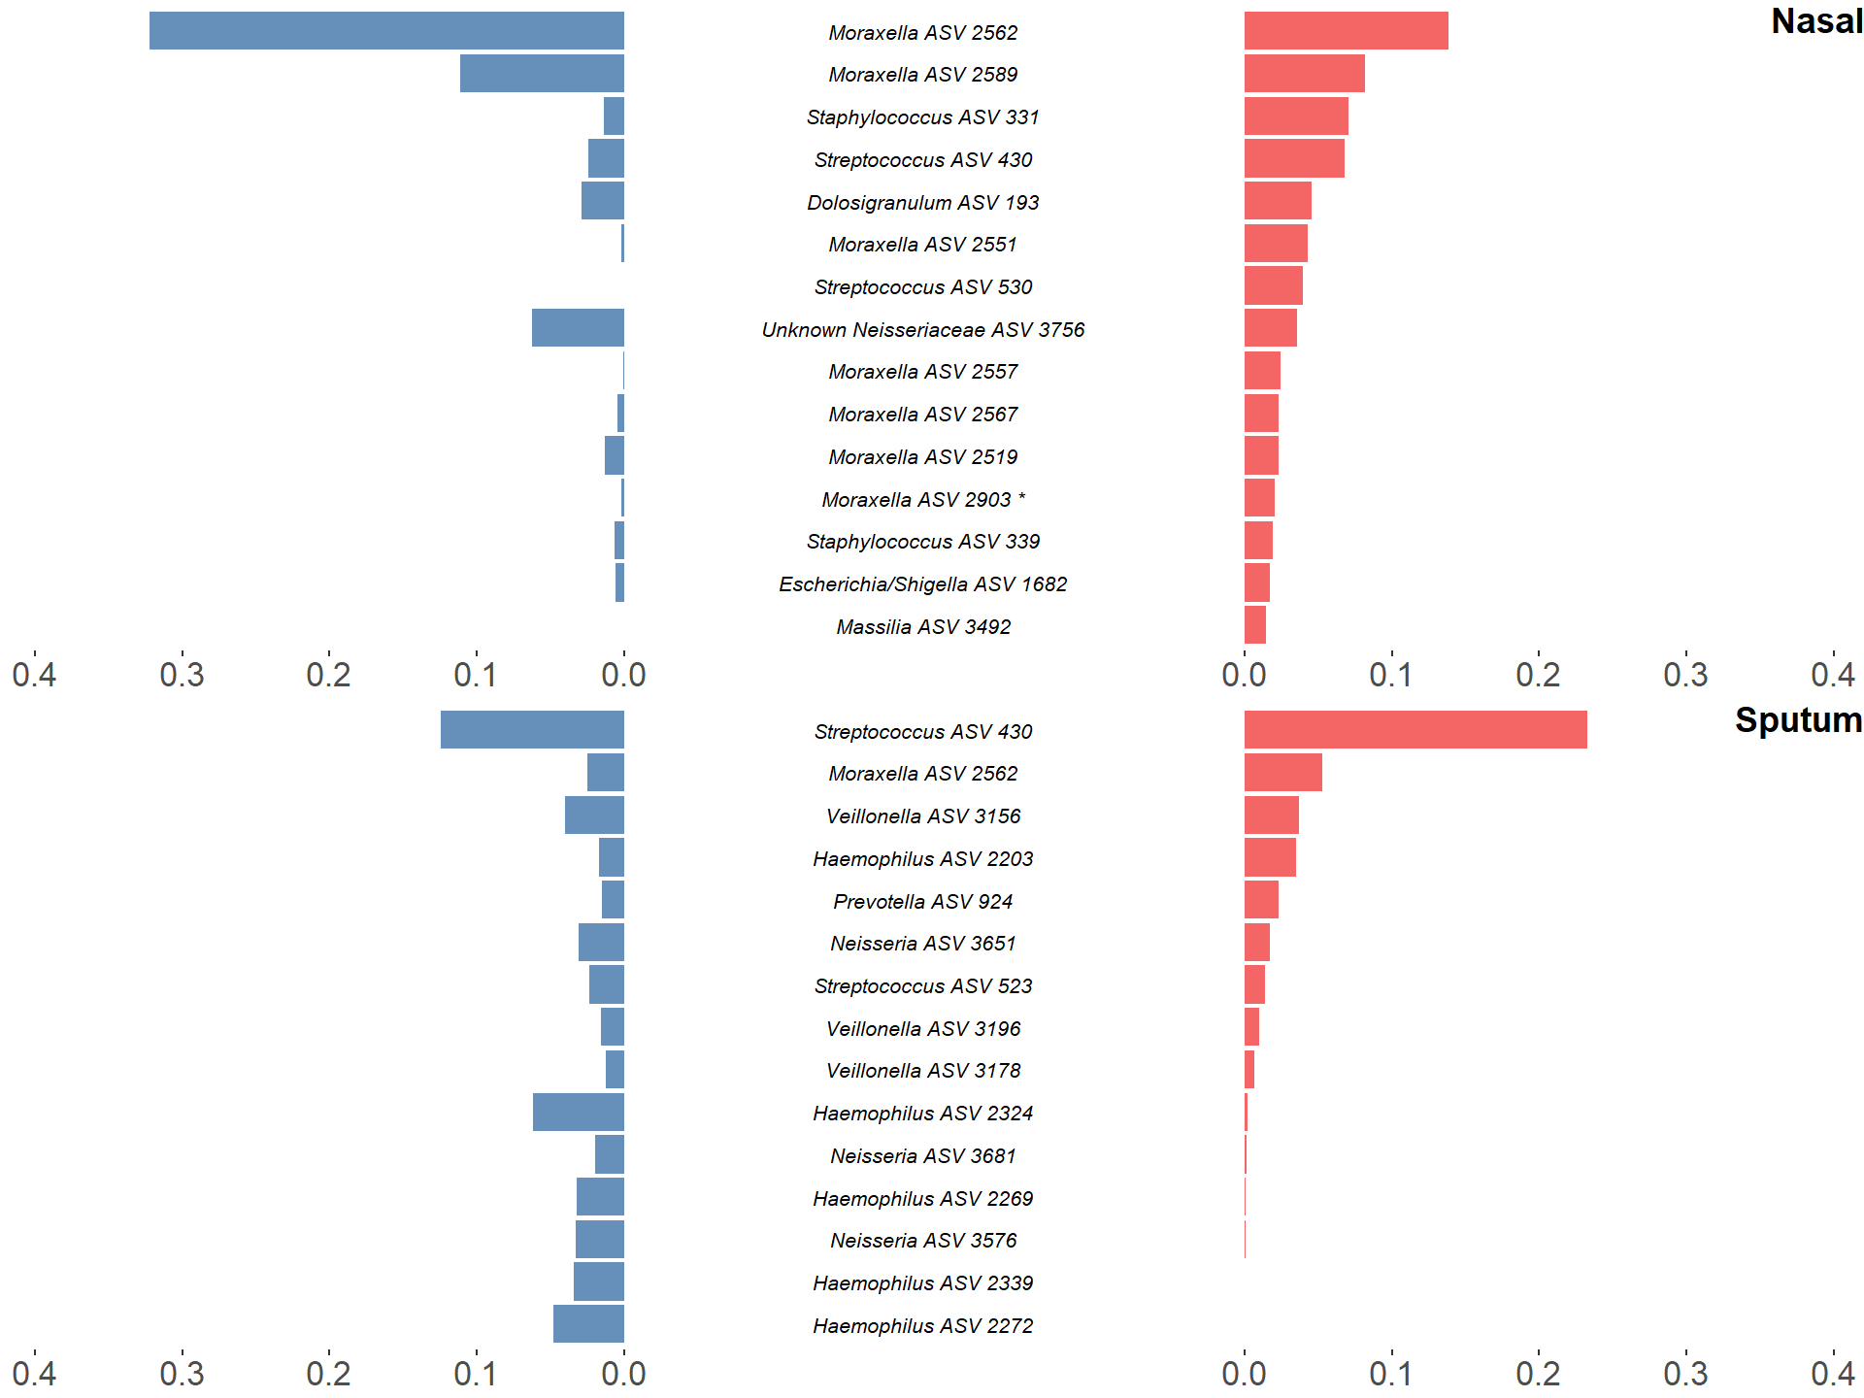
Before Treatment
After Treatment

*
*
*
Figure S3: Rank-abundance plots showing the 15 most abundant 16S rRNA gene amplicon sequence variants in paired samples from after treatment (red) and their respective abundance before treatment (blue). ASVs are ranked based on their relative sequence abundance after treatment. Taxonomic composition was altered in both sputum and nasal samples with a notable decrease of Haemophilus ASVs in sputum samples and Moraxella in nasal samples. Those ASVs which were identified as significantly differentially abundant by DESeq2 were marked by *. None of these particular ASVs were identified as differentially abundant by LEfSe.

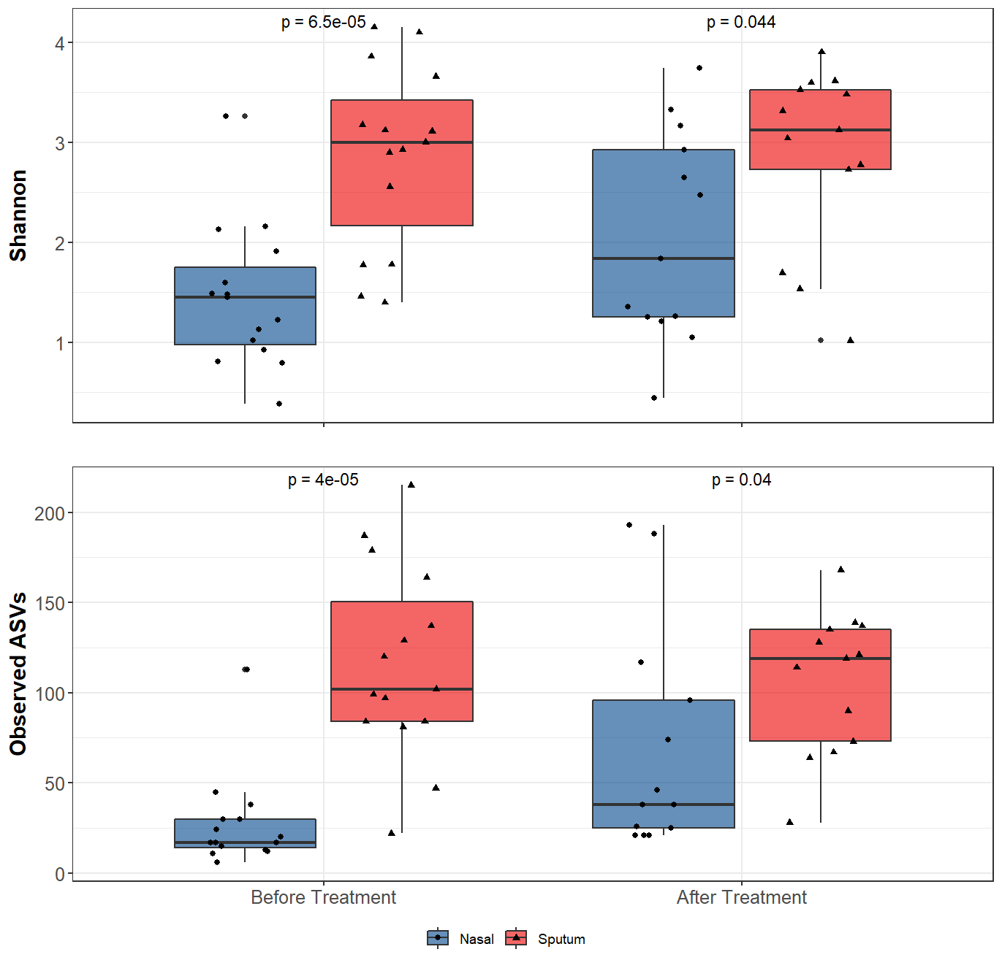
Figure S4: 16S rRNA gene-based bacterial alpha-diversity in paired sputum and nasal samples both before and after treatment for bronchiectasis exacerbation in paediatric patients. After assessing data for normality using the Shapiro-Wilks test, significance was calculated by using a paired t-test for the Shannon diversity metric and Wilcoxon rank-sum test for the observed number of ASVs.

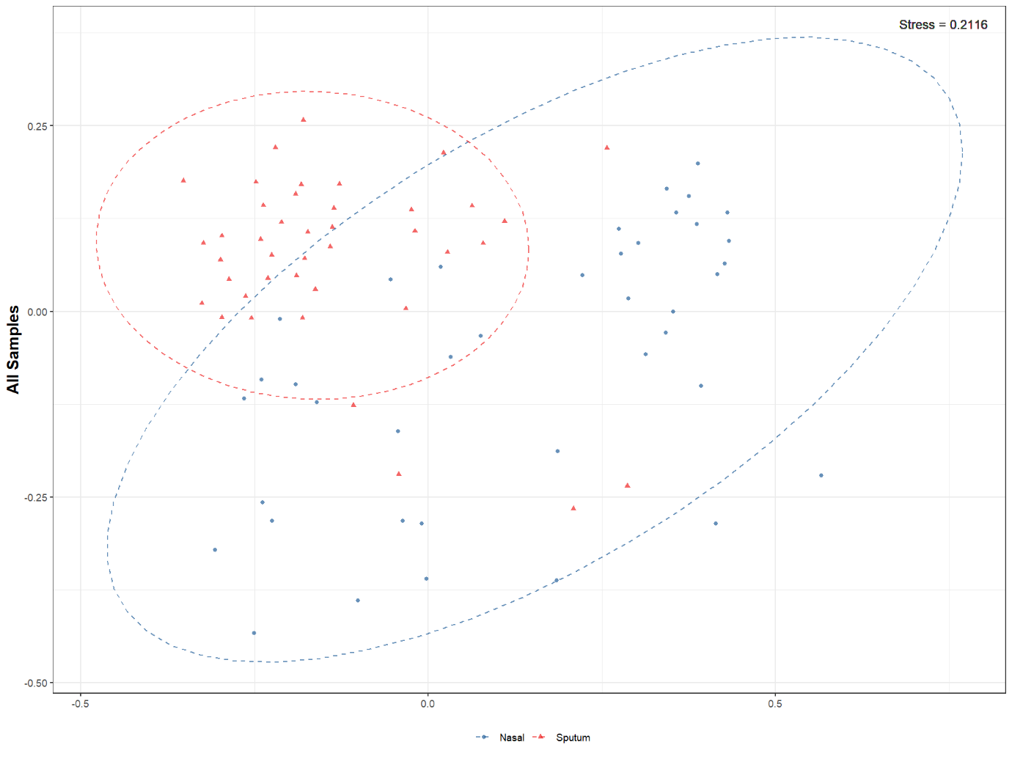
Figure S5: Non-metric multidimensional scaling plots of 16S rRNA gene-based beta-diversity using the Bray-Curtis metric for bacteria in nasal and sputum samples. The data shows bacterial community dispersion across sample site. The ellipses represent a confidence ellipse capturing 95% of the relevant data points.

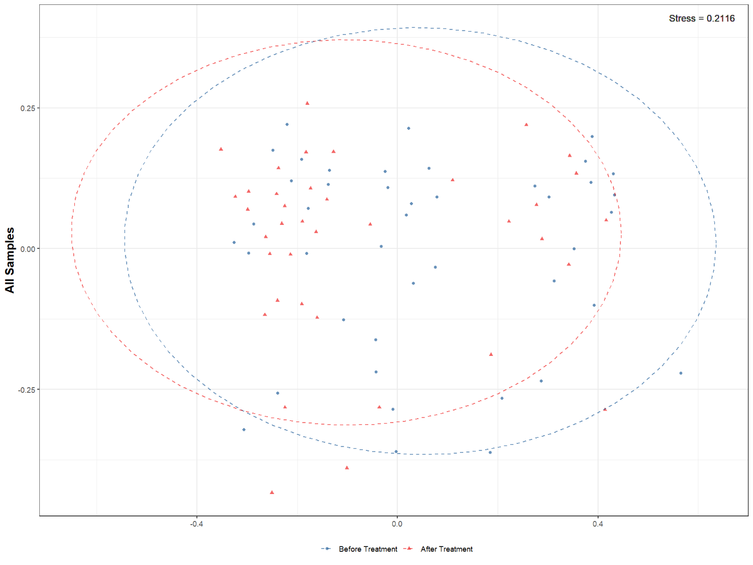
Figure S6: Non-metric multidimensional scaling plots of 16S rRNA gene-based beta-diversity using the Bray-Curtis metric for bacteria in nasal and sputum samples. There is no clear bacterial community separation across timepoint. The ellipses represent a confidence ellipse capturing 95% of the relevant data points.

Genus | Blank 1 | Blank 2 | Blank 3 | Blank 4 | Blank 5 | Blank 6 | Blank 7 | Blank 8 | Blank 9 | Blank 10
Unknown Alphaproteobacteria | 0 | 2 | 0 | 0 | 0 | 0 | 0 | 0 | 0 | 0
Lactobacillus | 0 | 0 | 0 | 0 | 4 | 0 | 0 | 0 | 0 | 0
Streptococcus | 0 | 0 | 0 | 0 | 0 | 0 | 37 | 0 | 0 | 0
Escherichia/Shigella | 0 | 0 | 0 | 0 | 0 | 0 | 308 | 8 | 5 | 0
Escherichia/Shigella | 0 | 0 | 0 | 0 | 0 | 0 | 5 | 0 | 0 | 0
Escherichia/Shigella | 7 | 0 | 0 | 0 | 0 | 0 | 0 | 0 | 0 | 0
Escherichia/Shigella | 0 | 0 | 0 | 0 | 0 | 0 | 7 | 0 | 0 | 0
Robinsoniella | 0 | 0 | 0 | 0 | 0 | 5 | 0 | 0 | 0 | 0
Tyzzerella | 0 | 0 | 0 | 0 | 0 | 0 | 69 | 0 | 0 | 0
Lachnoanaerobaculum | 8 | 0 | 0 | 0 | 0 | 0 | 0 | 0 | 0 | 0
Table S1: Raw count table of sequences derived from extraction blanks processed alongside samples.

Table S2 LefSE output for paired nasal samples across time
Taxa | Marker | p value
Haemophilus_ASV_2324 | Before Treatment | 0.003832
Haemophilus_ASV_2321 | Before Treatment | 0.017717
Rothia_ASV_1731 | After Treatment | 0.035248
Veillonella_ASV_3148 | After Treatment | 0.03519
Lactococcus_ASV_359 | After Treatment | 0.016594
Micrococcus_ASV_1590 | After Treatment | 0.016537
Veillonella_ASV_3144 | After Treatment | 0.040995
Subdoligranulum_ASV_3871 | After Treatment | 0.041077
Blautia_ASV_1954 | After Treatment | 0.046991
Staphylococcus_ASV_310 | After Treatment | 0.035248

Table S3 LefSE output for paired sputum samples across time
Taxa | Marker | p value
Saccharimonadaceae_TM7x_ASV_1435 | Before Treatment | 0.034494
Haemophilus_ASV_2304 | Before Treatment | 0.029615
Fusobacterium_ASV_2396 | Before Treatment | 0.015984
Fusobacterium_ASV_2418 | Before Treatment | 0.046159
Leptotrichia_ASV_2446 | Before Treatment | 0.021673
Capnocytophaga_ASV_756 | After Treatment | 0.047133
Actinomyces_ASV_1783 | After Treatment | 0.015887
Alloprevotella_ASV_1125 | After Treatment | 0.034494

Table S4: DESEq2 output for paired nasal samples across time
TaxaName | baseMean | log2FoldChange | lfcSE | stat | pvalue | padj
Staphylococcus_ASV_339 | 10.43603 | 4.246397 | 0.844312 | 5.029418 | 4.92E-07 | 6.84E-05
Haemophilus_ASV_2272 | 5.58357 | 2.729272 | 0.757602 | 3.602512 | 0.000315 | 0.021903
Moraxella_ASV_2903 | 3.80317 | -2.54004 | 0.761108 | -3.33729 | 0.000846 | 0.039197

Table S5: DESEq2 output for paired sputum samples across time
TaxaName | baseMean | log2FoldChange | lfcSE | stat | pvalue | padj
Haemophilus_ASV_2177 | 5.347449 | -2.51644 | 0.709413 | -3.54722 | 0.000389 | 0.02851
Streptobacillus_ASV_2467 | 3.734868 | 2.48089 | 0.713105 | 3.478998 | 0.000503 | 0.02851
Neisseria_ASV_3681 | 4.803994 | 2.795374 | 0.80449 | 3.474716 | 0.000511 | 0.02851
Neisseria_ASV_3809 | 5.031558 | 3.087448 | 0.808026 | 3.820978 | 0.000133 | 0.02851
Neisseria_ASV_3565 | 5.069385 | 2.597593 | 0.79194 | 3.280036 | 0.001038 | 0.046292

Table S6 LefSE output for paired samples before treatment
Taxa | Marker | p value
Moraxella_ASV_2562 | Nasal | 0.025811
Dolosigranulum_ASV_193 | Nasal | 7.47E-05
Suttonella_ASV_2766 | Nasal | 0.016594
Corynebacterium_ASV_1841 | Nasal | 0.000554
Streptococcus_ASV_431 | Sputum | 0.02706
Porphyromonas_ASV_1185 | Sputum | 0.007535
Fusobacterium_ASV_2425 | Sputum | 0.035248
Aggregatibacter_ASV_2225 | Sputum | 0.035248
Streptococcus_ASV_443 | Sputum | 0.018454
Veillonella_ASV_3148 | Sputum | 0.003188
Porphyromonas_ASV_1190 | Sputum | 0.003301
Neisseria_ASV_3593 | Sputum | 0.008797
Granulicatella_ASV_278 | Sputum | 0.002009
Prevotella_ASV_914 | Sputum | 0.03519
Neisseria_ASV_3606 | Sputum | 7.45E-05
Oribacterium_ASV_2023 | Sputum | 0.003282
Granulicatella_ASV_263 | Sputum | 0.017633
Neisseria_ASV_3651 | Sputum | 0.000179
Streptococcus_ASV_416 | Sputum | 0.006133
Haemophilus_ASV_2293 | Sputum | 0.016594
Alloprevotella_ASV_809 | Sputum | 0.007562
Streptococcus_ASV_511 | Sputum | 0.035248
Prevotella_ASV_1097 | Sputum | 0.001378
Porphyromonas_ASV_1177 | Sputum | 0.001389
Bergeyella_ASV_690 | Sputum | 0.035131
Veillonella_ASV_3170 | Sputum | 0.000551
Bergeyella_ASV_705 | Sputum | 0.035767
Fusobacterium_ASV_2381 | Sputum | 7.47E-05
Prevotella_ASV_1274 | Sputum | 0.007548
Streptococcus_ASV_436 | Sputum | 0.010906
Streptobacillus_ASV_2479 | Sputum | 0.02518
Lautropia_ASV_3442 | Sputum | 8.06E-05
Streptococcus_ASV_552 | Sputum | 0.017443
Haemophilus_ASV_2290 | Sputum | 0.009721
Porphyromonas_ASV_1187 | Sputum | 0.001403
Campylobacter_ASV_95 | Sputum | 0.000195
Catonella_ASV_3855 | Sputum | 0.03519
Absconditabacteriales__SR1__Unknown_Unknown_ASV_3320 | Sputum | 0.03519
Veillonella_ASV_3099 | Sputum | 0.001553
Streptococcus_ASV_548 | Sputum | 0.006041
Prevotella_ASV_928 | Sputum | 0.035248
Veillonella_ASV_3167 | Sputum | 0.03519
Lachnospiraceae_Unknown_ASV_2734 | Sputum | 0.01648
Megasphaera_ASV_3237 | Sputum | 0.035248
Streptobacillus_ASV_2435 | Sputum | 0.035248
Haemophilus_ASV_2220 | Sputum | 0.016594
Neisseria_ASV_3611 | Sputum | 0.035248
Haemophilus_ASV_2203 | Sputum | 2.18E-05
Leptotrichia_ASV_2838 | Sputum | 0.03519
Veillonella_ASV_3196 | Sputum | 0.000222
Streptococcus_ASV_509 | Sputum | 0.015337
Prevotella_ASV_1008 | Sputum | 0.007453
Alloprevotella_ASV_1126 | Sputum | 0.000554
Veillonella_ASV_3089 | Sputum | 0.03519
Porphyromonas_ASV_1191 | Sputum | 0.02518
Streptococcus_ASV_469 | Sputum | 0.02906
Haemophilus_ASV_2304 | Sputum | 0.000554
Streptococcus_ASV_523 | Sputum | 0.000793
Streptobacillus_ASV_2467 | Sputum | 0.035248
Veillonella_ASV_3178 | Sputum | 0.004884
Prevotella_ASV_924 | Sputum | 0.000114
Veillonella_ASV_3092 | Sputum | 0.003308
Haemophilus_ASV_2178 | Sputum | 0.035248
Haemophilus_ASV_2267 | Sputum | 0.007535
Haemophilus_ASV_2191 | Sputum | 0.035248
Streptococcus_ASV_415 | Sputum | 0.003265
Porphyromonas_ASV_1180 | Sputum | 0.000376
Haemophilus_ASV_2180 | Sputum | 0.015318
Haemophilus_ASV_2175 | Sputum | 0.000209
Haemophilus_ASV_2076 | Sputum | 0.016566
Alloprevotella_ASV_956 | Sputum | 0.007548
Neisseria_ASV_3600 | Sputum | 0.03519
Haemophilus_ASV_2337 | Sputum | 0.000483
Prevotella_ASV_1110 | Sputum | 0.004473
Streptococcus_ASV_521 | Sputum | 0.001945
Absconditabacteriales__SR1__Unknown_Unknown_ASV_3312 | Sputum | 0.016594
Fusobacterium_ASV_2396 | Sputum | 0.003295
Actinomyces_ASV_1619 | Sputum | 0.03519
Neisseria_ASV_3627 | Sputum | 0.000209
Neisseria_ASV_3613 | Sputum | 0.007562
Streptobacillus_ASV_2459 | Sputum | 0.03519
Campylobacter_ASV_88 | Sputum | 0.03519
Abiotrophia_ASV_273 | Sputum | 0.011277
Prevotella_ASV_1006 | Sputum | 0.007535
Prevotella_ASV_1248 | Sputum | 0.016594
Porphyromonas_ASV_1280 | Sputum | 0.035248
Leptotrichia_ASV_2860 | Sputum | 0.003308
Prevotella_ASV_1060 | Sputum | 0.016566
Neisseria_ASV_3587 | Sputum | 0.007562
Veillonella_ASV_3168 | Sputum | 0.003308
Johnsonella_ASV_2733 | Sputum | 0.035248
Fusobacterium_ASV_2418 | Sputum | 0.001383
Streptococcus_ASV_450 | Sputum | 0.00269
Porphyromonas_ASV_1282 | Sputum | 0.007562
Prevotella_ASV_1063 | Sputum | 0.035248
Rothia_ASV_1741 | Sputum | 0.035248
Gemella_ASV_303 | Sputum | 0.002922
Fusobacterium_ASV_2399 | Sputum | 0.007548
Prevotella_ASV_1247 | Sputum | 0.03519
Veillonella_ASV_3164 | Sputum | 0.003314
Veillonella_ASV_3156 | Sputum | 0.000216
Leptotrichia_ASV_2446 | Sputum | 0.007548
Streptococcus_ASV_430 | Sputum | 0.000344
Gemella_ASV_298 | Sputum | 0.026998
Veillonella_ASV_3191 | Sputum | 0.035248
Prevotella_ASV_1104 | Sputum | 0.016566
Porphyromonas_ASV_1199 | Sputum | 0.007548
Streptococcus_ASV_504 | Sputum | 0.001849

Table S7 LefSE output for paired samples after treatment
Taxa | Marker | p value
Corynebacterium_ASV_1858 | Nasal | 0.033775
Staphylococcus_ASV_322 | Nasal | 0.033698
Dolosigranulum_ASV_193 | Nasal | 0.002818
Neisseriaceae_Unknown_ASV_3756 | Nasal | 0.033775
Staphylococcus_ASV_331 | Nasal | 0.000411
Cutibacterium_ASV_1886 | Nasal | 0.002818
Helcococcus_ASV_3399 | Nasal | 0.033775
Streptococcus_ASV_431 | Sputum | 0.010266
Porphyromonas_ASV_1185 | Sputum | 0.033698
Kingella_ASV_3691 | Sputum | 0.048782
Streptococcus_ASV_443 | Sputum | 0.007367
Capnocytophaga_ASV_734 | Sputum | 0.033775
Veillonella_ASV_3148 | Sputum | 0.031327
Porphyromonas_ASV_1190 | Sputum | 0.045202
Oribacterium_ASV_2023 | Sputum | 0.045142
Streptococcus_ASV_449 | Sputum | 0.006726
Neisseria_ASV_3651 | Sputum | 0.015145
Streptococcus_ASV_416 | Sputum | 0.022014
Prevotella_ASV_1007 | Sputum | 0.033775
Capnocytophaga_ASV_1412 | Sputum | 0.015432
Leptotrichia_ASV_2792 | Sputum | 0.015395
Stomatobaculum_ASV_2014 | Sputum | 0.033467
Prevotella_ASV_1097 | Sputum | 0.013199
Porphyromonas_ASV_1177 | Sputum | 0.015432
Streptococcus_ASV_435 | Sputum | 0.015284
Veillonella_ASV_3170 | Sputum | 0.006744
Veillonella_ASV_3133 | Sputum | 0.00307
Atopobium_ASV_3328 | Sputum | 0.033621
Fusobacterium_ASV_2381 | Sputum | 0.014406
Prevotella_ASV_1274 | Sputum | 0.015432
Streptococcus_ASV_436 | Sputum | 0.033557
Lautropia_ASV_3442 | Sputum | 0.017459
Capnocytophaga_ASV_1411 | Sputum | 0.033698
Streptococcus_ASV_544 | Sputum | 0.001104
Streptococcus_ASV_432 | Sputum | 0.001107
Porphyromonas_ASV_1187 | Sputum | 0.01296
Cardiobacterium_ASV_2895 | Sputum | 0.015395
Campylobacter_ASV_95 | Sputum | 0.000937
Streptococcus_ASV_548 | Sputum | 0.005699
Prevotella_ASV_928 | Sputum | 0.033698
Haemophilus_ASV_2203 | Sputum | 0.012834
Veillonella_ASV_3196 | Sputum | 0.003737
Streptococcus_ASV_509 | Sputum | 0.000141
Streptococcus_ASV_469. | Sputum | 0.002811
Lautropia_ASV_3450 | Sputum | 0.01869
Veillonella_ASV_3178 | Sputum | 0.002735
Prevotella_ASV_924 | Sputum | 0.000193
Streptococcus_ASV_415 | Sputum | 0.015315
Capnocytophaga_ASV_1398 | Sputum | 0.033698
Porphyromonas_ASV_1180 | Sputum | 0.019157
Haemophilus_ASV_2180 | Sputum | 0.006744
Prevotella_ASV_1116 | Sputum | 0.006744
Neisseria_ASV_3692 | Sputum | 0.015284
Prevotella_ASV_1110 | Sputum | 0.003729
Streptococcus_ASV_521 | Sputum | 0.017846
Streptococcus_ASV_461 | Sputum | 0.006726
Neisseria_ASV_3627 | Sputum | 0.011092
Prevotella_ASV_1060 | Sputum | 0.033698
Capnocytophaga_ASV_1400 | Sputum | 0.033775
Streptococcus_ASV_450 | Sputum | 0.003359
Porphyromonas_ASV_1282 | Sputum | 0.015395
Fusobacterium_ASV_2399 | Sputum | 0.015432
Veillonella_ASV_3156 | Sputum | 0.003058
Streptococcus_ASV_505 | Sputum | 0.038654
Veillonella_ASV_3191 | Sputum | 0.033775
Porphyromonas_ASV_1199 | Sputum | 0.015432
Streptococcus_ASV_504 | Sputum | 0.023215

Table S8: DESEq2 output for paired before treatment samples
Taxa | baseMean | log2FoldChange | lfcSE | stat | pvalue | padj
Moraxella_ASV_2903 | 7.209665 | -3.56471 | 0.836973 | -4.25905 | 2.05E-05 | 0.002546
Staphylococcus_ASV_339 | 3.424511 | 2.576535 | 0.774343 | 3.327382 | 0.000877 | 0.023113
Corynebacterium_ASV_1841 | 25.82289 | -3.00432 | 0.893632 | -3.36193 | 0.000774 | 0.023113
Corynebacterium_ASV_1843 | 3.555116 | 2.52358 | 0.737163 | 3.423368 | 0.000619 | 0.023113
Neisseria_ASV_3681 | 4.579686 | 2.553966 | 0.771522 | 3.310294 | 0.000932 | 0.023113
Streptococcus_ASV_415 | 5.19538 | -1.92015 | 0.658311 | -2.91679 | 0.003537 | 0.043853
Ornithobacterium_ASV_702 | 2.787584 | -2.22157 | 0.735138 | -3.02198 | 0.002511 | 0.043853
Haemophilus_ASV_2175 | 3.181487 | -1.8225 | 0.624264 | -2.91943 | 0.003507 | 0.043853
Haemophilus_ASV_2272 | 4.756797 | 2.150555 | 0.734914 | 2.926266 | 0.003431 | 0.043853
Veillonella_ASV_3128 | 3.573013 | -2.03292 | 0.668299 | -3.04193 | 0.002351 | 0.043853
Porphyromonas_ASV_1199 | 2.876047 | 1.830613 | 0.642329 | 2.84996 | 0.004372 | 0.04929

Table S9: DESEq2 output for paired after treatment samples
TaxaName | baseMean | log2FoldChange | lfcSE | stat | pvalue | padj
Neisseria_ASV_3627 | 52.79287 | 5.100054 | 0.992616 | 5.137996 | 2.78E-07 | 5.86E-05
Veillonella_ASV_3133 | 9.881152 | 3.255925 | 0.798898 | 4.075521 | 4.59E-05 | 0.003229
Veillonella_ASV_3156 | 69.94568 | 3.873054 | 0.931709 | 4.156933 | 3.23E-05 | 0.003229
Dolosigranulum_ASV_193 | 18.49213 | 3.575422 | 0.942982 | 3.79161 | 0.00015 | 0.005698
Streptococcus_ASV_521 | 6.783653 | 2.793027 | 0.724992 | 3.852491 | 0.000117 | 0.005698
Veillonella_ASV_3196 | 14.86331 | 3.194281 | 0.846872 | 3.771858 | 0.000162 | 0.005698
Staphylococcus_ASV_331 | 12.83951 | -3.19251 | 0.857935 | -3.72116 | 0.000198 | 0.005978
Streptococcus_ASV_432 | 4.431063 | 2.432311 | 0.681038 | 3.571478 | 0.000355 | 0.008322
Cutibacterium_ASV_1886 | 4.205838 | -2.67104 | 0.743254 | -3.5937 | 0.000326 | 0.008322
Campylobacter_ASV_95 | 4.885859 | 2.237695 | 0.642403 | 3.483323 | 0.000495 | 0.010449
Streptococcus_ASV_509 | 3.701889 | 2.225804 | 0.657829 | 3.383559 | 0.000716 | 0.013046
Rothia_ASV_1730 | 3.77848 | 2.490259 | 0.73855 | 3.371821 | 0.000747 | 0.013046
Veillonella_ASV_3178 | 9.787428 | 2.602944 | 0.776653 | 3.351488 | 0.000804 | 0.013046
Moraxella_ASV_2643 | 3.59697 | 2.531421 | 0.767763 | 3.297137 | 0.000977 | 0.014721
Veillonella_ASV_3170 | 3.77813 | 2.373117 | 0.747645 | 3.174123 | 0.001503 | 0.021141
Hydrogenophilus_ASV_3365 | 3.428754 | -2.45174 | 0.781824 | -3.13592 | 0.001713 | 0.022592
Prevotella_ASV_924 | 26.83812 | 2.779433 | 0.893411 | 3.111036 | 0.001864 | 0.02314
Leptotrichia_ASV_2851 | 3.331533 | 2.402077 | 0.785822 | 3.056768 | 0.002237 | 0.026227
Micrococcus_ASV_1766 | 2.720239 | -2.0493 | 0.695643 | -2.9459 | 0.00322 | 0.03576
Lautropia_ASV_3442 | 32.36676 | 2.659839 | 0.921297 | 2.88706 | 0.003889 | 0.041025
Streptococcus_ASV_450 | 5.449457 | 1.919544 | 0.67126 | 2.859615 | 0.004242 | 0.042618
Haemophilus_ASV_2180 | 4.362166 | 2.122551 | 0.757948 | 2.800392 | 0.005104 | 0.048953

