Supplementary Material

Supplementary Tables
Supplementary Table 1. Metabolomics Changes in plasma in 1050 mg/kg choline group, 1850 mg/kg choline group, and 2650 mg/kg choline group
Metabolites | m/z | Rt (s) | 1850 mg/kg vs 1050 mg/kg |  |  | 2650 mg/kg vs 1050 mg/kg |  |  | 1850 mg/kg vs 2650 mg/kg
 |  |  | VIP | Change | t-test | VIP | Change | t-test | VIP | Change | t-test
Pro-Val | 214.13 | 323 |  |  |  |  |  |  | 4.80 | ↑ | 0.024
Dihydrouracil | 302.80 | 173 |  |  |  |  |  |  | 2.82 | ↑ | 0.049
5,6,7,8-tetrahydro-2-Naphthoic Acid | 254.83 | 157 |  |  |  | 1.22 | ↓ | 0.037 | 1.14 | ↑ | 0.007
L-Carnosine | 227.11 | 332 |  |  |  |  |  |  | 1.73 | ↑ | 0.012
L-Arabinono-1,4-lactone | 45.90 | 169 |  |  |  |  |  |  | 1.26 | ↑ | 0.048
Retinol (Vitamin A) | 286.23 | 34 | 2.62 | ↑ | 0.021 |  |  |  | 2.81 | ↑ | 0.016
Cholic acid | 373.27 | 197 | 2.03 | ↑ | 0.020 |  |  |  | 1.05 | ↑ | 0.005
Val-Tyr | 280.14 | 325 |  |  |  |  |  |  | 3.27 | ↑ | 0.034
Diethyltoluamide | 192.14 | 34 |  |  |  | 2.27 | ↓ | 0.007 | 2.66 | ↑ | 0.003
PC (16:0/16:0) | 756.55 | 48 |  |  |  |  |  |  | 5.17 | ↑ | 0.035
Phthalic acid Mono-2-ethylhexyl Ester | 279.16 | 32 | 4.66 | ↑ | 0.082 |  |  |  | 7.58 | ↑ | 0.020
2-Oxoadipic acid | 348.17 | 141 | 7.59 | ↑ | 0.027 | 1.22 | ↑ | 0.037 | 7.46 | ↑ | 0.050
Diethanolamine | 70.07 | 306 | 3.63 | ↑ | 0.018 | 4.83 | ↑ | 0.004 | 4.38 | ↓ | 0.072
L-Proline | 116.07 | 306 | 5.27 | ↑ | 0.026 | 7.82 | ↑ | 0.003 | 6.35 | ↓ | 0.064
D-Threitol | 290.15 | 181 |  |  |  |  |  |  | 1.00 | ↓ | 0.016
Pantothenate | 220.12 | 264 |  |  |  |  |  |  | 1.18 | ↓ | 0.011
Arg-Ala | 245.15 | 295 |  |  |  | 1.61 | ↑ | 0.015 | 2.04 | ↓ | 0.023
L-Histidine | 373.34 | 154 |  |  |  | 2.07 | ↑ | 0.091 | 2.20 | ↓ | 0.047
Mevalonic acid | 73.48 | 129 |  |  |  | 12.14 | ↑ | 0.079 | 8.93 | ↓ | 0.026
Ergothioneine | 230.09 | 321 | 2.22 | ↓ | 0.046 |  |  |  | 1.94 | ↓ | 0.065
Trimethylamine N-oxide | 76.07 | 320 | 8.29 | ↑ | 0.004 | 12.74 | ↑ | 0.001 | 10.23 | ↓ | 0.036
His-Gly | 213.10 | 135 |  |  |  | 1.02 | ↑ | 0.037
Leu-Leu | 245.18 | 184 | 1.51 | ↑ | 0.003 | 1.32 | ↑ | 0.001
1-Aminocyclopropanecarboxylic acid | 102.05 | 346 | 1.01 | ↑ | 0.007 | 1.25 | ↑ | 0.000
3-Methoxy-4-Hydroxyphenylglycol Sulfate | 42.58 | 263 |  |  |  | 1.86 | ↑ | 0.004
L-Tryptophan | 205.10 | 252 |  |  |  | 4.89 | ↑ | 0.045
N6, N6, N6-Trimethyl-L-lysine | 189.16 | 529 | 2.49 | ↑ | 0.005 | 2.07 | ↑ | 0.004
Tyramine | 120.08 | 251 | 8.37 | ↑ | 0.009 | 8.54 | ↑ | 0.004
Guanidoacetic acid | 118.06 | 251 |  |  |  | 1.31 | ↑ | 0.016
Dopamine | 136.07 | 294 | 1.84 | ↑ | 0.043 | 2.14 | ↑ | 0.003
L-Phenylalanine | 166.09 | 251 | 5.46 | ↑ | 0.023 | 6.06 | ↑ | 0.004
L-Tyrosine | 182.08 | 294 | 2.28 | ↑ | 0.060 | 2.75 | ↑ | 0.003
trans-2-Hydroxycinnamic acid | 165.05 | 294 | 1.85 | ↑ | 0.049 | 2.04 | ↑ | 0.006
DL-O-tyrosine | 146.06 | 252 |  |  |  | 1.41 | ↑ | 0.031
DL-Indole-3-lactic acid | 188.07 | 252 |  |  |  | 5.55 | ↑ | 0.048
L-Leucine | 253.00 | 130 |  |  |  | 4.82 | ↑ | 0.022
L-Methionine | 150.06 | 277 |  |  |  | 1.16 | ↑ | 0.042
L-Valine | 289.64 | 116 |  |  |  | 2.13 | ↑ | 0.024
L-Pyroglutamic acid | 130.05 | 363 |  |  |  | 3.50 | ↑ | 0.020
Hypoxanthine | 137.04 | 166 |  |  |  | 5.48 | ↓ | 0.040
1-Methylhistidine | 170.09 | 384 | 7.00 | ↓ | 0.052 | 7.22 | ↓ | 0.030
Triethanolamine | 150.11 | 165 | 4.85 | ↓ | 0.003 | 5.14 | ↓ | 0.007
N6-methyladenosine | 282.12 | 131 |  |  |  | 1.33 | ↓ | 0.038
His-Ser | 243.11 | 348 | 1.14 | ↑ | 0.047
Indole-2-carboxylic acid | 162.05 | 43 | 2.46 | ↑ | 0.049
Stearic acid | 42.53 | 283 | 7.60 | ↑ | 0.029
m/z, mass-to-charge ratio; VIP, variable importance in the projection; Rt, Retention time; Changes with “↑/↓” means increased/decreased after adding choline in diet. “-” means the level of metabolites shows no difference with the control
Supplementary Table 2. The relative abundances of nine phyla (%, >1% in at least one sample) and firmicutes/bacteroidetes ratio in 1050 mg/kg choline group, 1850 mg/kg choline group, and 2650 mg/kg choline group
Item | dietary choline level, mg/kg
 | 1050 | 1850 | 2650 | SEM | P-value
d 30
Firmicutes | 82.38 | 82.01 | 79.38 | 3.231 | 0.766
Proteobacteria | 5.58ª | 2.97^{ab} | 1.76^{b} | 1.107 | 0.041
Actinobacteria | 0.28^{b} | 0.28^{b} | 0.80ª | 0.169 | 0.040
Bacteroidetes | 7.23 | 11.26 | 7.81 | 2.852 | 0.871
Cyanobacteria | 0.04 | 0.02 | 0.13 | 0.058 | 0.722
Euryarchaeota | 1.41 | 0.73 | 1.73 | 0.671 | 0.910
Tenericutes | 1.57 | 1.63 | 1.33 | 0.320 | 0.523
Spirochaetes | 0.81 | 0.69 | 0.97 | 0.351 | 0.898
Melainabacteria | 0.16 | 0.16 | 0.26 | 0.058 | 0.534
d 110
Firmicutes | 74.21 | 57.83 | 58.89 | 5.240 | 0.099
Proteobacteria | 6.70 | 25.28 | 13.86 | 5.201 | 0.062
Actinobacteria | 0.50 | 0.47 | 8.72 | 2.010 | 0.054
Bacteroidetes | 7.84 | 10.35 | 12.09 | 2.712 | 0.379
Cyanobacteria | 0.02 | 0.09 | 0.08 | 0.028 | 0.222
Euryarchaeota | 0.27 | 1.38 | 1.26 | 0.518 | 0.062
Tenericutes | 2.50 | 2.35 | 1.66 | 0.486 | 0.526
Spirochaetes | 0.42 | 0.74 | 0.60 | 0.304 | 0.719
Melainabacteria | 0.14 | 0.10 | 0.14 | 0.034 | 0.912

2 Supplementary Figures
Supplementary Figure 1
(A)
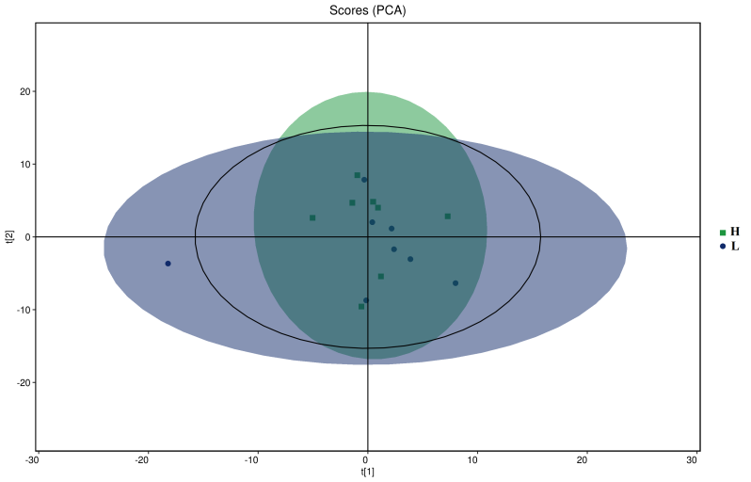
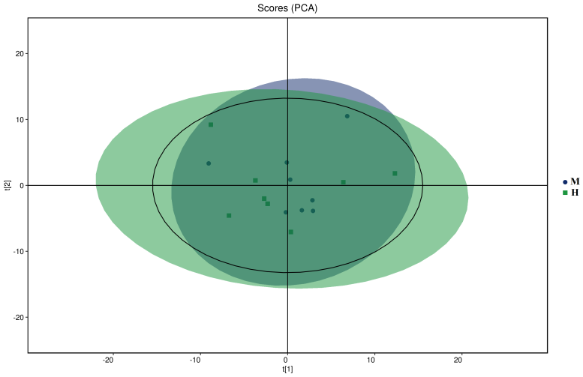
(B)
(C)
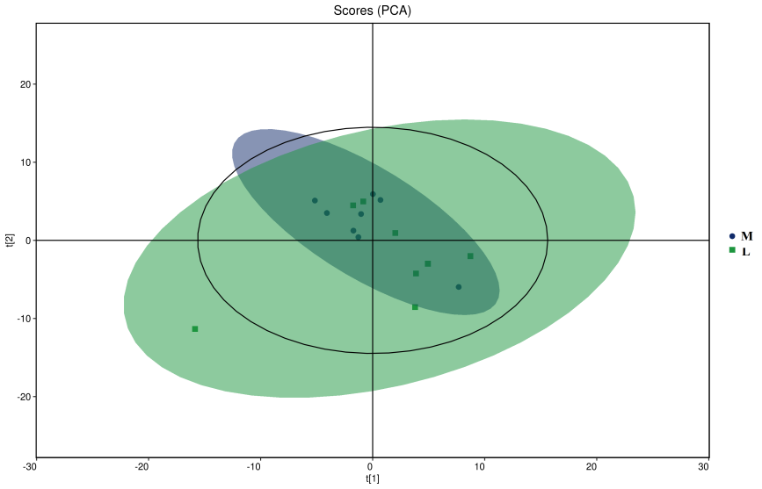
Supplementary Figure 2
(A)
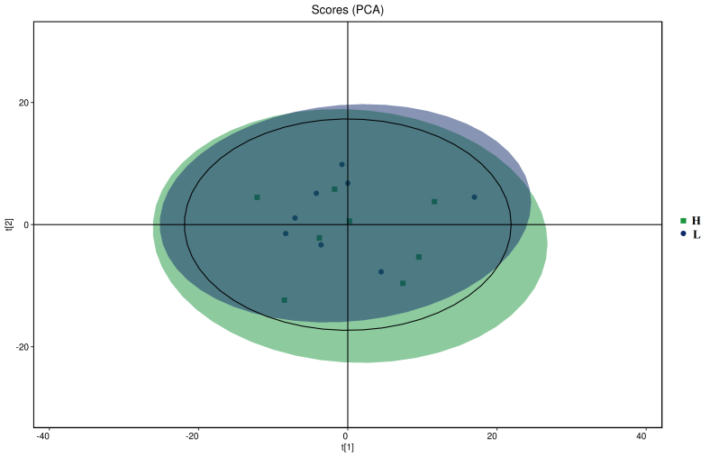
(B)
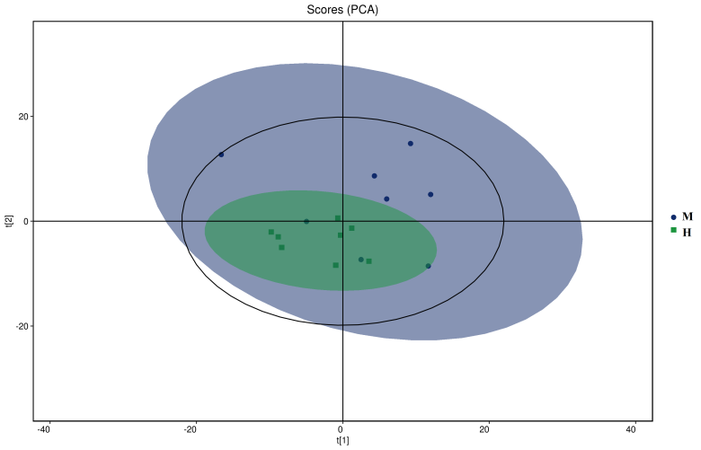
(C)
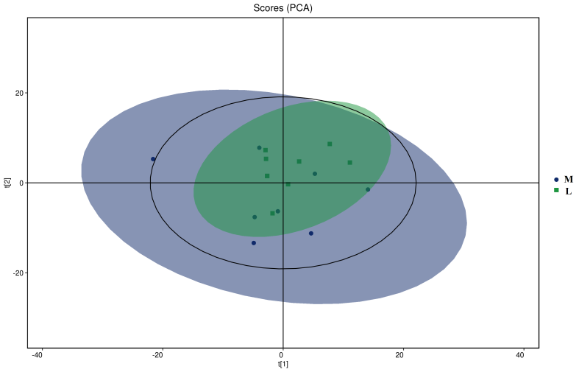

Supplementary Figure 1. PCA scores plot in ESI+ metabolomics profiles of plasma. t[1] = first principal component. t[2] = second principal component. L = 1050 mg/kg choline group; M = 1850 mg/kg choline group; H = 2650 mg/kg choline group.
Supplementary Figure 2. PCA scores plot in ESI－metabolomics profiles of plasma. t[1] = first principal component. t[2] = second principal component. L = 1050 mg/kg choline group; M = 1850 mg/kg choline group; H = 2650 mg/kg choline group.

