SUPPLEMENTARY MATERIAL

Study of the apoptotic effect of pure oleocanthal on PBMC cells isolated from one patient that participated in the trial
Methods
The PMBC cells were isolated according to the manufacturer`s instructions (Histopaque 1077, Sigma, Aldrich Company Ltd, Dorset, UK). Using the Viability/Cytotoxicity Assay (Biotium Fremont, CA USA) non cytotoxic dose of oleocanthal was founded (25μM).
PMBC cells from CLL patient was treated for 48 hr with 25μM of oleocanthal or 0 μM of oleocanthal (as a negative marker). After twice washes with PBS cells were stained for Tunnel assay and immunofluorescence.
Tunnel assay was performed according to the manufacturer’s instructions (Biotium, Inc. Fremont, CA USA).
The cellular expression of an apoptotic marker Cathepsin E was studied with immunofluorescence. For the first part of the experiments, the cells were analyzed at the basal state or after induction with 25 μΜ oleocanthal, the cells were washed twice with phosphate-buffered saline (PBS) and immunofluorescence was performed. The primary antibody was applied at an appropriate dilution, time and temperature (cathepsin 1:100, overnight at 4 °C), (Acris, USA). One-hour incubation period with the secondary antibodies was performed [fluorescein isothiocyanate (FITC) goat anti-rabbit immunoglobulin G (IgG)-FITC, sc-2012, 1:100, Santa Cruz Biotechnology, Inc., Dallas, TX, USA]. The cells were then wash the cells in PBS as needed and stained with 300 nM DAPI stain solution for 1–5 minutes, protected from light. After washing the cells were imaged
The images were acquired using a Nikon Eclipse TE 2000-U, Phihong Enterprise, Taiwan. The immunofluorescence data were quantified with the use of the computer program “ImageJ, National Institutes of Health, University of Wisconsin, WI, USA”.
Results
At basal state
DAPI Cathepsin
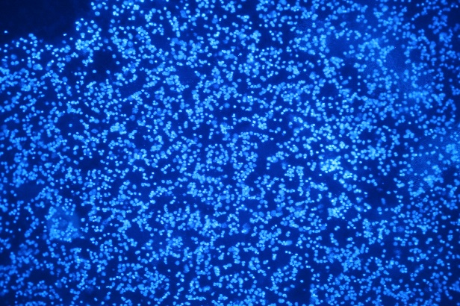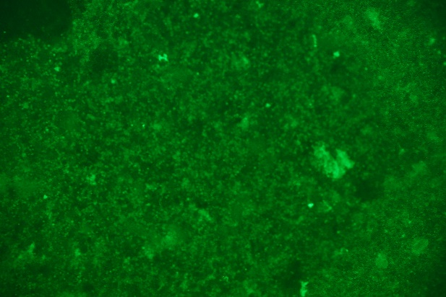

After induction with 25 μΜ oleocanthal
DAPI Cathepsin

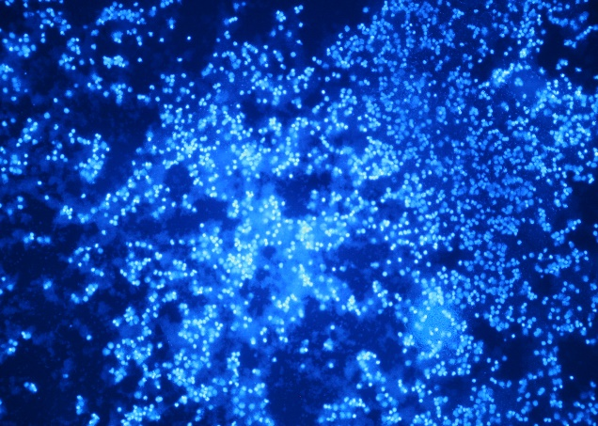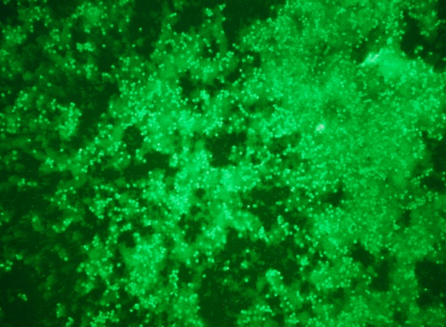

TUNEL Assay
At basal state After induction with 25 μΜ oleocanthal
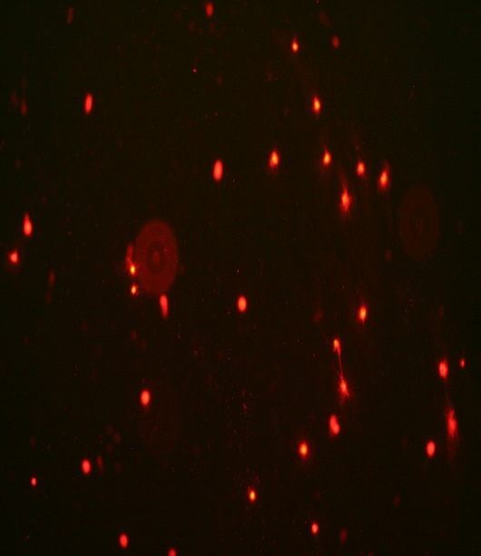

Table S1. Differences in hematological markers of patients with CLL (N=22) before and during the DI2 with High OC/OL-EVOO (M: male, F: female)
Whole blood count | Sex | 6 months before  a  Median  (min-max) | 3 months before  b  Median  (min-max) | Baseline  c  Median  (min-max) | 3 months after  d  Median  (min-max) | 6 months after  e  Median  (min-max) | p-value (adj)
White Blood  Cells  (x10³/mm³) | M | 13300.00  (8000-44800) | 18650.00  (6700-52000) | 16900.00  (8000-53600) | 13050.00  (7100-46100) | 11900.00  (7200-46000) | 0.199
 | F | 17000.00  (7500-40600) | 17400.00  (8700-58300) | 16700.00  (9800-69600) | 16350.00  (7000-57000) | 15650.00  (6600-33600) | b-e 0.019
Lymphocytes  (x 10³/mm³) | M | 10500.00  (4300-43200) | 11650.00  (3500-43200) | 10800.00  (3500-45400) | 7950.00  (2800-39400) | 8000.00  (3700-39400) | 0.076
 | F | 12000.00  (3000-33600) | 12250.00  (3300-50600) | 11150.00  (3300-59400) | 11350.00  (2700-49700) | 10700.00  (2500-26900) | b-e 0.001
Platelets  ( x10³/mm³) | M | 203000  (124000-257000) | 209000  (152000-269000) | 198500  (124000-306000) | 198000  (106000-338000) | 197000  (101000-280000) | 0.473
 | F | 215000  (162000-277000) | 202000  (160000-309000) | 205000  (178000-287000) | 202000  (154000-320000) | 189000  (125000-321000) | 0.998
Hematocrite (%) | M | 43.00  (38.50-49.80) | 44.40  (36.70-49.80) | 44.15  (37.30-48.40) | 44.25  (38.00-49.50) | 42.80  (36.00-49.20) | 0.090
 | F | 41.90  (38.90-44.90) | 41.20  (36.10-46.00) | 42.50  (36.40-45.70) | 41.15  (35.80-46.80) | 41.30  (36.00-47.10) | 0.190
Hemoglobin (g/dL) | M | 14.80  (12.90-16.30) | 14.65  (12.20-16.30) | 14.90  (12.40-15.80) | 14.65  (12.50-16.00) | 14.10  (12.00-16.50) | 0.179
 | F | 14.00  (12.80-15.70) | 13.70  (12.10-15.10) | 14.15  (12.00-15.60) | 13.95  (11.50-15.70) | 13.80  (11.70-16.10) | 0.110
Monocytes  (x103/mm3) | M | 0.20  (0.20-1.00) | 0.55  (0.10-0.90) | 0.35  (0.10-1.30) | 0.35  (0.20-1.20) | 0.40  (0.10-1.10) | 0.350
 | F | 0.35  (0.10-0.90) | 0.50  (0.10-2.00) | 0.55  (0.10-2.10) | 0.35  (0.20-1.60) | 0.30  (0.10-1.20) | 0.536
Neutrophils  (x103/mm3) | M | 3.40  (1.70-7.50) | 5.03  (2.20-8.90) | 4.35  (1.70-6.60) | 3.60  (2.00-6.92) | 3.70  (1.60-5.90) | b-e* 0.037
 | F | 4.70  (2.50-5.80) | 4.95  (2.60-8.30) | 4.20  (2.20-8.00) | 4.25  (1.80-5.70) | 4.05  (2.10-6.80) | 0.095
Eosinophils  (x103/mm3) | M | 0.21  (0.05-0.61) | 0.21  (0.06-0.48) | 0.24  (0.06-0.54) | 0.17  (0.06-0.43) | 0.17  (0.07-0.60) | 0.937
 | F | 0.18  (0.09-0.42) | 0.21  (0.09-0.64) | 0.14  (0.09-0.42) | 0.18  (0.10-0.44) | 0.25  (0.09-0.57) | 0.218
Basophils  (x103/mm3) | M | 0.04  (0.00-0.21) | 0.10  (0.00-0.21) | 0.05  (0.01-0.25) | 0.03  (0.01-0.10) | 0.02  (0.01-0.12) | 0.484
 | F | 0.03  (0.01-0.36) | 0.07  (0.01-1.30) | 0.04  (0.01-0.14) | 0.04  (0.02-0.23) | 0.03  (0.00-0.10) | 0.082
* Friedman test indicates that there are significant differences at all time points of the intervention. However, Dunn-Bonferroni post hoc tests indicate that there are no significant pairwise differences.

Table S2. Differences in biochemical markers of patients with CLL (N=22) before and during the DI2 with High OC/OL-EVOO (M: male, F: female)
Biochemical Marker | Sex | 6 months before  a  Median  (min-max) | 3 months before  b  Median  (min-max) | Baseline  c  Median  (min-max) | 3 months after  d  Median  (min-max) | 6 months after  e  Median  (min-max) | p-value (adj)
Glucose  (mg/dL) | M=12 | 103.00  (86.00-123.00) | 101.50  (86.00-138.00) | 105.50  (62.00-132.00) | 99.50  (58.00-125.00) | 98.00  (74.00-114.00) | 0.023*
 | F=10 | 104.00  (93.00-123.00) | 104.00  (90.00-133.00) | 104.00  (88.00-128.00) | 100.00  (91.00-114.00) | 101.00  (77.00-120.00) | 0.053*
Urea  (mg/dL) | M | 44.00  (34.00-68.00) | 49.00  (31.00-83.00) | 49.00  (32.00-58.00) | 41.00  (34.00-64.00) | 44.00  (31.00-58.00) | 0.615
 | F | 40.00  (25.00-55.00) | 39.50  (30.00-63.00) | 41.50  (30.00-85.00) | 39.00  (32.00-76.00) | 36.50  (30.00-60.00) | 0.053
Uric Acid  (mg/dL) | M | 5.80  (3.00-8.30) | 5.90  (2.80-7.10) | 6.40  (3.20-53.00) | 6.25  (3.10-8.60) | 6.00  (2.90-8.50) | 0.353
 | F | 5.25  (3.30-5.50) | 4.85  (3.20-6.20) | 4.85  (3.20-8.00) | 4.90  (3.20-5.80) | 4.55  (2.80-6.70) | 0.209
Creatinin  (mg/dL) | M | 1.10  (0.90-1.20) | 1.00  (0.90-1.30) | 1.00  (0.70-1.20) | 0.90  (0.70-1.40) | 0.90  (0.80-1.45) | 0.006*
 | F | 0.80  (0.70-1.10) | 0.75  (0.60-1.40) | 0.80  (0.60-1.40) | 0.80  (0.70-1.30) | 0.80  (0.60-1.30) | 0.889
SGPT  (U/L) | M | 19.00  (11.00-66.00) | 21.50  (8.00-46.00) | 21.50  (8.00-34.00) | 24.00  (10.00-74.00) | 15.00  (8.00-28.00) | 0.058
 | F | 18.50  (14.00-20.00) | 19.00  (13.00-37.00) | 17.50  (13.00-27.00) | 20.00  (11.00-29.00) | 16.50  (12.00-35.00) | 0.796
SGOT  (U/L) | M | 25.00  (14.00-51.00) | 23.50  (14.00-37.00) | 27.00  (14.00-40.00) | 26.00  (17.00-47.00) | 24.00  (18.00-29.00) | 0.113
 | F | 23.50  (17.00-42.00) | 27.50  (13.00-54.00) | 23.00  (13.00-40.00) | 21.00  (11.00-40.00) | 22.00  (12.00-38.00) | 0.522
LDH  (IU/L) | M | 213.00  (104.00-616.00) | 223.50  (104.00-576.00) | 205.00  (128.00-596.00) | 241.00  (164.00-445.00) | 180.00  (155.00-308.00) | 0.288
 | F | 200.50  (169.00-308.00) | 208.00  (170.00-288.00) | 224.50  (173.00-313.00) | 208.50  (165.00-280.00) | 233.00  (150.00-641.00) | 0.622
γGT  (U/L) | M | 19.00  (12.00-38.00) | 17.00  (11.00-45.00) | 16.00  (11.00-39.00) | 18.50  (13.00-37.00) | 15.00  (11.00-39.00) | 0.114
 | F | 13.50  (10.00-21.00) | 14.00  (9.00-19.00) | 14.50  (9.00-24.00) | 14.00  (10.00-20.00) | 14.50  (7.00-30.00) | 0.537
ALP  (U/L) | M | 73.00  (49.00-88.00) | 71.00  (54.00-240.00) | 70.50  (51.00-220.00) | 81.00  (52.00-198.00) | 77.00  (48.00-198.00) | 0.365
 | F | 71.00  (47.00-90.00) | 67.50  (38.00-89.00) | 61.50  (46.00-89.00) | 78.50  (42.00-92.00) | 72.50  (34.00-84.00) | 0.060
Lipidemic Profile
Total cholesterol (mg/dL) | M | 180.00  (137.00-208.00) | 178.00  (137.00-208.00) | 174.50  (141.00-195.00) | 184.00  (125.00-215.00) | 181.00  (125.00-203.00) | 0.918
 | F | 220.00  (190.00-277.00) | 215.50  (162.00-255.00) | 220.00  (140.00-305.00) | 233.00  (162.00-300.00) | 197.50  (159.00-286.00) | 0.49
Triglycerides  (mg/dL) | M | 106.00  (46.00-221.00) | 123.50  (49.00-221.00) | 126.00  (63.00-217.00) | 113.00  (45.00-191.00) | 90.00  (69.00-194.00) | 0.400
 | F | 117.00  (84.00-250.00) | 97.50  (65.00-256.00) | 106.00  (65.00-299.00) | 109.00  (61.00-298.00) | 103.50  (67.00-280.00) | 0.838
HDL cholesterol (mg/dL) | M | 57.00  (43.00-78.00) | 51.00  (37.00-70.00) | 54.50  (44.00-63.00) | 51.50  (32.00-62.00) | 50.00  (35.00-63.00) | 0.886
 | F | 79.00  (34.00-92.00) | 60.00  (36.00-108.00) | 62.00  (33.00-99.00) | 59.00  (16.00-98.00) | 58.50  (35.00-82.00) | 0.084
LDL cholesterol (mg/dL) | M | 102.00  (72.00-148.00) | 104.00  (70.00-148.00) | 93.00  (70.00-116.00) | 102.50  (73.00-139.00) | 105.00  (73.00-114.00) | 0.496
 | F | 117.00  (100.00-185.00) | 122.50  (75.00-182.00) | 112.00  (68.00-212.00) | 137.50  (75.00-190.00) | 114.50  (68.00-200.00) | 0.139

* Friedman test indicates that there are significant differences at all time points of the intervention. However, Dunn-Bonferroni post hoc tests indicate that there are no significant pairwise differences.

Table S3. Differences in apoptosis markers of patients with CLL (N=22) during the DI2 with High OC/OL-EVOO (M: male, F: female)
Apoptotic Markers | Sex | Baseline  a  Median  (min-max) | 3 months  b  Median  (min-max) | 6 months  c  Median  (min-max) | p-value  (adj)
ccK18  (U/L) | M | 123.06  (85.31-400.45) | 142.61  (68.12-585.58) | 239.29  (147.00-335.00) | 0.078
 | F | 131.26  (40.39-218.47) | 126.70  (46.94-385.24) | 184.44  (76.50-385.50) | 0.150
Apo1-Fas  (U/L) | M | 83.57  (53.33-202.31) | 89.68  (66.01-230.18) | 140.87  (70.00-295.11) | a-c 0.004
 | F | 95.69  (66.99-141.00) | 95.36  (74.03-611.81) | 139.10  (73.00-855.41) | a-c 0.042
Survivin/API4 (pg/mL) | M | 187.34  (62.65-300.71) | 100.69  (62.13-181.89) | 75.00  (35.00-110.20) | a-c 0.000  b-c 0.017
 | F | 117.57  (81.00-429.50) | 109.00  (102.63-256.58) | 88.69  (55.00-125.00) | 0.071

