Supplementary data
Figure S1
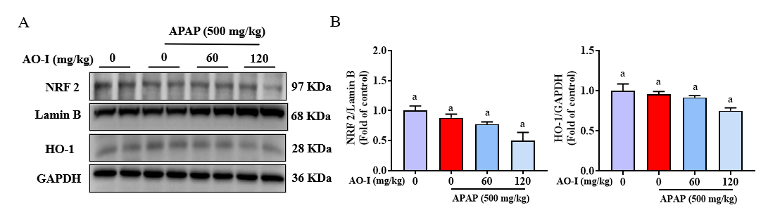
Figure S1. Effect of AO-I on APAP-induced NRF2 and HO-1 expression in the liver. (A) Protein levels of NRF2 and its downstream target gene HO-1 were detected by western blot. (B) Quantitative map of NRF2 and HO-1 protein expression. All data are presented as the mean ± SEM. Bars with different characters present statistically significant results, P < 0.05.

