Supplementary Material

Supplementary Figures and Tables

Supplementary Figures
Supplementary Figure 1. Correlations between PM_{2.5} concentrations and various meteorological factors: (a) relative humidity, (b) precipitation, (c) land surface temperature, (d) air temperature and (e) windspeed. Correlations significant at p<0.05 are marked with ‘×’.
Supplementary Figure 2. Spatial pattern of the trends in (a) relative humidity, (b) precipitation, (c) land surface temperature, (d) air temperature and (d) wind speed from 2001 to 2008 in the CZT.
Supplementary Figure 3. Spatial pattern of the trends in (a) relative humidity, (b) precipitation, (c) land surface temperature, (d) air temperature and (d) wind speed from 2008 to 2014 in the CZT.

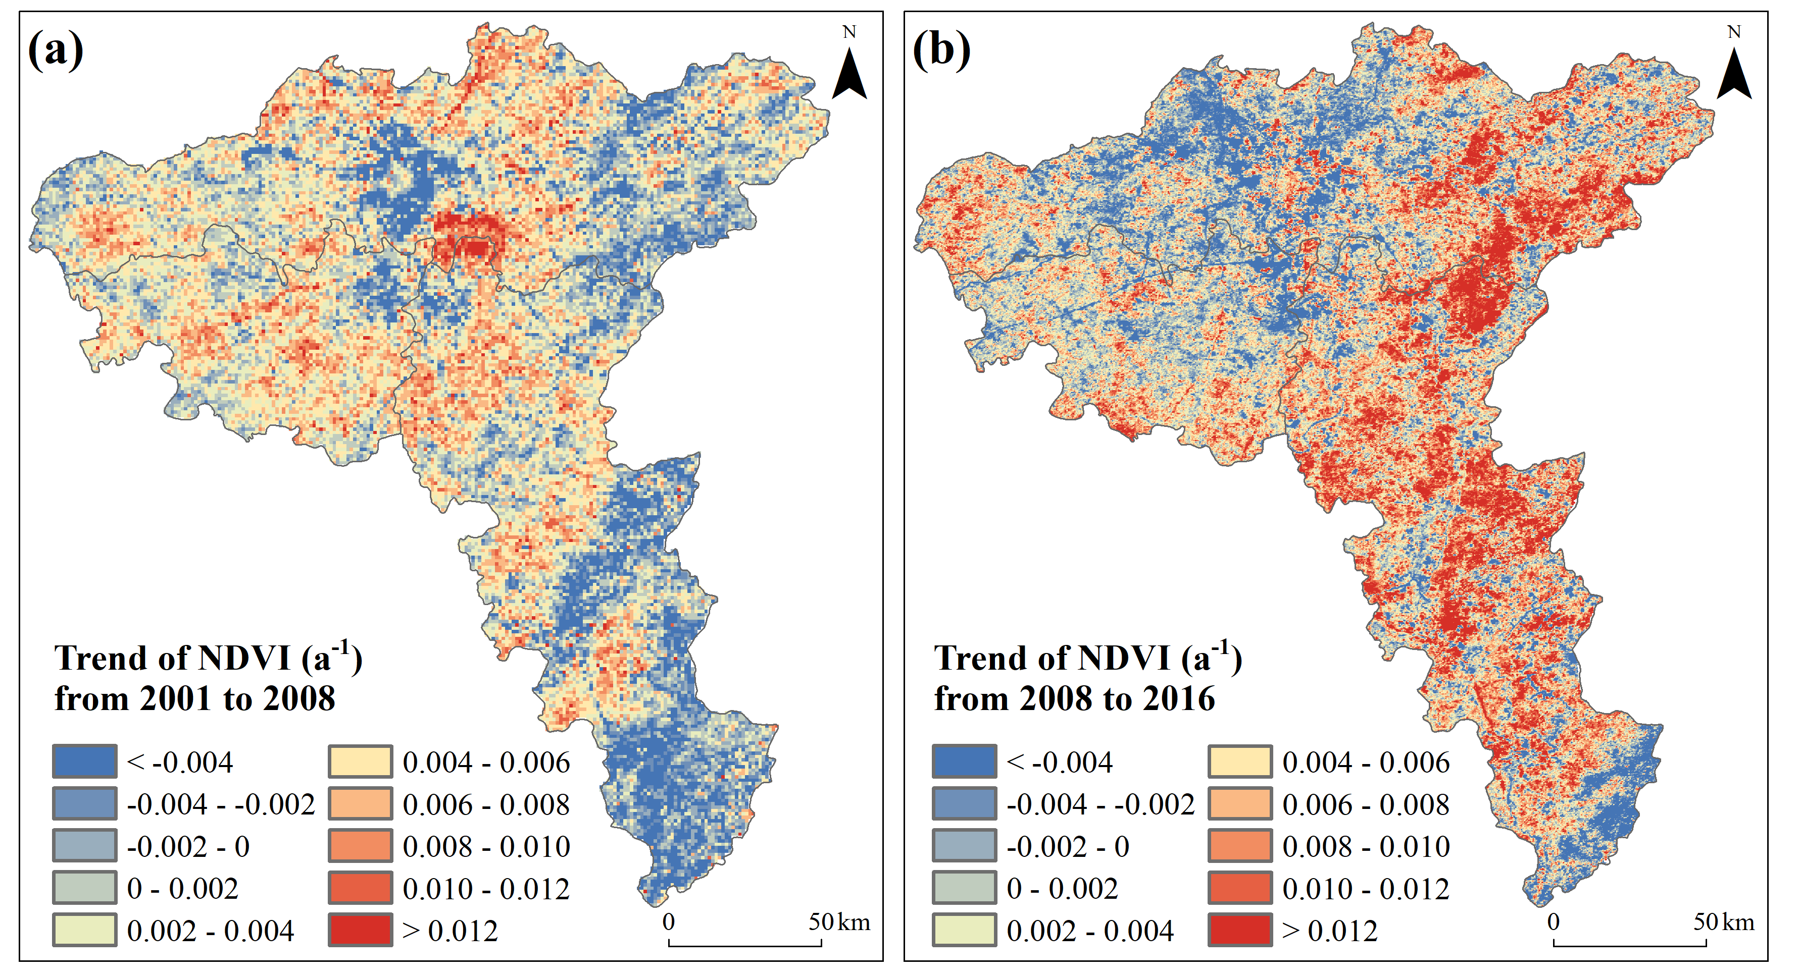
Supplementary Figure 4. Spatial pattern of the trends in NDVI during (a) 2001-2008 and (b) 2008-2014. NDVI data was calculated from MODIS surface spectral reflectance dataset MOD09GA at a resolution of 500m (https://lpdaac.usgs.gov/products/mod09gav006/).

