Supplementary Material

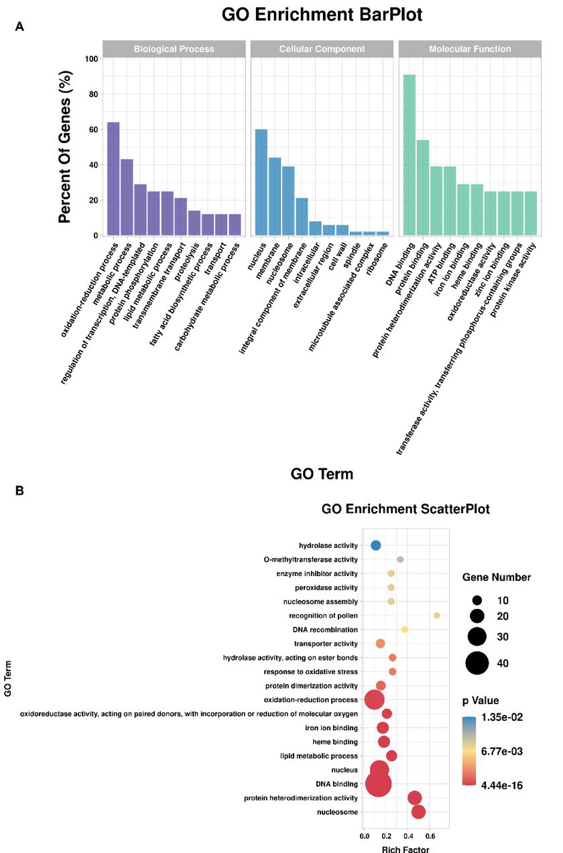

Figure S1 GO enrichment analysis of Arg-GlcNAcylated proteins. (A) Bar diagram of functional category enrichment analysis of GlcNAcylated proteins. Y-axis represents the percent of Genes in each category and the X-axis shows the name of the term. (B) Scatter plot for GO enrichment results. The top 20 enrichment GO terms are shown in the rainbow bubble chart. The Rich factor is the ratio of Arg-GlcNAcylated protein numbers annotation in this term to all gene numbers annotated in this term. The circle size stands for the number of modified proteins and the color stands for different P-values.

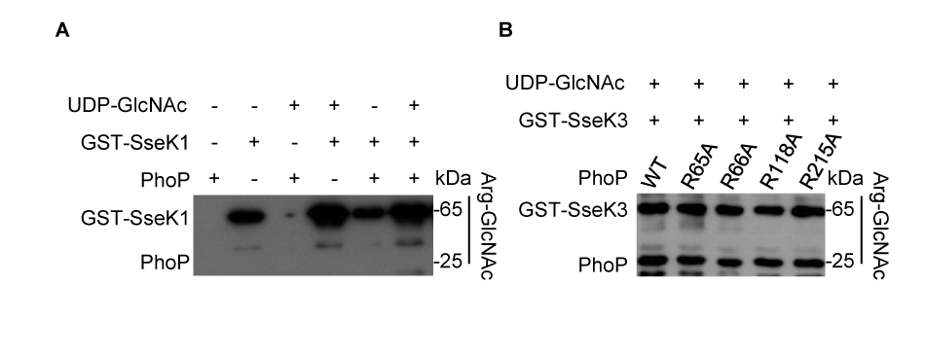
Figure S2 In vitro GlcNAcylation assay of PhoP. (A) Analysis of the enzymatic activity of SseK1 towards the PhoP protein. (B) GlcNAcylation activity of single mutations of the modification sites of PhoP in a recombinant reaction in vitro. Data in (A, B) are representative from at least three repetitions.

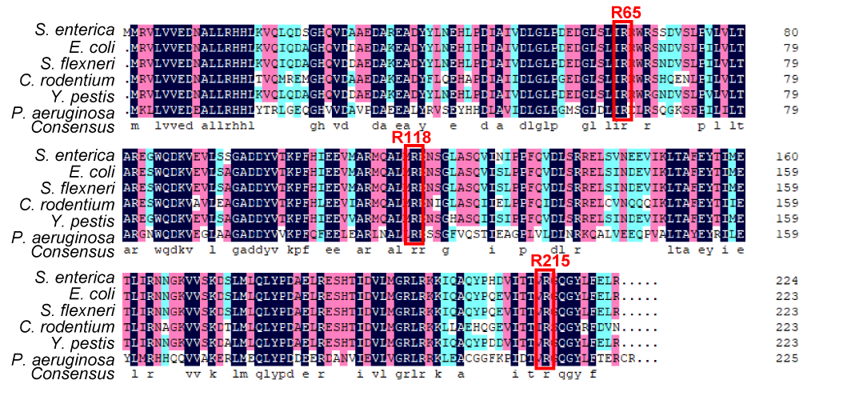

Figure S3 Multiple sequence alignment of PhoP in several bacteria. The red box indicates the conservative arginine of PhoP modified by SseK3.

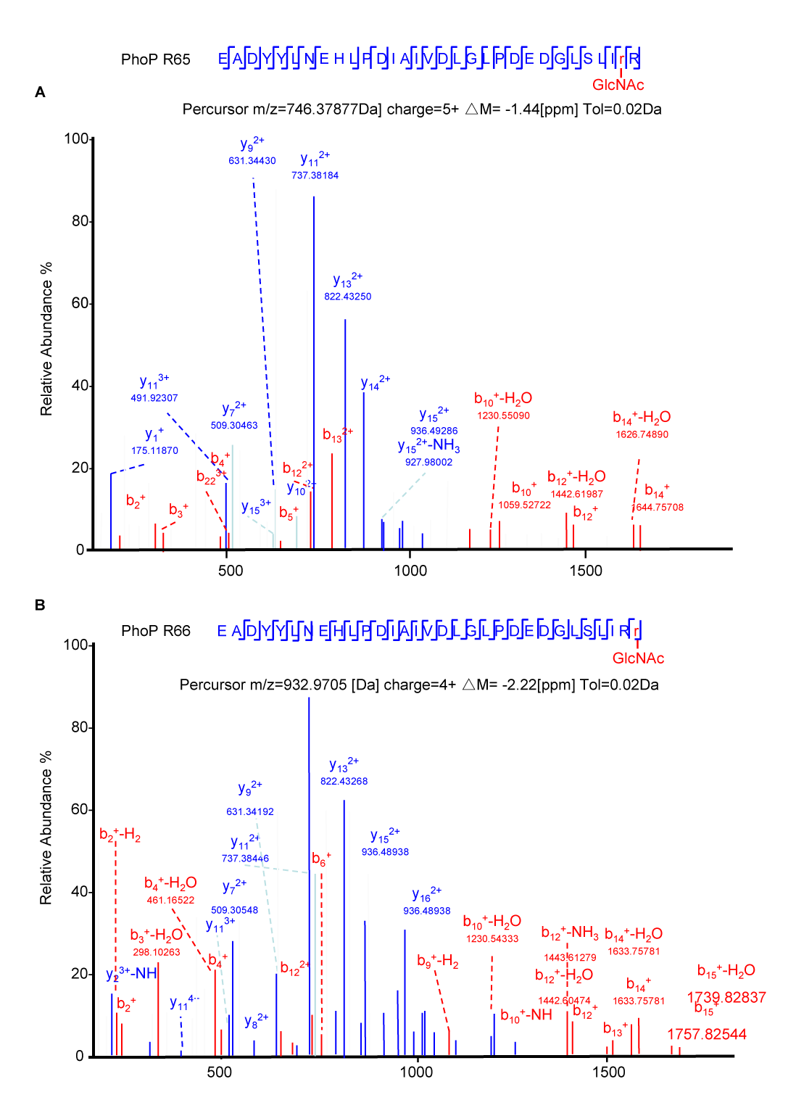

Figure S4 HCD analysis of the PhoP peptides around Arg65 and Arg66. HCD mass spectrum of Arg65 (A) and Arg66 (B) containing tryptic peptides from PhoP catalyzed by SseK3 in bacteria. The fragmentation patterns of the generated ions were exhibited along the peptide sequence on top of the spectrum.

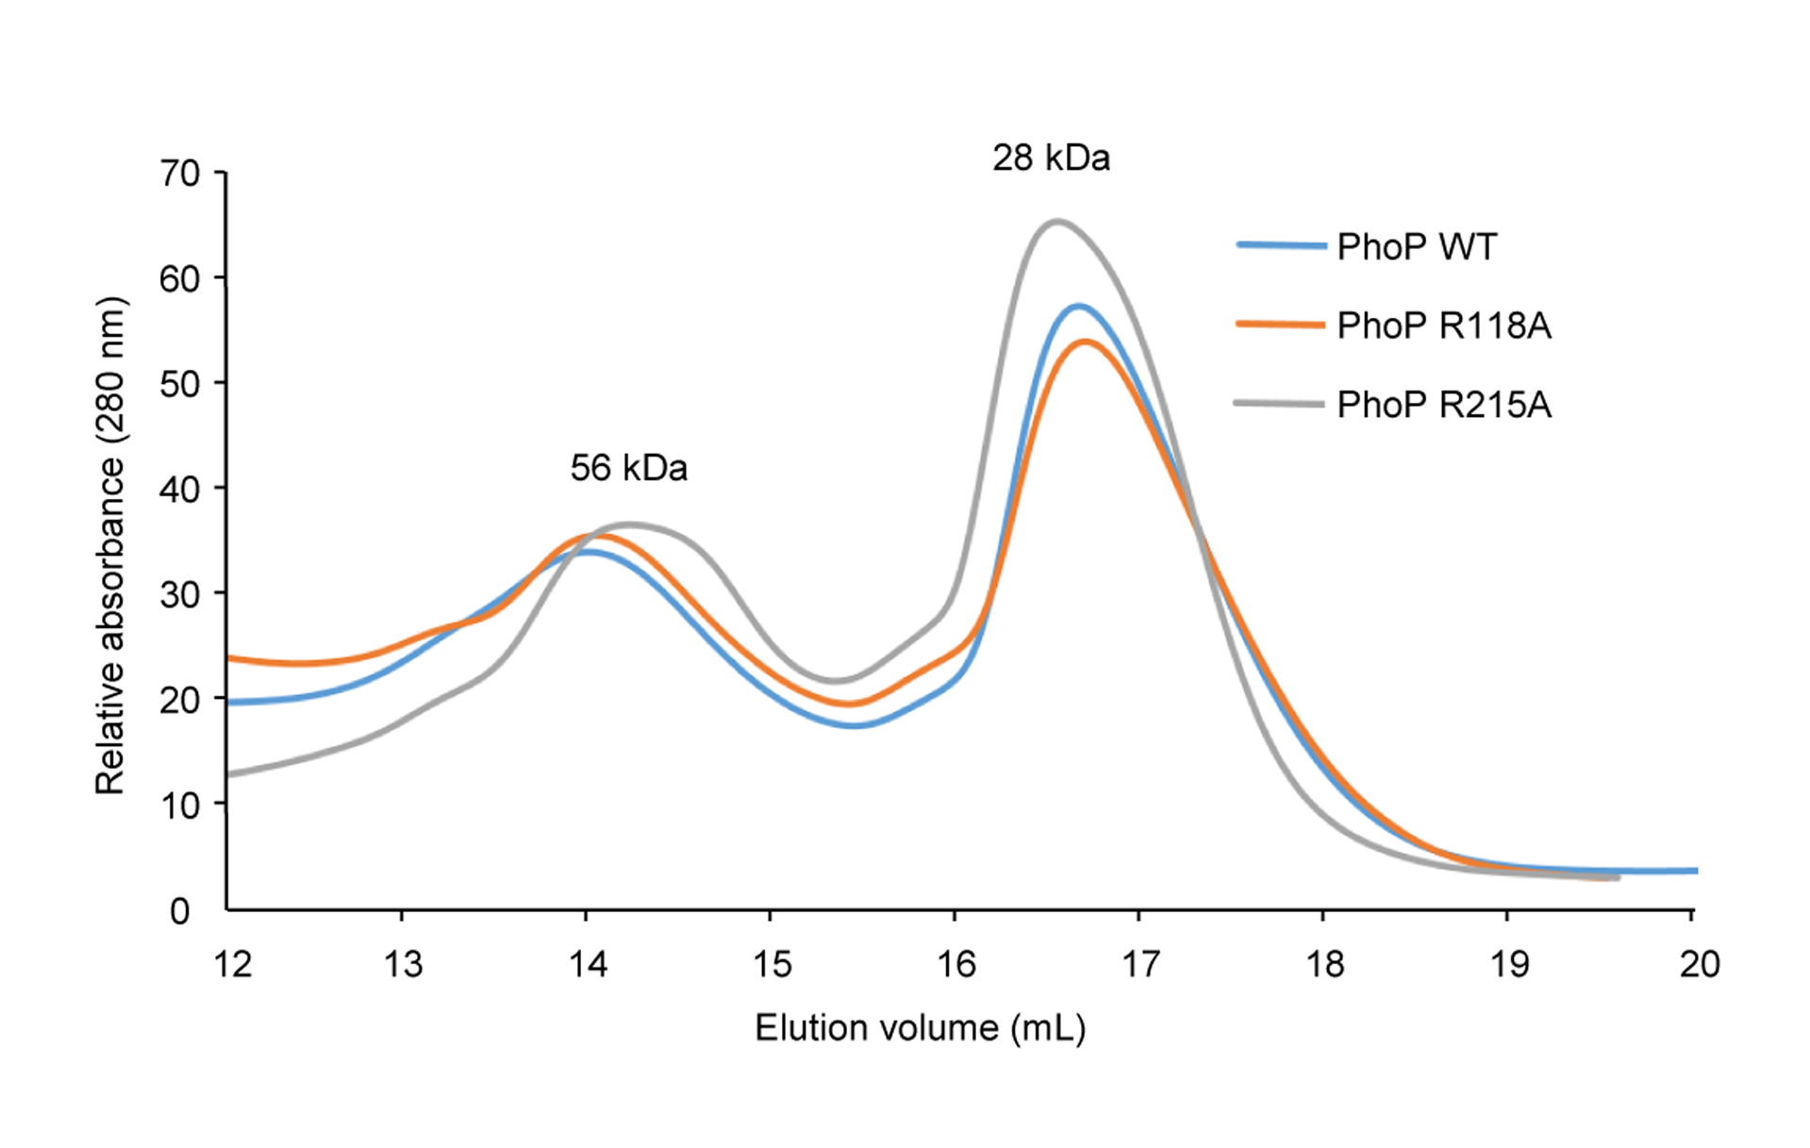
Figure S5 Size exclusion chromatography of PhoP wild-type protein and PhoP mutants. Size exclusion chromatography was performed with Superdex 200 increase 10/300GL columns (GE). The column was calibrated with thyroglobulin (669 kDa), ferritin (440 kDa), aldolase (158 kDa), conalbumin (75 kDa), ovalbumin (44 kDa), carbonic anhydrase (29 kDa) and ribonuclease A (13.7 kDa).

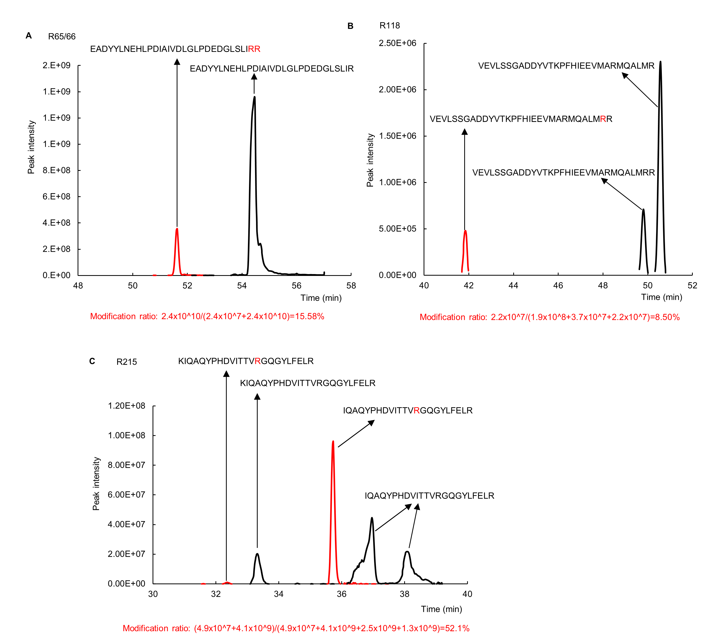

Figure S6 Glycosylation ratios of the modified PhoP peptides digested by trypsin. His-PhoP and GST-SseK3 were co-expressed and purified in E. coli BL21 (DE3). The purified His-PhoP was then digested with trypsin and analyzed by LC-MS/MS. Shown are the extracted ion chromatograms of the indicated peptides for R64/65 (A), R118 (B), R215 (C). The peak intensity indicated the relative abundance. The modification ratio was calculated by peak area. The black peak and red peak denote the unmodified and modified peptide, respectively.

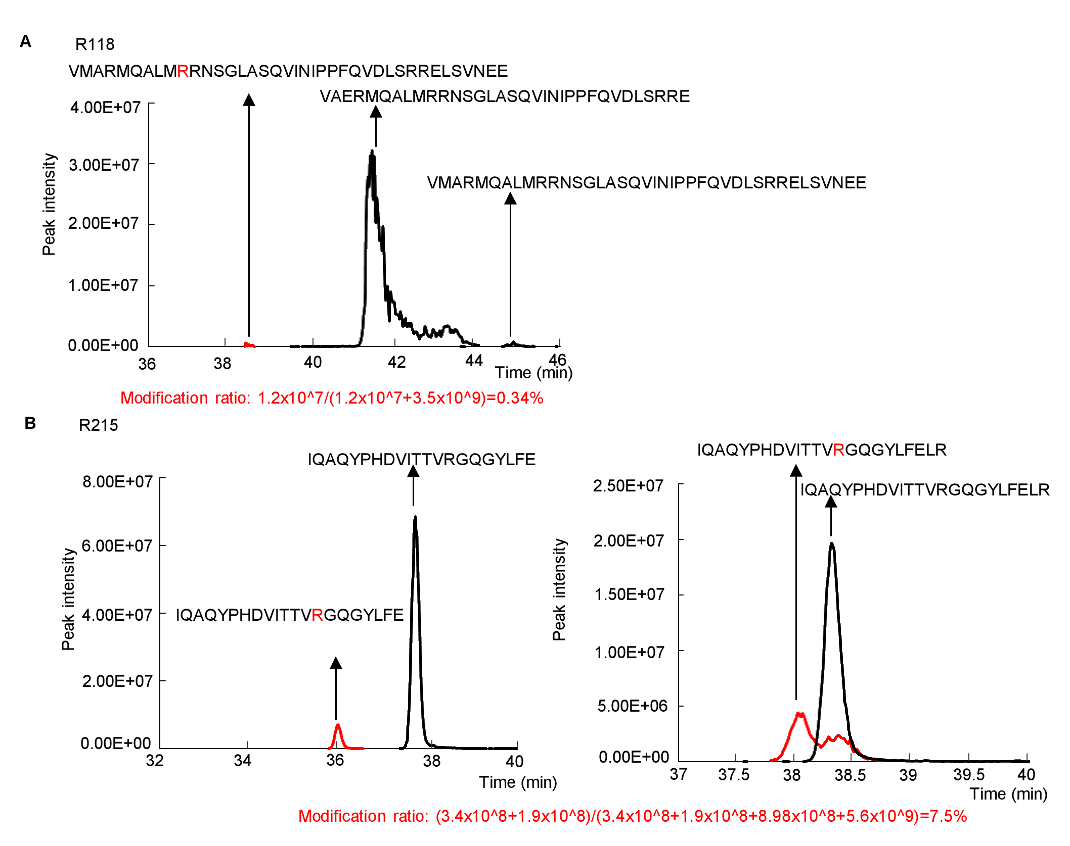
Figure S7 Glycosylation ratios of the modified PhoP peptides digested by Glu-C/Lys-C. His-PhoP and GST-SseK3 were co-expressed and purified in E. coli BL21 (DE3). The purified His-PhoP was then digested with Glu-C/Lys-C and analyzed by LC-MS/MS. Shown are the extracted ion chromatograms of the indicated peptides for R118 (A) and R215 (B). The peak intensity indicated the relative abundance. The modification ratio was calculated by peak area. The black peak and red peak denote the unmodified and modified peptide, respectively.

Table S1 Strains and plasmids used in this study.

Strains or plasmids | Description | Sources
Strains
E. coli TOP10 | phoP (Strep^{R}) | This study
E. coli TOP10 | phop(R118A) (Strep^{R}) | This study
S. Typhimurium SL1344 | WT(Strep^{R}) | Laboratory stock
SL1344 ∆123 | ∆sseK1/2/3(Strep^{R}) | (Xue et al., 2020)
SL1344 ∆123+pS1 | ∆sseK1/2/3+pET28a-sseK1 | (Xue et al., 2020)
SL1344 ∆123+pS1(DXD) | ∆sseK1/2/3+pET28a-sseK1(D223A,D225A) | (Xue et al., 2020)
SL1344 ∆123+pS3 | ∆sseK1/2/3+pET28a-sseK3 | (Xue et al., 2020)
SL1344 ∆123+pS3(DXD) | ∆sseK1/2/3+pET28a-sseK3(D226A,D228A) | (Xue et al., 2020)
SL1344 ∆123+pPhoP | ∆sseK1/2/3+pTrc99a-phoP | This study
SL1344 ∆123+pPhoP(R118A) | ∆sseK1/2/3+pTrc99a-phoP(R118A) | This study
SL1344 ∆12+pPhoP | ∆sseK1/2+pTRC99a-phoP | This study
SL1344 ∆23+pPhoP | ∆sseK2/3+pTRC99a-phoP | This study
plasmids
pET28a-sseK1(DXD) | endogenous promoter of sseK1 | This study
pET28a-sseK3(DXD) | endogenous promoter of sseK3 | This study
pTrc99a-phoP | C-terminal with 1xFlag | This study
pTrc99a-phoP(R118A) | C-terminal with 1xFlag | This study
pET28a-phoP | PhoP expression plasmid | This study
pET28a-phoP(R65A) | PhoP mutant expression plasmid | This study
pET28a-phoP(R66A) | PhoP mutant expression plasmid | This study
pET28a-phoP(R118A) | PhoP mutant expression plasmid | This study
pET28a-phoP(R215A) | PhoP mutant expression plasmid | This study
pET28a-phoP(R65/66/118/215A) | PhoP mutant expression plasmid | This study
pGEX-sseK1 | GST-SseK1 expression plasmid | This study
pGEX-sseK3 | GST-SseK3 expression plasmid | This study

Table S2 Primers pairs for real-time PCR

Primer name | Primer sequence (5’-3’)
sseK1 F | GGAAAACGGGATAATAGCTG
sseK2 F | GAAAACATCACCAAACTGGA
sseK3 F | TCAACAAAACCCCTATCTCA
gyrB F | CTGCTGTTGACCTTCTTCTAT
16S F | GAAATGTTGGGTTAAGTCCC
phoQ F | TAATGCGCCGTAATAGCGGT
phoP F | CGAACGCCGTGAGTTTGATG
pmrD F | GGCGATATCCTGTCGCCTTT
ssrB F | AAAACCGTCGAAACACACCG
mgtC R | CAAGGGTTAGGTTCGGTCCC
sseK1 R | TCAGAATAGGGATCAGCATC
sseK2 R | TTTCCTCCGGATTGTTTTTC
sseK3 R | TTGTCCAGCACTAAAATTCC
gyrB R | GTTCCTGCTTACCTTTCTTC
16S R | CCTTCCTCCAGTTTATCACT
phoQ R | CGAACGCCGTGAGTTTGATG
phoP R | TAATGCGCCGTAATAGCGGT
pmrD R | GTCGCAGGAATAACAGCGTG
ssrB R | CCTCATTCTTCGGGCACAGT
mgtC R | TCAGCTCTCGCGTTTTACGA
phoP F-EcoRI | GCGCGAATTCATATGATGCGCGTACTGGTTGT
phoP F-XbaI | GGCCCCTCTAGATTAGCGCAATTCAAAAAGAT
R65A-F | CCTTAATAGCACGCTGGCGCAGCAGTGATGTTTCA
R65A-R | GCTGCGCCAGCGTGCTATTAAGGAAAGGCCGTCTT
R66A-F | CCTTAATACGCGCATGGCGCAGCAGTGATGTTTCA
R66A-R | GCTGCGCCATGCGCGTATTAAGGAAAGGCCGTCTT
R118A-F | AATGGCACGTAATAGCGGTCTGGCCTCCCA
R118A-R | ACCGCTATTACGTGCCATTAACGCCTGCAT
R215A-R | GCGCGCTCTAGATTAGCGCAATTCAAAAAGATATCCTTGTCCGGCTACGGTGGTAAT
phoP promoter-F | 6-FAM-TCGCGCTGTGACTCTGGTCG
phoP ptomoter R | 6-FAM-ATCCTCTACAACCAGTACGC

Table S3 RNA-seq raw counts and SPI-2 gene expression

Table S4 Summary of Arg-GlcNAcylated peptides and proteins in mass spectrometry

Table S5 KEGG enrichment results

 | MainClass | Gene Hits In  Selected Set | All Genes In  Selected Set | Gene Hits  In Background | All Genes  In Background | p-value | Enrich Factor
02020 Two-component system | Environmental Information Processing | 9 | 25 | 187 | 1666 | 0.000962 | 3.207273
Signal transduction | Environmental Information Processing | 9 | 25 | 187 | 1666 | 0.000962 | 3.207273
Environmental adaptation | Organismal Systems | 2 | 25 | 6 | 1666 | 0.003127 | 22.21333
Organismal Systems | Organismal Systems | 2 | 25 | 7 | 1666 | 0.004337 | 19.04
01503 Cationic antimicrobial peptide (CAMP) resistance | Human Diseases | 3 | 25 | 37 | 1666 | 0.016571 | 5.403243
Environmental Information Processing | Environmental Information Processing | 11 | 25 | 439 | 1666 | 0.041426 | 1.669795
Genetic Information Processing | Genetic Information Processing | 6 | 25 | 197 | 1666 | 0.065399 | 2.029645
Drug resistance | Human Diseases | 3 | 25 | 64 | 1666 | 0.068103 | 3.12375
Translation | Genetic Information Processing | 3 | 25 | 81 | 1666 | 0.118111 | 2.468148
00310 Lysine degradation | Metabolism | 1 | 25 | 9 | 1666 | 0.127513 | 7.404444

Table S6 GO enrichment results

GO_Term | S  gene number | TS  gene number | B  gene number | TB  gene number | p-value
phosphorelay signal transduction system | 6 | 36 | 40 | 3687 | 0.00
translation elongation factor activity | 2 | 36 | 8 | 3687 | 0.00
glycerol kinase activity | 1 | 36 | 1 | 3687 | 0.01
dihydrolipoyllysine-residue succinyltransferase activity | 1 | 36 | 1 | 3687 | 0.01
flavin adenine dinucleotide binding | 1 | 36 | 1 | 3687 | 0.01
chemotaxis | 1 | 36 | 2 | 3687 | 0.02
glycerol ether metabolic process | 1 | 36 | 2 | 3687 | 0.02
cytosol | 1 | 36 | 5 | 3687 | 0.05
phosphorelay response regulator activity | 1 | 36 | 5 | 3687 | 0.05
RNA binding | 2 | 36 | 38 | 3687 | 0.05
structural constituent of ribosome | 2 | 36 | 47 | 3687 | 0.08
cytoplasm | 3 | 36 | 165 | 3687 | 0.22
tRNA binding | 1 | 36 | 30 | 3687 | 0.26
phosphorelay sensor kinase activity | 1 | 36 | 30 | 3687 | 0.26
nucleic acid binding | 1 | 36 | 36 | 3687 | 0.30
plasma membrane | 5 | 36 | 426 | 3687 | 0.40
oxidoreductase activity | 1 | 36 | 57 | 3687 | 0.43
DNA binding | 3 | 36 | 270 | 3687 | 0.50
ATP binding | 1 | 36 | 183 | 3687 | 0.84
integral component of membrane | 1 | 36 | 313 | 3687 | 0.96

