Supplementary Material

Supplementary Data
SF2_gk_gene_models_post_blast_post_filtering.fa – fasta file containing the sequence for all gene models used in this analysis
SF3_Hs_per_gene_model_per_population.txt – Table containing H_{S} per population per individual SNP.
SF4_Transcriptome_collapsing_script.py – Script used to remove redundancies and isoforms in the first assembly by collapsing similar contigs.
SF5_Reciprocal_BLAST_results – Results of the best reciprocal BLAST between Ectocarpus siliculosus and our dataset from Macrocystis pyrifera.
SF6A-H_RSEM Results – Files containing RSEM results for all the eight RNA samples tested.
SF7_bin_1st_and_2nd_codon_versus_3rd – Code for separating SNPs in the first two nucleotides of a codon from the third to later perform Fst test.
sample_names_and_populations.txt – file containing individual names and population of origin for samples used in this study
Master_data_table.xlsx – Table containing information on each gene model including stage of expression and analyses results.

Supplementary Figures and Tables

Supplementary Figures

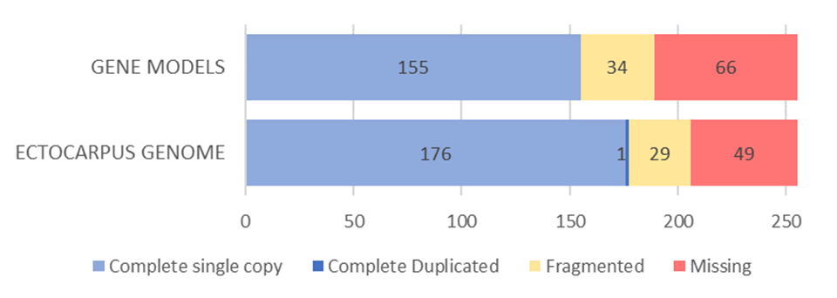
Supplementary Figure 1. BUSCO comparison. Comparison of BUSCO reports between our Macrocystis pyrifera gene model dataset and the complete annotated Ectocarpus siliculosus genome using the eukaryote_odb10 dataset and Busco v4.06.

Supplementary Table 1. dN/dS significance table. Pairwise Wilcoxon test with Holm correction values between dN/dS values calculated for each life stage.
 | Gameto Specific | Gameto Biased | Neutral | Sporo Biased
Gameto Biased | 1.3e-06 | - | - | -
Neutral | < 2e-16 | < 2e-16 | - | -
Sporo Biased | < 2e-16 | 8.3e-15 | 0.0300 | -
Sporo Specific | 9.1e-07 | 0.0073 | 0.9443 | 0.7468

Supplementary Table 2. MKT significance table. Pairwise Wilcoxon test with Holm correction values between alpha values calculated for each life stage.
 | Gameto Specific | Gameto Biased | Neutral | Sporo Biased
Gameto Biased | 0.78830 | - | - | -
Neutral | 0.78830 | 0.01499 | - | -
Sporo Biased | 0.00097 | 1.1e-07 | 7.2e-05 | -
Sporo Specific | 0.00392 | 0.00054 | 0.01499 | 0.78830

Supplementary Table 3. Sampling coordinates. Sampling coordinates for the three populations used for polymorphism analyses.
Sampling locations | Longitude | Latitude
Catalina Island | - 118.511 | 33.462
Carlsbad | -117.36 | 33.157
Santa Barbara | -120.119 | 34.47

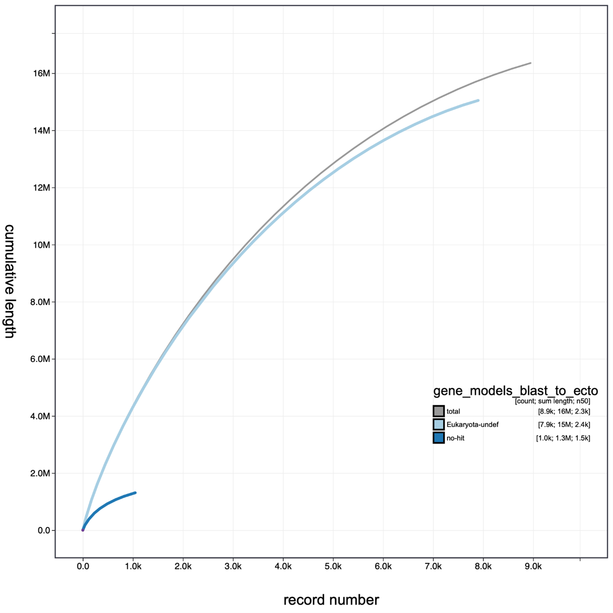
Supplementary Figure 2. BlobtTools cleaning results. Cumulative assembled length of gene models showing scaffold curves assigned to each phylum when compared to the total size of the assembly (gray line).

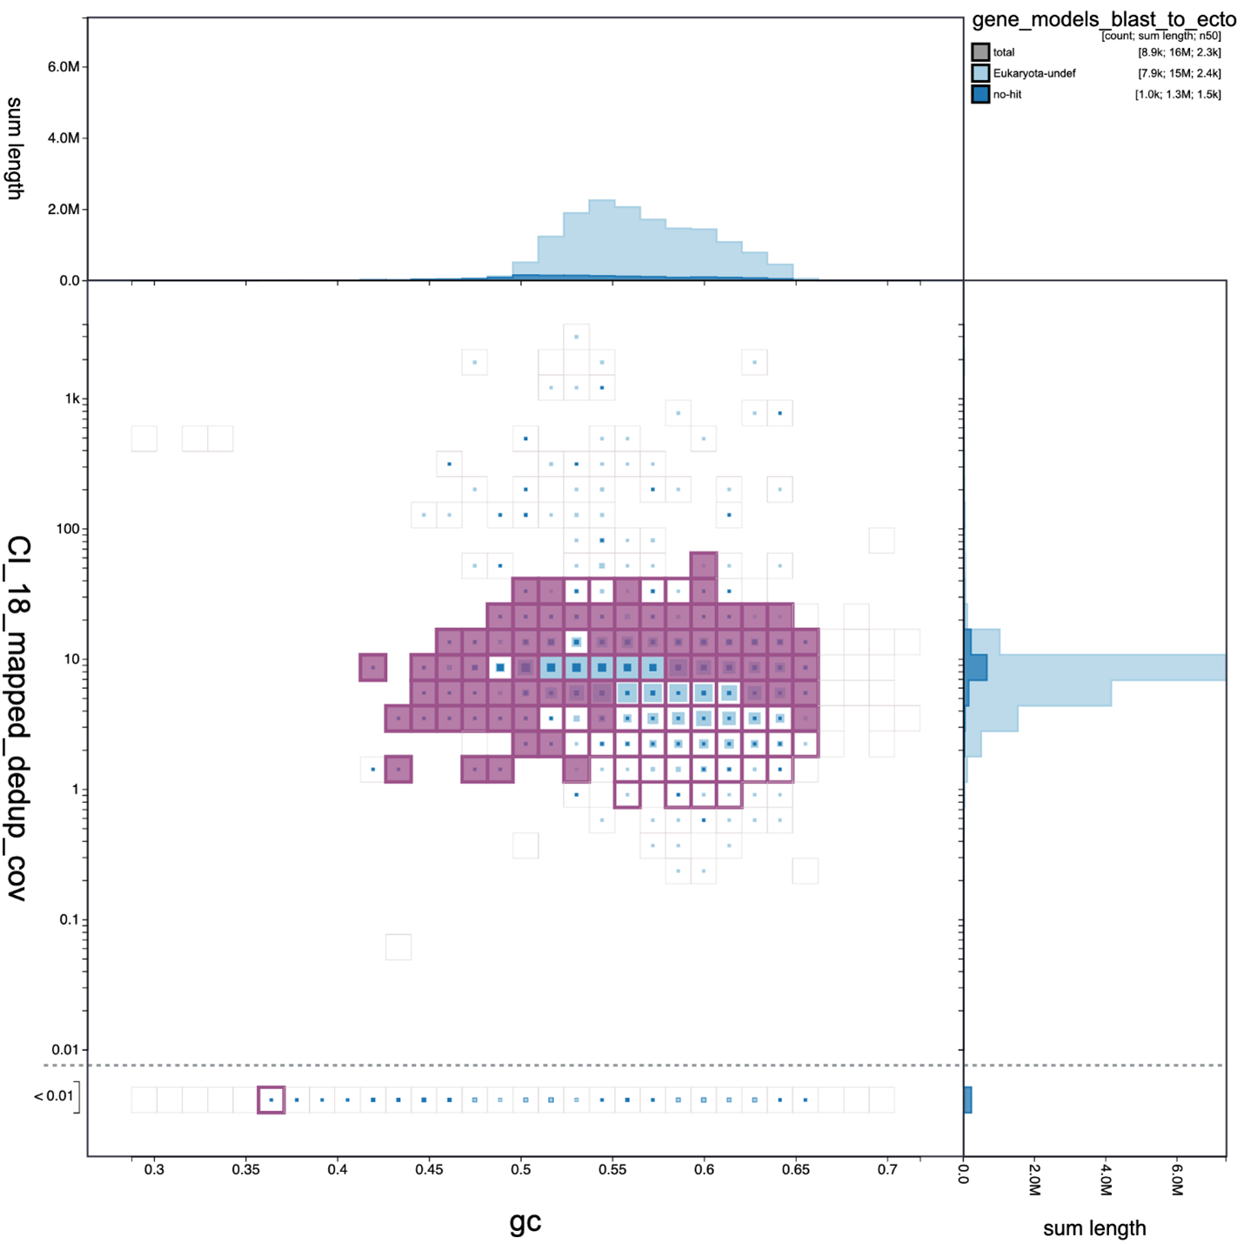
Supplementary Figure 3. GC content and coverage filtering. BlobTools graph showing gene models kept based on GC content and coverage in purple. Gene models were filtered to only contain scaffold with GC content between 0.35 and 0.65 with coverage ranging between 2x and 30x.

