Supplementary Material

Supplementary Tables
Supplementary Table 1: Dose Fractionation Concepts.
Fractionation | Ultracentral Tumors | Central Tumors | Peripheral Tumors
3 x 15 Gy | - | - | 2*
3 x 9 Gy | - | - | 1
5 x 10 Gy | - | - | 5
5 x 6 Gy | 1 | - | -
6 x 5 Gy | 1 | - | -
8 x 5 Gy | 1# | - | -
8 x 7.5 Gy | 1 | 2 | 2
10 x 5 Gy | 3 | - | -
10 x 5.5 Gy | 2# | - | -
10 x 6 Gy | 1 | - | -
12 x 5 Gy | 1# | - | -
Gy: Gray
* prescribed to the 65% isodose, # with one case prescribed to the median dose
Supplementary Table 2: Dose Constraints to Organs-at-Risk.
Volume Constraint | Dose Constraint per Single Fraction
 | 3 Fx | 5 Fx | 6 Fx | 8 Fx | 10 Fx
Esophagus
0.5 cm³ | < 8.4 Gy | < 6.8 Gy | < 6.0 Gy | < 5.0 Gy | < 4.4 Gy
Spinal Cord
0.1 cm³ | < 7.2 Gy | < 5.4 Gy | < 4.8 Gy | < 4.0 Gy | < 3.5 Gy
PBT
0.5 cm³ | < 10.7 Gy | < 7.0 Gy | < 6.3 Gy | < 5.5 Gy | < 4.8Gy
Heart
0.5 cm³ | < 8.7 Gy | < 5.8 Gy | < 5.3Gy | < 7.5 Gy | < 6.6 Gy
Brachial Plexus
0.5 cm³ | < 8.7 Gy | < 5.8 Gy | < 5.3 Gy | < 3.5 Gy | < 3.1 Gy
Thoracic Wall
30 cm³ | < 10 Gy | < 7.5 Gy | < 6.8 Gy | < 5.8 Gy | < 5.1 Gy
Great Vessels
0.5 cm³ | < 14.3 Gy | < 10.6 Gy | < 9.7 Gy | < 8.0 Gy | < 7.0 Gy
Fx: fraction, Gy: Gray, CTV: clinical target volume, PBT: proximal bronchial tree.

Supplementary Table 3: Linear multilevel model for planning target volume (PTV) coverage [%]. There were no divergent transitions.
Population Level Effect | Prior | Posterior
 |  | Mean | SD | 95% CI | $$\hat{R}$$
Intercept* | N(90%, 10%) | 90.02 | 0.9 | 88.36 91.91 | 1.00
Plan* [Adaptation] | N(0%, 20%) | 6.3 | 0.53 | 5.27 7.36 | 1.00
Localization [ultracentral] |  | 1.01 | 1.04 | -1.05 3.08 | 1.00
PTV Size  [10 cm³] |  | -0.12 | 0.11 | -0.37 0.07 | 1.00
Plan x Localization* |  | -2.0 | 0.57 | -3.12 -0.87 | 1.00
Plan x PTV Size* |  | -0.12 | 0.05 | -0.23 -0.02 | 1.00
SD: standard deviation, CI: compatibility interval, N: normal distribution, PTV: planning target volume, *compatibility interval does not contain 0

Supplementary Table 4: Linear multilevel model for clinical target volume (CTV) coverage [%]. There were no divergent transitions.
Population Level Effect | Prior | Posterior
 |  | Mean | SD | 95% CI | $$\hat{R}$$
Intercept* | N(90%, 10%) | 100.06 | 0.37 | 99.39 100.86 | 1.00
Plan [Adaptation] | N(0%, 20%) | 0.35 | 0.18 | -0.01 0.71 | 1.00
Localization [ultracentral] |  | -0.38 | 0.44 | -1.25 0.50 | 1.00
CTV Size  [10 cm³]* |  | -0.28 | 0.07 | -0.43 -0.17 | 1.00
Plan x Localization |  | -0.11 | 0.2 | -0.51 0.29 | 1.00
Plan x  CTV Size* |  | 0.13 | 0.02 | 0.08 0.18 | 1.00
SD: standard deviation, CI: compatibility interval, N: normal distribution, CTV: clinical target volume, *compatibility interval does not contain 0

Supplementary Table 5: Linear multilevel model for gross tumor volume (GTV) coverage [%]. There were no divergent transitions.
Population Level Effect | Prior | Posterior
 |  | Mean | SD | 95% CI | $$\hat{R}$$
Intercept* | N(90%, 10%) | 100.10 | 0.23 | 99.65 100.55 | 1.00
Plan [Adaptation] | N(0%, 20%) | -0.02 | 0.10 | -0.22 0.17 | 1.00
Localization [ultracentral] |  | -0.39 | 0.30 | -0.98 0.20 | 1.00
GTV Size  [10 cm³] |  | -0.07 | 0.05 | -0.18 0.02 | 1.00
Plan x Localization |  | 0.08 | 0.11 | -0.14 0.31 | 1.00
Plan x  GTV Size |  | 0.04 | 0.02 | 0.0 0.07 | 1.00
SD: standard deviation, CI: compatibility interval, N: normal distribution, GTV: gross tumor volume, *compatibility interval does not contain 0

Supplementary Table 6: Linear multilevel model for minimum BED₁₀ (BED_{min}) inside the planning target volume (PTV). There were no divergent transitions.
Population Level Effect | Prior | Posterior
 |  | Mean | SD | 95% CI | $$\hat{R}$$
Intercept* | N(100Gy,50Gy) | 77.86 | 5.42 | 67.48 88.99 | 1.00
Plan*  [Adaptation] | N(0Gy,50Gy) | 9.01 | 1.17 | 6.70 11.29 | 1.00
Localization* [ultracentral] |  | -15.22 | 6.98 | -28.97 -1.23 | 1.00
PTV Size*  [10 cm³] |  | -1.57 | 0.49 | -2.55 -0.63 | 1.00
Plan x Localization* |  | -5.21 | 1.27 | -7.71 -2.74 | 1.00
Plan x  PTV Size* |  | 0.37 | 0.12 | 0.14 0.61 | 1.00
SD: standard deviation, CI: compatibility interval, N: normal distribution, PTV: planning target volume, *compatibility interval does not contain 0

Supplementary Table 7: Linear multilevel model for minimum BED₁₀ (BED_{min}) inside the clinical target volume (CTV). There were no divergent transitions.
Population Level Effect | Prior | Posterior
 |  | Mean | SD | 95% CI | $$\hat{R}$$
Intercept* | N(100Gy,50Gy) | 106.59 | 6.66 | 93.73 120.15 | 1.00
Plan* [Adaptation] | N(0Gy,50Gy) | 6.52 | 1.02 | 4.52 8.54 | 1.00
Localization* [ultracentral] |  | -27.28 | 9.35 | -45.91 -8.81 | 1.00
CTV Size*  [10 cm³] |  | -3.37 | 0.59 | -4.52 -2.22 | 1.00
Plan x Localization* |  | -2.70 | 1.14 | -4.94 -0.46 | 1.00
Plan x  CTV Size* |  | 0.55 | 0.14 | 0.29 0.82 | 1.00
SD: standard deviation, CI: compatibility interval, N: normal distribution, CTV: clinical target volume, *compatibility interval does not contain 0

Supplementary Table 8: Linear multilevel model for minimum BED₁₀ (BED_{min}) inside the gross tumor volume (GTV). There were no divergent transitions.
Population Level Effect | Prior | Posterior
 |  | Mean | SD | 95% CI | $$\hat{R}$$
Intercept* | N(100Gy,50Gy) | 118.39 | 7.15 | 104.37 132.71 | 1.00
Plan [Adaptation]* | N(0Gy,50Gy) | 2.85 | 0.84 | 1.20 4.49 | 1.00
Localization [ultracentral]* |  | -34.35 | 9.86 | -53.73 -14.88 | 1.00
GTV Size  [10 cm³]* |  | -3.91 | 0.92 | -5.73 -2.11 | 1.00
Plan x Localization |  | -1.55 | 0.96 | -3.44 0.34 | 1.00
Plan x  GTV Size* |  | 0.34 | 0.16 | 0.03 0.65 | 1.00
SD: standard deviation, CI: compatibility interval, N: normal distribution, GTV: gross tumor volume, *compatibility interval does not contain 0

Supplementary Table 9: Linear multilevel model for mean BED₁₀ (BED_{mean}) inside the planning target volume (PTV). There were no divergent transitions.
Population Level Effect | Prior | Posterior
 |  | Mean | SD | 95% CI | $$\hat{R}$$
Intercept* | N(100Gy,50Gy) | 122.79 | 7.31 | 108.27 137.27 | 1.00
Plan*  [Adaptation] | N(0Gy,50Gy) | 1.39 | 0.33 | 0.75 2.04 | 1.00
Localization* [ultracentral] |  | -33.57 | 10.29 | -53.70 -12.75 | 1.00
PTV Size*  [10 cm³] |  | -0.68 | 0.19 | -1.05 -0.31 | 1.00
Plan x Localization* |  | -0.72 | 0.36 | -1.42 -0.02 | 1.00
Plan x  PTV Size |  | -0.01 | 0.03 | -0.08 0.06 | 1.00
SD: standard deviation, CI: compatibility interval, N: normal distribution, PTV: planning target volume, *compatibility interval does not contain 0

Supplementary Table 10: Linear multilevel model for mean BED₁₀ (BED_{mean}) inside the clinical target volume (CTV). There were no divergent transitions.
Population Level Effect | Prior | Posterior
 |  | Mean | SD | 95% CI | $$\hat{R}$$
Intercept* | N(100Gy,50Gy) | 130.45 | 7.90 | 114.70 145.72 | 1.00
Plan* [Adaptation] | N(0Gy,50Gy) | 0.81 | 0.33 | 0.17 1.46 | 1.00
Localization* [ultracentral] |  | -39.33 | 11.30 | -61.29 -16.56 | 1.00
CTV Size*  [10 cm³] |  | -0.50 | 0.24 | -0.98 -0.04 | 1.00
Plan x Localization |  | -0.54 | 0.36 | -1.26 0.18 | 1.00
Plan x  CTV Size |  | -0.01 | 0.04 | -0.09 0.08 | 1.00
SD: standard deviation, CI: compatibility interval, N: normal distribution, CTV: clinical target volume, *compatibility interval does not contain 0

Supplementary Table 11: Linear multilevel model for mean BED₁₀ (BED_{mean}) inside the gross tumor volume (GTV). There were no divergent transitions.
Population Level Effect | Prior | Posterior
 |  | Mean | SD | 95% CI | $$\hat{R}$$
Intercept* | N(100Gy,50Gy) | 133.64 | 8.83 | 116.04 151.01 | 1.00
Plan [Adaptation] | N(0Gy,50Gy) | 0.57 | 0.31 | -0.05 1.18 | 1.00
Localization [ultracentral]* |  | -42.13 | 12.55 | -66.57 -16.67 | 1.00
GTV Size  [10 cm³] |  | 0.03 | 0.39 | -0.74 0.81 | 1.00
Plan x Localization |  | -0.53 | 0.36 | -1.24 0.18 | 1.00
Plan x  GTV Size |  | -0.05 | 0.06 | -0.17 0.07 | 1.00
SD: standard deviation, CI: compatibility interval, N: normal distribution, GTV: gross tumor volume, *compatibility interval does not contain 0

Supplementary Table 12: Linear multilevel model for the amount of planning target volume exceeding the dose maximum [%]. There were no divergent transitions.
Population Level Effect | Prior | Posterior
 |  | Mean | SD | 95% CI | $$\hat{R}$$
Intercept* | N(5%, 5%) | 1.31 | 0.48 | 0.37 2.25 | 1.00
Plan* [Adaptation] | N(0%, 10%) | -0.97 | 0.37 | -1.71 -0.24 | 1.00
Localization [ultracentral] |  | -0.32 | 0.56 | -1.43 0.77 | 1.00
PTV Size  [10 cm³] |  | 0.01 | 0.05 | -0.09 0.11 | 1.00
Plan x Localization |  | 0.38 | 0.40 | -0.41 1.16 | 1.00
Plan x PTV Size |  | -0.02 | 0.04 | -0.10 0.05 | 1.00
SD: standard deviation, CI: compatibility interval, N: normal distribution, PTV: planning target volume, *compatibility interval does not contain 0

Supplementary Table 13: Violations of organs-at-risk constraints.
Case | PTV Location | Dose Fractionation | Plan | Fraction | OAR | Initial Distance PTV-OAR
# 1 | ultracentral | 10 x 5.5 Gy | Predicted | 1 | Esophagus | Overlap
 |  |  |  | 6 | PBT | Overlap
 |  |  |  | 8 | PBT
 |  |  |  | 9 | PBT
 |  |  |  | 10 | PBT
# 2 | ultracentral | 10 x 6.0 Gy | Predicted | 1 | Heart | Overlap
 |  |  |  | 7 | Heart
 |  |  | Adapted | 1 | Heart
 |  |  |  | 1 | Esophagus | Overlap
# 3 | ultracentral | 10 x 5.0 Gy | Predicted | 7 | PBT | Overlap
# 4 | central | 8 x 7.5 Gy | Predicted | 1 | Aorta | Overlap
 |  |  |  | 2 | Aorta
 |  |  |  | 5 | Aorta
 |  |  |  | 7 | Aorta
 |  |  |  | 8 | Aorta
# 5 | peripheral | 5 x 10 Gy | Predicted | 1 | Plexus | 1 – 2 mm
 |  |  |  | 2 | Plexus
 |  |  |  | 4 | Plexus
 |  |  |  | 5 | Plexus
# 6 | peripheral | 5 x 10 Gy | Predicted | 3 | Intestine | > 2 cm
PTV: Planning Target Volume, OAR: Organ-at-Risk

Supplementary Table 14: Logistic multilevel model for violation of organs at risk constraints. This model leaves out interaction terms with the “Plan” variable. There was one divergent transition.
Population Level Effect | Prior | Posterior
 |  | Mean (OR) | SD | 95% CI | $$\hat{R}$$
Intercept* | N(0, 2.0) | -3.99 | 1.02 | -6.22 -2.19 | 1.00
Plan* [Adaptation] |  | -1.94 (0.14) | 0.61 | -3.23 -0.83 | 1.00
Localization [ultracentral] |  | 0.17 (1.19) | 1.02 | -1.84 2.26 | 1.00
PTV Volume [10 cm³] |  | -0.24 (0.79) | 0.18 | -0.64 0.08 | 1.00
SD: standard deviation, CI: compatibility interval, N: normal distribution, PTV: planning target volume, *compatibility interval does not contain 0

Supplementary Table 15: Linear multilevel model for planning target volume size [cm³]. There were no divergent transitions.
Population Level Effect | Prior | Posterior
 |  | Mean | SD | 95% CI | $$\hat{R}$$
Intercept* | N(75cm³, 32.5cm³) | 48.37 | 10.15 | 28.16 68.36 | 1.00
Fraction* [1] | N(0cm³, 25cm³) | 0.42 | 0.16 | 0.11 0.74 | 1.00
SD: standard deviation, CI: compatibility interval, N: normal distribution, *compatibility interval does not contain 0

Supplementary Figures
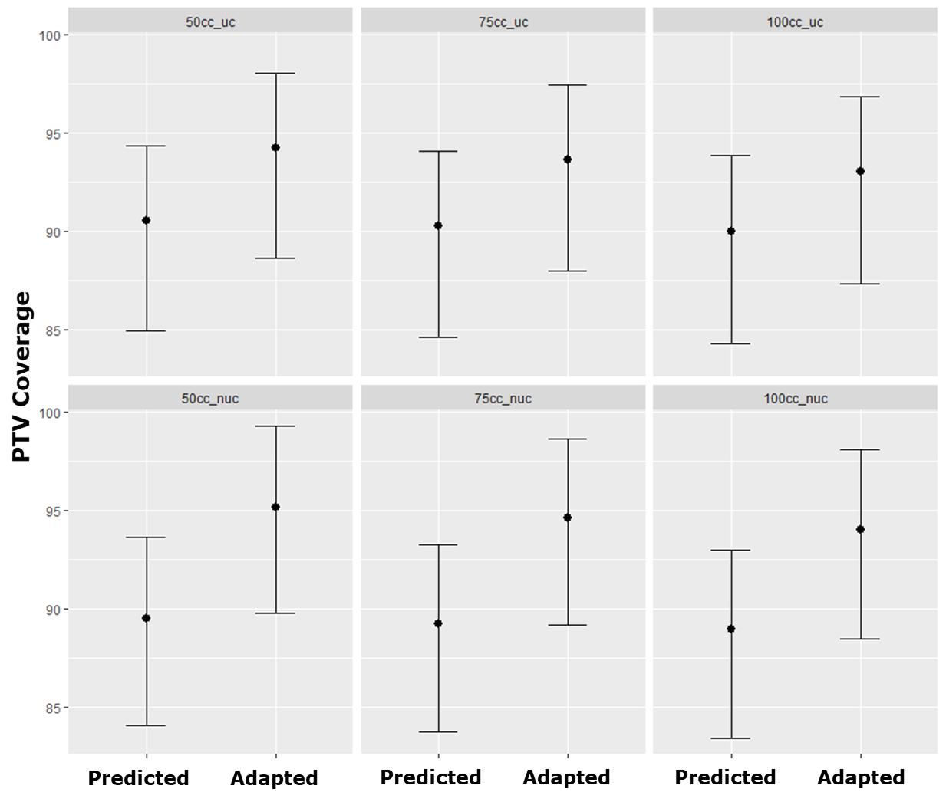
Supplementary Figure 1: Marginal effects plot for the interaction of planning target volume (PTV) size and ultracentral tumor location with the effect of plan adaptation on the PTV coverage. Three arbitrary PTV volumes (50 cm³, 75 cm³ and 100 cm³) were chosen. Rows: The positive effect of plan adaptation on PTV coverage is decreased for increasing PTV size. Columns: The positive effect of plan adaptation on PTV coverage is decreased for ultracentral tumor location. (cc: cm³, uc: ultracentral, nuc: non-ultracentral).

Supplementary Figure 2: BED_{min} inside the target volumes. The minimum biologically effective dose (BEDmin, alpha/beta-ratio = 10) is shown for the planning target volume (PTV), clinical target volume (CTV) and gross tumor volume (GTV) before (red) and after (blue) plan adaptation. Fractionation schemes for non-ultracentral tumors allowed a BED₁₀ > 100 Gray (Gy), while the most common fractionation given to ultracentral tumors was 10 x 5 -6 Gy which translates to a BED₁₀ 75 – 96 Gy.

Supplementary Figure 3: BED_{mean} inside the target volumes. The mean biologically effective dose (BED_{mean}, alpha/beta-ratio = 10) is shown for the planning target volume (PTV), clinical target volume (CTV) and gross tumor volume (GTV) before (red) and after (blue) plan adaptation. Fractionation schemes for non-ultracentral tumors allowed a BED₁₀ > 100 Gray (Gy), while the most common fractionation given to ultracentral tumors was 10 x 5 -6 Gy which translates to a BED₁₀ 75 – 96 Gy.

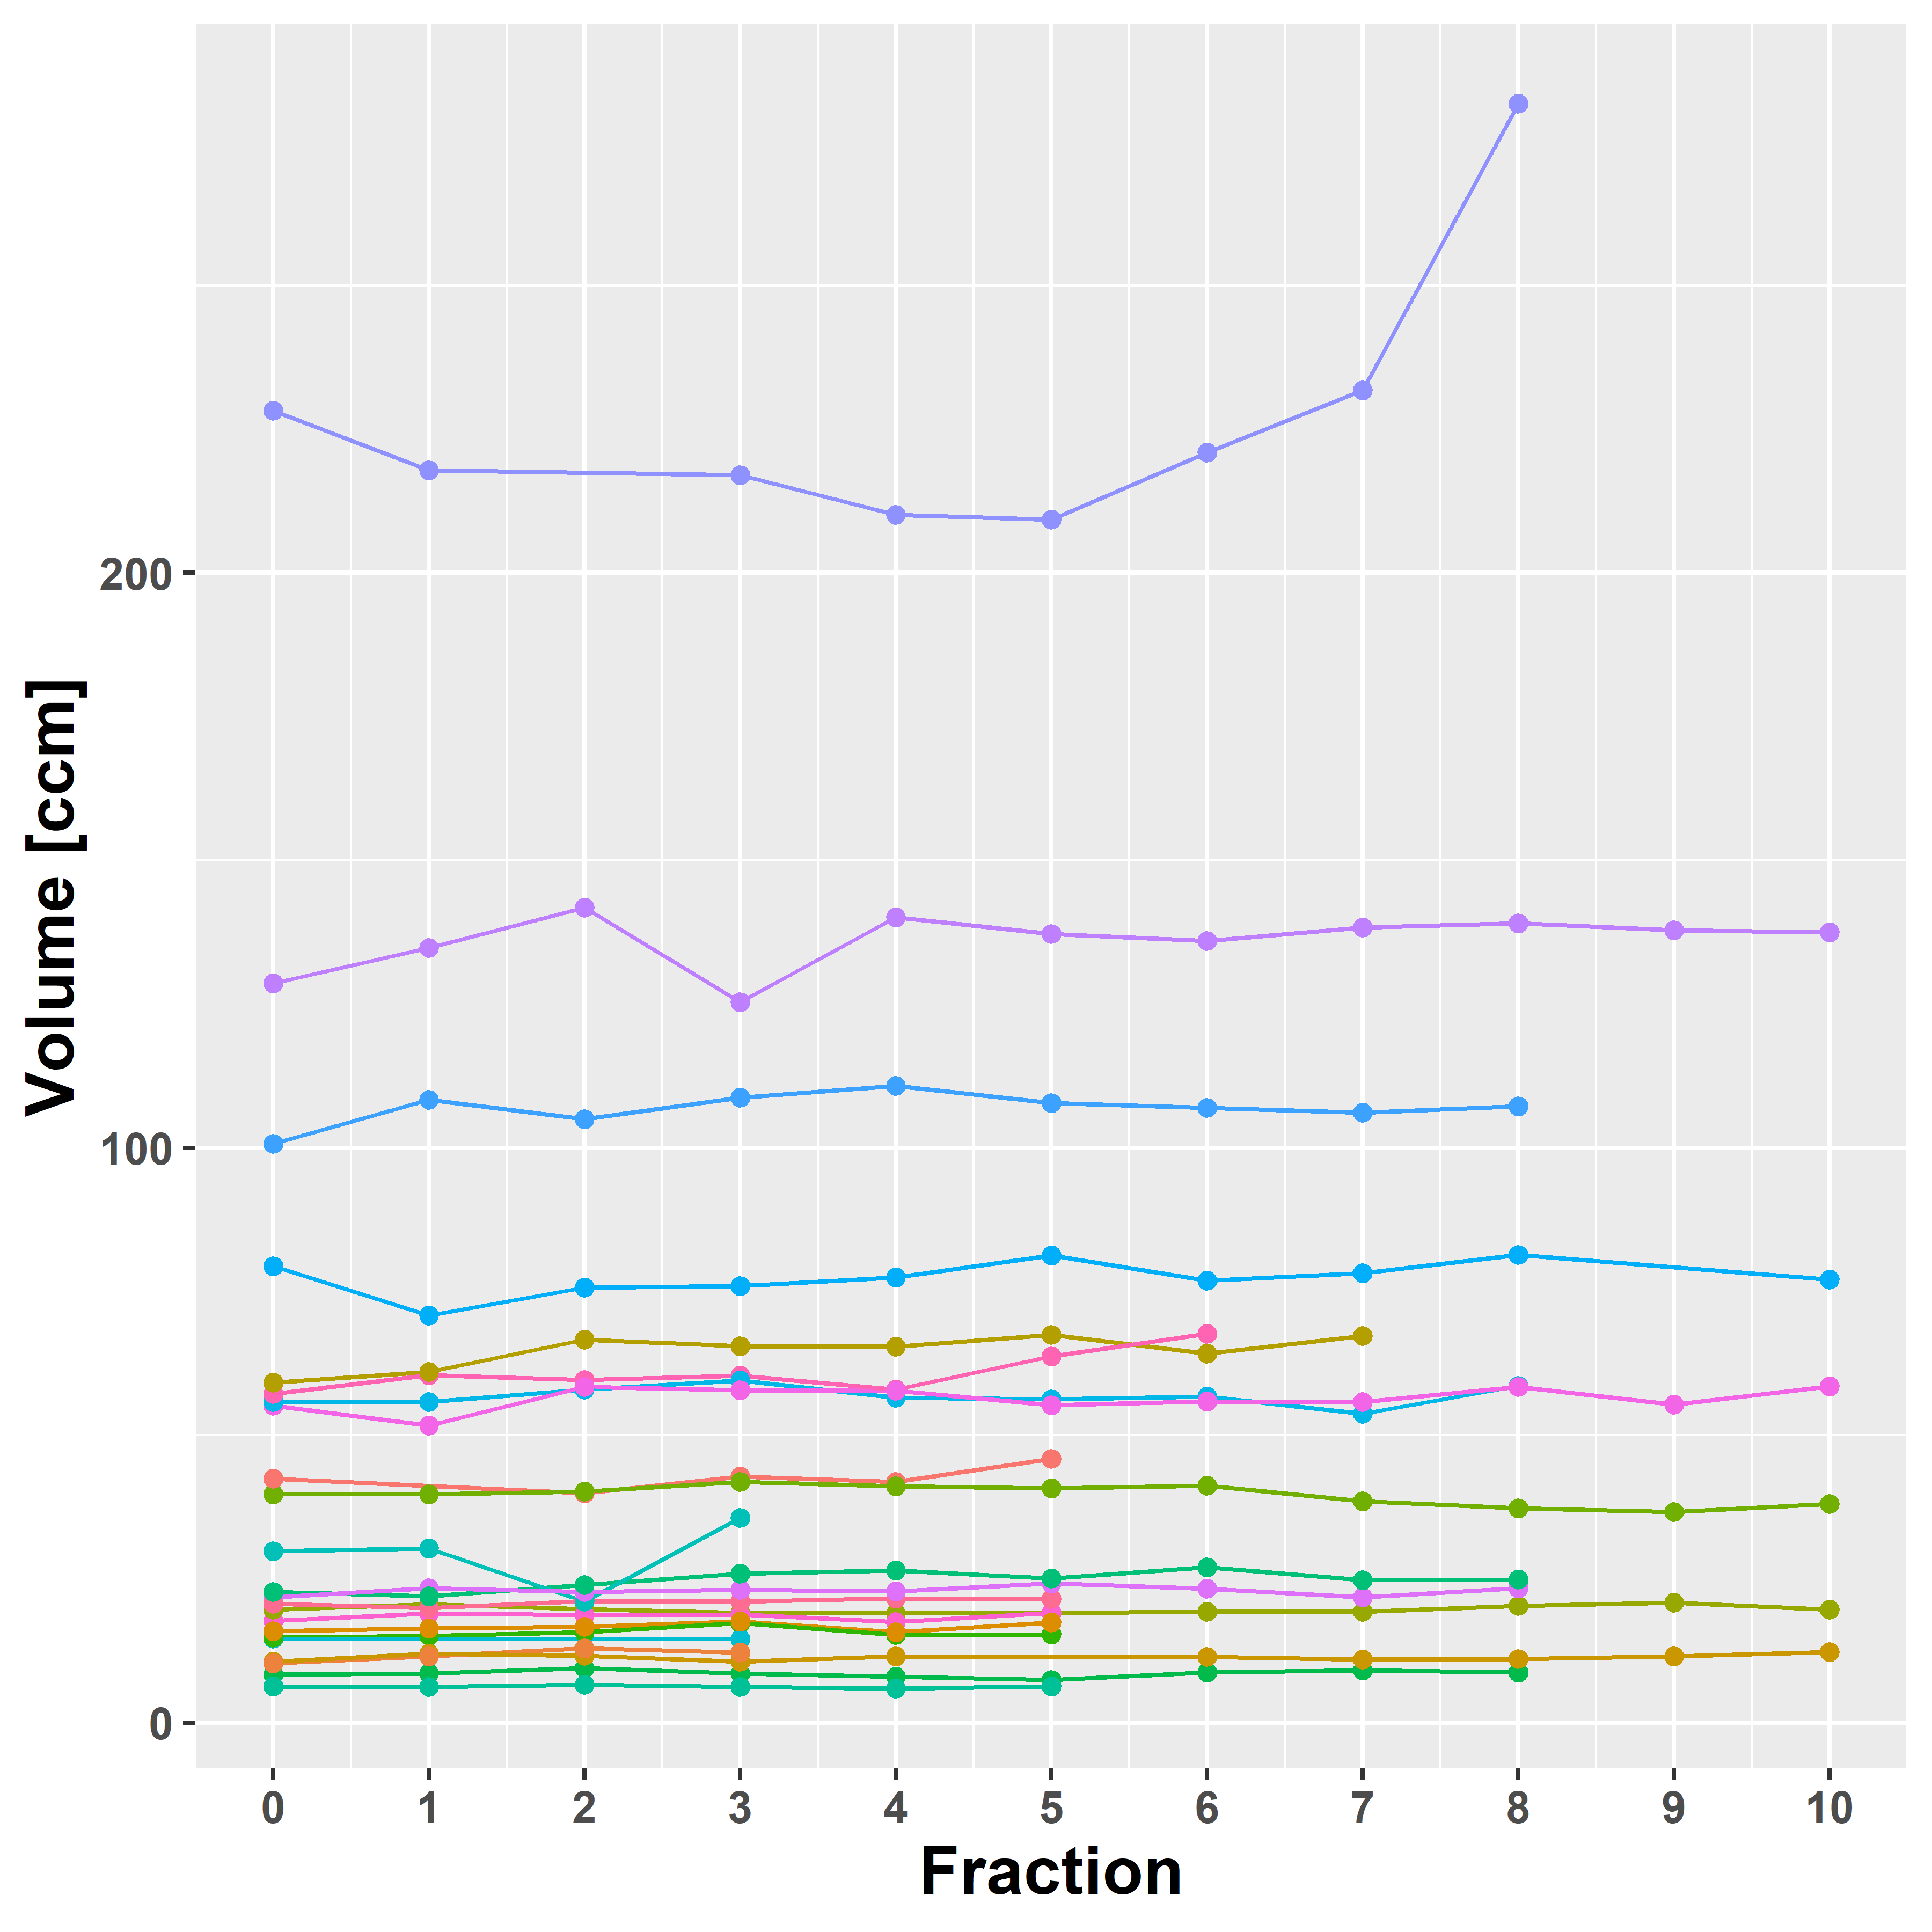
Supplementary Figure 4: Development of planning target volume size [cm³] over fractions for each lesion (N = 23).

Supplementary figure 5: Time requirements for online plan adaptation.

