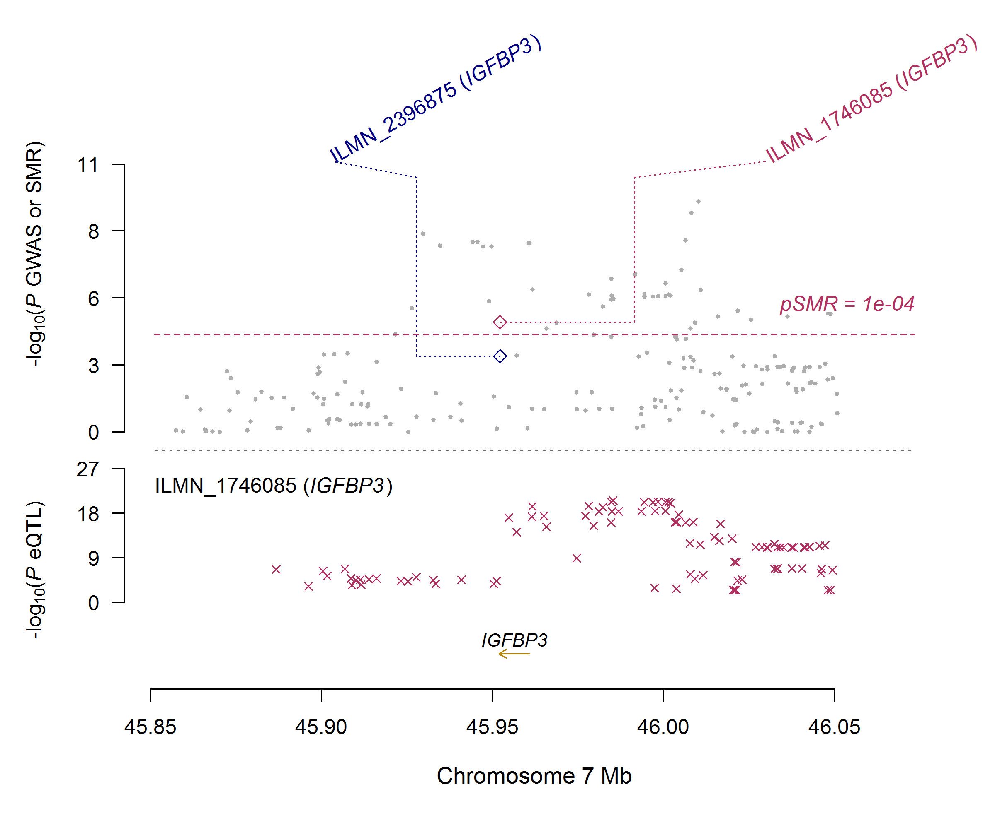
Supplementary figure S1 The association between IGFBP3 mRNA levels and DBP in Europeans.
The figure consists of 2 parts. The x-axis represents the genomic position (GRCh37.p13). The lower part of the figure shows the results of eQTL. The y-axis represents -log10 (P eQTL). In this part, we can see that IGFBP3 SNPs were strongly associated with IGFBP3 mRNA level (eQTL, Westra et al. 2013 Nat Genet). The upper part shows the results of GWAS and SMR analysis. The y-axis represents -log₁₀ (P value of GWAS or SMR). In this part, we found that IGFBP3 SNPs were strongly associated with DBP according to the GWAS (grey dots) and IGFBP3 mRNA levels were associated with DBP (diamonds).

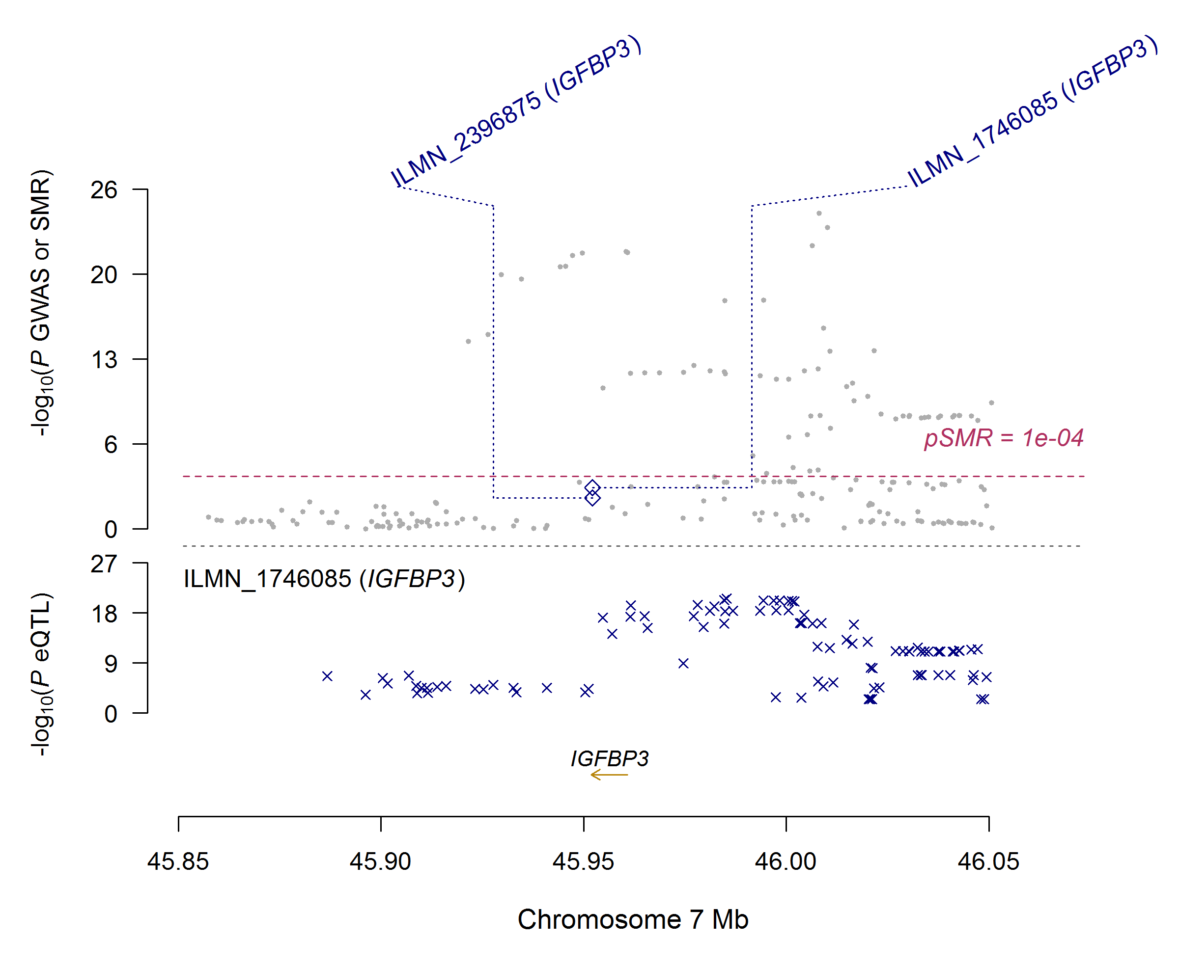
Supplementary figure S2 The association between IGFBP3 mRNA levels and SBP in Europeans.
The figure consists of 2 parts. The x-axis represents the genomic position (GRCh37.p13). The lower part of the figure shows the results of eQTL. The y-axis represents -log10 (P eQTL). In this part, we can see that IGFBP3 SNPs were strongly associated with IGFBP3 mRNA level (eQTL, Westra et al. 2013 Nat Genet). The upper part shows the results of GWAS and SMR analysis. The y-axis represents -log₁₀ (P value of GWAS or SMR). In this part, we found that IGFBP3 SNPs were strongly associated with SBP according to the GWAS (grey dots) and IGFBP3 mRNA levels were associated with SBP (diamonds).

