SUPPLEMENTARY MATERIAL
Supplementary Material 1. Search steps used in the structured literature review based on used the Web of Science database (all databases, 1980-2020) for temperature tolerance of the 20 aquatic prioritised ornamental species based on the abundance and frequency of import to New Zealand.

- The search terms ‘species name’ AND ‘temperature’ were used for initial screening. For example, one search included the terms “Paracheirodon innesi” (in Topic search) AND “temperature” (in Topic Search; quotation marks were not used).
- If there were fewer than 100 results to scan from these first level search terms, the titles and abstracts were assessed for relevance. If there were more than 100 search results, an additional search term – “tolerance” – was added to the search (i.e., species name AND temperature AND tolerance). A further level of search terminology was not required to manage the number of search results to be screened.
- Search results were assessed for relevance and saved to a marked list. This list was then assessed for data on temperature tolerance of each species. Inclusion criteria for data were simply that a species had to be reported from an experiment or field site in association with a clearly measured water temperature.
- Since the topic of specific interest was the temperature ranges of species, data recorded included the highest and lowest temperature reported in a study for a particular species (if many temperatures were reported), the type of data reported (e.g., field or experimental data), the type of experiment (e.g., critical minimum (CTmin) and critical maximum (CTmax) temperature experiments), and the citation for the recorded data.
Supplementary Material 2. Map of occurrence records obtained from for the Global Biodiversity Information Facility (GBIF.org) used for the species distribution models (MaxEnt models) for the 20 prioritised aquatic ornamental freshwater species imported to New Zealand.
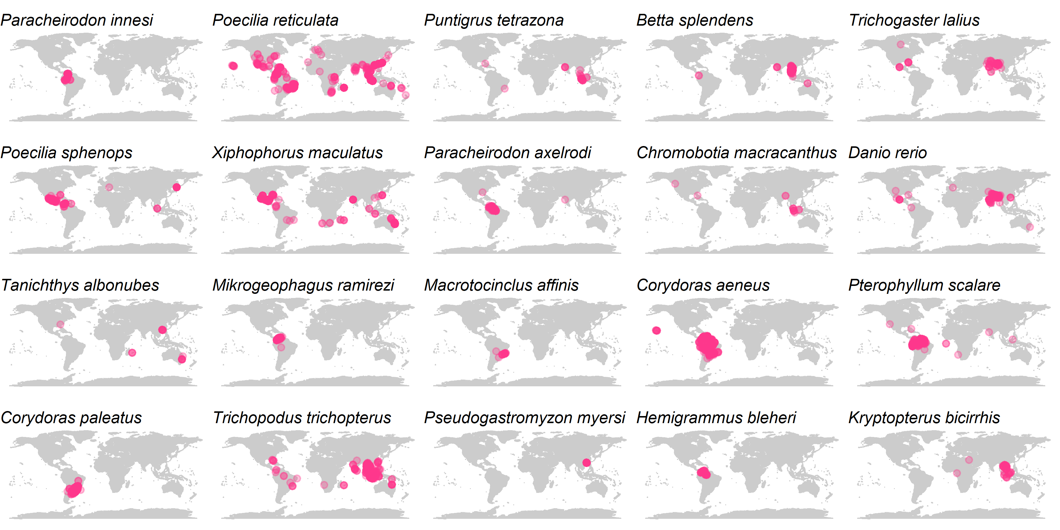

Supplementary Material 3. Area under the curve (AUC) values obtained for the training and test of the five-fold cross-validation of the MaxEnt models for the 20 prioritised aquatic ornamental species imported to New Zealand.
