Supplementary Material

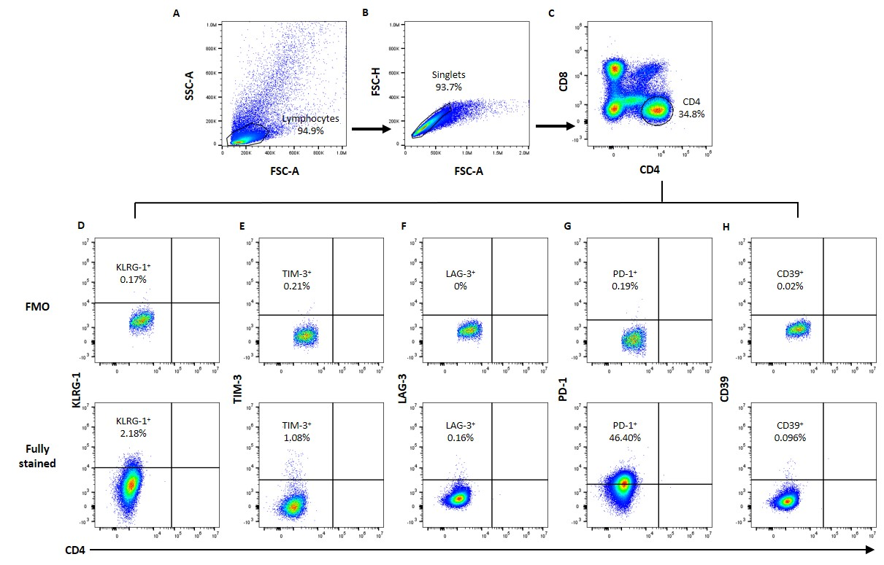
Supplementary Figure S1: Gating strategy for exhausted associated receptors on CD4⁺ T cells
(A) PBMCs were first gated to discriminate lymphocytes using forward-scatter (FSC) versus side scatter (SSC). Then, (B) single cells and (C) CD4 expression was analysed. Finally, expression of the inhibitory receptors (D) KLRG-1, (E) TIM-3, (F) LAG-3, (G) PD-1 and (H) CD39 on CD4⁺ T cells were analysed to discriminate the frequencies of exhausted CD4⁺ T cells subsets based on FMO controls.
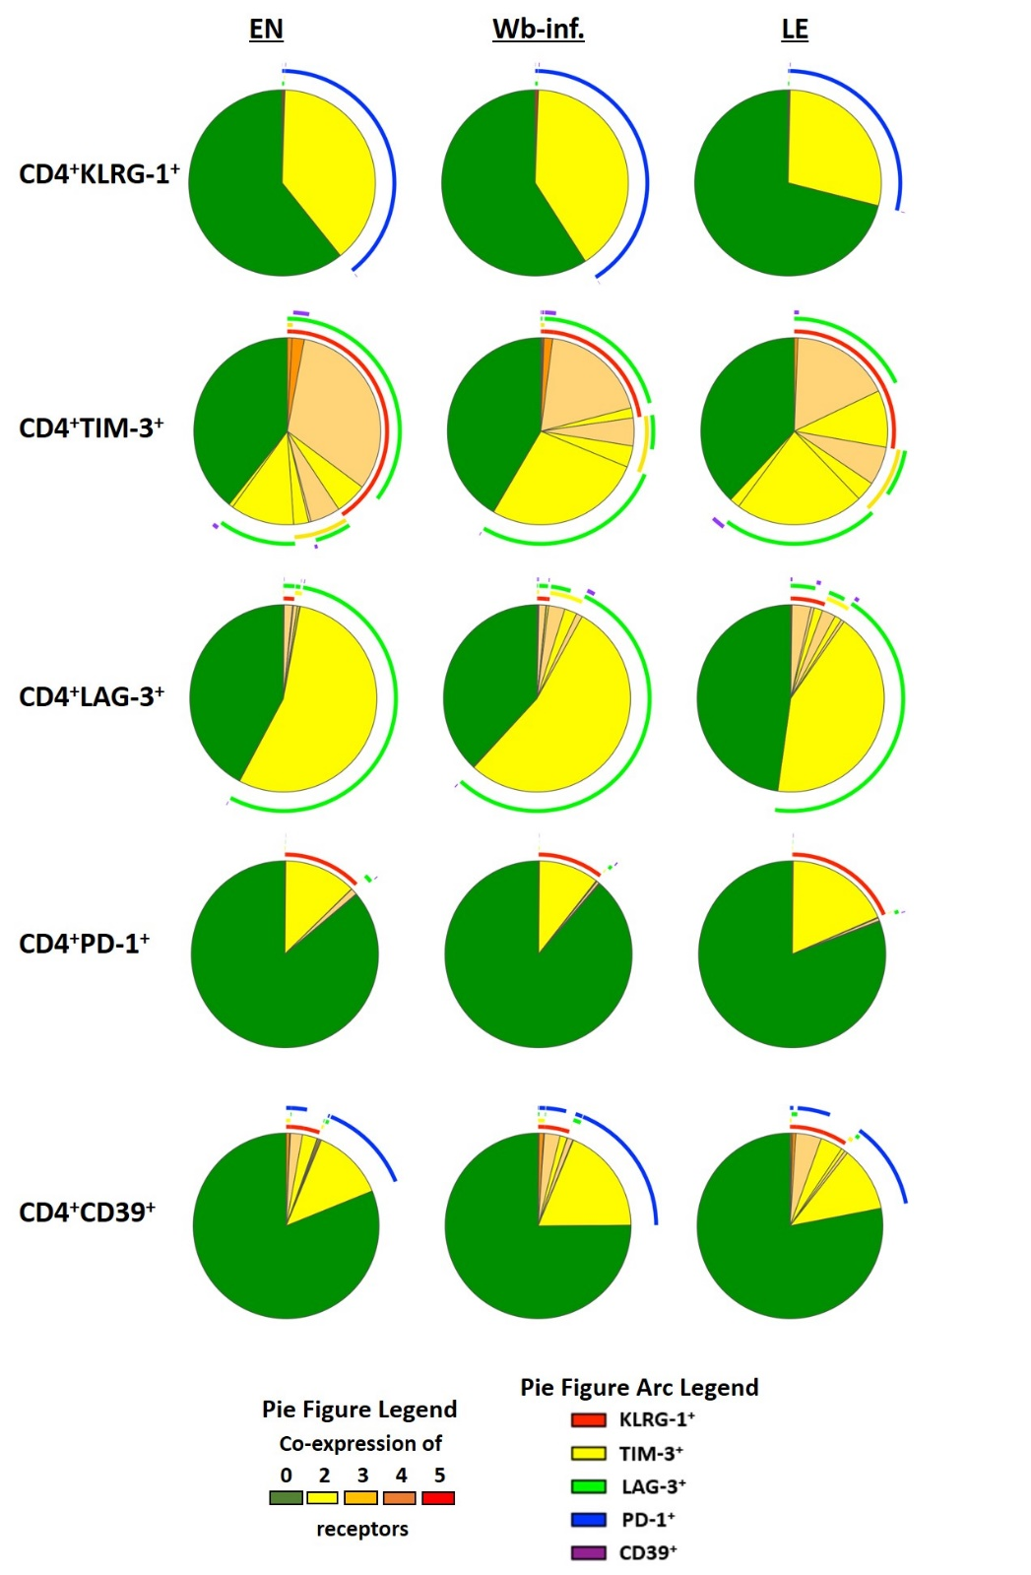
Supplementary Figure S2: Co-expression patterns of exhausted associated receptors in the Ghanaian patient cohorts
Co-expression of exhaustion associated receptors in healthy endemic normal subjects (EN, n=44), Wuchereria bancrofti-infected (Wb-inf., n=31) and lymphedema patients (LE, n=26) was analysed on CD4⁺KLRG1⁺, CD4⁺TIM-3⁺, CD4⁺LAG-3⁺, CD4⁺PD-1⁺ and CD4⁺CD39⁺ T cell subsets using Boolean gating.

