Supplementary Material

Kinetic energy dose as a unified metric for comparing ball mills in the mechanocatalytic depolymerization of lignocellulose
Martin Kessler, Roberto Rinaldi*
Department of Chemical Engineering, Imperial College London, United Kingdom
* Correspondence: r.rinaldi1@imperial.ac.uk

Contents
Table S1. Milling conditions for experiments carried out in the planetary mill Pulverisette 7 premium line equipped with 80 mL grinding jars containing 6.4 g H₂SO₄-impregnated beechwood per jar.
Table S2. Milling conditions for experiments carried out in the high-energy Emax mill equipped with 50 mL grinding jars containing 4 g H₂SO₄-impregnated beechwood per jar.
Figure S1. Internal dimensions of the grinding jars of the planetary mill (Pulverisette 7 premium line, 80 mL jar) and the high-energy Emax mill (50 mL jar). Blue lines indicate the paths of friction.

Table S1: Milling conditions for experiments carried out in the planetary mill Pulverisette 7 premium line equipped with 80 mL grinding jars containing 6.4 g H₂SO₄-impregnated beechwood per jar.

Entry | Ball diameter  (mm) | Ball count per jar  (unit) | Rotational speed  (rpm) | Milling time  (h)
1 | 4 | 391 | 400 | 1.5
2 | 4 | 391 | 500 | 1.5
3 | 4 | 391 | 600 | 1.5
4 | 4 | 391 | 800 | 1.5
5 | 5 | 201 | 500 | 4
6 | 5 | 201 | 500 | 8
7 | 5 | 201 | 600 | 4
8 | 5 | 261 | 600 | 1.5
9 | 10 | 33 | 600 | 1.5
10 | 10 | 34 | 500 | 0.5
11 | 10 | 34 | 500 | 1.17
12 | 10 | 34 | 500 | 3.75
13 | 10 | 34 | 600 | 1.73
14 | 10 | 26 | 500 | 1.5
15 | 10 | 26 | 500 | 0.5
16 | 10 | 26 | 500 | 3
17 | 10 | 26 | 400 | 1.5
18 | 10 | 26 | 500 | 4.4
19 | 10 | 26 | 500 | 2.5
20 | 10 | 26 | 500 | 0.18
21 | 15 | 10 | 600 | 1.5
22 | 20 | 4 | 600 | 1.5

Table S2. Milling conditions for experiments carried out in the high-energy Emax mill equipped with 50 mL grinding jars containing 4 g H₂SO₄-impregnated beechwood per jar.
Entry | Ball diameter  (mm) | Ball count per jar  (unit) | Rotational speed  (rpm) | Milling time  (h)
1 | 2 | 2061 | 1500 | 3
2 | 3 | 611 | 1500 | 3
3 | 4 | 250 | 1500 | 3
4 | 5 | 128 | 1500 | 3
5 | 5 | 128 | 1300 | 3
6 | 6 | 74 | 1500 | 3
7 | 7 | 46 | 1500 | 3
8 | 8 | 31 | 1500 | 3
9 | 9 | 21 | 1500 | 3
10 | 10 | 16 | 1500 | 3
11 | 10 | 16 | 1500 | 2
12 | 10 | 16 | 1500 | 1
13 | 10 | 16 | 800 | 3
14 | 10 | 16 | 800 | 2
15 | 10 | 16 | 800 | 1
16 | 10 | 16 | 1200 | 3
17 | 10 | 16 | 1200 | 2
18 | 10 | 16 | 1200 | 1
19 | 10 | 16 | 1200 | 0.3

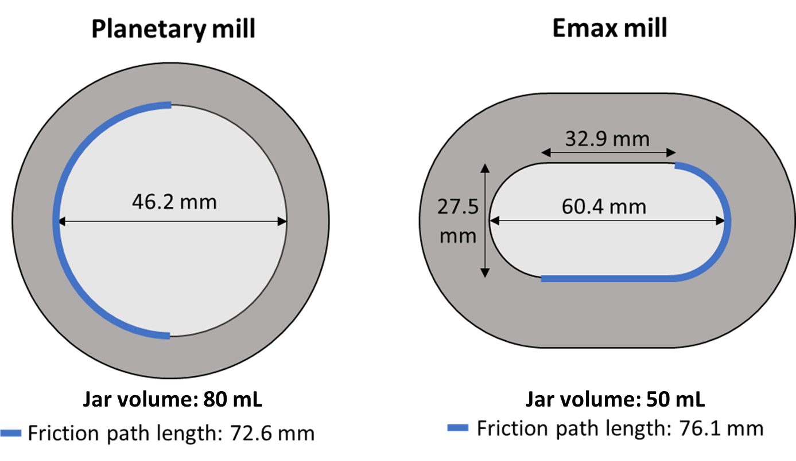
Figure S1. Internal dimensions of the grinding jars of the planetary mill (Pulverisette 7 premium line, 80 mL jar) and the high-energy Emax mill (50 mL jar). Blue lines indicate the paths of friction.

