Year-Round Dive Characteristics of Male Beluga Whales from the Eastern Beaufort Sea Population Indicate Seasonal Shifts in Foraging Strategies

Supplementary Material 3: Results on Successive Dive Types and Surface Duration, and Monthly Sea Ice Maps

Luke Storrie^{1,2}*, Nigel E. Hussey³, Shannon A. MacPhee², Greg O’Corry-Crowe⁴, John Iacozza¹, David G. Barber¹, Alex Nunes⁵ and Lisa L. Loseto^{1,2}

¹ Centre for Earth Observation Science, Department of Environment and Geography, The University of Manitoba, Winnipeg, MB, Canada
² Freshwater Institute, Fisheries and Oceans Canada, Winnipeg, MB, Canada
³ Department of Integrative Biology, University of Windsor, Windsor, ON, Canada
⁴ Harbor Branch Oceanographic Institute, Florida Atlantic University, Fort Pierce, FL, United States
⁵ Ocean Tracking Network, Dalhousie University, Halifax, NS, Canada

*Correspondence:
Luke Storrie
storriel@myumanitoba.ca

List of figures and tables
Figures
Figure S3a: Frequency of each dive type being followed by another dive type. 3
Figure S3b: Monthly sea ice concentrations from July 2018 - June 2019 5

Tables
Table S3a: Comparisons of post-dive surface intervals among dive types. 2
Table S3b: Post-dive surface intervals of dive types depending on following dive type. 4
Table S3c: Comparisons of post-dive surface intervals among Deep Benthic and Deep Pelagic V dives followed by different dive types. 4

1. Overview
This document contains supplementary results regarding comparisons in post-dive surface intervals among dive types (Table S3a), frequency of a dive type being followed by another dive type (Figure S3a), and comparisons among post-dive surface intervals depending on the successive dive type (Table S3b, Table S3c). Figure S3b shows the sea ice concentrations over the study area from July 2018 – June 2019.

2. Comparing post-dive surface intervals among dive types
The post-dive surface interval was not included in the dive classification procedure, as we wanted to maximize the number of dives that could be classified; and due to gaps in the data this metric was sometimes underestimated. Instead, incorrect surface durations were converted to NA (see Supplementary material 2), and this metric was compared among dive types following classification with a Tukey’s test following an ANOVA (Table S3a).

Table S3a: Results of the Tukey’s test comparing difference in (log-transformed) post-dive surface intervals between dive types, following an ANOVA. Number of dives of each type with a complete post-dive surface interval used in calculations: Deep benthic (DB) = 11512, Deep pelagic V (DPV) = 2219, Deep Pelagic W (DPW) = 2133, Deep Pelagic Skew (DPS) = 345, Intermediate Benthic (IB) = 21523, Intermediate Pelagic (IP) = 11383, Shallow V (SV) = 32087, Shallow W (SW) = 7704.
Dive type contrast |  | Difference | P-value
DPV-DB | 0.13 |  | <0.001
DPW-DB | -0.78 |  | <0.001
DPS-DB | -1.02 |  | <0.001
IB-DB | -1.03 |  | <0.001
IP-DB | -1.03 |  | <0.001
SV-DB | -0.70 |  | <0.001
SW-DB | -0.77 |  | <0.001
DPW-DPV | -0.91 |  | <0.001
DPS-DPV | -1.15 |  | <0.001
IB-DPV | -1.17 |  | <0.001
IP-DPV | -1.17 |  | <0.001
SV-DPV | -0.83 |  | <0.001
SW-DPV | -0.90 |  | <0.001
DPS-DPW | -0.24 |  | <0.001
IB-DPW | -0.25 |  | <0.001
IP-DPW | -0.25 |  | <0.001
SV-DPW | 0.08 |  | 0.002
SW-DPW | 0.01 |  | 1.000
IB-DPS | -0.01 |  | 1.000
IP-DPS | -0.01 |  | 1.000
SV-DPS | 0.32 |  | <0.001
SW-DPS | 0.25 |  | <0.001
IP-IB | 0.00 |  | 1.000
SV-IB | 0.34 |  | <0.001
SW-IB | 0.26 |  | <0.001
SV-IP | 0.33 |  | <0.001
SW-IP | 0.26 |  | <0.001
SW-SV | -0.07 |  | <0.001

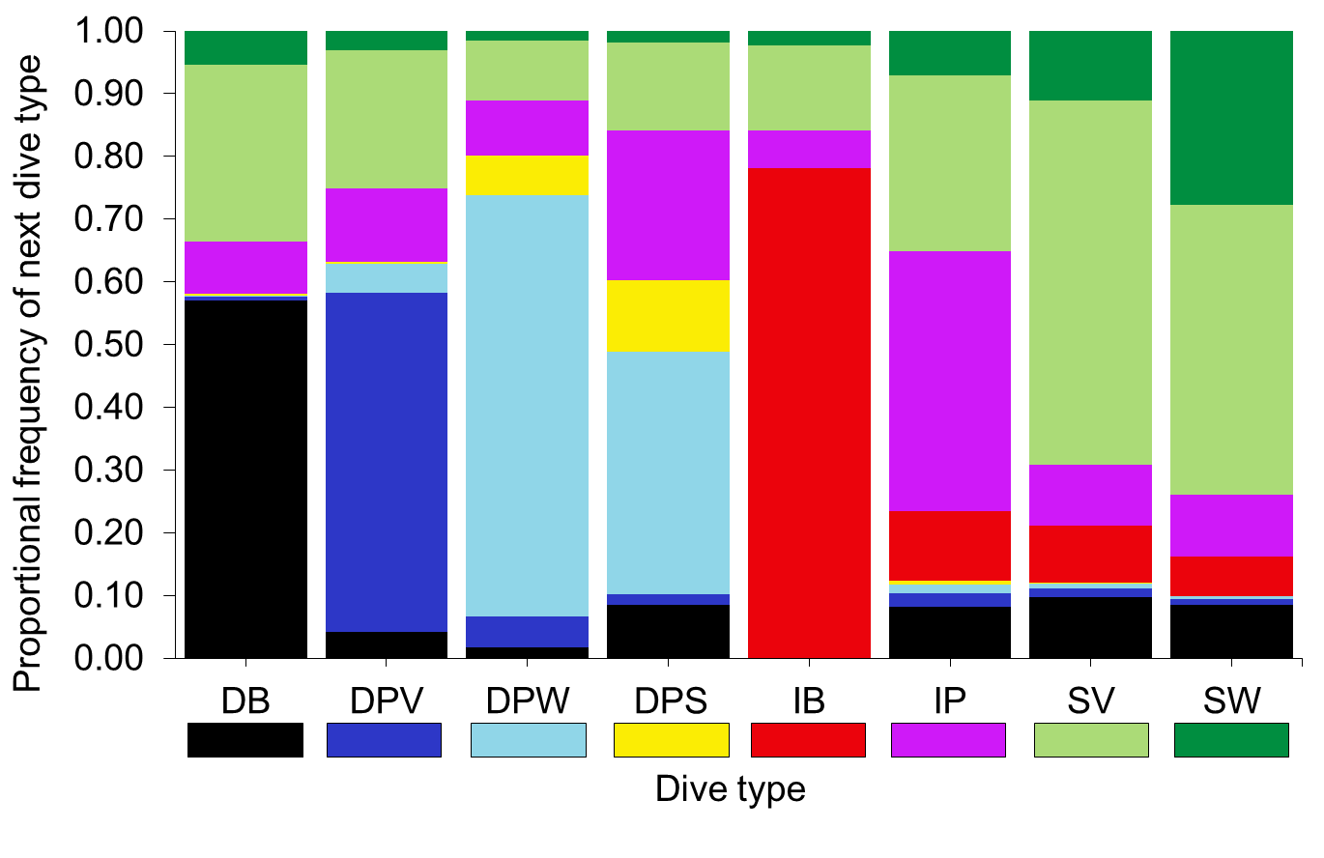
Figure S3a: Proportional frequency of each dive type at time t (x-axis) being followed by a given dive type at time t + 1 (y-axis). Colours beneath each named dive type corresponds to colour of each dive type in the bar chart and in Table 2 of the manuscript, for example 57% of Deep Benthic dives were followed by a Deep Benthic dive, and 8% of Deep Benthic dives were followed by an Intermediate Pelagic dive. Dive type abbreviations: Deep Benthic = DB, Deep Pelagic V = DPV, Deep Pelagic W = DPW, Deep Pelagic Skew = DPS, Intermediate Benthic = IB, Intermediate Pelagic = IP, Shallow V = SV, Shallow W = SW.

Table S3b: Median post-dive surface intervals for each dive type at time t when followed by a given dive type at time t + 1. Only calculated for dives which followed a dive type ≥5% of the time, see Figure S3a. Parentheses contain 5th and 95th percentiles. Dive type abbreviations: Deep Benthic = DB, Deep Pelagic V = DPV, Deep Pelagic W = DPW, Deep Pelagic Skew = DPS, Intermediate Benthic = IB, Intermediate Pelagic = IP, Shallow V = SV, Shallow W = SW.
Dive type (at time t) | Following dive type (at time t + 1)
 | DB | DPV | DPW | DPS | IB | IP | SV | SW
DB | 5.00  (1.75, 15.00) | NA | NA | NA | NA | 2.50  (0.25, 17.50) | 3.75  (0.25, 12.75) | NA
DPV | NA | 5.00  (2.50, 16.25) | NA | NA | NA | 3.00  (0.70, 10.25) | 3.75  (0.50, 15.25) | NA
DPW | NA | NA | 1.75  (0.75, 4.00) | 1.50  (0.25, 2.75) | NA | 1.25  (0.25, 5.00) | 1.63  (0.25, 5.98) | NA
DPS | 2.50  (0.73, 4.53) | NA | 1.25  (0.25, 2.74) | 1.88  (0.25, 4.06) | NA | 1.25  (0.25, 3.75) | 1.63  (0.25, 19.55) | NA
IB | NA | NA | NA | NA | 1.25  (0.25, 4.00) | 1.50  (0.25, 5.00) | 1.75  (0.25, 8.50) | NA
IP | 2.50  (0.25, 11.25) | NA | NA | NA | 1.50  (0.25, 5.00) | 1.25  (0.25, 4.75) | 1.50  (0.25, 7.25) | 1.75  (0.25, 5.00)
SV | 2.75  (0.25, 12.56) | NA | NA | 2.00  (0.25, 12.59) | 2.00  (0.25, 8.25) | 1.50  (0.25, 7.00) | 2.00  (0.25, 9.75) | 1.75  (0.25, 6.75)
SW | 3.75  (1.25, 12.75) | NA | NA | NA | 1.75  (0.25, 5.75) | 1.75  (0.25, 5.75) | 1.75  (0.25, 6.75) | 1.75  (0.50, 5.00)

Table S3c: Results of the Tukey’s test comparing difference in (log-transformed) post-dive surface intervals between Deep Benthic (DB) and Deep Pelagic V (DPV) type dives when followed by an Intermediate Pelagic (IP) or Shallow V (SV) dive type compared to a dive of the same type (i.e. a Deep Benthic followed by a Deep Benthic dive), following an ANOVA.
Dive type at time t | Dive type at time t + 1 | Difference | P-value
DB | IP | 0.57 | <0.001
DB | SV | 0.48 | <0.001
DPV | IP | 0.62 | <0.001
DPV | SV | 0.45 | <0.001

3. Sea ice maps
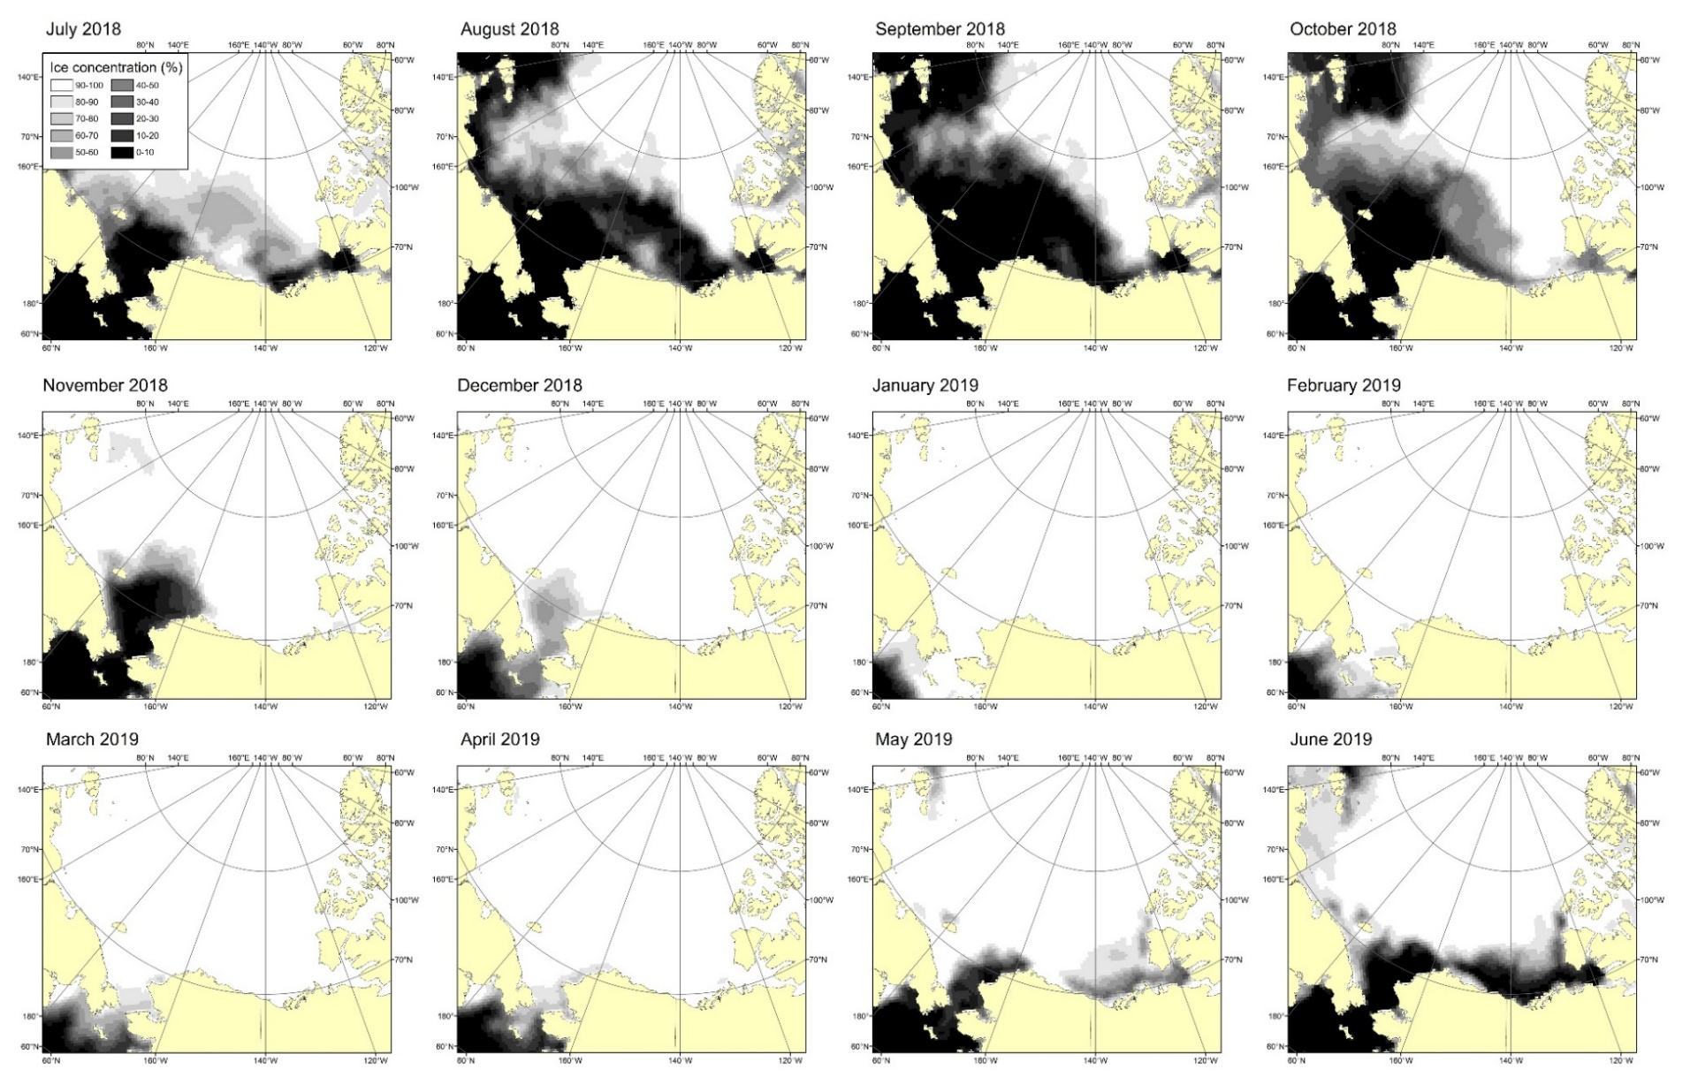
Figure S3b: Monthly sea ice concentration from July 2018 to June 2019 (i.e. the duration over which the belugas with the longest deployments from 2018 transmitted for). Downloaded from NOAA/NSIDC Climate Data Record of Passive Microwave Sea Ice Concentration, Version 4, on a 25 km grid (Meier et al. 2021).
References
Meier W. N., Fetterer F., Windnagel A.K. & Stewart J.S. 2021. NOAA/NSIDC Climate Data Record of Passive Microwave Sea Ice Concentration, Version 4. July 3rd 2018 – November 15th 2019. Boulder, Colorado USA. NSIDC: National Snow and Ice Data Center. doi: https://doi.org/10.7265/efmz-2t65. Accessed July 19th 2021.

