**Supplementary Figures and Tables**

**1.1. Supplementary Figures**

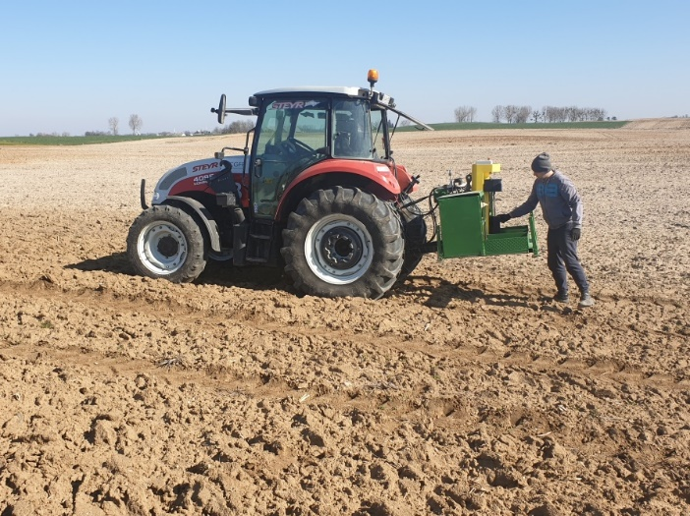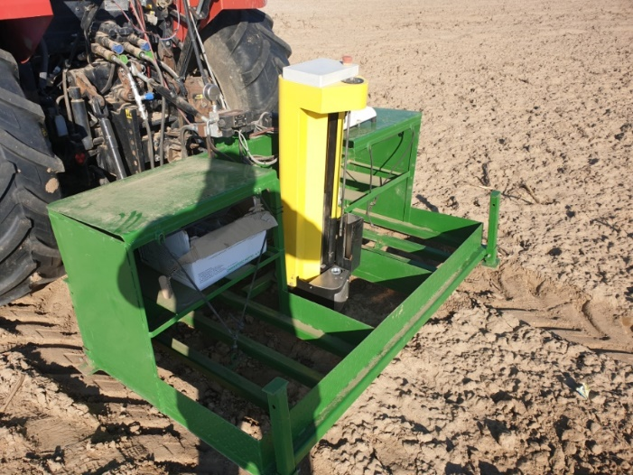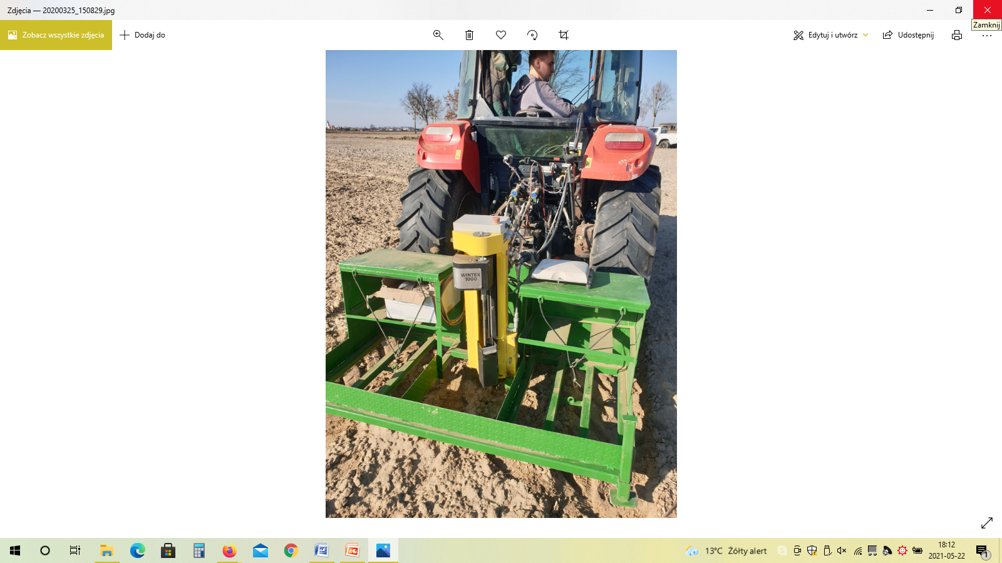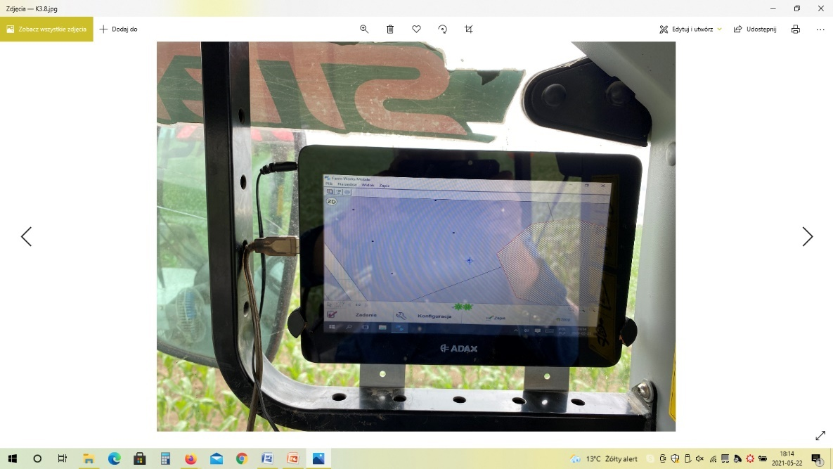

**Supplementary Figure S1.** Automatic Egner cane and GPS system for representative sampling for laboratory analysis (photo: A. Slomczewski)



**Supplementary Figure S2.** Rarefaction curves for the studied soil rasters based on the taxa (S) number.

**Supplementary Figure S3.** Subdominant (>2%) fungal genera in the studied rasters of K20 field under intercropping mixture and K21 field under maize monoculture in spring, summer and autumn seasons.

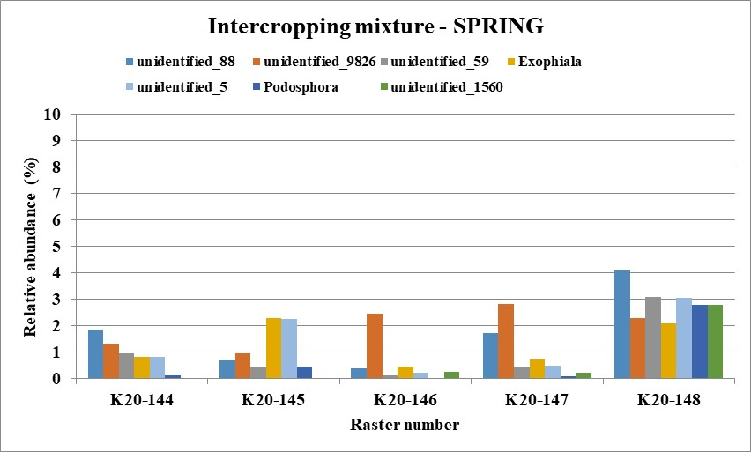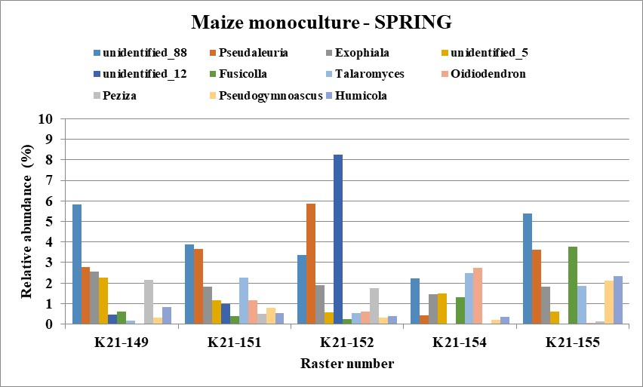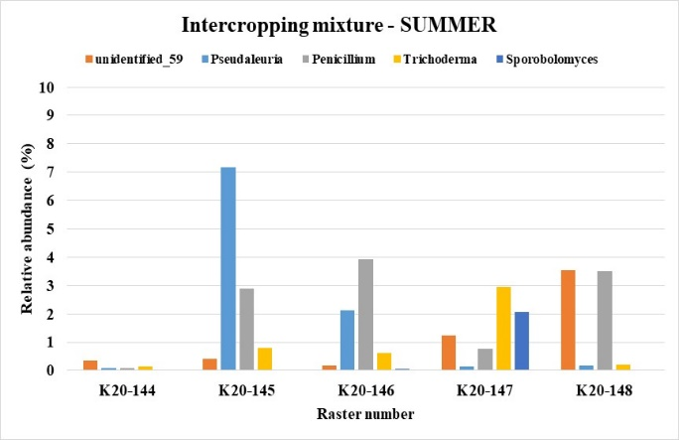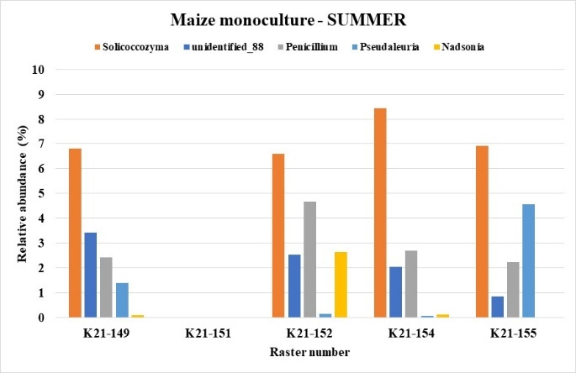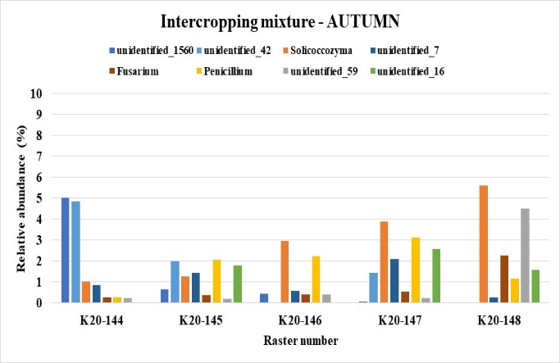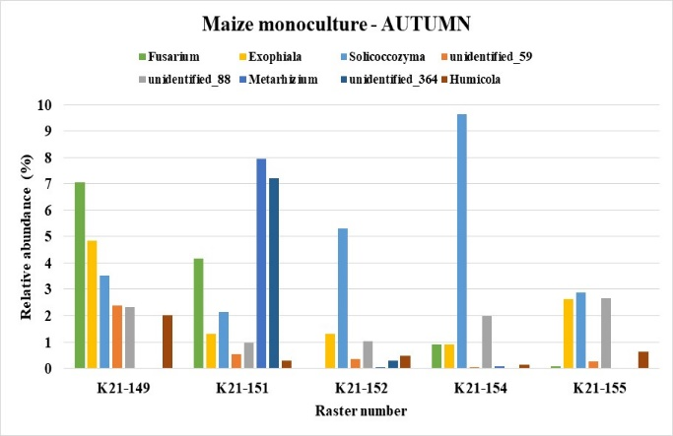

**Supplementary Figure S4.** Accompanying (>1%) fungal genera in the studied rasters of K20 field under intercropping mixture and K21 field under maize monoculture in spring, summer and autumn seasons

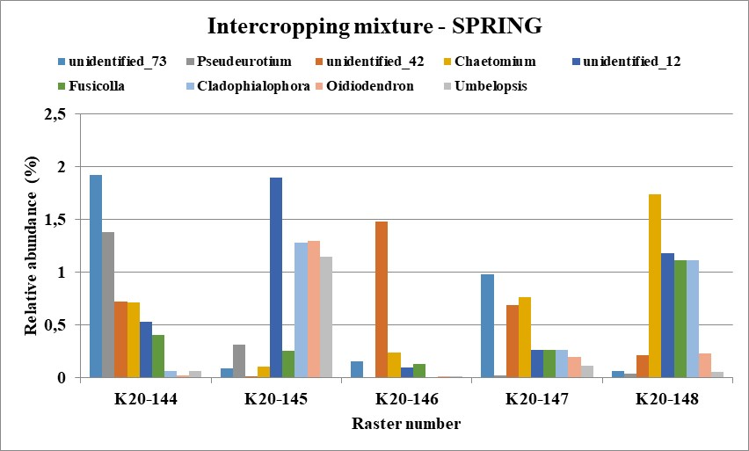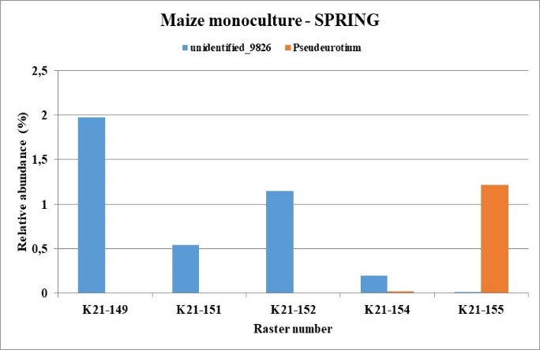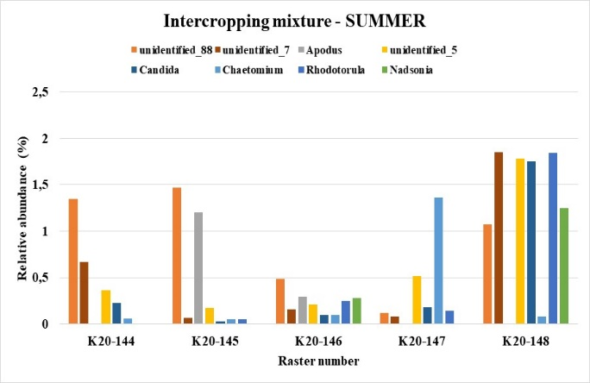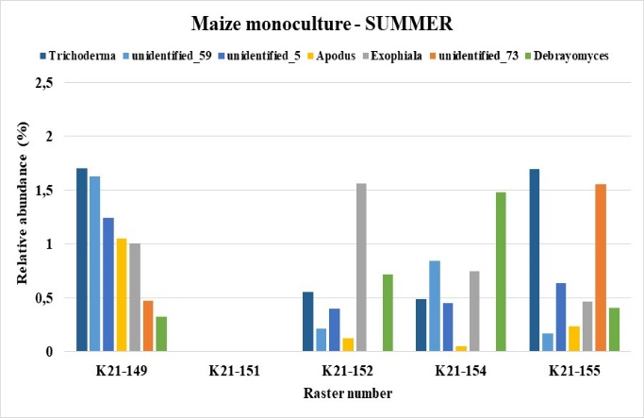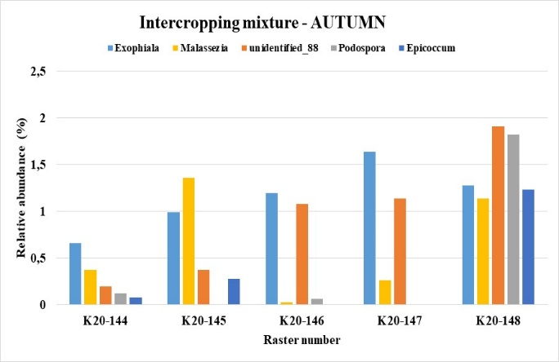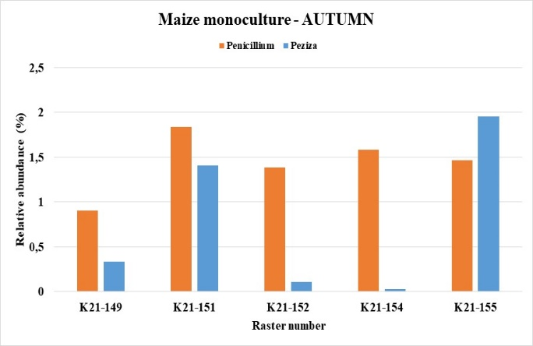

**1.2. Supplementary Tables**

**Table S1.** The basic chemical properties of the studied soils at different seasons: K20 - intercropping mixture and K21 - maize monoculture (mean values of three replicates ± standard deviation level). Small letters in the upper index mean significant differences in the parameters between studied soil rasters (Tukey’s mean separation test, *p*<0.05, n=3).

|  |  |  |  |  |
| --- | --- | --- | --- | --- |
| **Nr of raster** | **pH(H2O)** | **Eh (mV)** | **TOC (%)** | **Moisture (%)** |
| **SPRING** | | | | |
| K20-144 | 6.07a±0.04 | 509.23b±0.12 | 0.71b±0.01 | 4.59a±0.07 |
| K20-145 | 6.07a±0.03 | 526.50c±0.85 | 0.82b±0.04 | 5.89b±0.11 |
| K20-146 | 7.90c±0.03 | 493.60a±0.08 | 0.61a±0.03 | 7.56c±0.05 |
| K20-147 | 6.21a±0.03 | 514.30c±0.16 | 1.16c±0.04 | 9.53d±0.08 |
| K20-148 | 6.07a±0.04 | 525.60c±0.21 | 1.34d±0.03 | 8.92e±0.06 |
| K21-149 | 6.02a±0.01 | 514.70b±0.04 | 0.52e±0.03 | 6.20b±0.03 |
| K21-151 | 6.40b±0.01 | 509.60b±1.60 | 0.59e±0.03 | 7.36c±0.06 |
| K21-152 | 5.82d±0.04 | 520.20c±0.08 | 0.56e±0.01 | 8.51e±0.12 |
| K21-154 | 6.83b±0.02 | 507.00b±0.16 | 0.67a±0.05 | 7.40c±0.06 |
| K21-155 | 7.93c±0.03 | 499.70**a**±0.21 | 1.02c±0.02 | 8.41e±0.05 |
| **SUMMER** | | | | |
| K20-144 | 6.63b±0.05 | 534.40d±0.20 | 0.85b±0.02 | 10.26f±0.03 |
| K20-145 | 6.20a±0.05 | 534.33d±0.26 | 0.79b±0.02 | 7.70c±0.06 |
| K20-146 | 5.95d±0.01 | 533.86d±0.25 | 0.77b±0.03 | 9.13e±0.07 |
| K20-147 | 6.29a±0.03 | 527.07c±0.20 | 0.77b±0.04 | 10.92f±0.04 |
| K20-148 | 5.70d±0.02 | 534.57d±0.05 | 1.14c±0.04 | 14.64g±0.08 |
| K21-149 | 5.31e±0.02 | 561.53e±0.70 | 0.71b±0.05 | 10.24f±0.03 |
| K21-151 | 5.44e±0.01 | 567.60e±0.17 | 0.45e±0.01 | 9.09e±0.08 |
| K21-152 | 5.46e±0.01 | 568.03e±0.59 | 0.62a±0.04 | 8.84e±0.06 |
| K21-154 | 6.08a±0.02 | 542.67d±0.37 | 0.77b±0.03 | 10.73f±0.09 |
| K21-155 | 6.60b±0.04 | 537.73d±0.95 | 0.70b±0.04 | 10.44f±0.05 |
| **AUTUMN** | | | | |
| K20-144 | 6.17a±0.03 | 491.07a±0.28 | 0.58e±0.02 | 13.05g±0.06 |
| K20-145 | 6.60b±0.01 | 417.73f±3.02 | 0.52e±0.03 | 10.88f±0.08 |
| K20-146 | 6.94c±0.01 | 424.83f±0.12 | 0.42e±0.01 | 12.23h±0.09 |
| K20-147 | 6.61b±0.03 | 469.67a±0.25 | 0.51e±0.05 | 12.01h±0.11 |
| K20-148 | 5.99a±0.16 | 499.13a±0.76 | 0.87b±0.01 | 16.32i±0.04 |
| K21-149 | 5.99a±0.02 | 496.53a±0.33 | 0.23f±0.02 | 11.87f±0.06 |
| K21-151 | 5.84d±0.01 | 515.30c±0.21 | 0.35f±0.01 | 9.66e±0.03 |
| K21-152 | 6.33b±0.01 | 506.57b±0.23 | 0.36f±0.02 | 9.61e±0.05 |
| K21-154 | 6.55b±0.02 | 484.07a±0.17 | 0.39e±0.03 | 13.35g±0.02 |
| K21-155 | 6.99c±0.04 | 426.17f±0.12 | 0.40e±0.03 | 11.88f±0.03 |

**Table S2.** DNA concentration and purity in the studied soils at different seasons: K20 - intercropping mixture and K21 - maize monoculture (mean values of three replicates ± standard deviation level)

|  |  |  |  |
| --- | --- | --- | --- |
| **Nr of raster** | **DNA content [µg·ml-1]** | **A260/280**  **ratio** | **A260/230 ratio** |
| **SPRING** | | |
| K20-144 | 9.05±2.33 | 1.54±0.11 | 0.50±0.01 |
| K20-145 | 13.90±2.05 | 1.71±0.16 | 0.54±0.13 |
| K20-146 | 8.75±1.91 | 1.66±0.03 | 0.61±0.08 |
| K20-147 | 11.75±2.59 | 1.62±0.05 | 0.60±0.04 |
| K20-148 | 17.70±3.82 | 1.57±0.04 | 0.53±0.02 |
| K21-149 | 13.30±1.57 | 1.52±0.16 | 0.48±0.06 |
| K21-151 | 8.10±1.54 | 1.62±0.09 | 0.49±0.02 |
| K21-152 | 13.85±1.10 | 1.51±0.18 | 0.48±0.01 |
| K21-154 | 13.84±2.60 | 1.62±0.04 | 0.56±0.00 |
| K21-155 | 18.10±1.08 | 1.72±0.04 | 0.86±0.02 |
| **SUMMER** | | |
| K20-144 | 16.04±0.24 | 1.60±0.04 | 0.46±0.01 |
| K20-145 | 14.78±0.25 | 1.63±0.04 | 0.42±0.01 |
| K20-146 | 8.61±0.15 | 1.59±0.05 | 0.32±0.01 |
| K20-147 | 20.89±0.86 | 1.57±0.09 | 0.47±0.01 |
| K20-148 | 19.66±0.17 | 1.63±0.02 | 0.55±0.01 |
| K21-149 | 18.99±0.58 | 1.62±0.10 | 0.47±0.01 |
| K21-151 | 9.63±0.33 | 1.67±0.06 | 0.35±0.01 |
| K21-152 | 9.84±0.12 | 1.52±0.04 | 0.39±0.01 |
| K21-154 | 12.25±0.19 | 1.53±0.04 | 0.44±0.01 |
| K21-155 | 12.60±0.29 | 1.59±0.04 | 0.44±0.01 |
| **AUTUMN** | | |
| K20-144 | 4.042±2.43 | 1.76±0.07 | 1.55±0.22 |
| K20-145 | 3.57±0.67 | 1.72±0.12 | 1.00±0.09 |
| K20-146 | 2.38±0.95 | 1.60±0.09 | 0.75±0.16 |
| K20-147 | 1.66±1.11 | 1.48±0.05 | 0.65±0.03 |
| K20-148 | 3.08±0.04 | 1.81±0.02 | 0.74±0.15 |
| K21-149 | 2.44±0.25 | 2.06±0.06 | 0.48±0.25 |
| K21-151 | 10.19±0.54 | 1.44±0.05 | 0.55±0.14 |
| K21-152 | 10.72±0.75 | 1.88±0.03 | 0.49±0.06 |
| K21-154 | 5.67±0.69 | 1.67±0.19 | 0.73±0.03 |
| K21-155 | 8.45±0.84 | 1.72±0.10 | 0.80±033 |