Supporting information
Synthesis of Novel Suramin Analogs with Anti-Proliferative Activity via FGF1 and FGFRD2 blockade

Nuzhat Parveen,¹ Yan-Liang Lin,²
- Chemistry Department, National Tsing Hua University, Hsinchu 300, Taiwan.
- Department of Applied Chemistry, National Yang Ming Chiao Tung University, Hsinchu 300, Taiwan.
* Correspondence:
Chin Yu: cyu.nthu@gmail.com, Chung-Ming Sun: cmsun@nctu.edu.tw, Ruey-Hwang Chou: rhchou@gmail.com

Ruey-Hwang Chou,^{1,2,3,4*} Chung-Ming Sun,^{5,6*} Chin Yu^{7*}
- Graduate Institute of Biomedical Sciences, China Medical University, Taichung 40402, Taiwan, R.O.C
- The Ph.D. Program of Biotechnology and Biomedical Industry, China Medical University, Taichung 40402, Taiwan, R.O.C.
- Center for Molecular Medicine, China Medical University Hospital, Taichung 40402, Taiwan, R.O.C.
- Department of Medical Laboratory and Biotechnology, Asia University, Taichung 41354, Taiwan, R.O.C.
- Department of Medicinal and Applied Chemistry, Kaohsiung Medical University, Kaohsiung 807, Taiwan.
- Department of Applied Chemistry, National Yang Ming Chiao Tung University, Hsinchu 300, Taiwan.
- Chemistry Department, National Tsing Hua University, Hsinchu 300, Taiwan.
*authors to whom correspondence should be addressed.

Prof. Chin Yu*
Department of Chemistry
National Tsing Hua University Hsinchu, Taiwan.
Email: cyu.nthu@gmail.com

Prof. Chung Ming Sun*
Department of Applied Chemistry
National Chiao Tung University Hsinchu, Taiwan.
Email: cmsun@nctu.edu.tw

Prof. Ruey-Hwang Chou*
Associate Professor, Graduate Institute of Biomedical Sciences,
Center for Molecular Medicine,
China Medical University,
9F, No. 6, Hsueh-Shih Road, Taichung, 40454, Taiwan
Tel: 886-4-22052121 ext. 7935 (Office) or 7913 (Lab)
Fax: 886-4-22333496
E-mail: rhchou@cmu.edu.tw

S1.NMR Results of all the Compounds (compound 4-compound21)

S2. Stability of the compounds in aqueous solution and DMSO

11 Days
1 Day
4 Days
Figure S2-1. ¹H NMR spectrum of compound 15 in DMSO-d₆.

1 Day
4 Days
11 Days
Figure S2-2. ¹H NMR spectrum of compound 15 in D₂O.

Figure S2-3. ¹H NMR spectrum of compound 18 in DMSO-d₆.
11 Days
4 Days
1 Day

Figure S2-4. ¹H NMR spectrum of compound 18 in D₂O.
1 Day
4 Days
11 Days

S3. SDS PAGE of FGF1

S4. HPLC Details for FGF1

P: PEAK
PM: PROTEIN MARKER
S5. ESI-MASS of FGF1
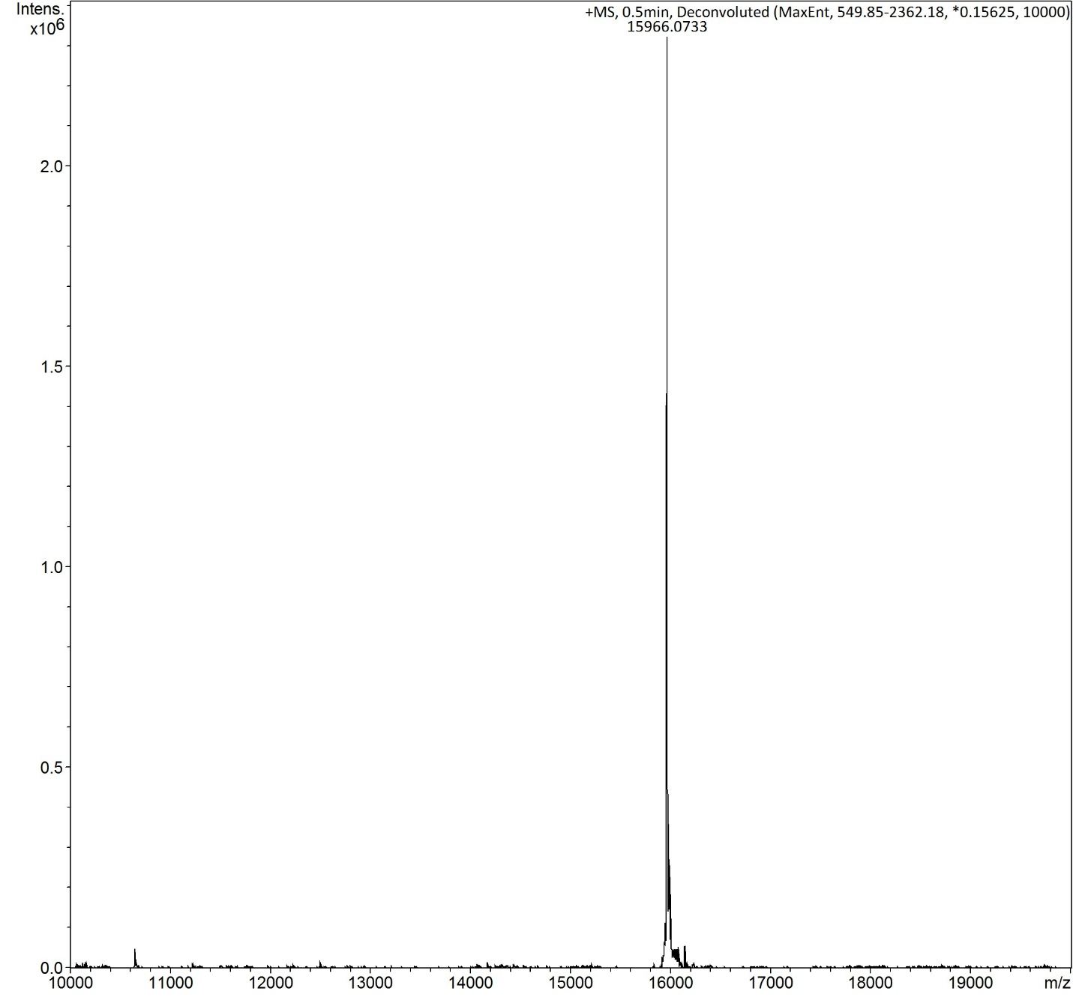
Theoretical MW: 15967.00
Experimental MW: 15966.0733

Compound 14
S6. Validation of Docking protocol

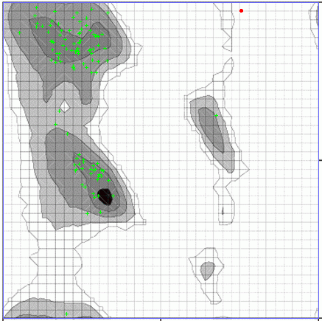

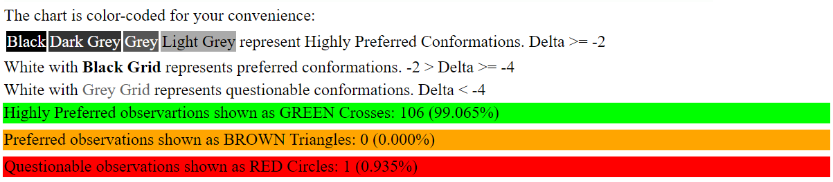

Compound 15

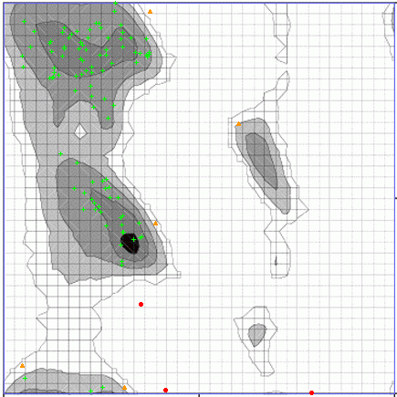

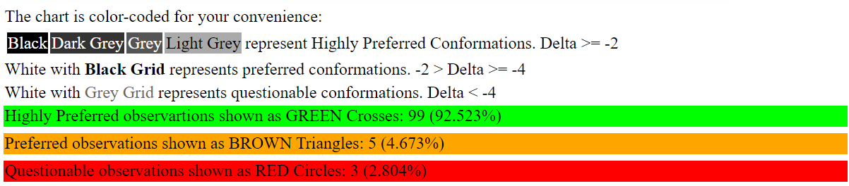

Compound 17

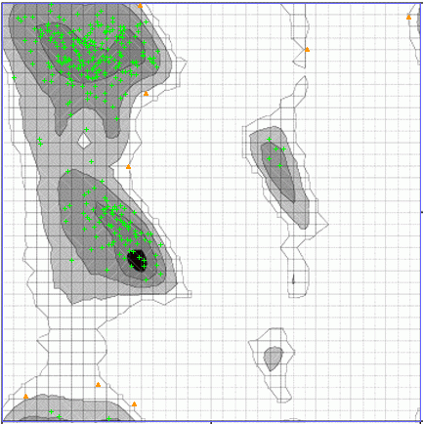

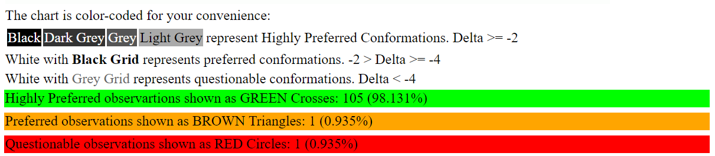
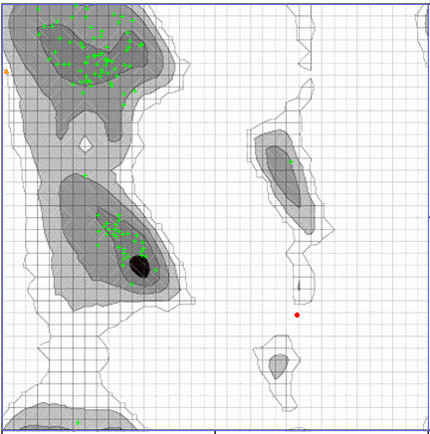
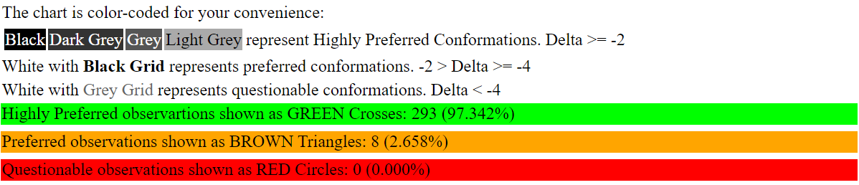
Compound 18

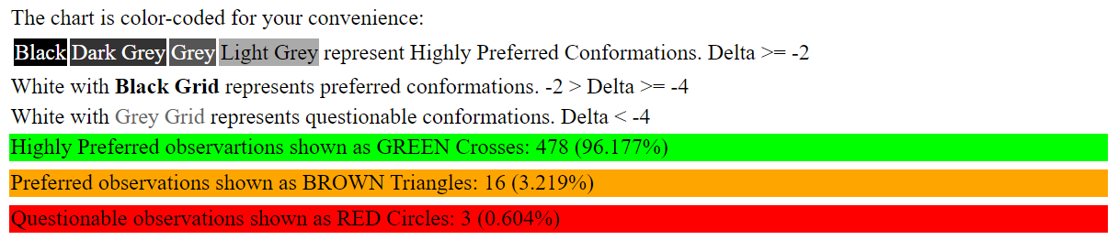
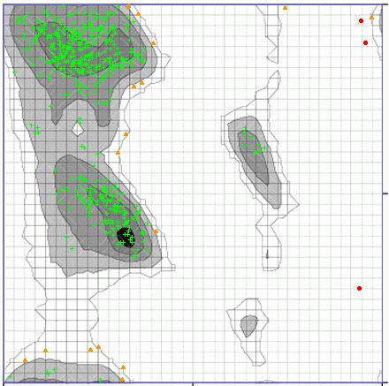
Compound 21

S7. Cytotoxicity evaluated against normal breast cell line

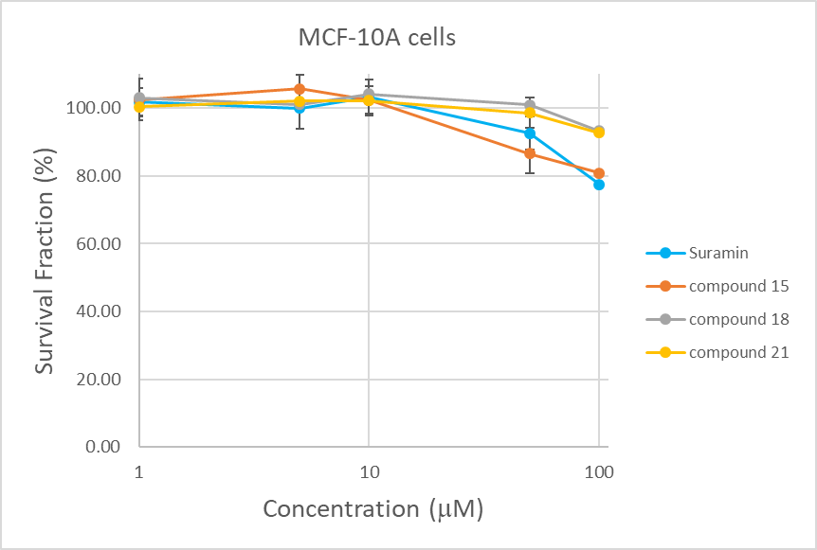

S8. Statistical data for the cytotoxicity

Name | Blank 450 | Mean | Std Dev | CV (%) | Fold | Fold (mean) | SD (fold)
Control | 1.175 | 1.165 | 0.011 | 1.0% | 1.008 | 1.00 | 0.01
 | 1.17 |  |  |  | 1.004
 | 1.167 |  |  |  | 1.002
 | 1.149 |  |  |  | 0.986
1 uM suramin | 1.186 | 1.211 | 0.053 | 4.4% | 1.018 | 1.04 | 0.05
 | 1.173 |  |  |  | 1.007
 | 1.197 |  |  |  | 1.027
 | 1.289 |  |  |  | 1.106
5 uM suramin | 1.137 | 1.160 | 0.038 | 3.3% | 0.976 | 1.00 | 0.03
 | 1.217 |  |  |  | 1.044
 | 1.147 |  |  |  | 0.984
 | 1.138 |  |  |  | 0.977
10 uM suramin | 1.187 | 1.116 | 0.068 | 6.1% | 1.019 | 0.96 | 0.06
 | 1.064 |  |  |  | 0.913
 | 1.159 |  |  |  | 0.995
 | 1.052 |  |  |  | 0.903
50 uM suramin | 0.936 | 1.004 | 0.063 | 6.3% | 0.803 | 0.86 | 0.05
 | 0.988 |  |  |  | 0.848
 | 1.088 |  |  |  | 0.934
 | 1.004 |  |  |  | 0.862
100 uM suramin | 0.795 | 0.817 | 0.018 | 2.2% | 0.682 | 0.70 | 0.02
 | 0.82 |  |  |  | 0.704
 | 0.838 |  |  |  | 0.719
 | 0.816 |  |  |  | 0.700
1 uM Compound 15 | 1.143 | 1.163 | 0.023 | 2.0% | 0.981 | 1.00 | 0.02
 | 1.162 |  |  |  | 0.997
 | 1.195 |  |  |  | 1.026
 | 1.152 |  |  |  | 0.989
5 uM Compound 15 | 1.161 | 1.146 | 0.047 | 4.1% | 0.996 | 0.98 | 0.04
 | 1.116 |  |  |  | 0.958
 | 1.206 |  |  |  | 1.035
 | 1.101 |  |  |  | 0.945
10 uM Compound 15 | 1.151 | 1.122 | 0.046 | 4.1% | 0.988 | 0.96 | 0.04
 | 1.117 |  |  |  | 0.959
 | 1.059 |  |  |  | 0.909
 | 1.162 |  |  |  | 0.997
50 uM Compound 15 | 0.998 | 0.982 | 0.028 | 2.8% | 0.856 | 0.84 | 0.02
 | 1.012 |  |  |  | 0.868
 | 0.955 |  |  |  | 0.820
 | 0.961 |  |  |  | 0.825
100 uM Compound 15 | 0.927 | 0.880 | 0.039 | 4.4% | 0.796 | 0.75 | 0.03
 | 0.887 |  |  |  | 0.761
 | 0.833 |  |  |  | 0.715
 | 0.872 |  |  |  | 0.748
1 uM Compound 18 | 1.234 | 1.224 | 0.031 | 2.5% | 1.059 | 1.05 | 0.03
 | 1.224 |  |  |  | 1.050
 | 1.182 |  |  |  | 1.014
 | 1.256 |  |  |  | 1.078
5 uM Compound 18 | 1.176 | 1.176 | 0.030 | 2.5% | 1.009 | 1.01 | 0.03
 | 1.214 |  |  |  | 1.042
 | 1.141 |  |  |  | 0.979
 | 1.173 |  |  |  | 1.007
10 uM Compound 18 | 1.108 | 1.160 | 0.041 | 3.5% | 0.951 | 1.00 | 0.03
 | 1.161 |  |  |  | 0.996
 | 1.207 |  |  |  | 1.036
 | 1.165 |  |  |  | 1.000
50 uM Compound 18 | 1.184 | 1.139 | 0.059 | 5.2% | 1.016 | 0.98 | 0.05
 | 1.149 |  |  |  | 0.986
 | 1.053 |  |  |  | 0.904
 | 1.169 |  |  |  | 1.003
100 uM Compound 18 | 1.098 | 1.057 | 0.042 | 4.0% | 0.942 | 0.91 | 0.04
 | 1.004 |  |  |  | 0.862
 | 1.043 |  |  |  | 0.895
 | 1.081 |  |  |  | 0.928
1 uM Compound 21 | 1.107 | 1.167 | 0.045 | 3.8% | 0.950 | 1.00 | 0.04
 | 1.215 |  |  |  | 1.043
 | 1.169 |  |  |  | 1.003
 | 1.177 |  |  |  | 1.010
5 uM Compound 21 | 1.145 | 1.178 | 0.040 | 3.4% | 0.983 | 1.01 | 0.03
 | 1.151 |  |  |  | 0.988
 | 1.183 |  |  |  | 1.015
 | 1.233 |  |  |  | 1.058
10 uM Compound 21 | 1.136 | 1.163 | 0.021 | 1.8% | 0.975 | 1.00 | 0.02
 | 1.167 |  |  |  | 1.002
 | 1.187 |  |  |  | 1.019
 | 1.163 |  |  |  | 0.998
50 uM Compound 21 | 1.137 | 1.124 | 0.011 | 0.9% | 0.976 | 0.96 | 0.01
 | 1.128 |  |  |  | 0.968
 | 1.113 |  |  |  | 0.955
 | 1.119 |  |  |  | 0.960
100 uM Compound 21 | 1.046 | 1.021 | 0.071 | 7.0% | 0.898 | 0.88 | 0.06
 | 1.046 |  |  |  | 0.898
 | 1.075 |  |  |  | 0.923
 | 0.916 |  |  |  | 0.786

Compound 17 0.5 uM | 0.241 | 0.233 | 0.012 | 5.3% | 1.082 | 1.04 | 0.06
 | 0.231 |  |  |  | 1.037
 | 0.216 |  |  |  | 0.970
 | 0.243 |  |  |  | 1.091
Compound 17 1 uM | 0.235 | 0.226 | 0.011 | 4.7% | 1.055 | 1.01 | 0.05
 | 0.232 |  |  |  | 1.042
 | 0.211 |  |  |  | 0.947
 | 0.225 |  |  |  | 1.010
Compound 17 5 uM | 0.201 | 0.222 | 0.017 | 7.8% | 0.902 | 1.00 | 0.08
 | 0.215 |  |  |  | 0.965
 | 0.233 |  |  |  | 1.046
 | 0.239 |  |  |  | 1.073
Compound 17 10 uM | 0.218 | 0.220 | 0.008 | 3.7% | 0.979 | 0.99 | 0.04
 | 0.227 |  |  |  | 1.019
 | 0.225 |  |  |  | 1.010
 | 0.209 |  |  |  | 0.938
Compound 17 100 uM | 0.197 | 0.208 | 0.009 | 4.2% | 0.884 | 0.93 | 0.04
 | 0.209 |  |  |  | 0.938
 | 0.218 |  |  |  | 0.979
 | 0.206 |  |  |  | 0.925
Compound 14 0.5 uM | 0.228 | 0.233 | 0.021 | 9.1% | 1.024 | 1.04 | 0.09
 | 0.253 |  |  |  | 1.136
 | 0.244 |  |  |  | 1.095
 | 0.205 |  |  |  | 0.920
Compound 14 1 uM | 0.248 | 0.231 | 0.019 | 8.3% | 1.113 | 1.03 | 0.09
 | 0.227 |  |  |  | 1.019
 | 0.205 |  |  |  | 0.920
 | 0.242 |  |  |  | 1.086
Compound 14 5 uM | 0.219 | 0.225 | 0.014 | 6.3% | 0.983 | 1.01 | 0.06
 | 0.241 |  |  |  | 1.082
 | 0.23 |  |  |  | 1.033
 | 0.208 |  |  |  | 0.934
Compound 14 10 uM | 0.206 | 0.211 | 0.014 | 6.7% | 0.925 | 0.95 | 0.06
 | 0.193 |  |  |  | 0.866
 | 0.225 |  |  |  | 1.010
 | 0.218 |  |  |  | 0.979
Compound 14 100 uM | 0.209 | 0.198 | 0.013 | 6.6% | 0.938 | 0.89 | 0.06
 | 0.195 |  |  |  | 0.875
 | 0.181 |  |  |  | 0.813
 | 0.208 |  |  |  | 0.934

