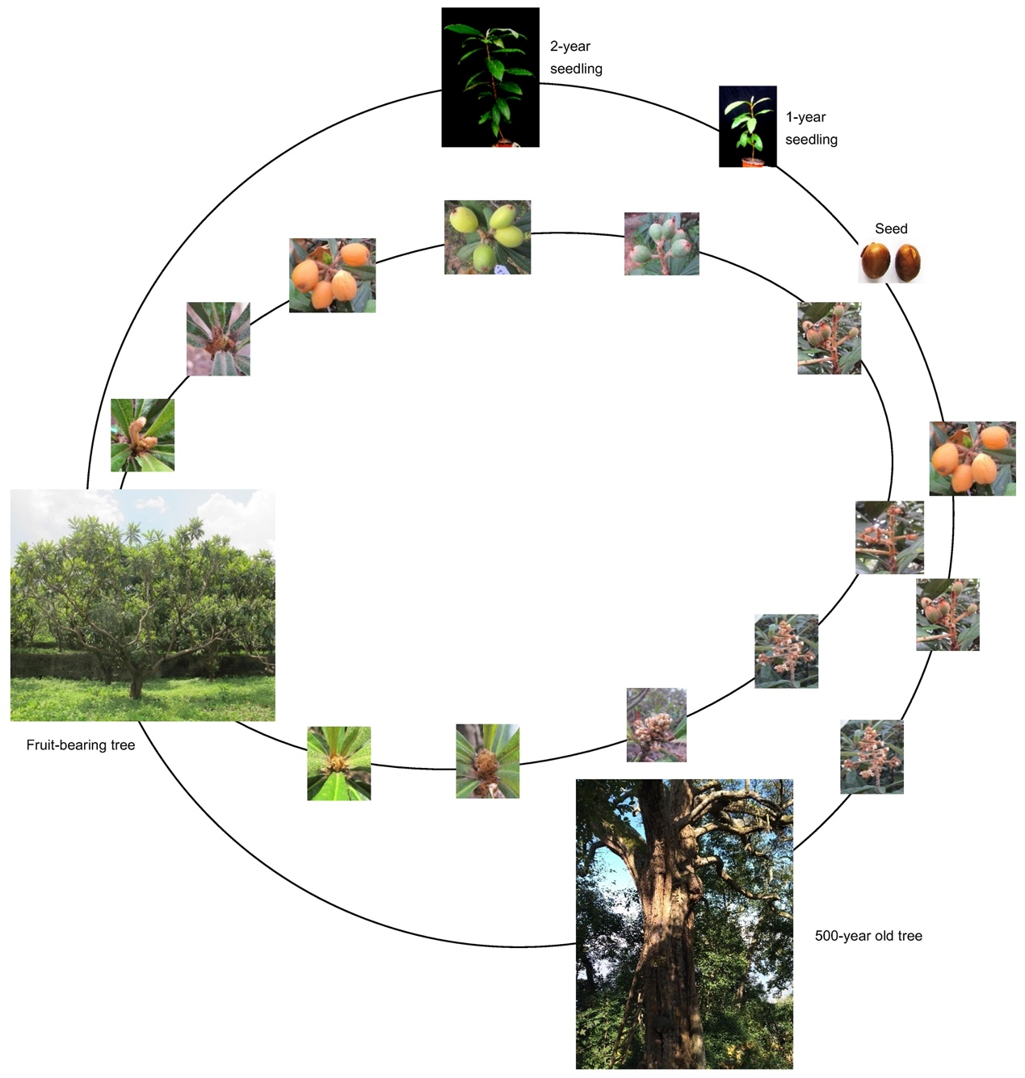
Figure S1. The life history and annual growth cycle of cultivated loquat. The outside circle shows the life history of cultivated loquat, from flowering, fruit set, fruit development, seed (reproductive phase), to seedling (juvenile phase), to fruit-bearing tree (adult phase), and finally to a 500-year-old flowering tree. The inside circle represents an annual growth cycle of cultivated loquat.

Figure S2. Promoter sequences of EjFT1, EjFT2, EjSOC1-1 and EjSOC1-2. The RAV1AAT (CAACA) / RAV1BAT (CACCTG) motifs were highlighted in yellow or blue. The four underlined segments in both proEjFT1 and proEjFT2 were used for Y1H assays.
Figure S3. Sequence alignments of EjRAV1 and EjRAV2 with other RAV homologs. Amino acid sequences were aligned using Genedoc software. Both EjRAV1 and EjRAV2 proteins are characterized by an AP2 domain (in red box) and a B3 domain (in blue box); nuclear localization signal (NLS, in purple box) and B3 repression domain (BRD, in green box). Identical residues are shaped in black while conserved residues are in gray.

Figure S4. In vitro binding ability of EjRAV1/2 proteins to EjFT promoters by EMSA assays.

Figure S5. In vitro binding ability of EjRAV1/2 proteins to EjSOC1 promoters by EMSA assays. No specific band was detected in all the EMSA assays.
Table S1 Primers used in this study.

Usages | Primer names |  | Forward primer (5′→3′) | Reverse primer (5′→3′)
Over-expression | 35S-EjRAV1 |  | GTCGACGGTATCGATAAGCTTATGGATGGAATAAGCAGCACAG | TCCCCCGGGCTGCAGGAATTCCAAAGCTCCAATGATCCTTGGC
 | 35S-EjRAV2 |  | GTCGACGGTATCGATAAGCTTATGGACGGAATAAGCAGCACAG | TCCCCCGGGCTGCAGGAATTCCAAAGCCCCAATGATCCTTGGC
Subcellular  localization | EjRAV1-GFP |  | GTCGACGGTATCGATAAGCTTATGGATGGAATAAGCAGCACAG | TCCCCCGGGCTGCAGGAATTCCAAAGCTCCAATGATCCTTGGC
 | EjRAV2-GFP |  | GTCGACGGTATCGATAAGCTTATGGACGGAATAAGCAGCACAG | TCCCCCGGGCTGCAGGAATTCCAAAGCCCCAATGATCCTTGGC
Q-RT-PCR | qEjRAV1 |  | TGAGCTCCCACTCCAAGTCTG | CGACCGTTGTCCGTCCC
 | qEjRAV2 |  | AGATTTACGAGAAGCACCA | GTCGTCGTTTCCTTCGTC
 | qEjAP1 |  | TGATGCTCAAGTTGCTGTGG | TGCATGAATCTGTGGCGTAC
 | qEjFT1 |  | ATTCCAGCAACAACCG | TGGCGAAACAGCACAAAA
 | qEjFT2 |  | GGTTACCGATATTCCAGC | GCGAAACACCACCAAAA
 | qEjSCO1-1 |  | GCGTTATCAGAAGCATGCGAAAGA | GCTCGGACGTTGTAGACGCTC
 | qEjSOC1-2 |  | GAGCGATATCAGAATCACGC | GGATCGGACGTTGTTCACGC
 | qEjRPL18 |  | ATGGGATTTGGCTTCGTTATC | AGAGTT TTGCTGGGATGGTG
 | qAtFT |  | ACCCTGGTGCATACACTGTT | GGTGGAGAAGACCTCAGGAA
 | qAtSOC1 |  | GTGATCTCCACTCAACAAAAA | CAACAAGAGAGAAGCAGCTTTA
 | qAtAP1 |  | CATGGGTGGTCTGTATCAAGAAGAT | CATGCGGCGAAGCAGCCAAGGTT
 | qAtLFY |  | ACGCCGTCATTTGCTACTCT | CTTTCTCCGTCTCTGCTGCT
 | qAtUBQ10 |  | GGACCAGCAGCGTCTCATCTTCGCT | CTTATTCATCAGGGATTATACAAG
LUC/REN  assays | pSAK277- EjRAV1 |  | ACTAGTGGATCCAAAGAATTCATGGATGGAATAAGCAGCACAG | GACTCTAGAAGTACTCTCGAGCTACAAAGCTCCAATGATCCTTG
 | pSAK277- EjRAV2 |  | ACTAGTGGATCCAAAGAATTCATGGACGGAATAAGCAGCACAG | GACTCTAGAAGTACTCTCGAGCTACAAAGCCCCAATGATCCTTG
 | proEjFT1-0800 |  | GTCGACGGTATCGATAAGCTTGCCCTCCTCATGCCCTTCTA | CGCTCTAGAACTAGTGGATCCACCGTAGGTCACCCTGAGAG
 | proEjFT2-0800 |  | GTCGACGGTATCGATAAGCTTTCAATCAGATTCCTTGAAAAAAC | CGCTCTAGAACTAGTGGATCCTTTTCTTTCTTTTGGATATATAAG
EMSA | EjFT1-P1 |  | TGGCAATATGACATGCAATGCAACAGAATATAAATAGTTGATTTTG | CAAAATCAACTATTTATATTCTGTTGCATTGCATGTCATATTGCCA
 | EjFT1-P1-mutant |  | TGGCAATATGACATGCAATGTTTTTGAATATAAATAGTTGATTTTG | CAAAATCAACTATTTATATTCAAAAACATTGCATGTCATATTGCCA
 | EjFT1-P2 |  | GTACTAATTAGGTTTGAATCCACCTGAGGACTTATGTCATCCATT | AATGGATGACATAAGTCCTCAGGTGGATTCAAACCTAATTAGTAC
 | EjFT1-P3 |  | AGGACTTATGTCATCCATTTTGTTGTAATAACTGCTGCATTTC | GAAATGCAGCAGTTATTACAACAAAATGGATGACATAAGTCCT
 | EjFT1-P4 |  | GACATACAGAGAACACATTGCAACAGATGATGCATGGAAGAATGA | TCATTCTTCCATGCATCATCTGTTGCAATGTGTTCTCTGTATGTC
 | EjFT1-P5 |  | TAGGGATAGGGACCCCCTTGTTGTTGGACGAGTGGTTGGTGATGTT | AACATCACCAACCACTCGTCCAACAACAAGGGGGTCCCTATCCCTA
 | EjFT2-P1 |  | CATTTCTCAAATAGCACTTATCAACATATATTCTGGATCAATTCAGG | CCTGAATTGATCCAGAATATATGTTGATAAGTGCTATTTGAGAAATG
 | EjFT2-P2 |  | GCACAAAATTTTGGAATCATCTTGTTGAGGATGAATTTCACAGTGAT | ATCACTGTGAAATTCATCCTCAACAAGATGATTCCAAAATTTTGTGC
 | EjFT2-P3 |  | GTGTATGGATATAAAGTTCAACATTGAAAATCTAAAATAAT | ATTATTTTAGATTTTCAATGTTGAACTTTATATCCATACAC
 | EjFT2-P4 |  | CAAAATAAAATGAAAAGTACAACAAATTAGGAGACAAGATGCCT | AGGCATCTTGTCTCCTAATTTGTTGTACTTTTCATTTTATTTTG
 | EjFT2-P5 |  | AGCAATACAGCATGCAACGCAACAGAATATAAATAGCCAATAGG | CCTATTGGCTATTTATATTCTGTTGCGTTGCATGCTGTATTGCT
 | EjSOC1-1-P1 |  | GGAAAAGGGCAAAATGTGTTGTGCCAGACAAGGTGG | CCACCTTGTCTGGCACAACACATTTTGCCCTTTTCC
 | EjSOC1-1-P2 |  | AATTAATGCTATAGGCTTGTTGCGTTTTCGACTTCTGATTGG | CCAATCAGAAGTCGAAAACGCAACAAGCCTATAGCATTAATT
 | EjSOC1-1-P3 |  | GTAGTCGTACGGACGATGTTGATGTATTGCTAACATTGT | ACAATGTTAGCAATACATCAACATCGTCCGTACGACTAC
 | EjSOC1-1-P4 |  | AAAGGGTAGGTGTGTTGGTTGCCTAAGGTCAATCATC | GATGATTGACCTTAGGCAACCAACACACCTACCCTTT
 | EjSOC1-1-P5 |  | CAGGATCTATTGCCTTCCACCTGATCTATACCATCATTCCA | TGGAATGATGGTATAGATCAGGTGGAAGGCAATAGATCCTG
 | EjSOC1-2-P1 |  | GGTTAAGTAATAATCTAATAATCAACAATCACATTATTTAGTT | AACTAAATAATGTGATTGTTGATTATTAGATTATTACTTAACC
Y1H assays | pGADT7 | EjRAV1 | GCCATGGAGGCCAGTGAATTCATGGATGGAATAAGCAGCACAG | CAGCTCGAGCTCGATGGATCCCAAAGCTCCAATGATCCTTGGC
 |  | EjRAV2 | GCCATGGAGGCCAGTGAATTCATGGACGGAATAAGCAGCACAG | CAGCTCGAGCTCGATGGATCCCAAAGCCCCAATGATCCTTGGC
 | pAbAi | FT1-seq1 | GAAAAGCTTGAATTC GAGCTC  GAGCAGAATCTTTCATTGAG | ATACAGAGCACATGCCTCGAGGTATCCAAGTAAGTTGTGAC
 |  | FT1-seq2 | GAAAAGCTTGAATTC GAGCTC  GTCCTCTTCATTCGGTACG | ATACAGAGCACATGCCTCGAGCAATGATTGAAATGCAGCAG
 |  | FT1-seq3 | GAAAAGCTTGAATTC GAGCTC  TCAAGACATACAGAGAACAC | ATACAGAGCACATGCCTCGAGAACATCGCAATCATTCTTCC
 |  | FT1-seq4 | GAAAAGCTTGAATTC GAGCTC  GAAAATGCCTAGGGATAGG | ATACAGAGCACATGCCTCGAGAGACCTTGTGAAGGGATC
 |  | FT2-seq1 | GAAAAGCTTGAATTC GAGCTC  ATGCATCCACCGATTTAAG | ATACAGAGCACATGCCTCGAGTCTCTACCATTACCCCTC
 |  | FT2-seq2 | GAAAAGCTTGAATTC GAGCTC  CACTTTGCTCTTGAAGACG | ATACAGAGCACATGCCTCGAGGGATGTAGCTCAACTACTAC
 |  | FT2-seq3 | GAAAAGCTTGAATTCGAGCTCTATAAAGTTCAACATTGAA | ATACAGAGCACATGCCTCGAGTCCTAATTTGTTGTACTT
 |  | FT2-seq4 | GAAAAGCTTGAATTCGAGCTC GAATGACATATGGAGCAG | ATACAGAGCACATGCCTCGAGTATATTCTGTTGCGTTGCA

Table S2. Positions of RAV protein binding sites upstream of four flowering integrator gene promoters. The yellow shading shows CAACA motif and blue shading shows CACCTG motif, ‘-’showed no binding motifs.

proEjFT1 | proEjFT2 | proEjSOC1-1 | proEjSOC1-2
-1583~-1578 bp | -1616~-1612 bp | -1834~-1830 bp | -1919~-1915 bp
-1059~-1054 bp | -1281~-1217 bp | -1760~-1756 bp | _
-1033~-1029 bp | -797~-793 bp | -1707~-1703 bp | _
-782~-778 bp | -695~-691 bp | -965~-952 bp | _
-73~-66 bp | -179~-175 bp | -272~-267 bp | _

