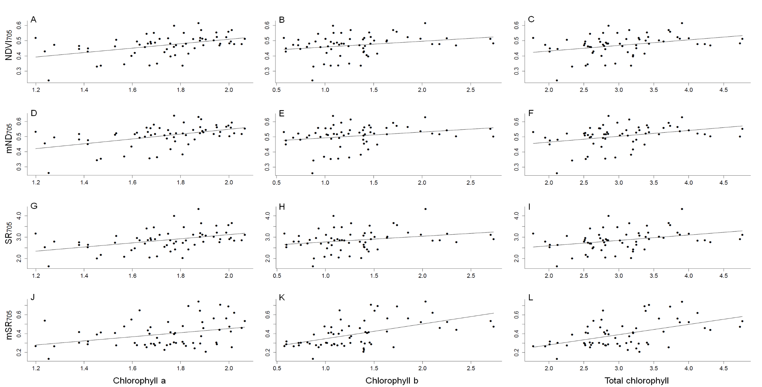

Figure S1. Correlations between NDVI705 indices (A, B, C); mND705 (D, F, G); SR705 (G, H, I) and mSR705 (J, K, L) and chlorophyll a, b, and total contents.

Table S1. Tree species with the highest importance value index (IVI), which considers the density, frequency and basal area of the individuals. The IVI was calculated for 18 plots, six at each of the following successional stages: early, intermediate and late. See text for details on species selection for the present study.
Species | Family | IVI | Successional Stage
 |  |  | Early | Intermediate | Late
Myracrodruon urundeuva Fr. Allemão | Anacardiaceae | 32.54 | x
Handroanthus chrysotrichus (Mart. ex A.DC.) Mattos | Bignoniaceae | 26.63 |  |  | x
Tabebuia reticulata A.H.Gentry | Bignoniaceae | 22.13 |  | x | x
Combretum duarteanum Cambess. | Combretaceae | 20.92 |  | x | x
Commiphora leptophloeus (Mart.) J.B.Gillett | Burseraceae | 11.97 |  | x | x
Senna spectabilis Irwin, Barneby | Fabaceae Caesalpinioideae | 9.49 | x
Cenostigma pluviosum (DC.) Gagnon & G.P. Lewis | Fabaceae Caesalpinioideae | 9.43 | x | x | x
Terminalia fagifolia Fr. Allemão | Combretaceae | 9.31 |  | x | x
Handroanthus ochraceus (Cham.) Mattos | Bignoniaceae | 8.60 | x | x
Machaerium acutifolium Benth. | Fabaceae Faboideae | 5.59 | x
Mimosa hostilis Benth. | Fabaceae Mimosoideae | 4.47 | x
Senegalia polyphylla (DC) Britton & Rose | Fabaceae Mimosoideae | 3.87 | x
Spondias tuberosa Arruda | Anacardiaceae | 3.77 |  | x

Table S2. Deviance analyses of the minimum adequate models, showing the effects of the successional stages (early, intermediate and late) on herbivory, specific leaf mass (SLM), water content, chlorophyll a, b and total, carotenoids and reflectance indices for three tropical dry forest species.
Response Variable | Cenostigma pluviosum  (Early x Intermediate x Late) |  |  |  | H. ochraceus  (Early x Intermediate) |  |  |  | T. reticulata  (Intermediate x Late)
 | DF | Deviance | P |  | DF | Deviance | P |  | DF | Deviance | P
Herbivory | 2 | 65.958 | ns |  | 1 | 39.896 | < 0.05 |  | 1 | 7.580 | ns
SLM | 2 | 18.253 | ns |  | 1 | 503.110 | ns |  | 1 | 1428.900 | < 0.05
Water content | 2 | 156.200 | ns |  | 1 | 43.836 | < 0.05 |  | 1 | 28.117 | < 0.05
Chlorophyll a | 2 | 0.478 | < 0.05 |  | 1 | 0.118 | < 0.05 |  | 1 | 0.175 | < 0.05
Chlorophyll b | 2 | 4.869 | < 0.05 |  | 1 | 0.014 | ns |  | 1 | 0.288 | < 0.05
Total chlorophyll | 2 | 8.376 | < 0.05 |  | 1 | 0.212 | ns |  | 1 | 0.912 | < 0.05
Carotenoids | 2 | 12.397 | < 0.05 |  | 1 | 0.190 | ns |  | 1 | 8.028 | < 0.05
mND705 | 2 | 0.104 | < 0.05 |  | 1 | 0.006 | < 0.05 |  | 1 | 0.0001 | ns
mSR705 | 2 | 0.365 | < 0.05 |  | 1 | 0.097 | < 0.05 |  | 1 | 0.0009 | ns
WI | 2 | 0.002 | < 0.05 |  | 1 | 0.011 | < 0.05 |  | 1 | 2.52E-08 | ns

