Supplementary Material

Supplementary Figures

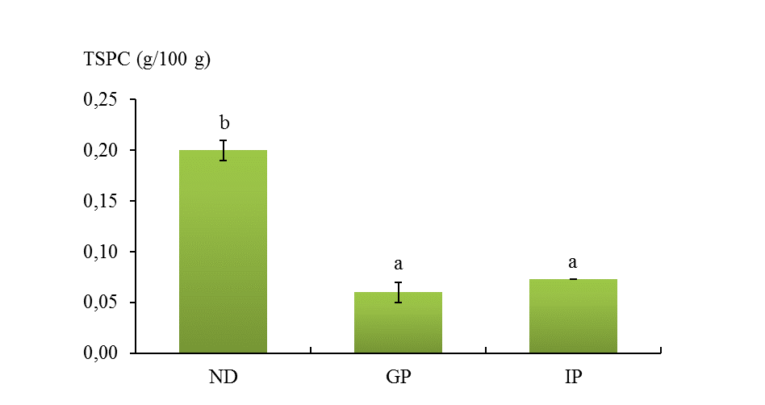
Supplementary Figure 1. Total soluble phenolic compounds (TSPC) in Pisane C₉ during simulated digestion. Abbreviations: gastric phase (GP), intestinal phase (IP); non-digested (ND). Different lowercase letters denote significant differences between phases (one-way ANOVA, post hoc Dun- can’s test, p ≤ 0.05).

