Abiotic drivers of seedling bank diversity in subtropical forests of southern China
Francesco Martini^{1,2,#,*}, Chaobo Zou^{1,2}, Xiaoyang Song^{3,4}, Uromi Manage Goodale^{1,2,5,*}

SUPPLEMENTARY MATERIALS

¹ Guangxi Key Laboratory of Forest Ecology and Conservation, College of Forestry, Guangxi University, Nanning, PR China

² State Key Laboratory of Conservation and Utilization of Subtropical Agro-bioresources, College of Forestry, Guangxi University, Nanning, PR China

³ CAS Key Laboratory of Tropical Forest Ecology, Xishuangbanna Tropical Botanical Garden, Chinese Academy of Sciences, Yunnan, PR China

⁴ Center of Conservation Biology, Core Botanical Gardens, Chinese Academy of Sciences, Mengla, PR China

⁵ Seed Conservation Specialist Group, Species Survival Commission, International Union for Conservation of Nature (IUCN), Gland, Switzerland

# Current Affiliation: Center for Interdisciplinary Research on Ecology and Sustainability, National Dong Hwa University, Hualien

* Author for correspondence: UMG: uromi.manage.goodale@outlook.com; uromi.goodale@aya.yale.edu and FM: franmart12@hotmail.it

TABLE S1 Seedling abundance (N), seedling density, seedling species richness (S), species Shannon diversity index (H’), Simpson diversity index (D’), Chao2 richness estimator, and singletons for the four forest sites studied here.
Forest | N° of plots | N | Density (n m⁻²) | S | H’ | D’ | Chao2 | Singletons
Cenwanglaoshan | 5 | 1498 | 12.48 | 78 | 2.01 | 0.71 | 106.125 | 30
Dayaoshan | 4 | 442 | 4.6 | 57 | 3.10 | 0.92 | 90.603 | 23
Mulun | 2 | 473 | 9.85 | 43 | 1.92 | 0.64 | 61.75 | 15
Huaping | 2 | 139 | 2.89 | 29 | 2.72 | 0.90 | 61.666 | 14

TABLE S2 Mean (± SD) canopy openness and soil properties of the four forest sites studied here. Soil properties were measured on soil sampled at a depth of 0–10 cm from the soil surface without leaf litter.

 | Cenwanglaoshan | Dayaoshan | Mulun | Huaping
Canopy openness (%) | 14.85 ± 4.65 | 14.44 ± 3.52 | 14 ± 1.98 | 15.26 ± 4.39
Soil pH | 4.08 ± 0.57 | 4.15 ± 0.31 | 4.18 ± 0.21 | 7.44 ± 0.3
Soil total N (g/kg) | 0.92 ± 0.42 | 0.41 ± 0.32 | 1.16 ± 0.43 | 0.52 ± 0.17
Soil total C (g/kg) | 11.39 ± 7.14 | 5.2 ± 5.32 | 11.89 ± 4.42 | 6.28 ± 2.09
Soil C:N ratio | 11.69 ± 2.14 | 12.3 ± 2.15 | 10.33 ± 1.57 | 12.08 ± 1.82
Plant-available soil P (mg/kg) | 28.14 ± 30.4 | 24.03 ± 44.86 | 4.53 ± 3.15 | 2.36 ± 2.48
Plant-available soil K (mg/kg) | 167.16 ± 86.15 | 109.74± 106.77 | 137.75 ± 47.2 | 111.78 ± 44.31
Soil Ca (mg/kg) | 562.61 ± 662.21 | 81.13 ± 187.39 | 5576.5± 2247.02 | 28.78 ± 26.96
Soil Fe (mg/kg) | 481.57 ± 153.28 | 339.32± 138.59 | 77.1 ± 29.5 | 273.07± 70.02
Soil Mg (mg/kg) | 108.68 ± 81.49 | 44.46 ± 63.77 | 1553.39± 430.19 | 38.41 ± 15.7
Soil Mn (mg/kg) | 83.96 ± 77.38 | 18.41 ± 30.84 | 315.07 ± 84.83 | 24.22 ± 24.6
Soil S (mg/kg) | 40.96 ± 28.01 | 26.6 ± 22.23 | 68.04 ± 32.67 | 38.93 ± 11.32

TABLE S3 Results of mixed models for the response variables analyzed in this study and values of the variance inflation factor (VIF). We used GLMM with negative binomial distribution for species richness, seedling abundance, and singletons, and linear mixed models for Shannon, Simpson, and Chao2 estimator. The significant explanatory variables (p < 0.05) are in bold font.
Response | Predictor | VIF | Estimate | SE | z-value/t-value | p
Richness | Intercept |  | 1.68401 | 0.08540 | 19.719 | <0.001
 | Elevation | 1.94 | -0.1707 | 0.118 | -1.447 | 0.148
 | Canopy op. | 1.08 | 0.0223 | 0.0487 | 0.458 | 0.647
 | Slope | 1.05 | 0.0872 | 0.0577 | 1.512 | 0.13
 | soilPC1 | 1.19 | -0.0039 | 0.076 | -0.051 | 0.96
 | soilPC2 | 2.22 | 0.1243 | 0.0988 | 1.259 | 0.208
 | soilCP3 | 1.31 | 0.0427 | 0.0752 | 0.568 | 0.57
Simpson | Intercept |  | 0.60698 | 0.02590 | 23.432 | <0.001
 | Elevation | 2.18 | -0.10742 | 0.03839 | -2.798 | 0.0113
 | Canopy op. | 1.08 | 0.01362 | 0.02076 | 0.656 | 0.5131
 | Slope | 1.06 | 0.05428 | 0.02269 | 2.392 | 0.0196
 | soilPC1 | 1.09 | -0.04910 | 0.02531 | -1.940 | 0.0667
 | soilPC2 | 2.20 | 0.03552 | 0.03493 | 1.017 | 0.3153
 | soilCP3 | 1.18 | -0.01305 | 0.02551 | -0.512 | 0.6141
Shannon | Intercept |  | 1.23722 | 0.07058 | 17.529 | <0.001
 | Elevation | 2.09 | -0.24882 | 0.10237 | -2.431 | 0.0251
 | Canopy op. | 1.08 | -0.00698 | 0.05148 | -0.136 | 0.8924
 | Slope | 1.06 | 0.16599 | 0.05768 | 2.878 | 0.0052
 | soilPC1 | 1.11 | -0.11788 | 0.06736 | -1.750 | 0.0954
 | soilPC2 | 2.17 | 0.09750 | 0.09047 | 1.078 | 0.28734
 | soilCP3 | 1.22 | -0.01016 | 0.06763 | -0.150 | 0.88195
Abundance | Intercept |  | 2.85136 | 0.20947 | 13.612 | <0.001
 | Elevation | 1.70 | -0.06839 | 0.27265 | -0.251 | 0.8020
 | Canopy op. | 1.13 | 0.02991 | 0.08246 | 0.363 | 0.7168
 | Slope | 1.05 | -0.14712 | 0.10075 | -1.460 | 0.1442
 | soilPC1 | 1.53 | 0.21177 | 0.16731 | 1.266 | 0.2056
 | soilPC2 | 2.55 | 0.34273 | 0.20171 | 1.699 | 0.0893
 | soilCP3 | 1.78 | 0.23719 | 0.15633 | 1.517 | 0.1292
Singletons | Intercept |  | 1.09518 | 0.09242 | 11.850 | <0.001
 | Elevation | 2.19 | -0.16221 | 0.13510 | -1.201 | 0.230
 | Canopy op. | 1.09 | 0.08459 | 0.06475 | 1.306 | 0.191
 | Slope | 1.05 | 0.07388 | 0.07703 | 0.959 | 0.338
 | soilPC1 | 1.10 | 0.06029 | 0.08664 | 0.696 | 0.486
 | soilPC2 | 2.28 | 0.12774 | 0.12077 | 1.058 | 0.290
 | soilCP3 | 1.18 | 0.03881 | 0.09085 | 0.427 | 0.669
Chao 2 | Intercept |  | 2.21761 | 0.10407 | 21.308 | <0.001
 | Elevation | 2.02 | -0.24108 | 0.14850 | -1.623 | 0.122
 | Canopy op. | 1.08 | -0.02137 | 0.07072 | -0.302 | 0.763
 | Slope | 1.05 | 0.08625 | 0.08057 | 1.070 | 0.288
 | soilPC1 | 1.12 | 0.08625 | 0.08057 | 0.319 | 0.753
 | soilPC2 | 2.16 | 0.18329 | 0.12833 | 1.428 | 0.161
 | soilCP3 | 1.25 | 0.05532 | 0.09755 | 0.567 | 0.576
TABLE S4 Results of the piecewise SEM. Random factor was ‘1|forest/plot’ for all models. Models were run with standardized predictor values. Significant results (p < 0.05) are in bold font.
Response | Predictor | Estimate | SE | Crit.Value | p-value
Richness | Elevation | -0.2080 | 0.1171 | -1.7758 | 0.0758
 | Canopy op. | -0.0764 | 0.0662 | -1.1530 | 0.2489
 | Slope | 0.0268 | 0.0586 | 0.4573 | 0.6474
 | soilPC1 | 0.0113 | 0.0762 | 0.1480 | 0.8823
 | soilPC2 | 0.1344 | 0.0992 | 1.3553 | 0.1753
 | soilCP3 | 0.0530 | 0.0746 | 0.7104 | 0.4775
Simpson | Elevation | -0.0898 | 0.038 | -2.3647 | 0.0290
 | Canopy op. | -0.0217 | 0.0257 | -0.8431 | 0.4013
 | Slope | 0.0602 | 0.0224 | 2.6912 | 0.0089
 | soilPC1 | -0.0640 | 0.0256 | -2.5037 | 0.0204
 | soilPC2 | 0.0235 | 0.0342 | 0.6879 | 0.4955
 | soilCP3 | -0.0249 | 0.0251 | -0.9918 | 0.3328
Shannon | Elevation | -0.2620 | 0.1026 | -2.5527 | 0.0196
 | Canopy op. | -0.0804 | 0.0619 | -1.2982 | 0.1975
 | Slope | 0.1369 | 0.0557 | 2.4582 | 0.0161
 | soilPC1 | -0.1227 | 0.0684 | -1.7951 | 0.0861
 | soilPC2 | 0.0886 | 0.0881 | 1.0064 | 0.3199
 | soilCP3 | -0.0171 | 0.0673 | -0.2541 | 0.8017
Abundance | Elevation | -0.1297 | 0.2672 | -0.4855 | 0.6274
 | Canopy op. | 0.0188 | 0.1121 | 0.1673 | 0.8671
 | Slope | -0.2006 | 0.105 | -1.9108 | 0.0560
 | soilPC1 | 0.2586 | 0.1675 | 1.5442 | 0.1226
 | soilPC2 | 0.3999 | 0.2065 | 1.9367 | 0.0528
 | soilCP3 | 0.3012 | 0.1552 | 1.9409 | 0.0523
Singletons | Elevation | -0.2061 | 0.1315 | -1.5675 | 0.1170
 | Canopy op. | -0.0441 | 0.0965 | -0.4570 | 0.6477
 | Slope | -0.0082 | 0.0787 | -0.1045 | 0.9168
 | soilPC1 | 0.0976 | 0.0845 | 1.1559 | 0.2477
 | soilPC2 | 0.1340 | 0.1194 | 1.1222 | 0.2618
 | soilCP3 | 0.0525 | 0.0877 | 0.5986 | 0.5495
Chao 2 | Elevation | -0.3251 | 0.1458 | -2.2303 | 0.0390
 | Canopy op. | -0.0576 | 0.0795 | -0.7255 | 0.4700
 | Slope | 0.0096 | 0.0732 | 0.1315 | 0.8957
 | soilPC1 | 0.0595 | 0.0959 | 0.6199 | 0.5416
 | soilPC2 | 0.2129 | 0.1197 | 1.7794 | 0.0820
 | soilCP3 | 0.0689 | 0.0941 | 0.7324 | 0.4710
Canopy op. | Elevation | 0.0418 | 0.1002 | 0.4178 | 0.6827
 | Slope | -0.1239 | 0.0883 | -1.4032 | 0.1655
soilPC1 | Elevation | 0.5073 | 0.174 | 2.9161 | 0.0148
 | Slope | -0.0204 | 0.0612 | -0.3332 | 0.7398
soilPC2 | Elevation | 0.7949 | 0.1539 | 5.1659 | 0.0016
 | Slope | 0.0267 | 0.0746 | 0.3581 | 0.7211
soilPC3 | Elevation | -0.3605 | 0.2454 | -1.4687 | 0.1680
 | Slope | -0.0330 | 0.0785 | -0.4208 | 0.6749
Circular relationships
soilPC1 | soilPC2 | 0.6781 |  | 8.8018 | <0.001
soilPC1 | soilPC3 | -0.6529 |  | -8.2229 | <0.001
soilPC2 | soilPC3 | -0.7038 |  | -9.4513 | <0.001

FIGURE S1 Location of the four National Nature Reserves in Guangxi Zhuang Autonomous Region, China.

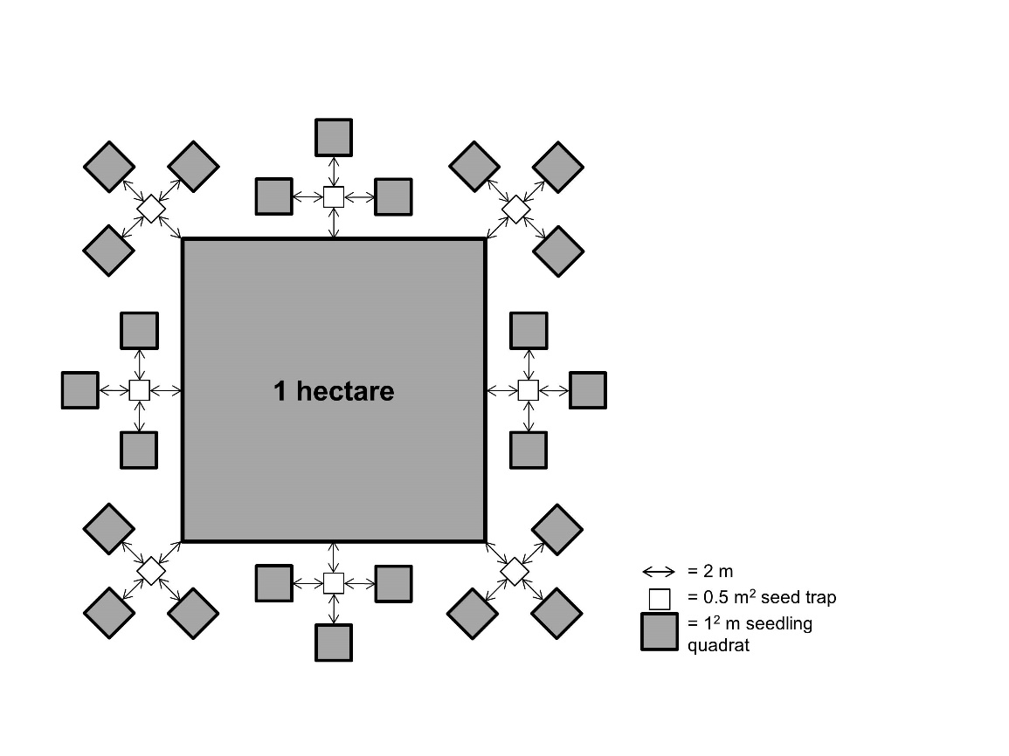
FIGURE S2 Scheme of the study design. The same design was reproduced in each of the 13 one-ha plots used in this study. Seed traps were not used for this study.

FIGURE S3 Species accumulation curves of all the forests combined (left) and for each individual forest (right). In the x-axis are the sites corresponding to the census stations, and the y-axis shows the number of species. In the right figure, colors correspond to: Cenwanglaoshan = red, Dayaoshan = green, Mulun = purple and Huaping = blue.

FIGURE S4 Seedling density in the four forests studied here over the two years of investigation from November 2017 to November 2019.Each point represents a monitored census time. Each line is a forest, denoted by different colors and different point shapes. CWL = Cenwanglaoshan, DY = Dayaoshan, ML = Mulun, HP = Huaping.

FIGURE S5 Effects of the measured abiotic variables on (A) Chao2 richness estimator and (B) singletons. Estimated full coefficients and 95% confidence intervals (CIs) are shown for each model. Because all explanatory variables were not significant, all points are empty (p > 0.05). On top of each figure are the marginal R² (R²_{m}) and the conditional R² (R²_{c}).

FIGURE S6 Piecewise structural equation modeling of (A) Chao2 richness estimator and (B) singletons. Solid black lines represent positive significant relationship (p < 0.05) and solid red lines negative significant relationship (p < 0.05). Dashed lines indicate non-significant relationships (p > 0.05). The arrow indicates the direction of the relationship. The value of the significant relationships is over imposed on the arrow.

