Soil bacterial community in multiple cropping system increased grain yield within 40 cultivation years
Tao Chen ^{a,b,}, Ruiwen Hu ^{a,1}, Zhongyi Zheng ª, Jiayi Yang ª, Huan Fan ª, Xiaoqiang Deng ^{b}, Wang Yao ^{c}, Qiming Wang ^{d}, Shuguang Peng ^{e,*}, Juan Li ^{a,*}
ª College of Agronomy, Hunan Agricultural University, Changsha, China
^{b} Hunan Tobacco Company Chenzhou Branch, Chenzhou, China
^{c} Hunan Tobacco Company Zhangjiajie Branch, Zhangjiajie, China
^{d} College of Bioscience and Biotechnology, Hunan Agricultural University, Changsha, China
^{e} China National Tobacco Corporation Hunan Branch, Changsha, China

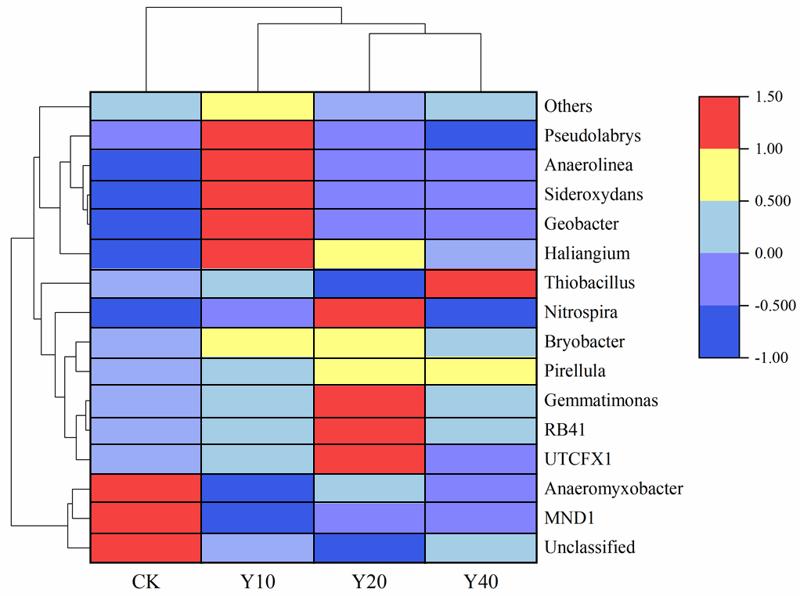
Fig.S1. Cluster heat map of 15 most abundant bacterial genera in the soil bacterial community. Results are means of eight replicates.

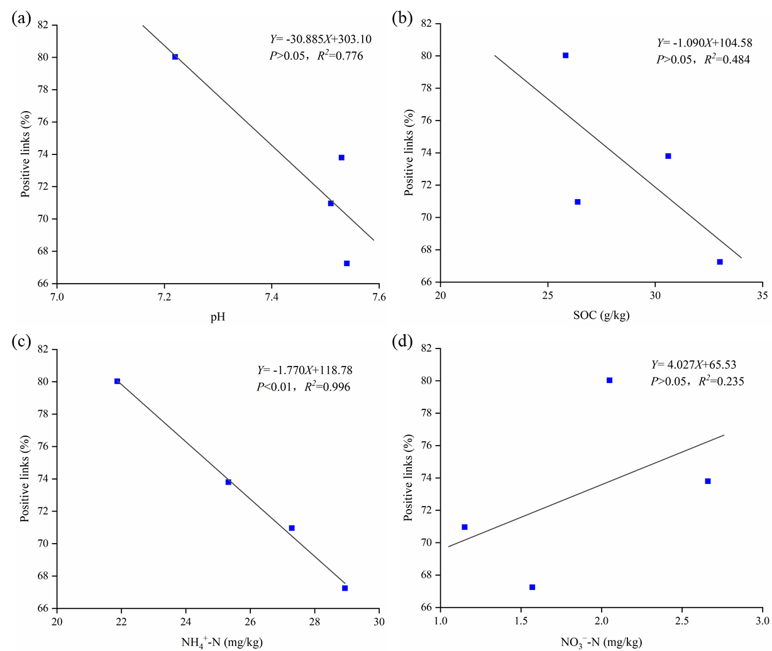
Fig.S2. Linear regression between percentage of positive links of molecular ecological network and edaphic factors. (a) positive links and pH. (b) positive links and SOC. (c) positive links and NH₄⁺-N. (d) positive links and NO₃⁻-N.

Table.S1. Dissimilarity analysis of soil bacterial community structure.
Treatment | ADONIS |  | ANOSIM |  | MRPP
 | R² | P | R | P | δ | P
CK vs Y10 | 0.133 | 0.034 | 0.087 | 0.162 | 0.526 | 0.01
CK vs Y20 | 0.156 | 0.014 | 0.272 | 0.008 | 0.473 | 0.008
CK vs Y40 | 0.096 | 0.138 | 0.086 | 0.118 | 0.525 | 0.093
Y10 vs Y20 | 0.110 | 0.109 | 0.121 | 0.099 | 0.427 | 0.079
Y10 vs Y40 | 0.081 | 0.258 | 0.045 | 0.277 | 0.479 | 0.188
Y20 vs Y40 | 0.092 | 0.165 | 0.065 | 0.179 | 0.425 | 0.117
Note: The bold numbers indicate significant correlation at the level of p < 0.05.

Table.S2. An envfit analysis (envfit function used with 999 permutations) shows soil properties variables that correlate to bacterial community.
Variables | RDA1 | RDA2 | R² | p
pH | 0.87754 | 0.47950 | 0.2873 | 0.004
SOC | 0.79541 | -0.60608 | 0.1302 | 0.144
NH₄⁺-N | 0.86551 | 0.50089 | 0.3062 | 0.005
NO₃⁻-N | -0.73268 | -0.68058 | 0.1892 | 0.048
Note: The bold numbers indicate significant correlation at the level of p < 0.05. SOC, Soil organic carbon; NH₄⁺-N, Ammonium-N; NO₃⁻-N, Nitrate-N.

Table.S3. The proportion of all variables explained the bacterial community variation.
 | Inertia | Proportion
Total | 6.444 | 100%
Constrained | 0.965 | 14.98%
Unconstrained | 5.479 | 85.02%

Table.S4. LDA Effect Size analysis results (only with significant differences).
Treatment | Domain | Phylum | Class | Order | Family | Genus | LDA score | P value
Y40 | Bacteria | Acidobacteria | Subgroup_5 | - | - | - | 3.132 | 0.002
Y40 | Bacteria | Acidobacteria | Subgroup_5 | Unclassified | - | - | 3.132 | 0.002
Y40 | Bacteria | Acidobacteria | Subgroup_5 | Unclassified | Unclassified | - | 3.132 | 0.002
Y40 | Bacteria | Acidobacteria | Subgroup_5 | Unclassified | Unclassified | Unclassified | 3.132 | 0.002
Y40 | Bacteria | Armatimonadetes | - | - | - | - | 3.141 | 0.004
Y40 | Bacteria | Proteobacteria | Deltaproteobacteria | Myxococcales | Polyangiaceae | - | 3.144 | 0.035
Y40 | Bacteria | Proteobacteria | Gammaproteobacteria | Betaproteobacteriales | Hydrogenophilaceae | - | 3.396 | 0.003
Y40 | Bacteria | Proteobacteria | Gammaproteobacteria | Betaproteobacteriales | Hydrogenophilaceae | Thiobacillus | 3.370 | 0.002
Y20 | Bacteria | Acidobacteria | - | - | - | - | 4.258 | 0.039
Y20 | Bacteria | Acidobacteria | Blastocatellia__Subgroup_4_ | - | - | - | 4.047 | 0.002
Y20 | Bacteria | Acidobacteria | Blastocatellia__Subgroup_4_ | 11_24 | - | - | 3.546 | 0.001
Y20 | Bacteria | Acidobacteria | Blastocatellia__Subgroup_4_ | 11_24 | Unclassified | - | 3.546 | 0.001
Y20 | Bacteria | Acidobacteria | Blastocatellia__Subgroup_4_ | 11_24 | Unclassified | Unclassified | 3.546 | 0.001
Y20 | Bacteria | Acidobacteria | Blastocatellia__Subgroup_4_ | Pyrinomonadales | - | - | 3.829 | 0.008
Y20 | Bacteria | Acidobacteria | Blastocatellia__Subgroup_4_ | Pyrinomonadales | Pyrinomonadaceae | - | 3.829 | 0.008
Y20 | Bacteria | Acidobacteria | Blastocatellia__Subgroup_4_ | Pyrinomonadales | Pyrinomonadaceae | RB41 | 3.829 | 0.008
Y20 | Bacteria | Acidobacteria | Holophagae | - | - | - | 3.556 | 0.031
Y20 | Bacteria | Acidobacteria | Holophagae | Subgroup_7 | - | - | 3.552 | 0.033
Y20 | Bacteria | Acidobacteria | Holophagae | Subgroup_7 | Unclassified |  | 3.544 | 0.033
Y20 | Bacteria | Acidobacteria | Holophagae | Subgroup_7 | Unclassified | Unclassified | 3.544 | 0.033
Y20 | Bacteria | Chloroflexi | Anaerolineae | SBR1031 | Unclassified |  | 3.412 | 0.024
Y20 | Bacteria | Chloroflexi | Anaerolineae | SBR1031 | Unclassified | Unclassified | 3.412 | 0.024
Y20 | Bacteria | Gemmatimonadetes | S0134_terrestrial_group | - | - | - | 3.227 | 0.000
Y20 | Bacteria | Gemmatimonadetes | S0134_terrestrial_group | Unclassified | - | - | 3.227 | 0.000
Y20 | Bacteria | Gemmatimonadetes | S0134_terrestrial_group | Unclassified | Unclassified | - | 3.227 | 0.000
Y20 | Bacteria | Gemmatimonadetes | S0134_terrestrial_group | Unclassified | Unclassified | Unclassified | 3.227 | 0.000
Y10 | Bacteria | Acidobacteria | Acidobacteriia | - | - | - | 3.603 | 0.031
Y10 | Bacteria | Acidobacteria | Acidobacteriia | Acidobacteriales | - | - | 3.152 | 0.040
Y10 | Bacteria | Acidobacteria | Blastocatellia__Subgroup_4_ | Blastocatellales | - | - | 3.170 | 0.047
Y10 | Bacteria | Acidobacteria | Blastocatellia__Subgroup_4_ | Blastocatellales | Blastocatellaceae | - | 3.170 | 0.047
Y10 | Bacteria | Chloroflexi | Anaerolineae | Anaerolineales | Anaerolineaceae | RBG_16_58_14 | 3.231 | 0.013
Y10 | Bacteria | Patescibacteria | Microgenomatia | Candidatus_Woesebacteria | - | - | 3.137 | 0.037
Y10 | Bacteria | Patescibacteria | Microgenomatia | Candidatus_Woesebacteria | Unclassified | - | 3.089 | 0.015
Y10 | Bacteria | Patescibacteria | Microgenomatia | Candidatus_Woesebacteria | Unclassified | Unclassified | 3.089 | 0.015
Y10 | Bacteria | Proteobacteria | Gammaproteobacteria | Betaproteobacteriales | Gallionellaceae | Sideroxydans | 3.488 | 0.033
Y10 | Bacteria | Proteobacteria | Gammaproteobacteria | Ectothiorhodospirales | - | - | 3.169 | 0.001
Y10 | Bacteria | Proteobacteria | Gammaproteobacteria | Ectothiorhodospirales | Thioalkalispiraceae | - | 3.168 | 0.001
Y10 | Bacteria | Proteobacteria | Gammaproteobacteria | Ectothiorhodospirales | Thioalkalispiraceae | Thioalkalispira | 3.168 | 0.001
Y10 | Bacteria | Verrucomicrobia | - | - | - | - | 3.420 | 0.012
Y10 | Bacteria | Verrucomicrobia | Verrucomicrobiae | - | - | - | 3.420 | 0.012
Y10 | Bacteria | Verrucomicrobia | Verrucomicrobiae | Pedosphaerales | - | - | 3.276 | 0.018
Y10 | Bacteria | Verrucomicrobia | Verrucomicrobiae | Pedosphaerales | Pedosphaeraceae | - | 3.276 | 0.018
CK | Bacteria | Acidobacteria | Subgroup_17 | - | - | - | 3.275 | 0.024
CK | Bacteria | Acidobacteria | Subgroup_17 | Unclassified | - | - | 3.275 | 0.024
CK | Bacteria | Acidobacteria | Subgroup_17 | Unclassified | Unclassified | - | 3.275 | 0.024
CK | Bacteria | Acidobacteria | Subgroup_17 | Unclassified | Unclassified | Unclassified | 3.275 | 0.024
CK | Bacteria | Proteobacteria | Deltaproteobacteria | Myxococcales | Archangiaceae | - | 3.396 | 0.019
CK | Bacteria | Proteobacteria | Deltaproteobacteria | Myxococcales | Archangiaceae | Anaeromyxobacter | 3.400 | 0.023
CK | Bacteria | Rokubacteria | - | - | - | - | 3.473 | 0.036
CK | Bacteria | Rokubacteria | NC10 | - | - | - | 3.473 | 0.036
CK | Bacteria | Rokubacteria | NC10 | Rokubacteriales | - | - | 3.431 | 0.026
CK | Bacteria | Rokubacteria | NC10 | Rokubacteriales | Unclassified | - | 3.431 | 0.026
CK | Bacteria | Rokubacteria | NC10 | Rokubacteriales | Unclassified | Unclassified | 3.431 | 0.026

Table.S5. Taxonomy of keystone OTUs in Zi-Pi plot. Module hubs: Z_{i} > 2.5, connectors: P_{i} > 0.62. P: Phylum. The OTUs in red indicate that the species play important roles in multiple different networks.
 | Nodes | Taxonomy
CK Module Hubs | OTU302, OTU2560, OTU264, OTU601, OTU18, OTU102, OTU8, OTU166, OTU4, OTU120 | P: Proteobacteria
 | OTU134 | P: Planctomycetes
 | OTU81, OTU20, OTU235 | P: Acidobacteria
 | OTU52, OTU675, OTU412, OTU396 | P: Chloroflexi
 | OTU87, OTU11 | P: Nitrospirae
 | OTU197 | P: Latescibacteria
 | OTU428 | P: Gemmatimonadetes
 | OTU391 | P: Dadabacteria
CK Connector | OTU10016 | P: Acidobacteria
 | OTU7790, OTU226, OTU1312 | P: Proteobacteria
 | OTU853, OTU2630, OTU6873 | P: Chloroflexi
 | OTU453 | P: Actinobacteria
Y10 Module Hubs | OTU891, OTU1106, OTU482, OTU1830, OTU696 | P: Proteobacteria
 | OTU312, OTU961 | P: Bacteroidetes
 | OTU683, OTU1060 | P: Planctomycetes
 | OTU1353, OTU232, OTU2548, OTU4772 | P: Acidobacteria
 | OTU284, OTU16921, OTU279 | P: Chloroflexi
 | OTU1682 | P: Latescibacteria
 | OTU185 | P: Rokubacteria
 | OTU1187 | P: Gemmatimonadetes
 | OTU393 | P: Zixibacteria
 | OTU2250 | P: Nitrospirae
Y10 Connector | OTU100, OTU313 | P: Proteobacteria
 | OTU358, OTU395, OTU1329 | P: Acidobacteria
 | OTU3 | P: Thaumarchaeota
 | OTU48 | P: Chloroflexi
Y20 Module Hubs | OTU648, OTU1315, OTU4 | P: Proteobacteria
 | OTU16993, OTU288, OTU1607, OTU172 | P: Chloroflexi
 | OTU371 | P: Bacteroidetes
 | OTU1653, OTU1888 | P: Verrucomicrobia
 | OTU324, OTU409, OTU1329 | P: Acidobacteria
 | OTU238 | P: Armatimonadetes
 | OTU241, OTU3399 | P: Planctomycetes
Y20 Connector | OTU162 | P: Proteobacteria
 | OTU32 | P: Nitrospirae
 | OTU2943, OTU8886, OTU8335, OTU216, OTU1248 | P: Chloroflexi
 | OTU10 | P: Crenarchaeota
 | OTU310 | P: Cyanobacteria
Y40 Module Hubs | OTU21, OTU102, OTU65, OTU22, OTU1335, OTU909, OTU4 | P: Proteobacteria
 | OTU170, OTU321 | P: Gemmatimonadetes
 | OTU512 | P: Latescibacteria
 | OTU26, OTU2943, OTU627, OTU430, OTU666, OTU340 | P: Chloroflexi
 | OTU11 | P: Nitrospirae
 | OTU409, OTU358, OTU8543, OTU2548, OTU97 | P: Acidobacteria
 | OTU227, OTU4874 | P: Planctomycetes
Y40 Connector | OTU323, OTU188, OTU291 | P: Proteobacteria
 | OTU569 | P: Spirochaetes
 | OTU156 | P: Planctomycetes
 | OTU1637 | P: Patescibacteria
 | OTU686 | P: Zixibacteria

Table.S6. Taxonomy information of OTUs marked red.
OTU | Domain | Phylum | Class | Order | Family | Genus
OTU102 | Bacteria | Proteobacteria | Deltaproteobacteria | NB1-j | Unclassified | Unclassified
OTU4 | Bacteria | Proteobacteria | Alphaproteobacteria | Rhizobiales | Xanthobacteraceae | Pseudolabrys
OTU11 | Bacteria | Nitrospirae | Thermodesulfovibrionia | Unclassified | Unclassified | Unclassified
OTU2548 | Bacteria | Acidobacteria | Subgroup6 | Unclassified | Unclassified | Unclassified
OTU358 | Bacteria | Acidobacteria | Subgroup20 | Unclassified | Unclassified | Unclassified
OTU1329 | Bacteria | Acidobacteria | Subgroup5 | Unclassified | Unclassified | Unclassified
OTU409 | Bacteria | Acidobacteria | Subgroup22 | Unclassified | Unclassified | Unclassified
OTU2943 | Bacteria | Chloroflexi | Anaerolineae | Anaerolineales | Anaerolineaceae | Unclassified

* Corresponding author. E-mail address: kyspsg@sina.com (SG. Peng), adalee619@163.com (J. Li). These authors contributed equally to this work.

