**Figure S1a.** Concentration of short chain fatty acids (VFA) for ARef and ATemp

**Figure S1b**. Concentration of short chain fatty acids (VFA) for BRef and BTemp

**Figure S2 (a-f).** Relationship between different operating parameters1.

**1** Operating parameters; RMP-Residual methane potential [mL CH4/g VS], Hydraulic retention time [day], OLR – Organic loading rate [g VS/m3 and day] , DD –Degree of degradation [%],

GP – Daily biogas production (normal volume) [mL CH4/L digester volume and day], Efficiency- efficiency [%]



**Figure S3.** Relative abundance of microbial order (based on total bacterial and archaeal sequences) in the reference (ARef, BRef) and the reactors with increasing temperature (ATemp, BTemp). A and B are the inoculum used to seed the lab-scale reactors. Operating day and temperature at the point of sampling are given on the x-axis.



**Figure S4.** Principal coordinates analysis (PCoA) plot of microbial community structure

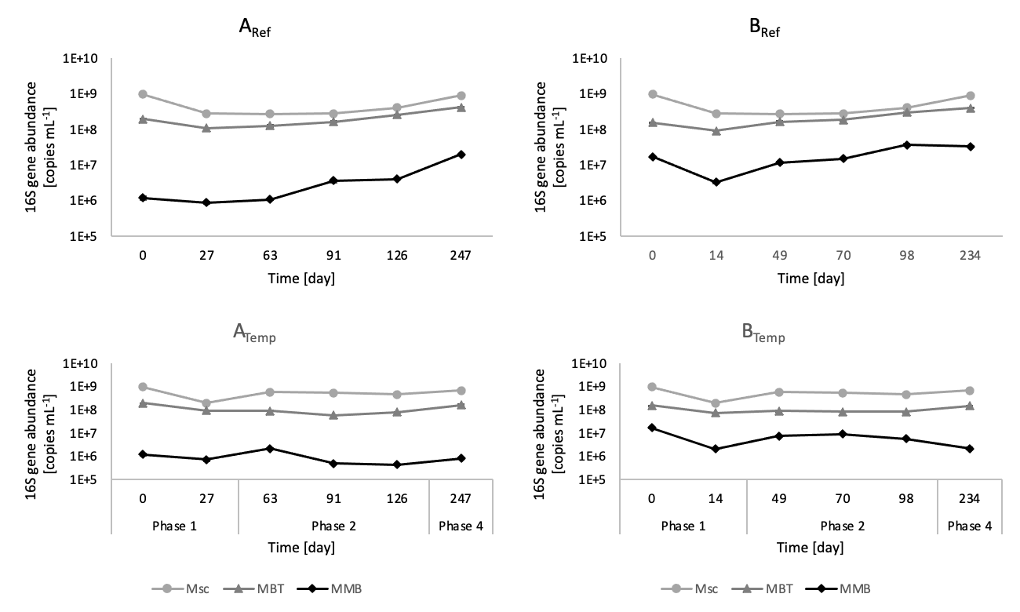

**Figure S5.** Methanogenic abundance.Logarithmic gene copies/mL of *Methanomicrobiales* (MMB), *Methanosarcinaceae* (Msc) and *Methanobacteriales* (MMB) over time in the reactors operating at mesophilic (ARef and BRef) and thermophilic (ATemp, BTemp) temperature. Grey lines, show experimental phases.