Supplementary Material

Supplementary Figures
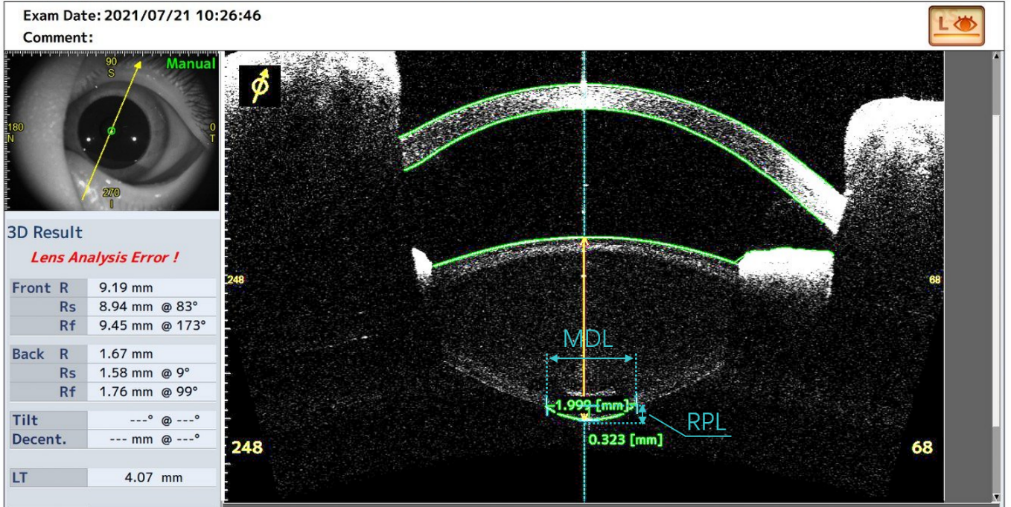
Supplementary Figure S1. Maximum diameter of the lesion (MDL) was defined as the largest distance between the margins of both sides of the posterior lesion in cross-sectional images from different directions. Rear projection length (RPL) was defined as the perpendicular distance from the center of the lens posterior surface to the focal protrusion apex.

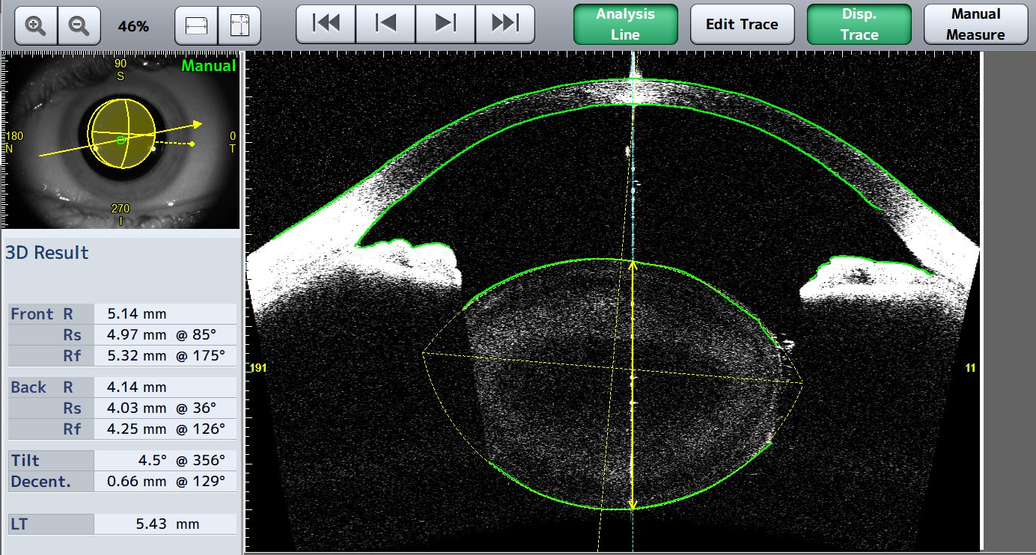
Supplementary Figure S2. In this CASIA2 screenshot of microspherophakia (MSP), anterior and posterior surface of the lens were delineated manually followed by automatic alignment, then the steep lens radius (R_{s}) and flat lens radius (R_{f}) could be calculated by the built-in software on the left column.

