**Supplementary Material**

**Table of Contents**

**Supplementary Figure 1.** The 1H NMR spectrum of compound **1** in CD3OD-*d*4 (500

Hz)……………………………………………………………………………………..3

**Supplementary Figure 2.** The 13C NMR and DEPT135 spectra of compound **1** in CD3OD-*d*4 (125MHz)………………………………………………………………….4

**Supplementary Figure 3.** The HSQC spectrum of compound **1** in CD3OD-*d*4……..5

**Supplementary Figure 4.** The 1H-1H COSY spectrum of compound **1** in CD3OD -*d*4……………………………………………………………………………………6

**Supplementary Figure 5.** The HMBC spectrum of compound **1** in CD3OD-*d*4……..7

**Supplementary Figure 6.** The HRESIMS spectrum of compound **1**………………8

**Supplementary Figure 7.** The 1H NMR spectrum of compound **2** in CD3OD-*d*4 (500 MHz) ……………………………………………………………………………….9

**Supplementary Figure 8.** The 13C NMR and DEPT135 spectra of compound **2** in CD3OD-*d*4 (125MHz)……………………………………………………………….10

**Supplementary Figure 9.** The HSQCspectrum of compound **2** in CD3OD-*d*4……11

**Supplementary Figure 10.** The 1H-1H COSY spectrum of compound **2** in CD3OD- *d*4……………………………………………………………………………………..12

**Supplementary Figure 11.** The HMBC spectrum of compound **2** in CD3OD-*d*4…13

**Supplementary Figure 12.** The HRESIMS spectrum of compound **2**…………14

**Supplementary Figure 13.** The 1H NMR spectrum of compound **3** in DMSO-*d*6 (500 MHz)…………………………………………………………………………………15

**Supplementary Figure 14.** The 13C NMR and DEPT135 spectra of compound **3** in DMSO-*d*6(125 MHz)…………………………………………………………….16

**Supplementary Figure 15.** The HSQCspectrum of **3** in DMSO-*d*6………………...17

**Supplementary Figure 16.** The 1H-1H COSY spectrum of compound **3** in DMSO-*d*6……………………………………………………………………………18

**Supplementary Figure 17.** The HMBC spectrum of compound **3** in DMSO-*d*6…..19

**Supplementary Figure 18.** The ROESY spectrum of compound **3** in DMSO-*d*6….20

**Supplementary Figure 19.** The HRESIMS spectrum of compound **3**……………21

**Supplementary Figure 20.** The 1H NMR spectrum of compound **4** in CD3OD-*d*4 (600 Hz)…………………………………………………………………………….22

**Supplementary Figure 21.** The DEPTQ spectrum of compound **4** in CD3OD-*d*4 (150Hz)……………………………………………………………………………....23

**Supplementary Figure 22.** The HSQC spectrum of compound **4** in CD3OD-*d*4…..24

**Supplementary Figure 23.** The 1H-1H COSY spectrum of compound **4** in CD3OD- *d*4…………………………………………………………………………….25

**Supplementary Figure 24.** The HMBCspectrum of compound **4** in CD3OD-*d*4…26

**Supplementary Figure 25**. The HRESIMS spectrum of compound **4**……………...27

**Supplementary Figure 26.** Marfey’s method applying for compound **3**…………...28

**Supplementary Figure 27.** HPLC analysis of compounds **1-3**……………………..29

**Supplementary Table 1.** 1H and 13C NMR data for **5-8** (500 and 125 MHz, *δ* in ppm)………………………………………………………………………………….30

**Supplementary Table 2 .**Appearance, specific rotation and MS data of **5**-**8**.………..31

**Supplementary Figure 1.** The 1H NMR spectrum of compound **1** in CD3OD-*d*4 (500 MHz)

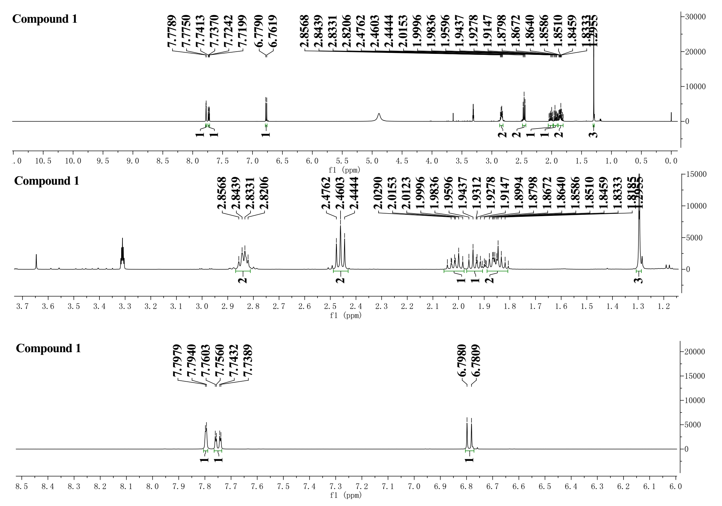

**Supplementary Figure 2.** The 13C NMR and DEPT135 spectra of compound **1** in CD3OD-*d*4 (125MHz)

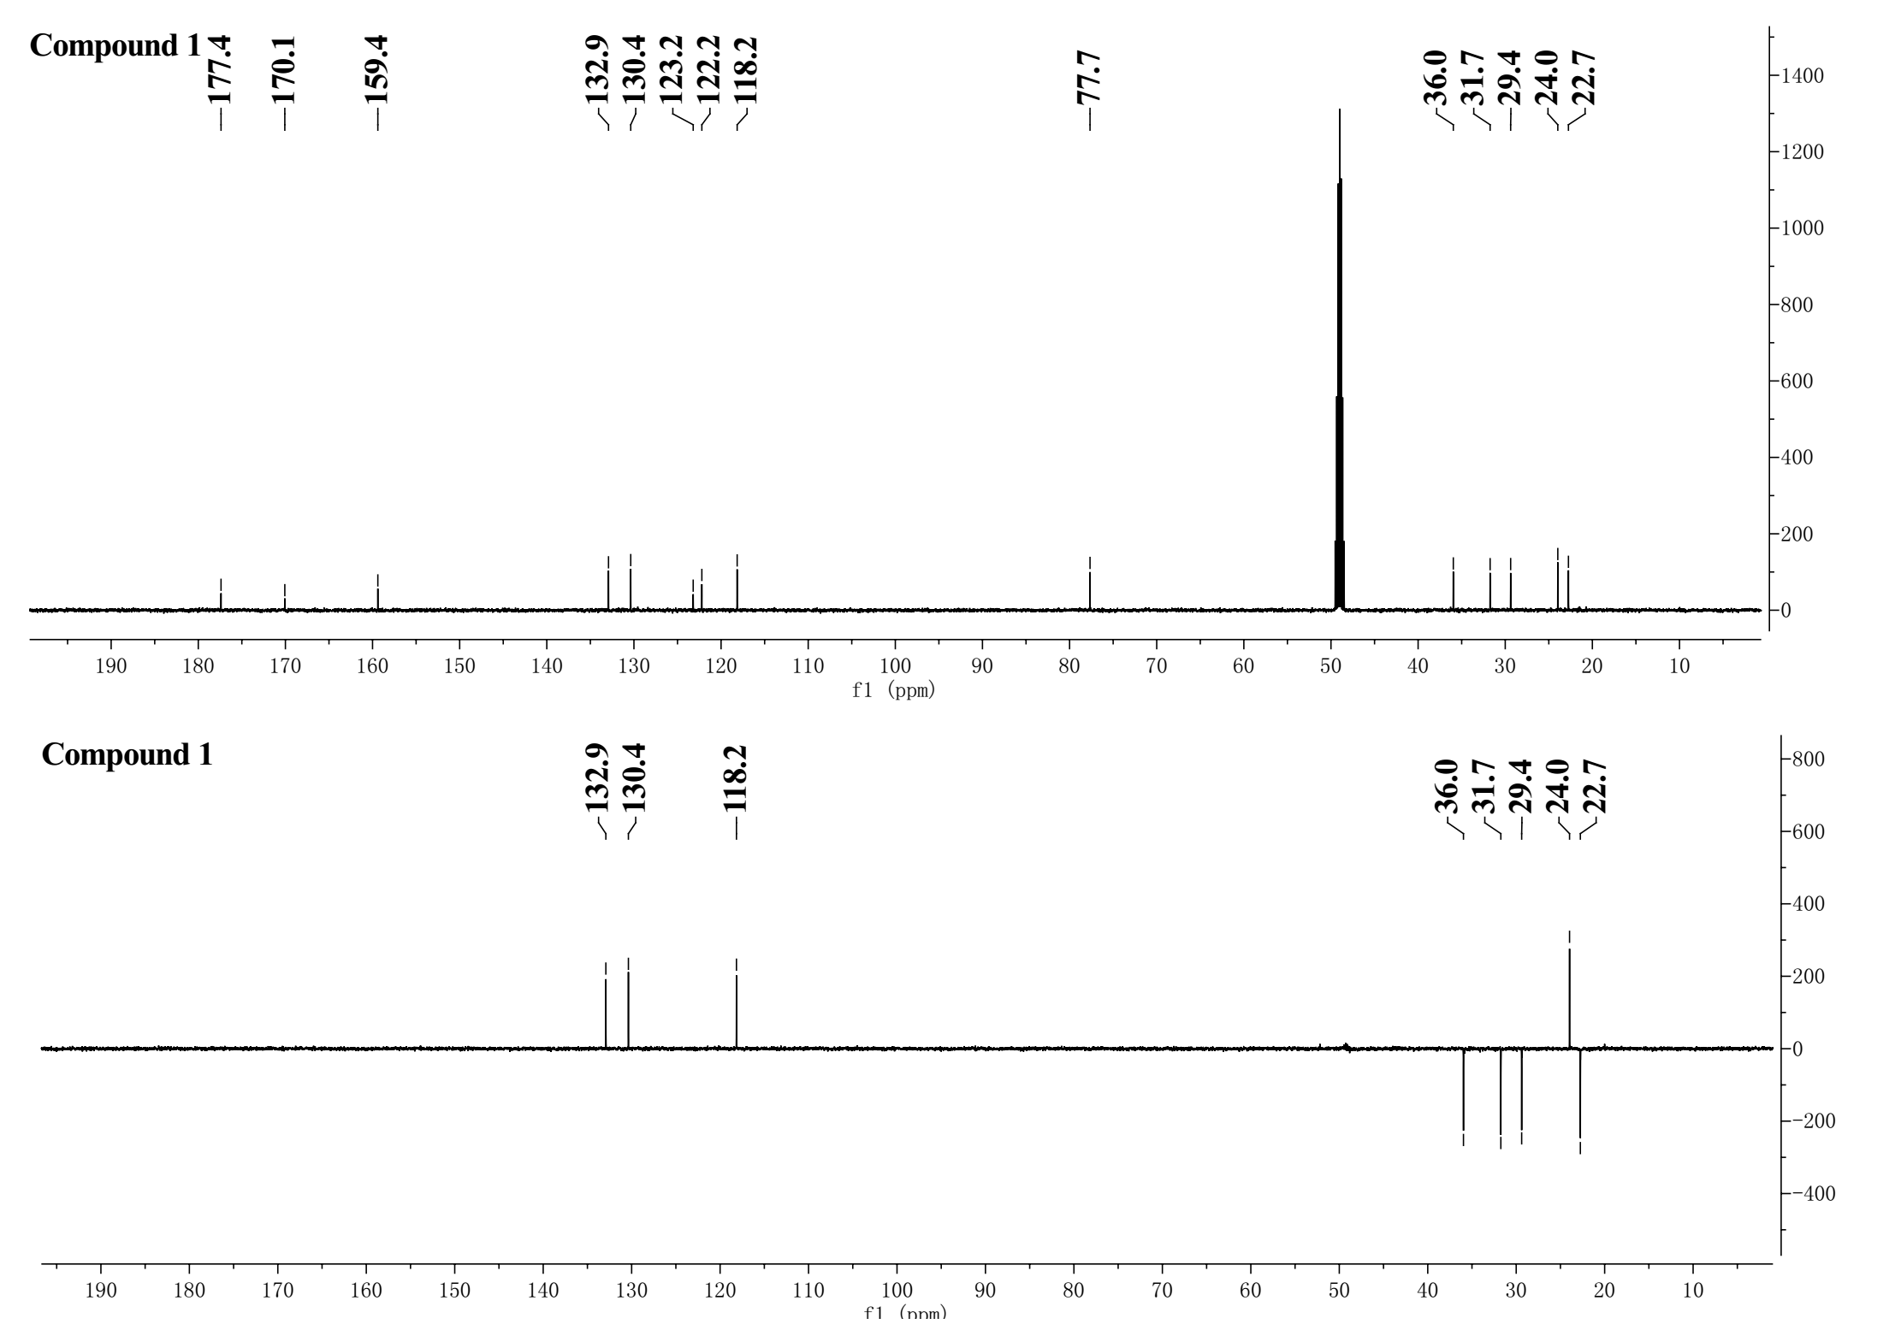

**Supplementary Figure 3.** The HSQC spectrum of compound **1** in CD3OD-*d*4

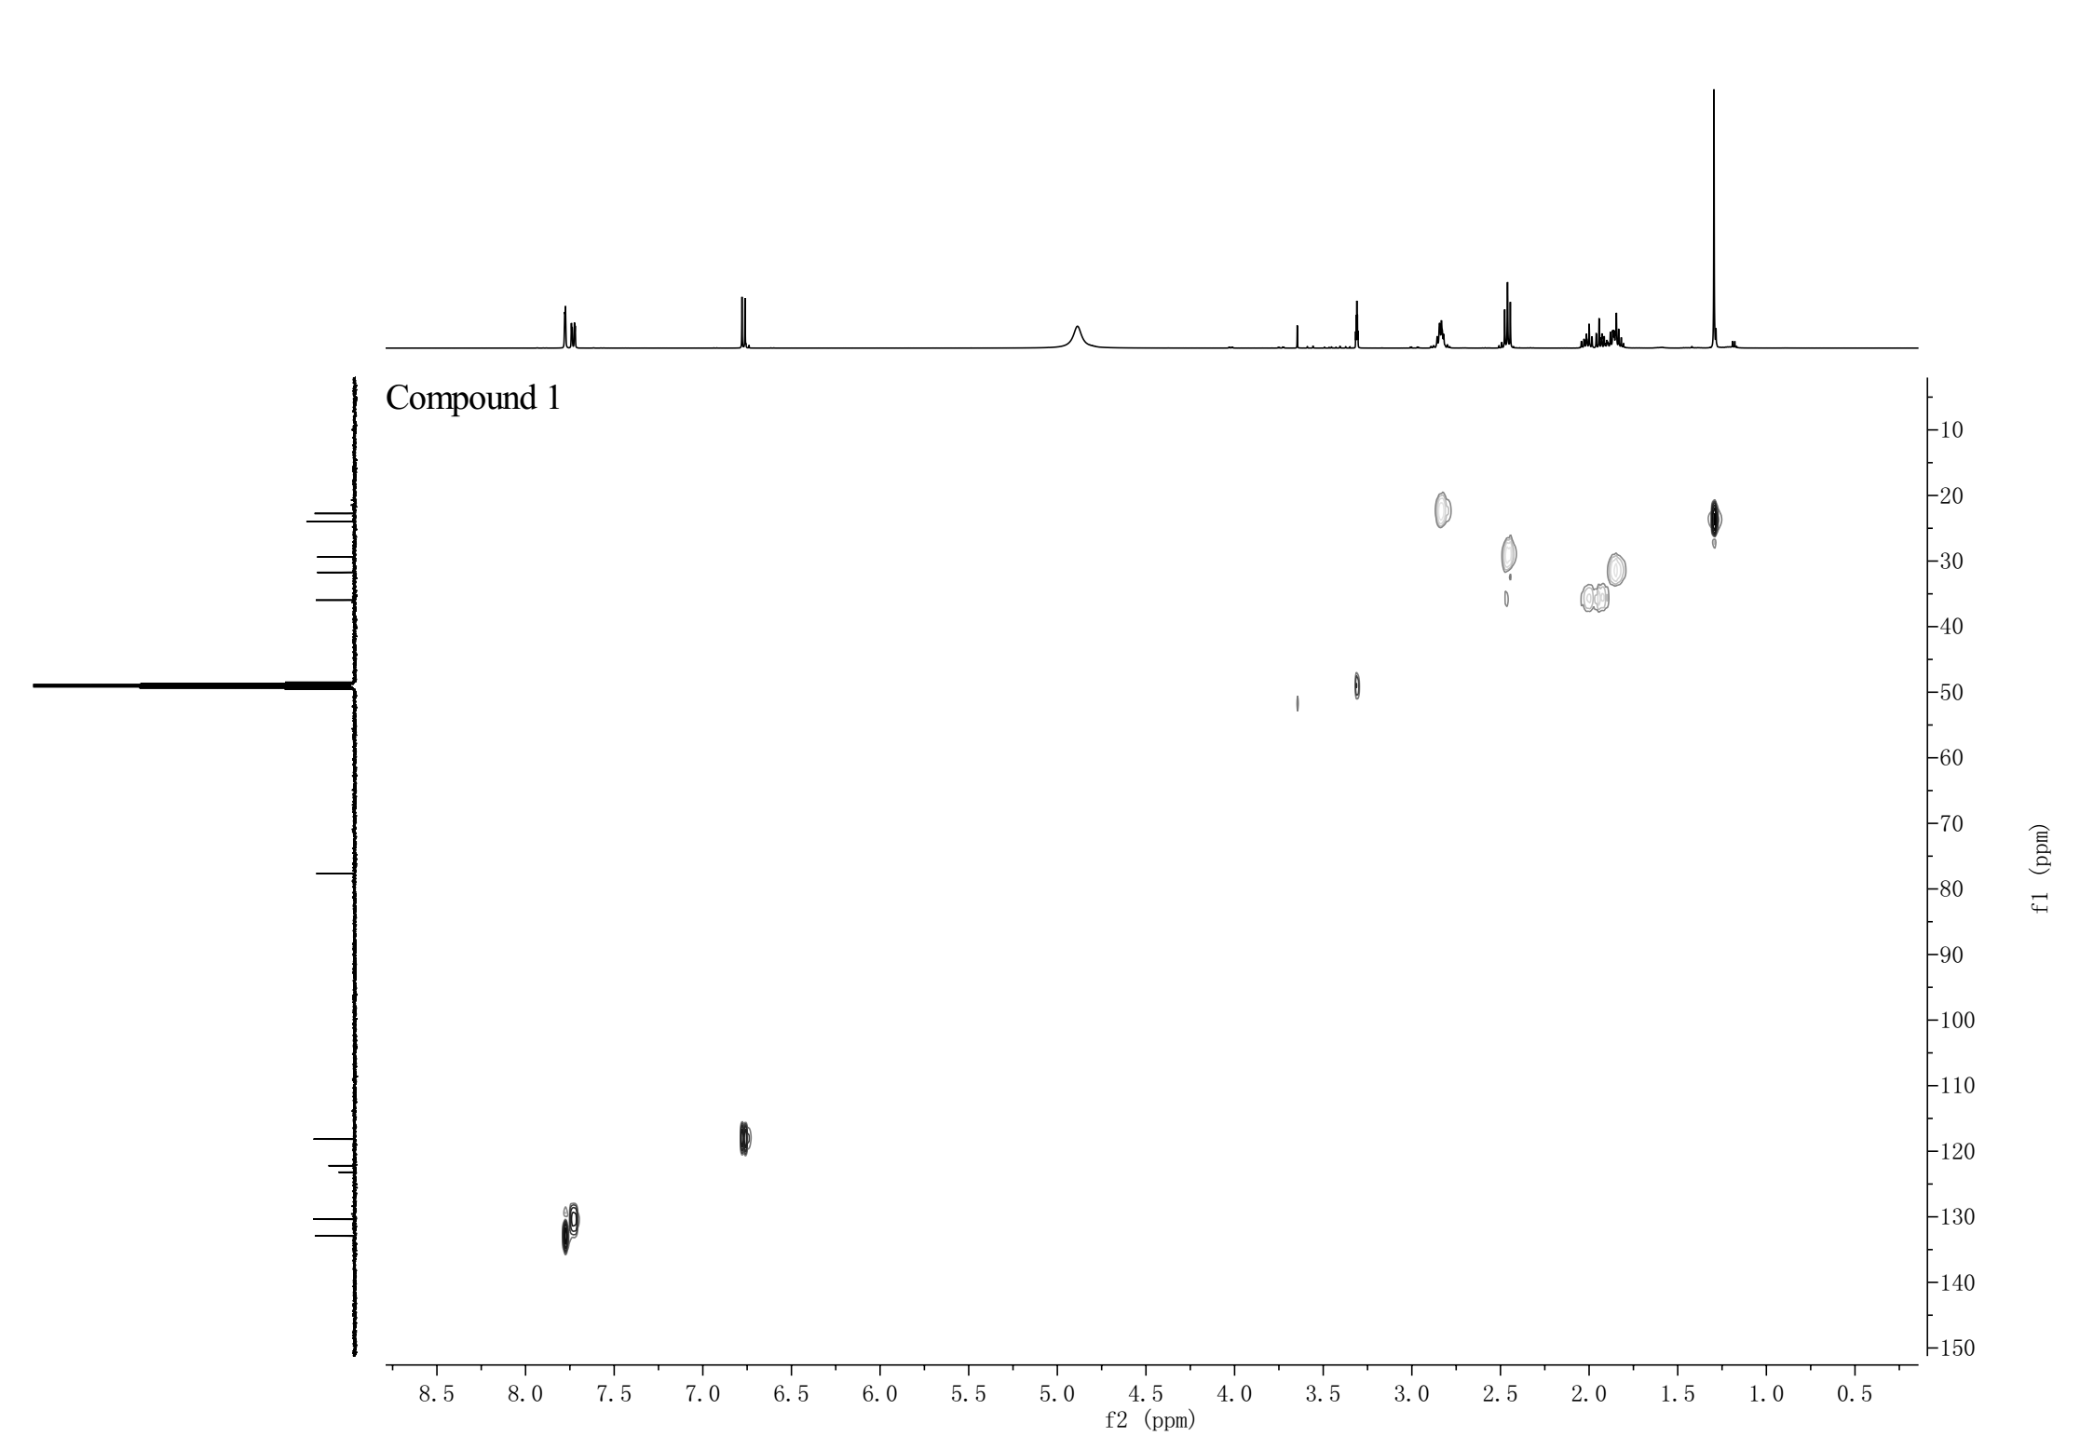

**Supplementary Figure 4.** The 1H-1H COSY spectrum of compound **1** in CD3OD-*d*4

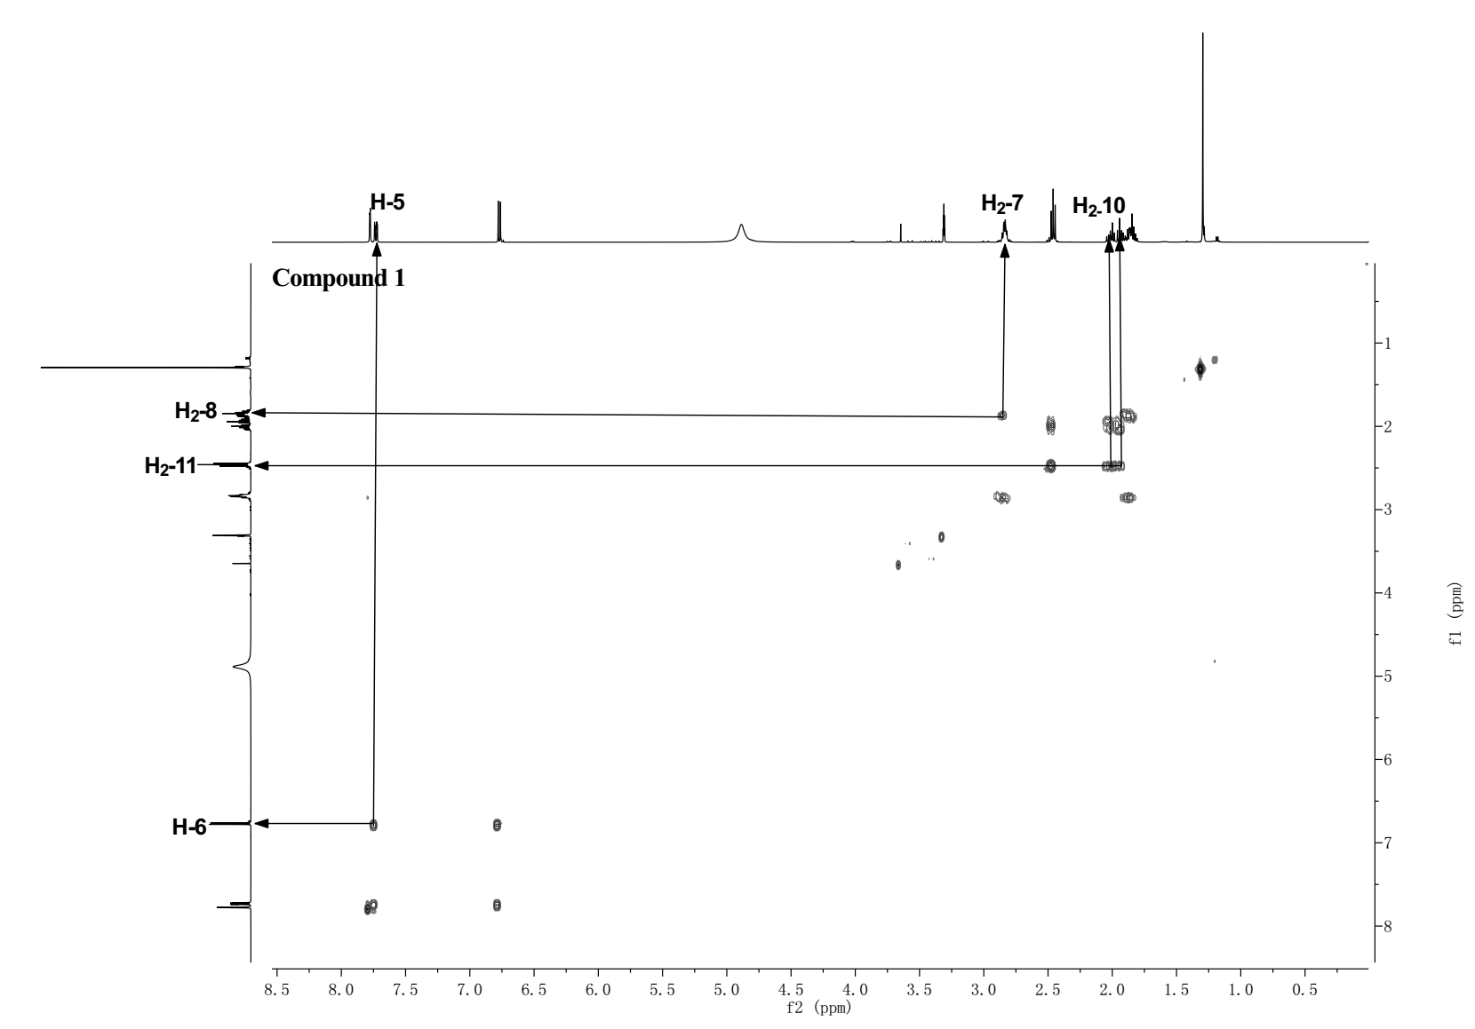

**Supplementary Figure 5.** The HMBC spectrum of compound **1** in CD3OD-*d*4

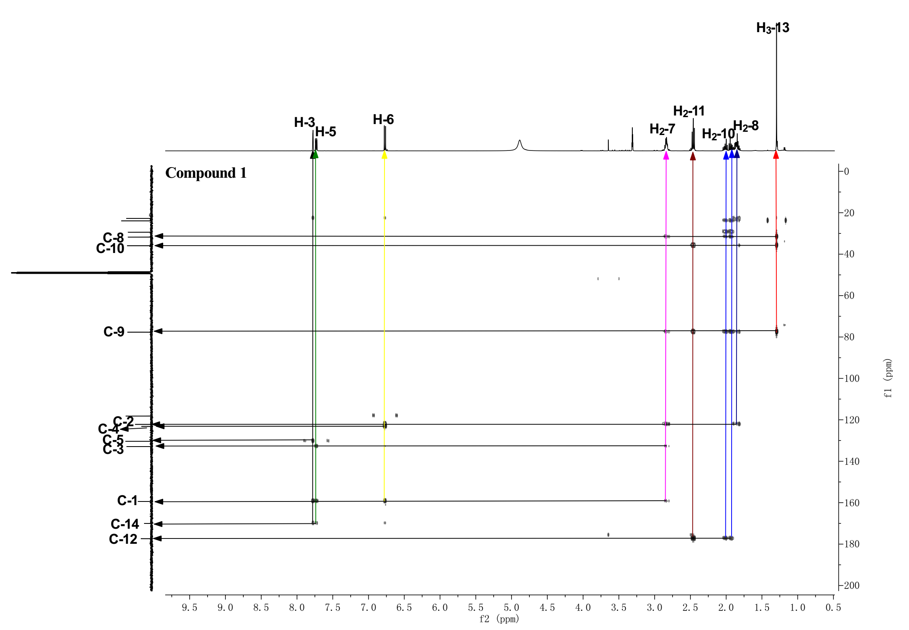



**Supplementary Figure 6.** The HRESIMS spectrum of compound **1**

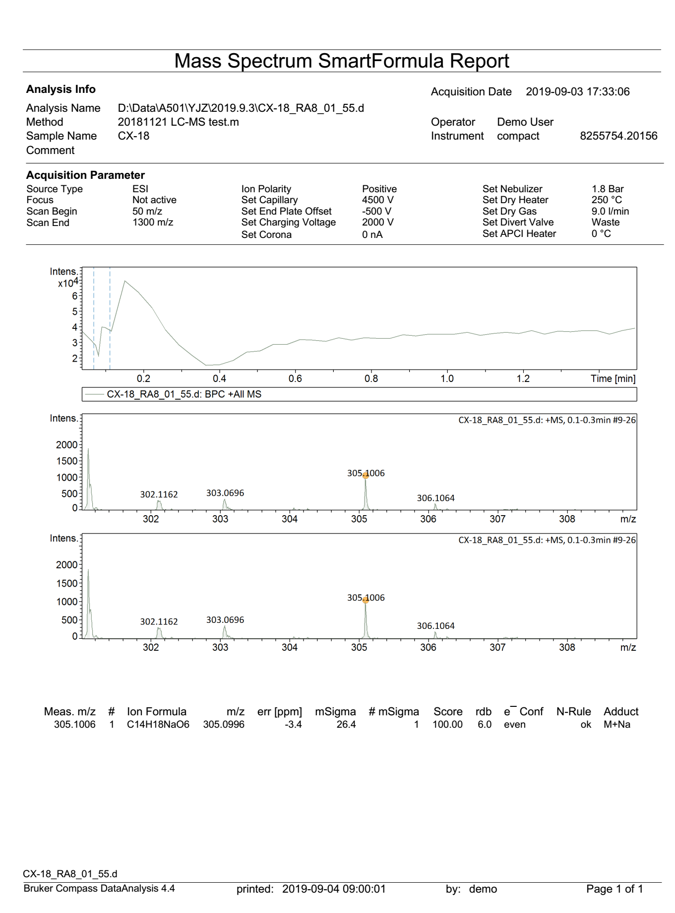

**Supplementary Figure 7.** The 1H NMR spectrum of compound **2** in CD3OD-*d*4 (500 MHz)

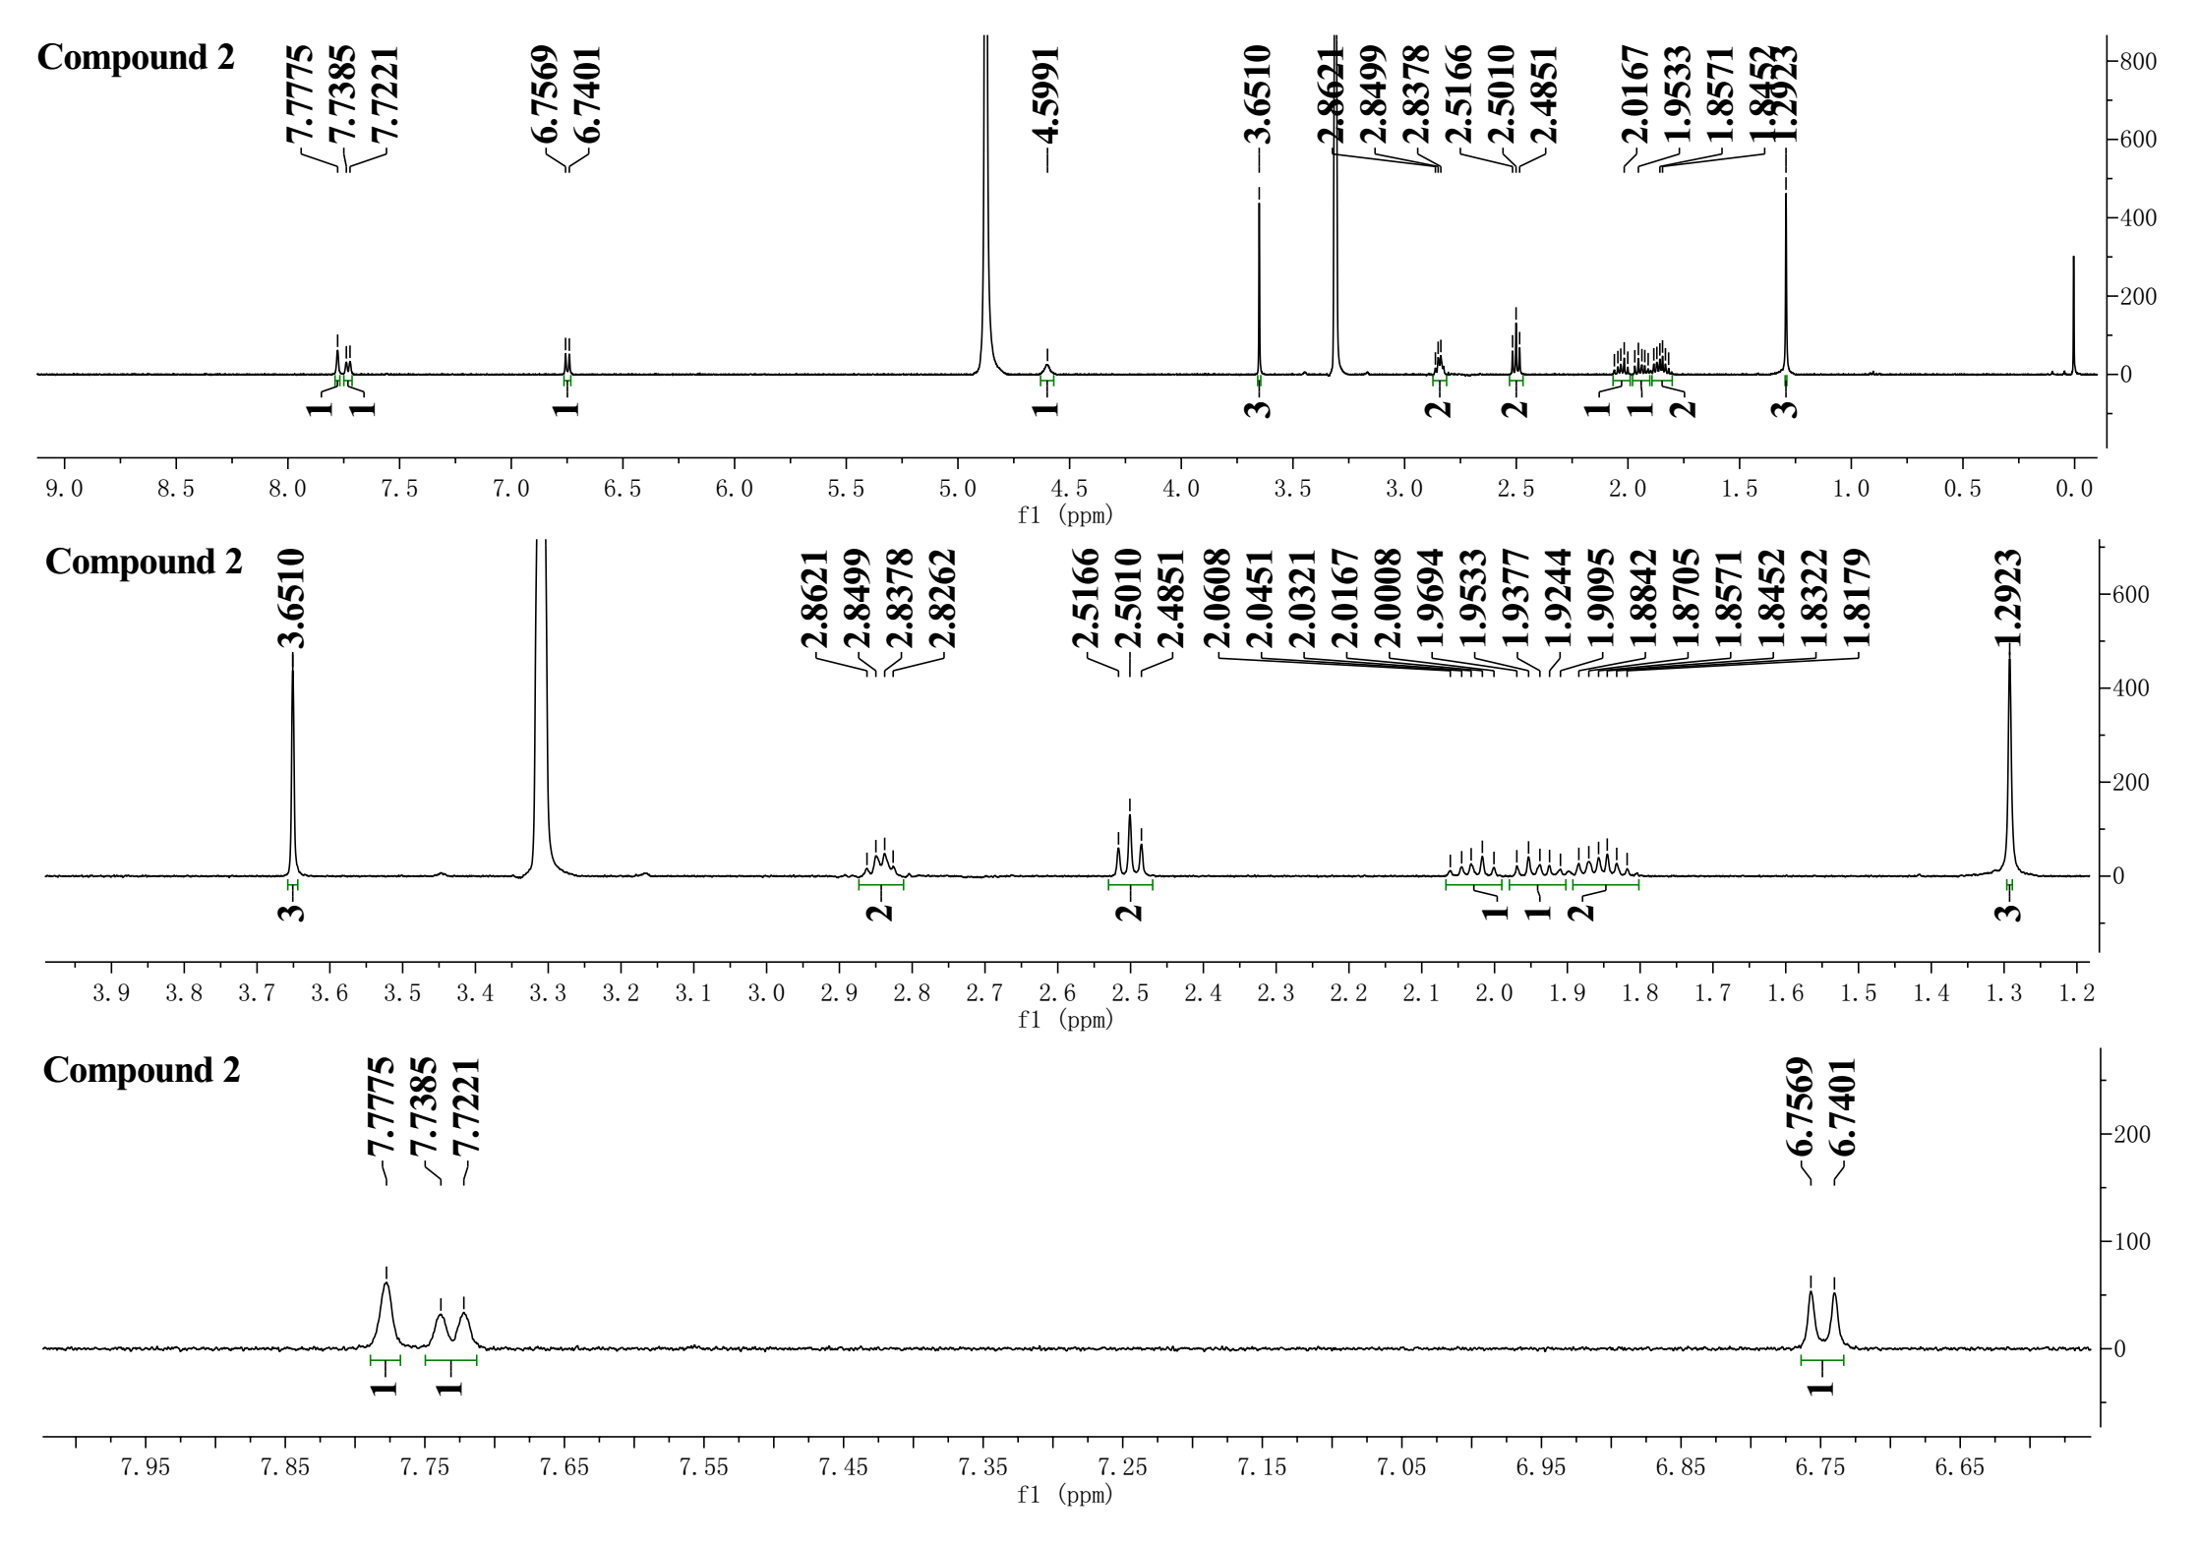

**Supplementary Figure 8.** The 13C NMR and DEPT135 spectra of compound **2** in CD3OD-*d*4 (125 Hz)

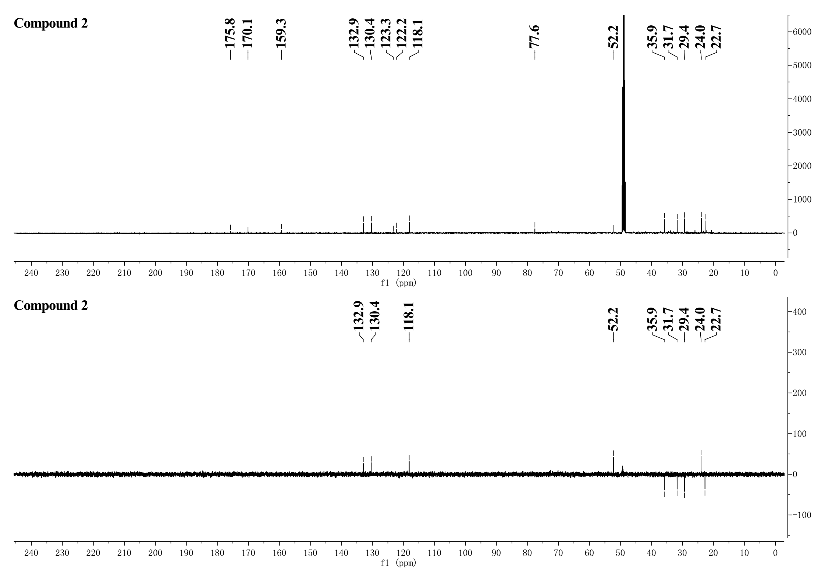

**Supplementary Figure 9.** The HSQC spectrum of compound **2** in CD3OD-*d*4

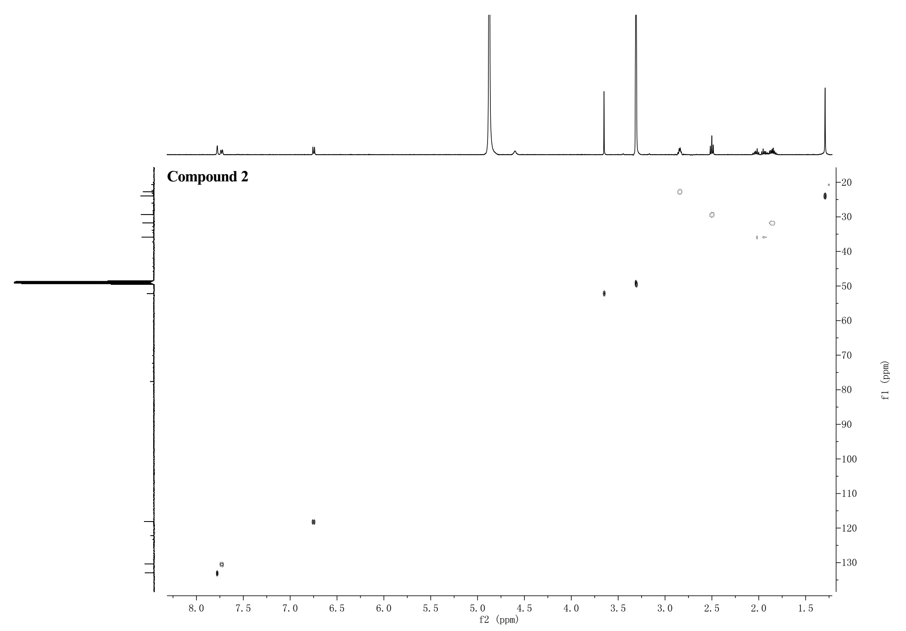

**Supplementary Figure 10.** The 1H-1H COSY spectrum of compound **2** in CD3OD-*d*4

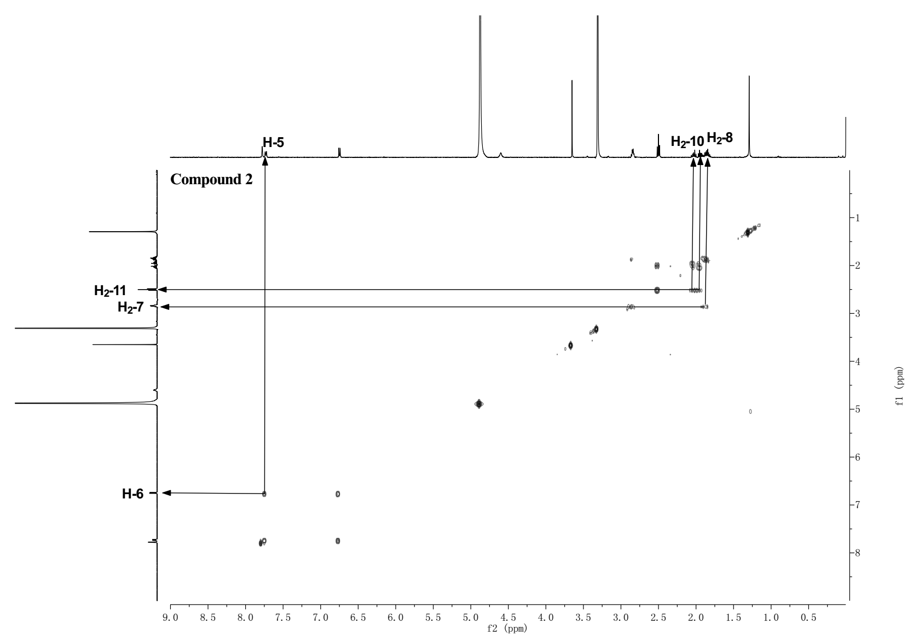

**Supplementary Figure 11.** The HMBC spectrum of compound **2** in CD3OD-*d*4

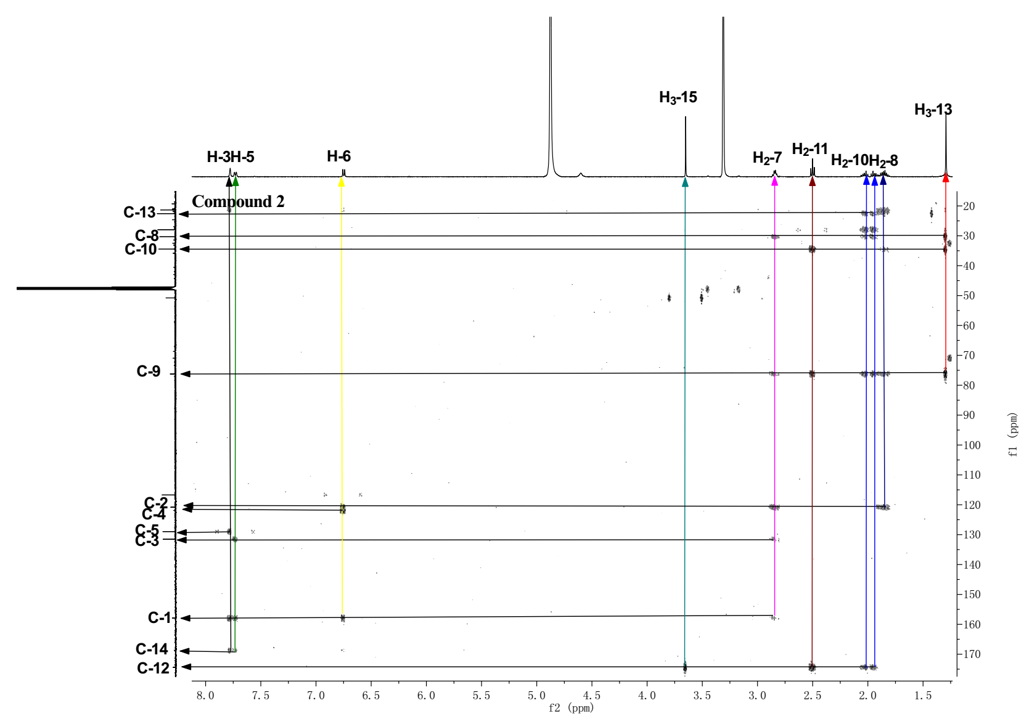



**Supplementary Figure 12.** The HRESIMS spectrum of compound **2**

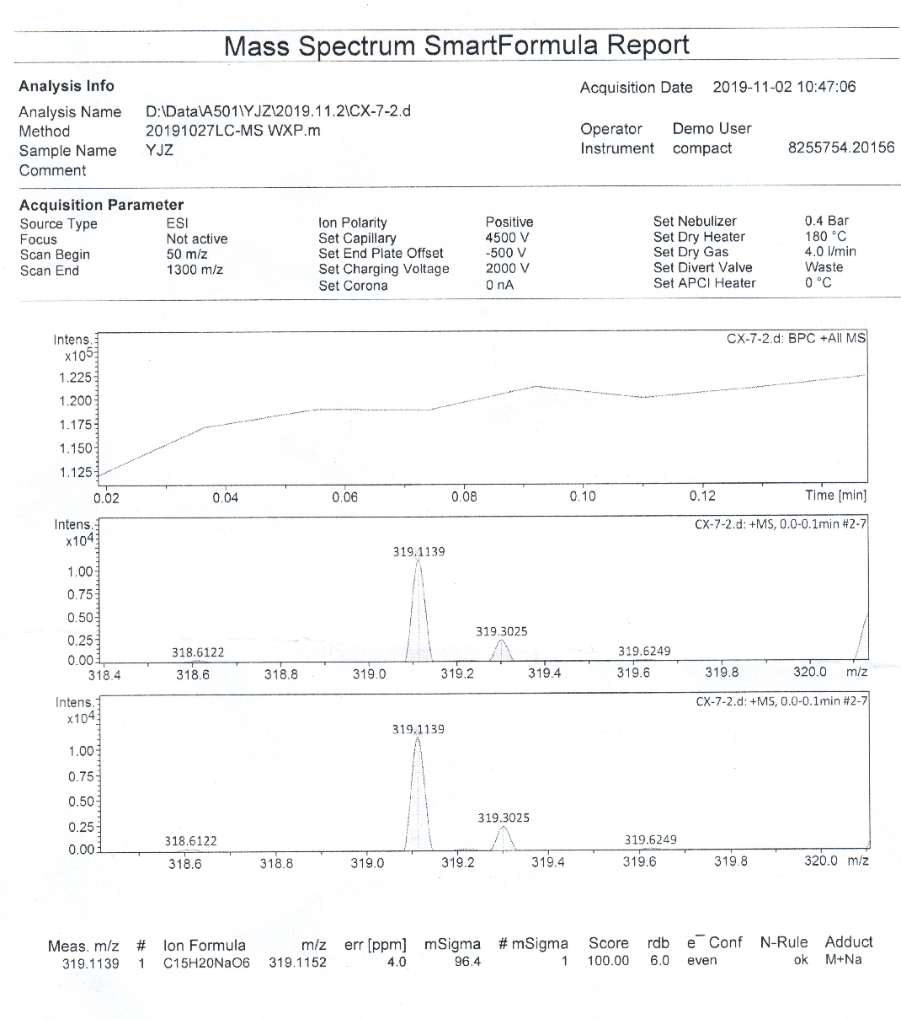

**Supplementary Figure 13.** The 1H NMR spectrum of compound **3** in DMSO-*d*6 (500 MHz)

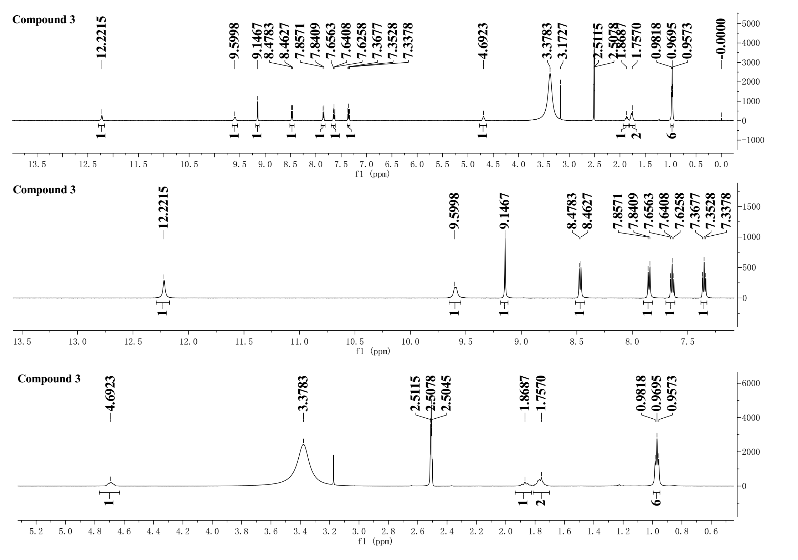

**Supplementary Figure 14.** The 13C NMR and DEPT135 spectra of compound **3** in CD3OD-*d*4 (125 Hz)

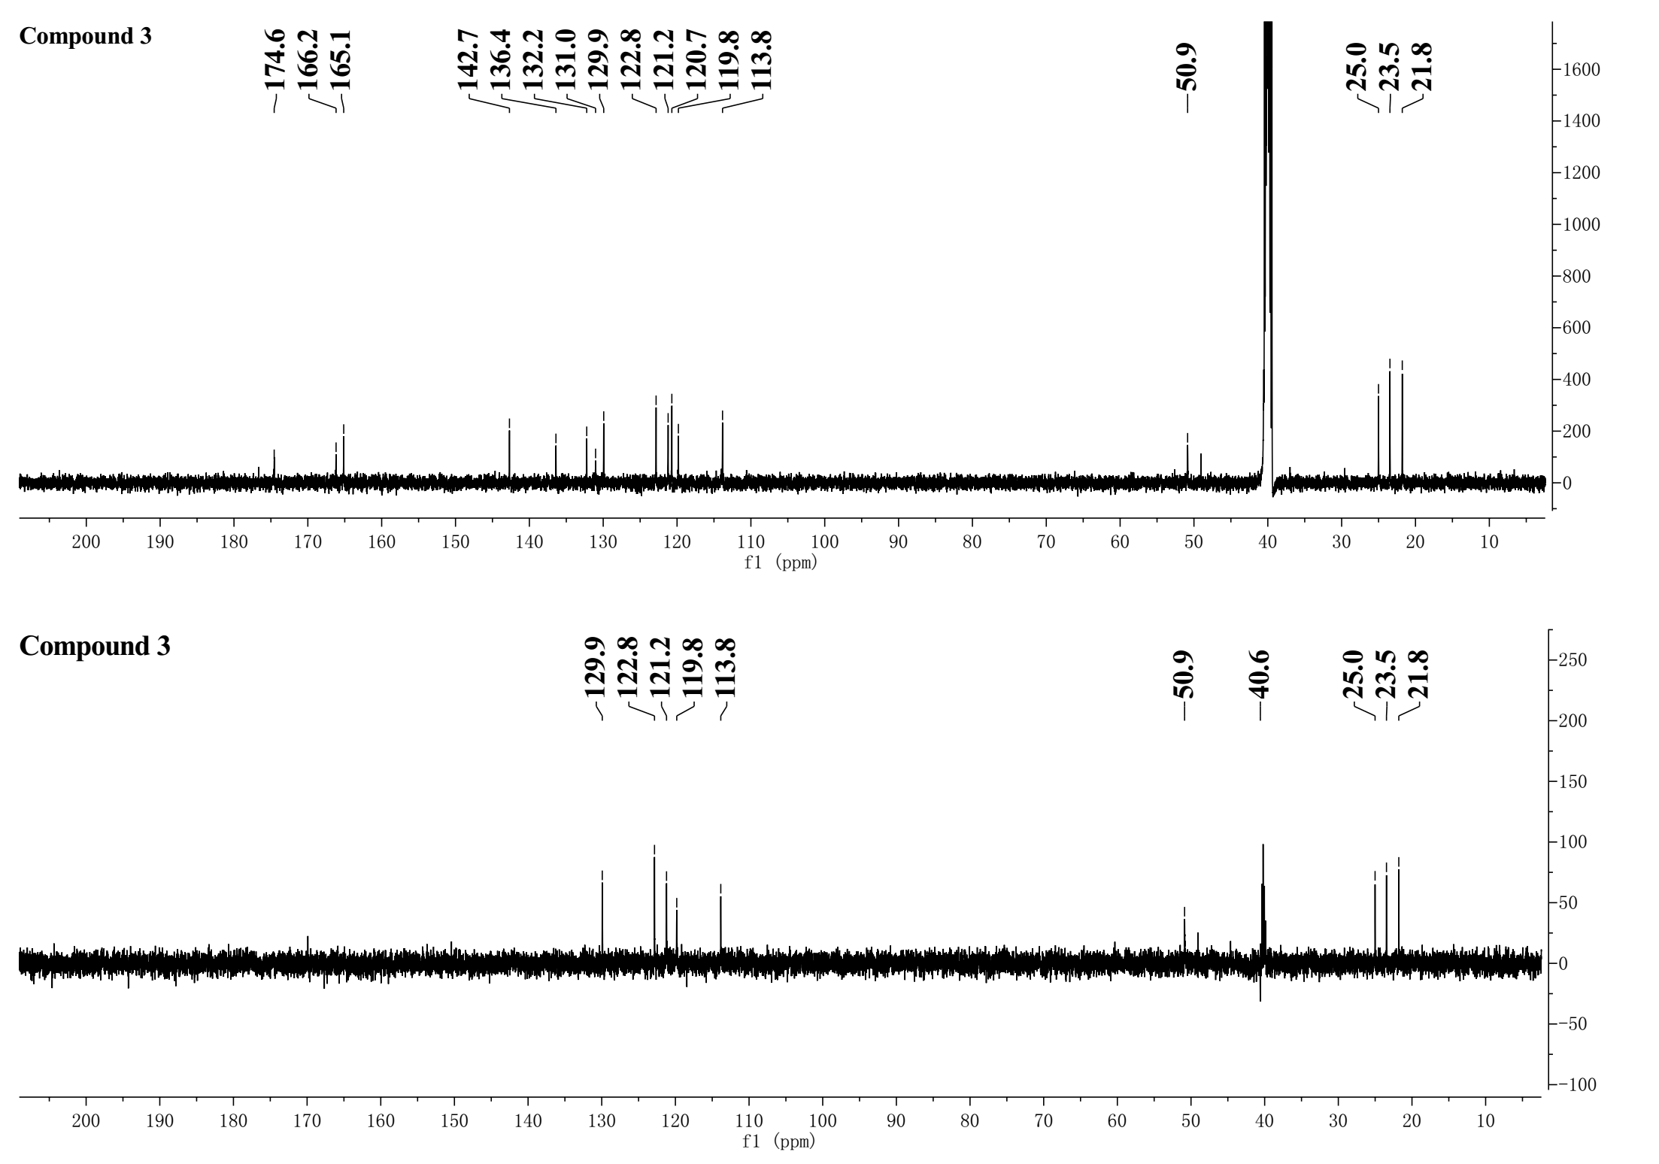

**Supplementary Figure 15.** The HSQC spectrum of compound **3** in DMSO-*d*6

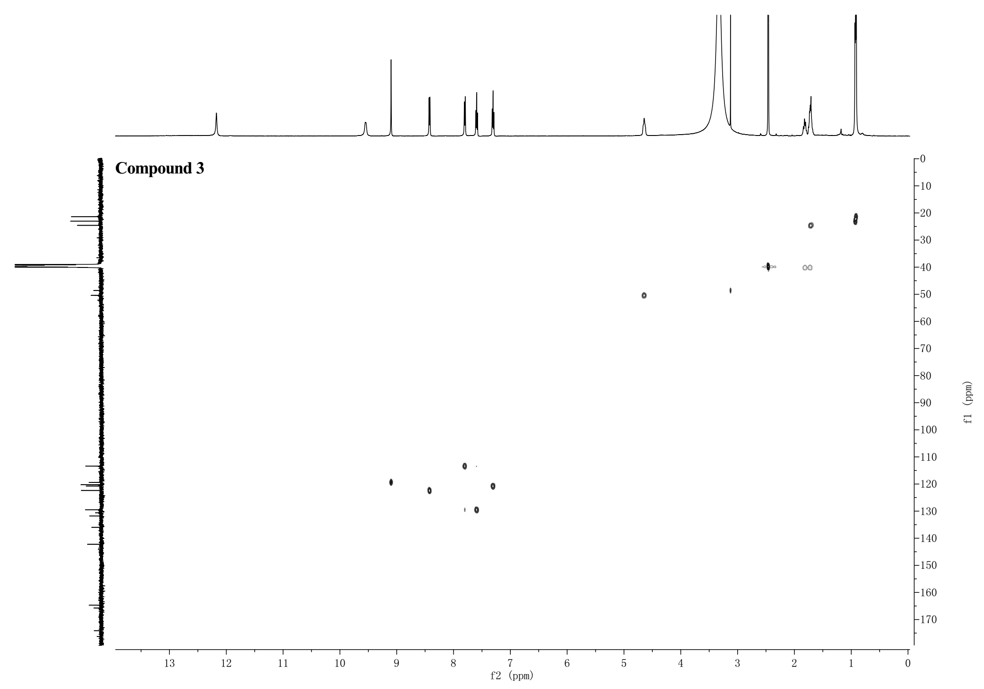

**Supplementary Figure 16.** The 1H-1H COSY spectrum of compound **3** in DMSO-*d*6

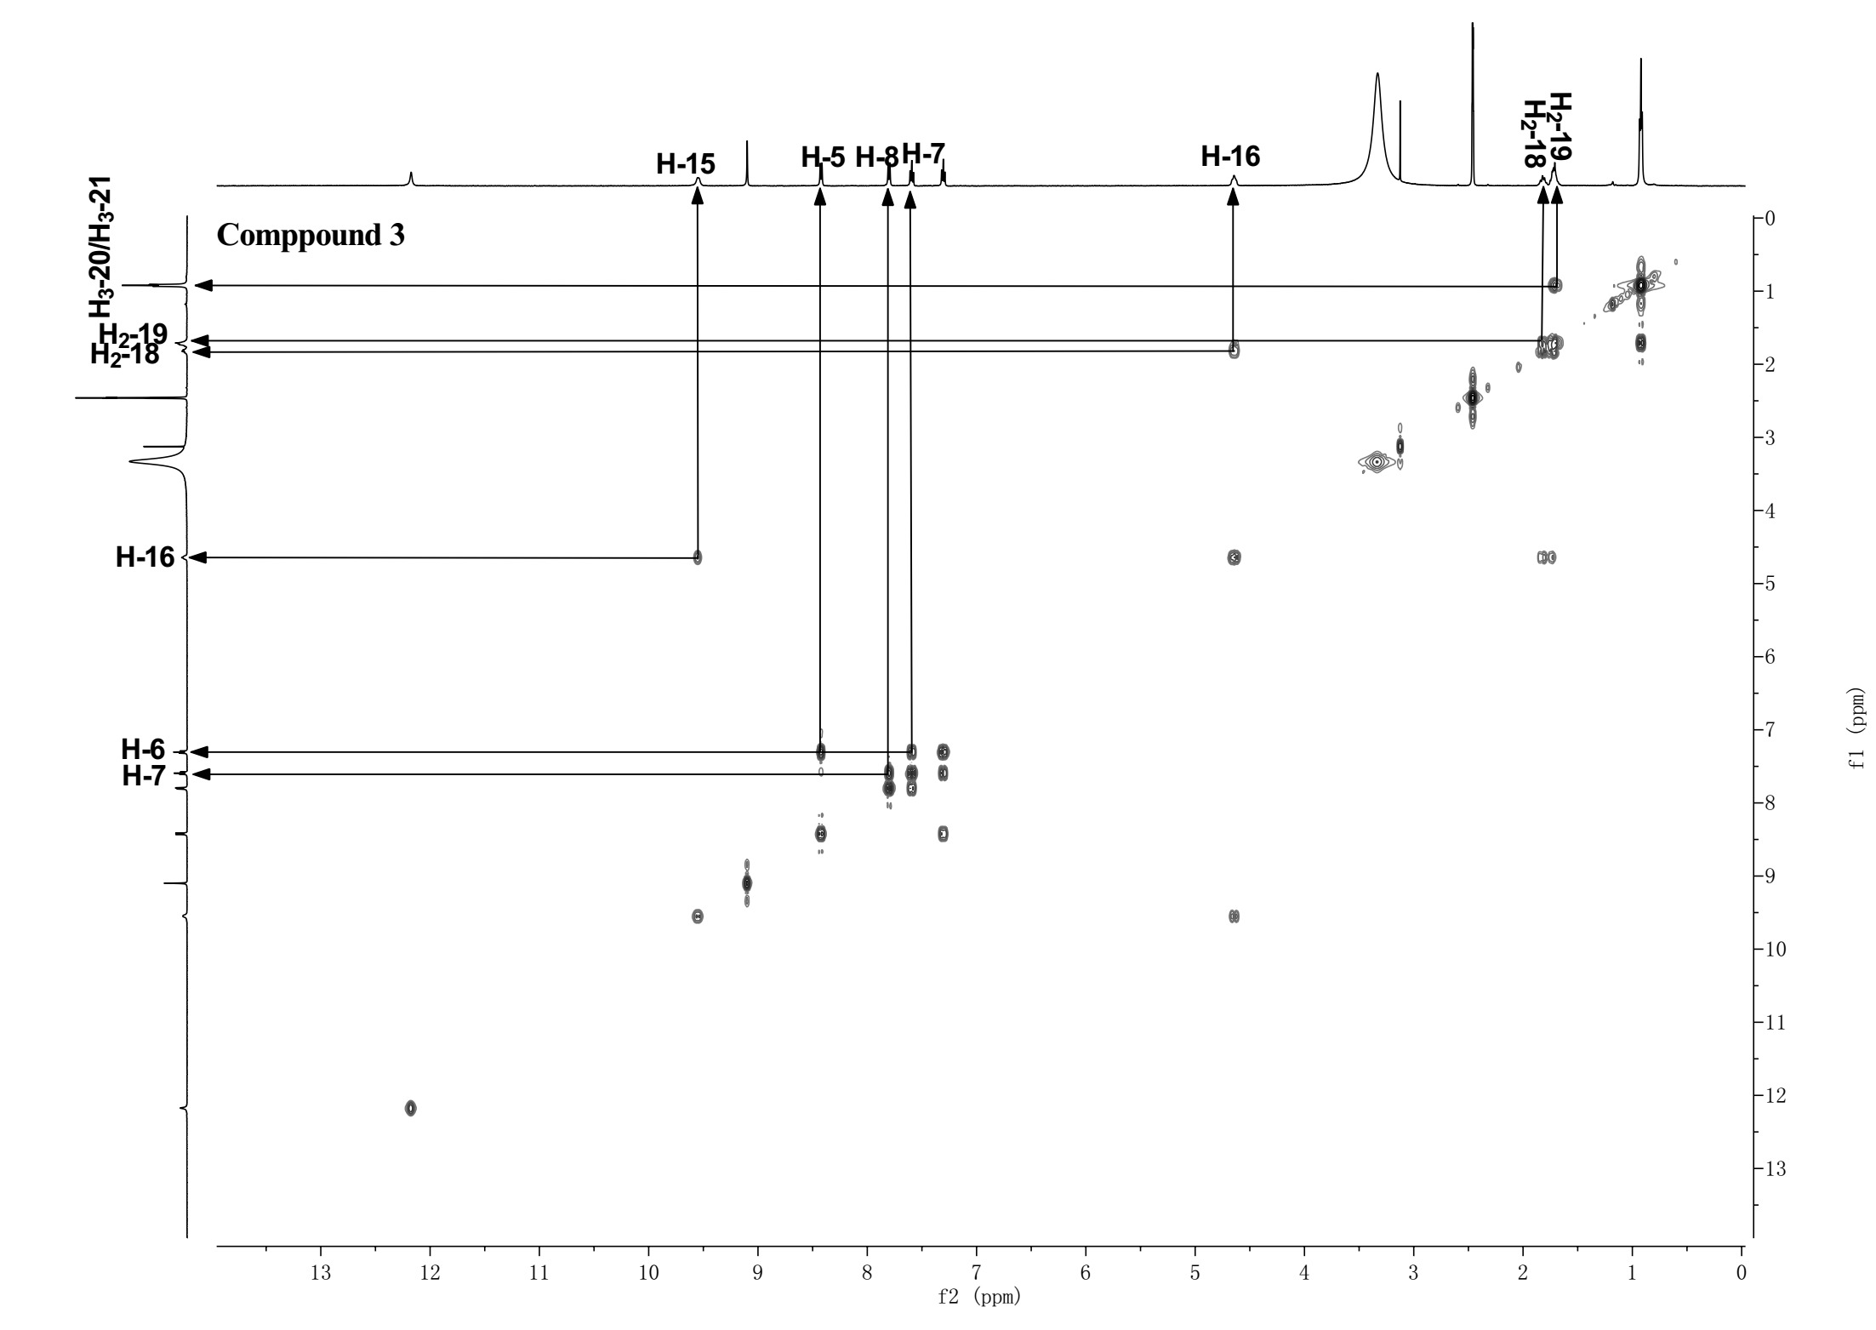

**Supplementary Figure 17**. The HMBC spectrum of compound **3** in DMSO-*d*6

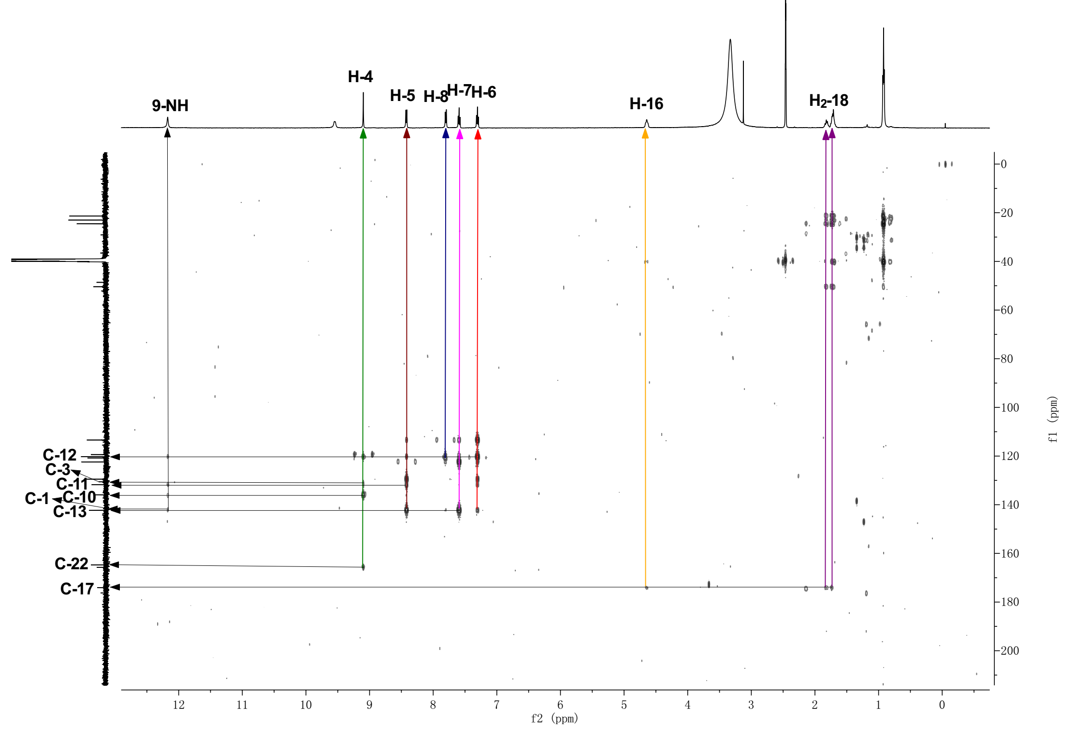



**Supplementary Figure 18.** The ROESY spectrum of compound **3** in DMSO-*d*6

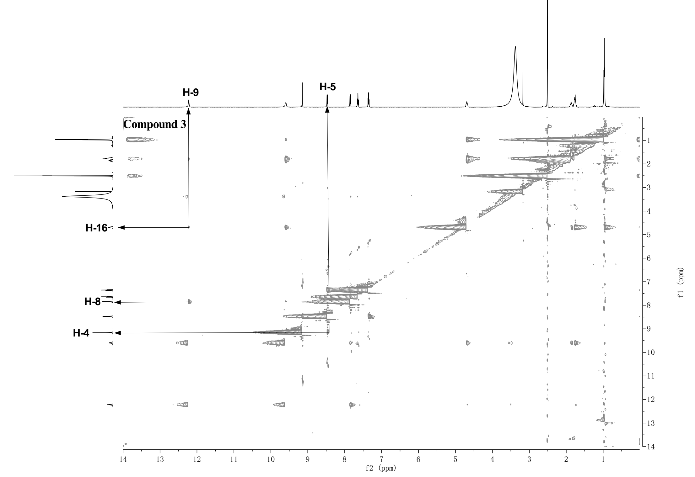



**Supplementary Figure 19.** The HRESIMS spectrum of compound **3**

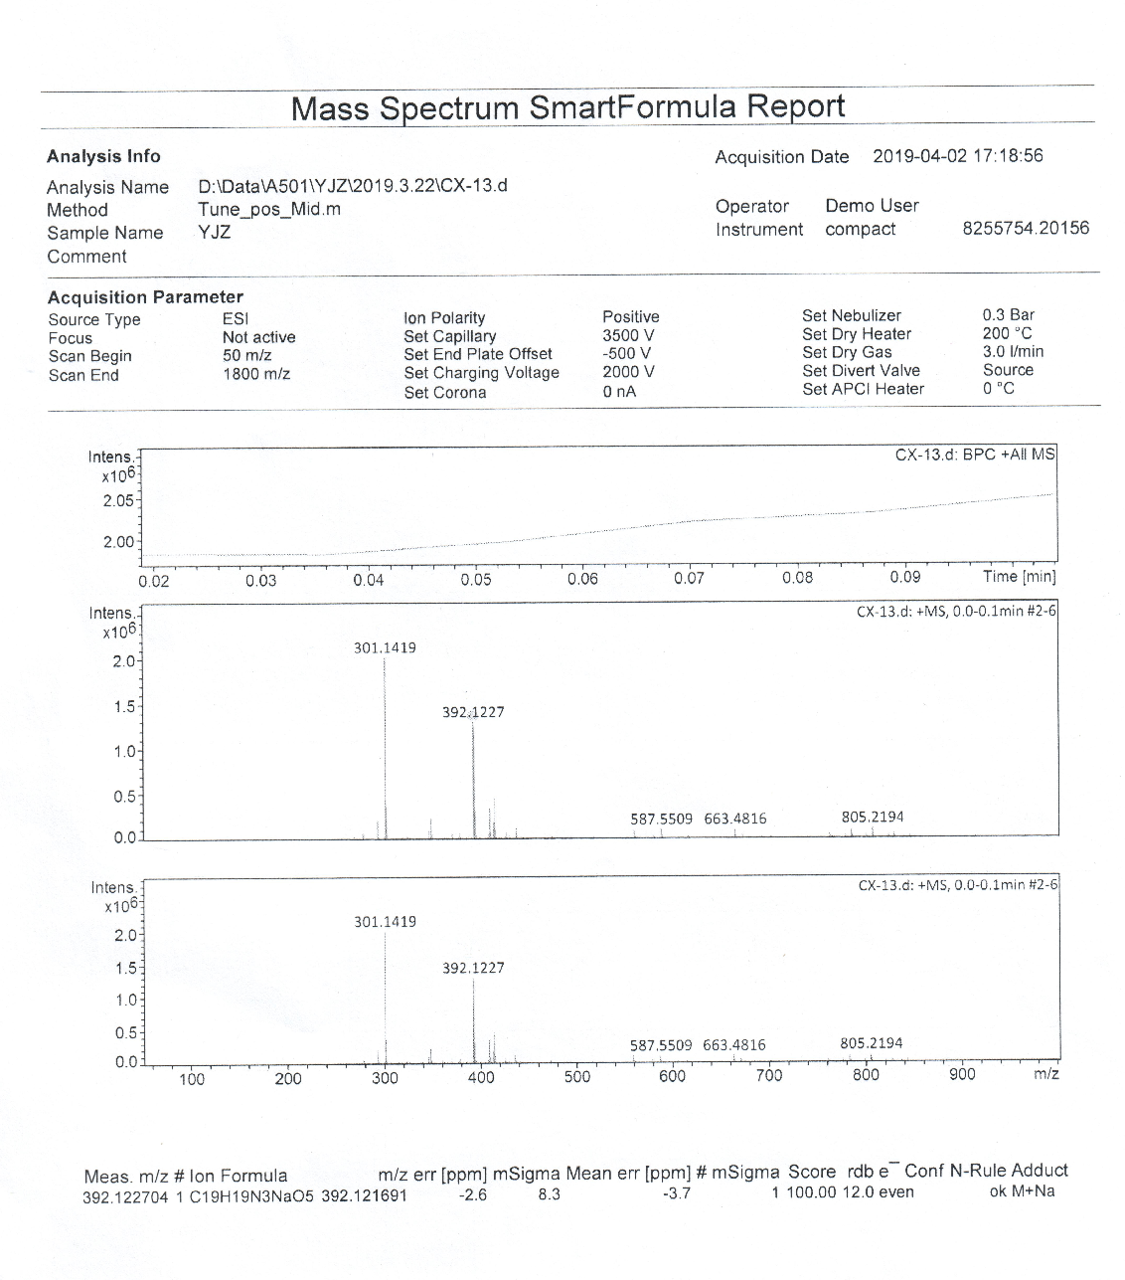

**Supplementary Figure 20.** The 1H NMR spectrum of compound **4** in CD3OD-*d*4 (600 MHz)

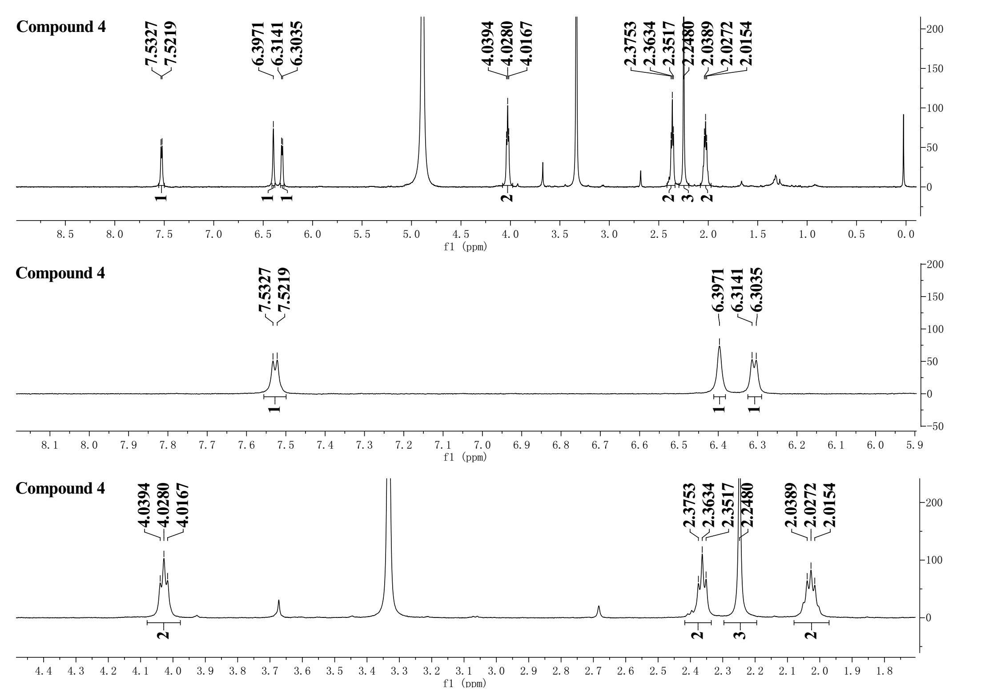

**Supplementary Figure 21.** The DEPTQ spectrum of compound **4** in CD3OD-*d*4 (125 MHz)

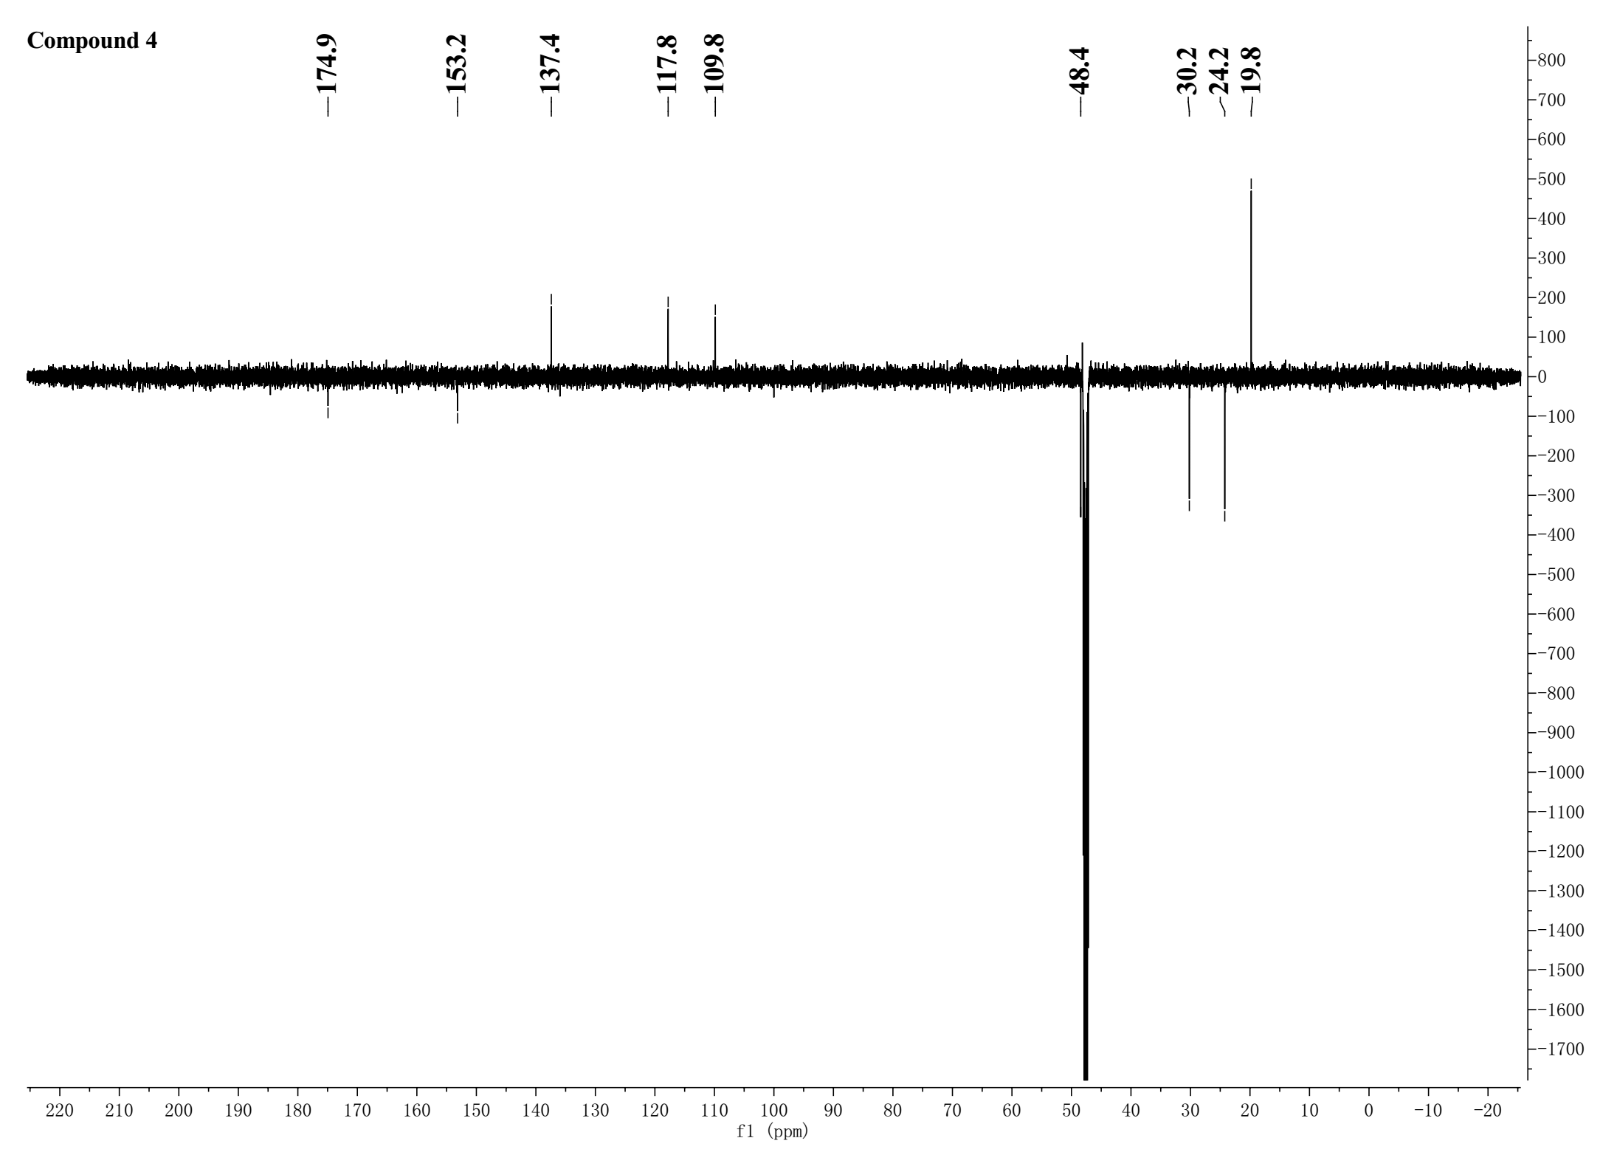

**Supplementary Figure 22.** The HSQC spectrum of compound **4** in CD3OD-*d*4

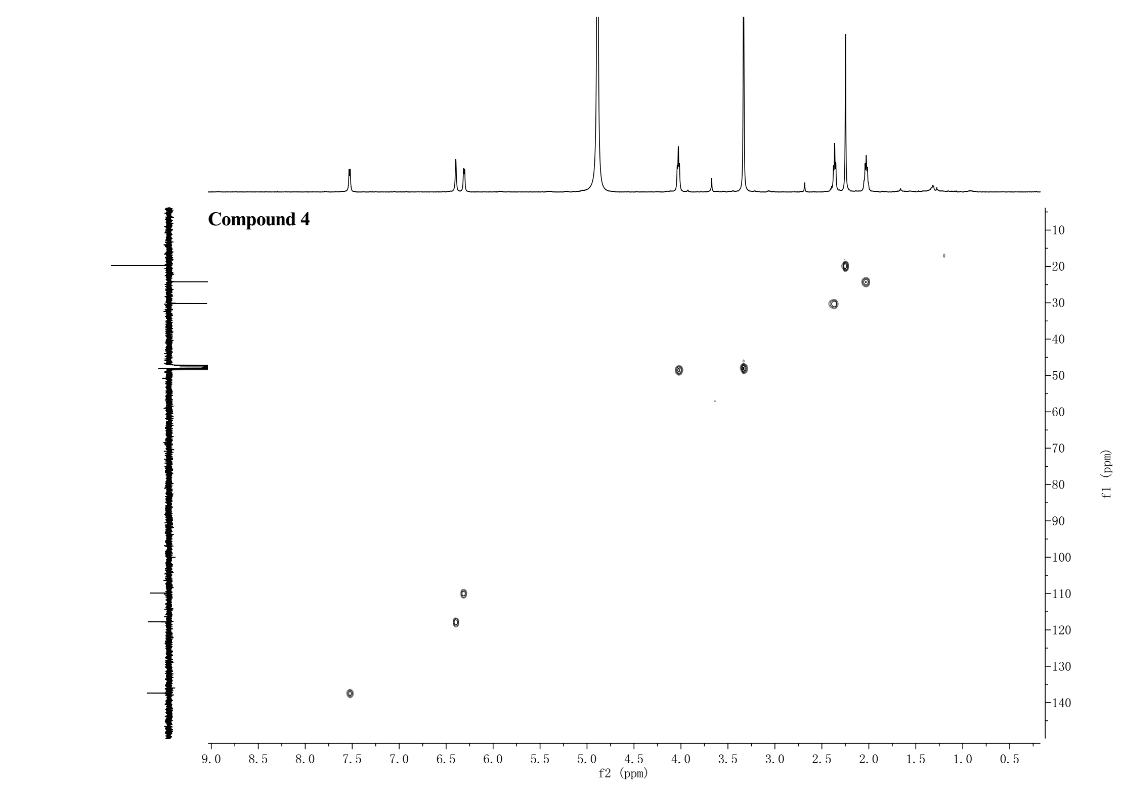

**Supplementary Figure 23.** The 1H-1H COSY spectrum of compound **4** in CD3OD-*d*4

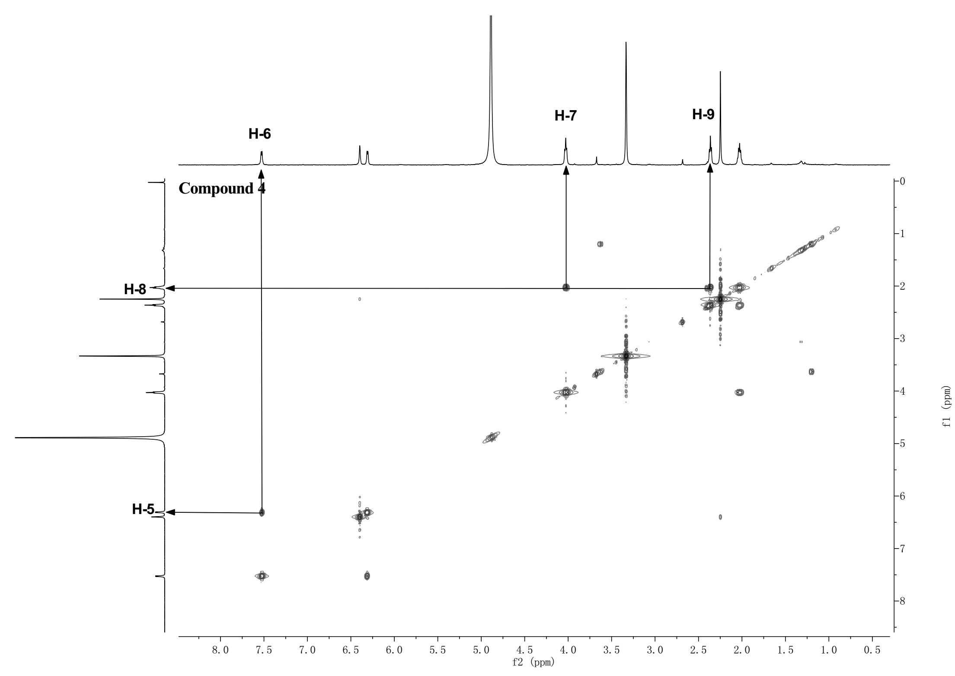

**Supplementary Figure 24.** The HMBC spectrum of compound **4** in CD3OD-*d*4

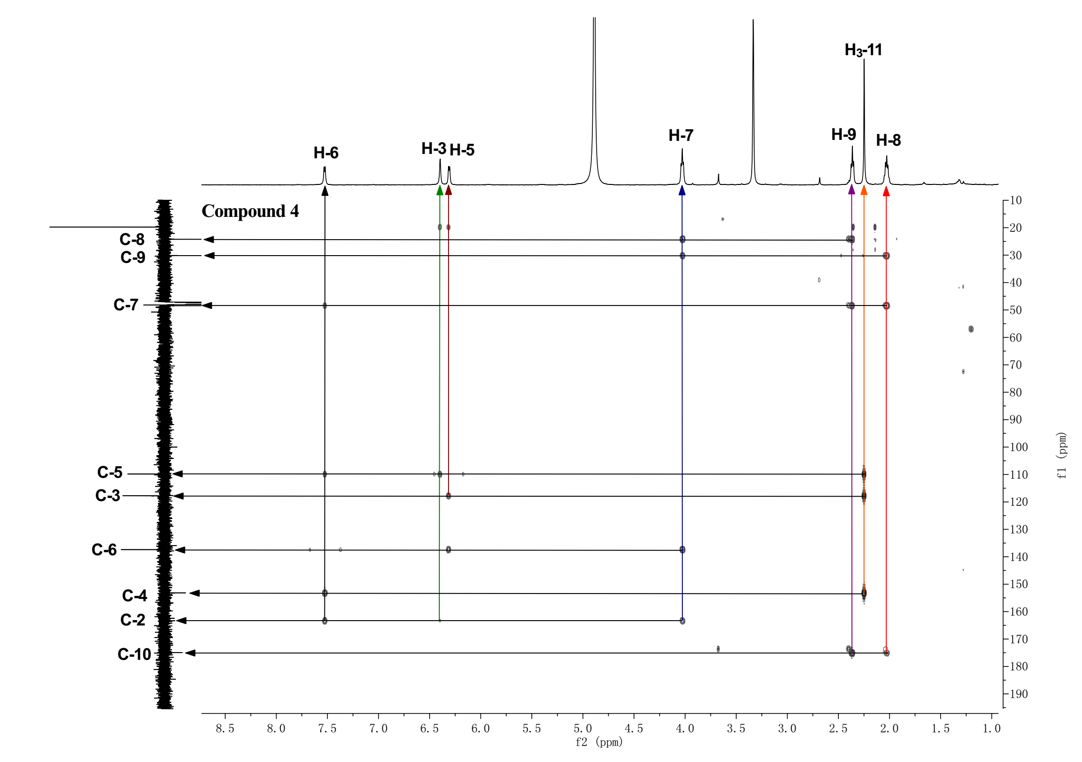



**Supplementary Figure 25.** The HRESIMS spectrum of compound **4**

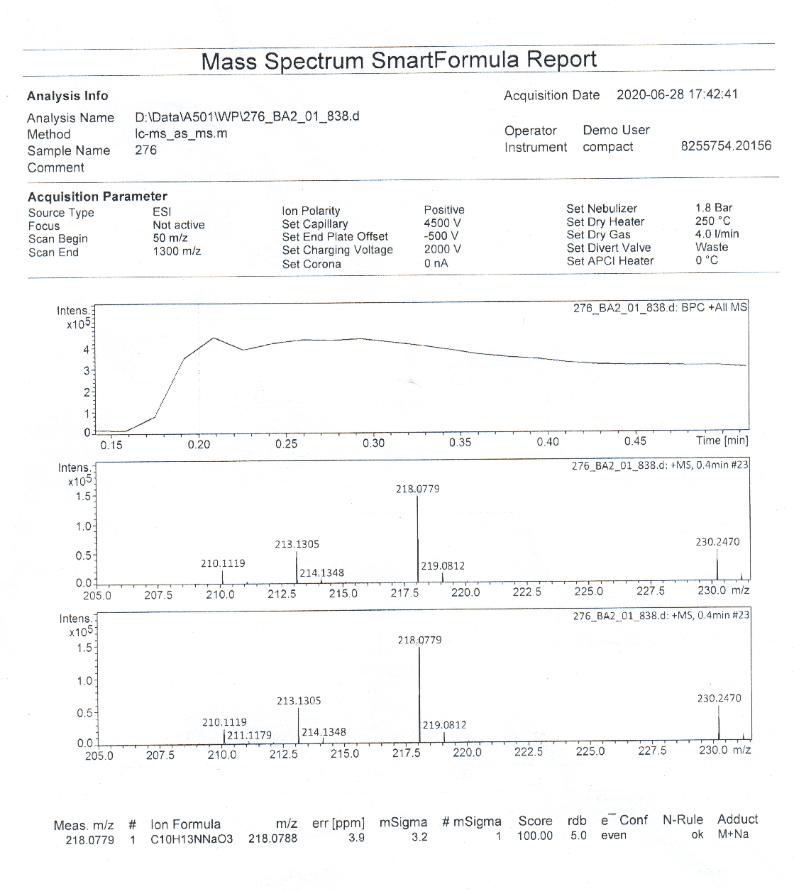

**Supplementary Figure 26**. Marfey’s method applying for compound **3 (**ODS column : Cosmosil-pack, 4.6 × 250 mm, 5 µm, 1 mL/min, Nacalai Tesque; Solvents: (A) water + 0.1% TFA, (B) MeCN; linear gradient: 0 min, 75% A + 25% B; 40 min, 40% A + 60% B; 45 min, 100% B; temperature, 30 °C; flow rate, 1 mL/min; UV detection at λmax 340 nm; FDAA, 15.7 min)**.**

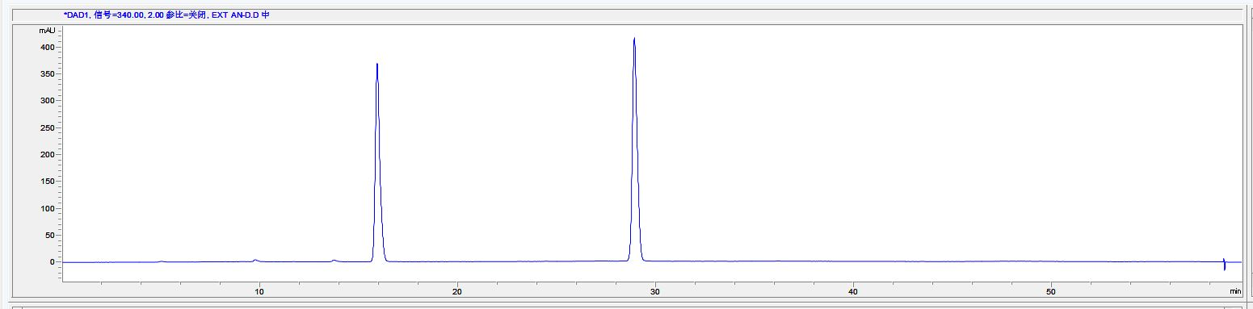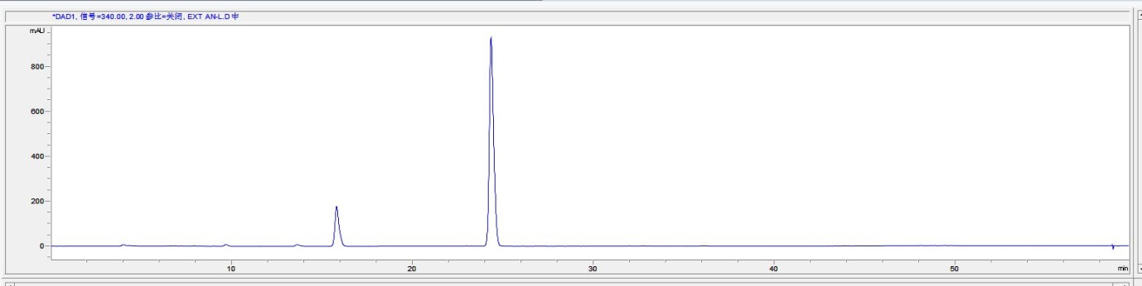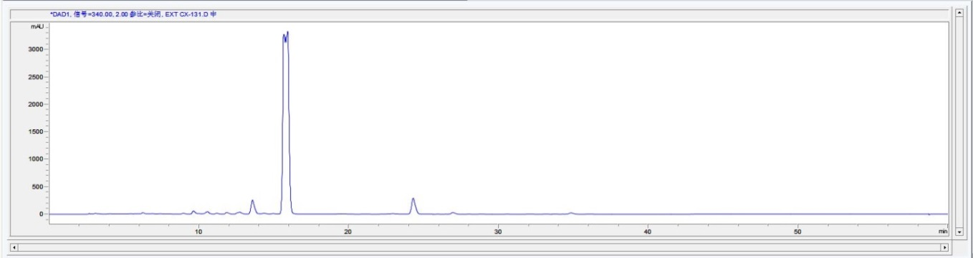

FDAA derivatives of standard L-Ile by ODS column

FDAA derivatives of the acid hydrolysate of **3** by ODS column

FDAA derivatives of standard D-Ile by ODS column

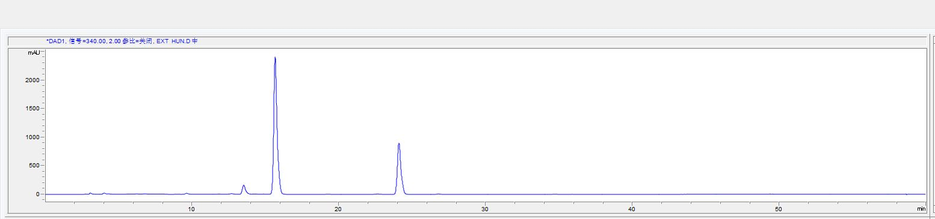

Co-injection of FDAA derivatives of the acid hydrolysates of **3** with standard L-Ile by ODS column

**Supplementary Figure 27**. HPLC analysis of compounds **1**-**3**

Compound **1**: ODS column : Cosmosil-pack, 4.6 × 250 mm, 5 µm, 1 mL/min, Nacalai Tesque; Solvents: (A) water + 0.05% TFA, (B) MeOH; linear gradient: 0 min, 90% A + 10% B; 15 min,

100% B; temperature, 30 °C; UV detection at λmax 262 nm; flow rate, 1; t*R* 14.051; Area%: 96.19%.

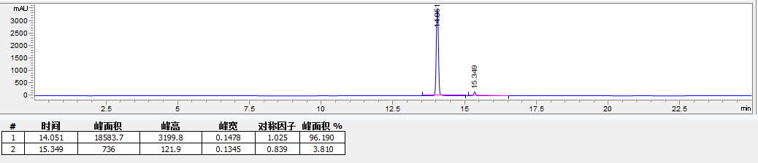

Compound **2**:.ODS column : Cosmosil-pack, 4.6 × 250 mm, 5 µm, 1 mL/min, Nacalai Tesque; Solvents: (A) water + 0.05% TFA, (B) MeOH; linear gradient: 0 min, 90% A + 10% B; 15 min, 100% B; temperature, 30 °C; UV detection at λmax 262 nm; flow rate, 1; t*R* 15.335; Area%: 100%.

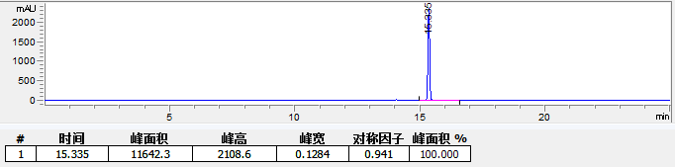

Compound **3**: 5PFP column : Cosmosil-pack, 4.6 × 250 mm, 5 µm, 1 mL/min, Nacalai Tesque; Solvents: (A) water + 0.05% TFA, (B) MeCN; Isocratic system:0 min, 70% A + 30% B; 45 min, 70% A + 30% B; temperature, 30 °C; flow rate, 1; UV detection at λmax 278 nm; t*R* 24.888 min; Area%: 96.589%.

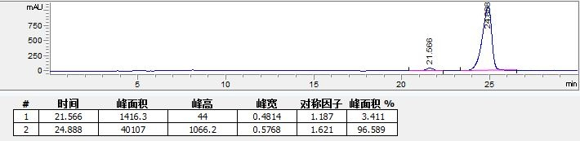

|  |  |  |  |  |  |  |  |  |
| --- | --- | --- | --- | --- | --- | --- | --- | --- |
| **No.** | **5**a | | **6** a | | **7**b | | **8** a | |
| ***δ*C** | ***δ*H, mult.**  (*J* in Hz) | ***δ*C** | ***δ*H, mult.**  (*J* in Hz) | ***δ*C** | ***δ*H, mult.**  (*J* in Hz) | ***δ*C** | ***δ*H, mult.**  (*J* in Hz) |
| 1 | - | - | 175.8, C | - | 172.8, C |  | 175.7, C |  |
| 2 | 135.1,CH | 8.26, br s | 122.7, C | 7.64, br. d, (5.2 ) | 122.8, CH | 7.47, dd, (5.7, 1.5) | 123.0, CH | 7.72, dd, (5.8, 1.5) |
| 3 | 116.6, C | - | 157.1, CH | 6.17, br. d, (5.2 ) | 153.7, CH | 6.21, dd, (5.6, 1.9) | 156.6, CH | 6.19, dd, (6.0, 2.0) |
| 3a | 127.7, C | - | - | - | - | - | - | - |
| 4 | 123.5, CH | 8.2, d, (7.80) | 88.2, CH | 5.08, br. s | 86.1, CH | 4.99, td, (4.8, 1.9) | 88.4 , CH | 5.02, td, (4.9, 1.7) |
| 5 | 124.1, CH | 7.24, d, (7.80) | 71.7, CH | 3.78, m | 71.8, CH | 3.82, m | 72.3, CH | 3.71, m |
| 6 | 125.3, CH | 7.27, d, (8.00 ) | 34.2, CH2 | 1.57, overlap | 33.1, CH2 | 1.60, overlap | 34.2, CH2 | 1.57, m |
| 7 | 113.8, CH | 7.49, d, (8.00 ) | 30.6, CH2 | 1.36, overlap | 29.4, CH2 | 1.36, overla | 30.7, CH2 | 1.38, m |
| 7a | 139.1, CH | - | - | - | - | - | - | - |
| 8 | - | - | 26.8, CH2 | 1.36, overlap | 25.5, CH2 | 1.36, | 26.8, CH2 | 1.38, m |
| 9 | - | - | 26.8, CH2 | 1.57, overlap | 25.4, CH2 | 1.60, overlap | 26.8, CH2 | 1.57, m |
| 10 | - | - | 40.1, CH2 | 1.42, m | 39.1, CH2 | 1.44, overlap | 40.1, CH2, | 1.43, m |
| 11 | - | **-** | 68.5, CH | 3.70, m | 68.1, CH | 3.77, m | 68.5, CH | 3.71, m |
| 12 | - | - | 23.5, CH3 | 1.14, d, (5.6) | 23.6, CH3 | 1.19, d, ( 6.0) | 23.5, CH3 | 1.14, d, (6.2) |
| 1ˈ | 192.7,C | - | - | - | - | - | - | - |
| 2ˈ | 47.9, CH2 | 4.62, s | - | - | - | - | - | - |
| 3ˈ | - | - | - | - | - | - | - | - |
| 4ˈ | 174.2, CH | - | - | - | - | - | - | - |
| 5ˈ | 23.3, CH3 | 2.11, s | - | - | - | - | - | - |

**Supplementary Table 1.** 1H and 13C NMR data for **5-8** (500 and 125 MHz, *δ* in ppm)

a 1H and 13C NMR Data were measured in CD3OD. b 1H and 13C NMR Data were measured in CDCl3.



**Supplementary Table 2.** Appearance, specific rotation and MS data for **5-8**

|  |  |  |  |
| --- | --- | --- | --- |
| Compounds | Appearance | [α]D  (20C, MeOH) | Molecular weghit and Molecular formula |
| **5** | white solid | - | 239.0812 [M + Na]+  calcd. for C12H12N2O2Na: 239.0791 |
| **6** | yellow oil | -127 (*c* 0.2) | 251.1267 [M +Na]+  calcd. for C12H20O4Na: 251.1254 |
| **7** | yellow oil | -53 (*c* 0.2) | 251.1239 [M +Na]+  calcd. for C12H20O4Na : 251.1254 |
| **8** | yellow oil | +67 (*c* 0.2) | 251.1274 [M +Na]+  calcd. for C12H20O4Na : 251.1254 |