Supplementary Figure 3A. AABC Chart: Cause Analysis Chart

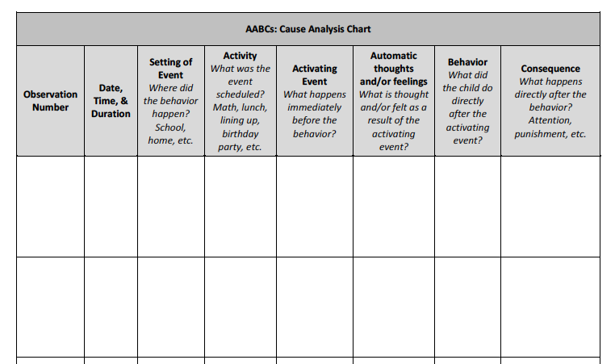

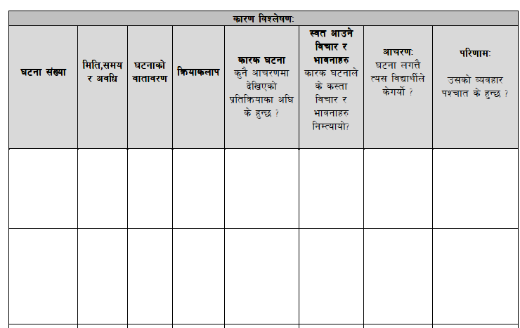
Supplementary Figure 3B. Themes of AABC Chart

Themes of AABC Chart
Date, Time, & Duration | 1. Common days of the week  2. Common time of day when the Behavior occurs (specify morning, afternoon, or evening)
Setting of Event | 1. School  2. Home  3. Both  4. If other, specify
Activity | 1. Specific subject (specify subject)  2. Unstructured time (lunch, recess, break time, or specify if other)  3. Transitions (specify from what/where and to what/where is the transition)  4. If other, specify
Activating Event  What happens immediately before the behavior? | 1. Peer interaction (specify socializing, being alone, or specify if other)  2. Adult interaction (specify school staff, family, or specify if other)  3. Involving a challenging task for the student (specify task)  4. If other, specify
Automatic thoughts and/or feelings  What is thought and/or felt as a result of the activating event? | 1. Thought types: self-image or others' images, one's or others' capabilities, one's self-worth or others' worth, worry for self or other, injustice, betrayal  2. Feelings types: angry, frustrated, sad, happy, scared  3. If other, specify  4. Core beliefs and evidence to support
Behavior  What did the child do directly after the activating event? | 1. Physical behavior (specify aggression (specify if towards person, animal, property, or specify if other), yelling, crying, sleeping, silent, or specify if other)  2. Mood (specify happy, sad, angry, worried, blunted, or specify if other)  3. If other, specify
Consequence  What happens directly after the behavior? | 1. Attention (specify positive or negative)  2. Escape  3. Tangible  4. Sensory  5. If other, specify
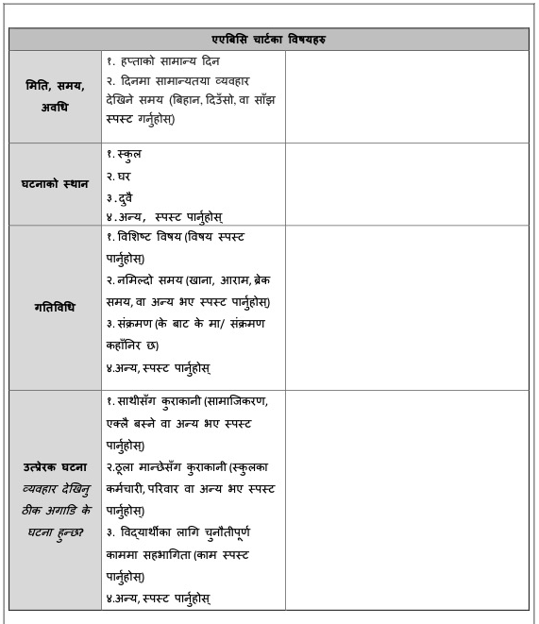
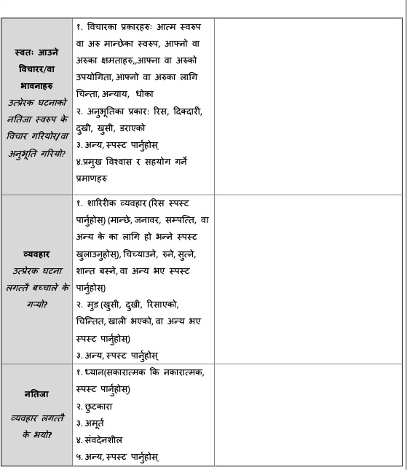

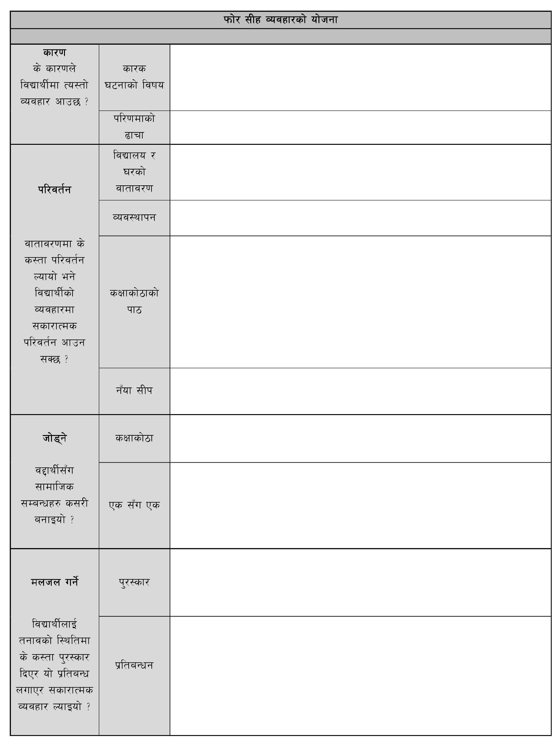
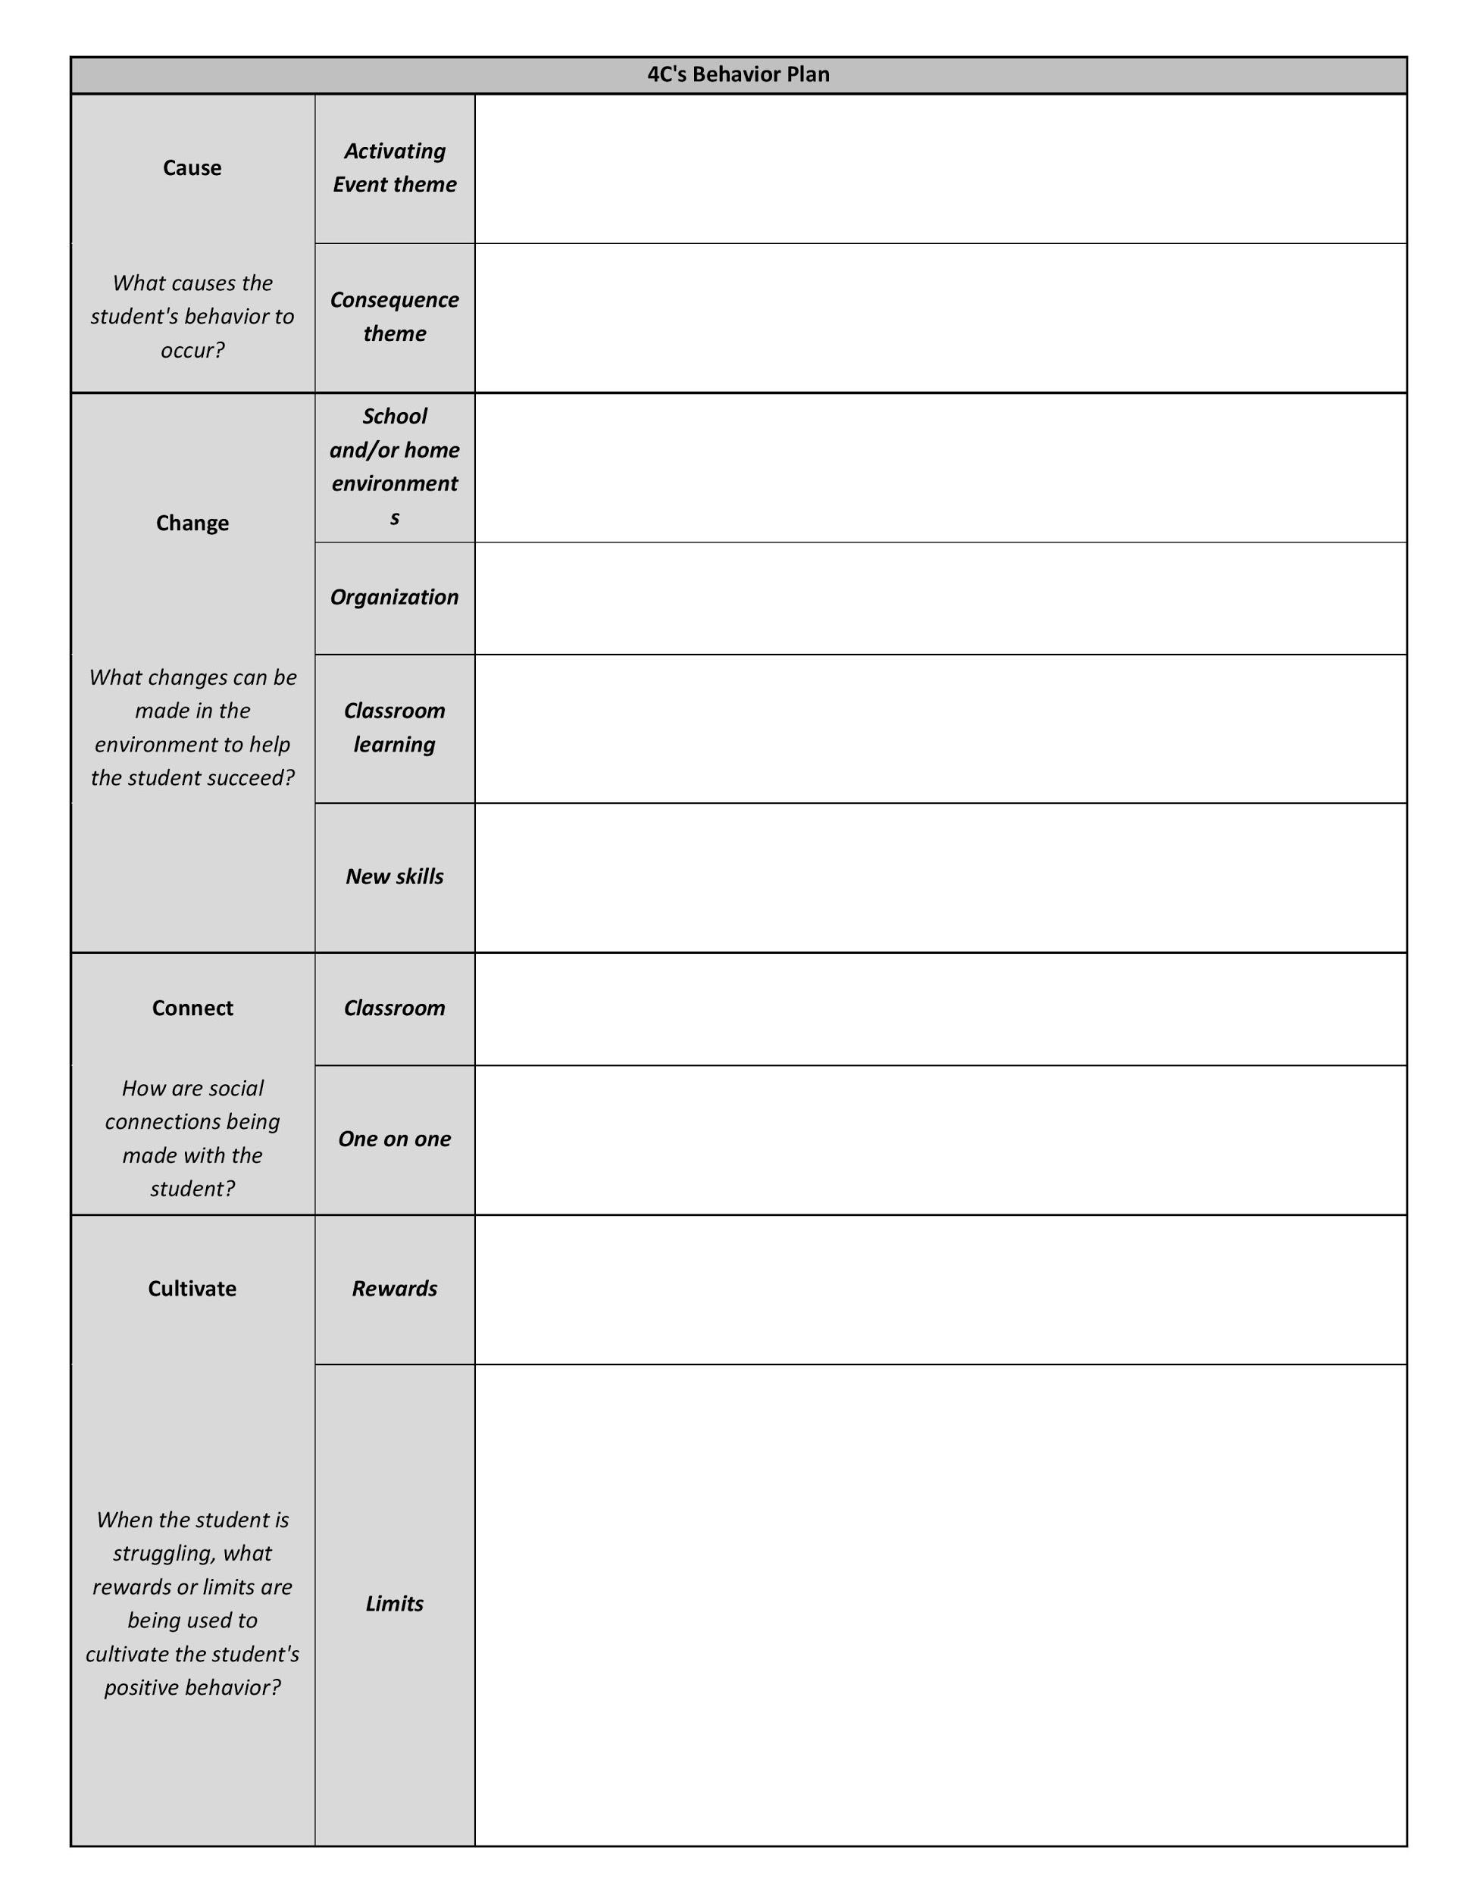
Supplementary Figure 3C. 4Cs Behavior Plan

