Supplementary Material
Table of Contents

Supplemental Table 1. STROBE checklist for cross-sectional studies..…………...………Page 2

Supplemental Table 2. Summary of missing data………………………....……….………Page 3

Supplemental Table 3. Univariate associations between hospital mortality and early indicators of inflammation, immune suppression, and myeloid derived suppressor cell (MDSC) populations……………………………………….………………………....……….………Page 6

Supplemental Figure 1. Gating strategy for myeloid-derived suppressor cells…………….Page 7

Supplemental Figure 2. Illustrative examples of enzyme-linked immunospot assays….….Page 8

Supplemental Figure 3. Additional inflammatory cytokine time series analyses…………..Page 9

Supplemental Table 1. STROBE checklist for cross-sectional studies.

 | Item No | Recommendation | Page No
Title and abstract | 1 | (a) Indicate the study’s design with a commonly used term in the title or the abstract | 1
 |  | (b) Provide in the abstract an informative and balanced summary of what was done and what was found | 1
Introduction
Background/rationale | 2 | Explain the scientific background and rationale for the investigation being reported | 2
Objectives | 3 | State specific objectives, including any prespecified hypotheses | 2
Methods
Study design | 4 | Present key elements of study design early in the paper | 2-4
Setting | 5 | Describe the setting, locations, and relevant dates, including periods of recruitment, exposure, follow-up, and data collection | 2-4
Participants | 6 | (a) Give the eligibility criteria, and the sources and methods of selection of participants | 2,3
Variables | 7 | Clearly define all outcomes, exposures, predictors, potential confounders, and effect modifiers. Give diagnostic criteria, if applicable | 2-4
Data sources/ measurement | 8 | For each variable of interest, give sources of data and details of methods of assessment (measurement). Describe comparability of assessment methods if there is more than one group | 2-4
Bias | 9 | Describe any efforts to address potential sources of bias | 3, 4
Study size | 10 | Explain how the study size was arrived at | 4
Quantitative variables | 11 | Explain how quantitative variables were handled in the analyses. If applicable, describe which groupings were chosen and why | 4
Statistical methods | 12 | (a) Describe all statistical methods, including those used to control for confounding | 4
 |  | (b) Describe any methods used to examine subgroups and interactions | 4
 |  | (c) Explain how missing data were addressed | 4
 |  | (d) If applicable, describe analytical methods taking account of sampling strategy | Not applicable
 |  | (e) Describe any sensitivity analyses | 4
Results
Participants | 13 | (a) Report numbers of individuals at each stage of study—eg numbers potentially eligible, examined for eligibility, confirmed eligible, included in the study, completing follow-up, and analysed | 4
 |  | (b) Give reasons for non-participation at each stage | 4
 |  | (c) Consider use of a flow diagram | Considered
Descriptive data | 14 | (a) Give characteristics of study participants (eg demographic, clinical, social) and information on exposures and potential confounders | 4, 5, Table 1
 |  | (b) Indicate number of participants with missing data for each variable of interest | Supplement
Outcome data | 15 | Report numbers of outcome events or summary measures | 4-6, Table 2
Main results | 16 | (a) Give unadjusted estimates and, if applicable, confounder-adjusted estimates and their precision (eg, 95% confidence interval). Make clear which confounders were adjusted for and why they were included | 4-6, Table 2
 |  | (b) Report category boundaries when continuous variables were categorized | Not applicable
 |  | (c) If relevant, consider translating estimates of relative risk into absolute risk for a meaningful time period | Not applicable
Other analyses | 17 | Report other analyses done—eg analyses of subgroups and interactions, and sensitivity analyses | 5, 6, Figures 2 and 4
Discussion
Key results | 18 | Summarise key results with reference to study objectives | 6
Limitations | 19 | Discuss limitations of the study, taking into account sources of potential bias or imprecision. Discuss both direction and magnitude of any potential bias | 8
Interpretation | 20 | Give a cautious overall interpretation of results considering objectives, limitations, multiplicity of analyses, results from similar studies, and other relevant evidence | 6-8
Generalisability | 21 | Discuss the generalisability (external validity) of the study results | 8
Other information
Funding | 22 | Give the source of funding and the role of the funders for the present study and, if applicable, for the original study on which the present article is based | 8

Supplemental Table 2. Summary of data missing at random or censored over time relative to the total number of subjects enrolled.

Variable | Percent missing
Age | 0.0
Female | 0.0
Race
African American | 0.0
American Indian | 0.0
Asian | 0.0
Pacific Islander | 0.0
White | 0.0
Other or Unknown | 0.0
Body mass index | 0.0
Charlson comorbidity index | 0.0
Comorbidities
Acute renal failure | 0.0
Chronic obstructive pulmonary disease | 0.0
Congestive heart failure | 0.0
Current smoker | 0.0
Diabetes | 0.0
Oral hypoglycemic prescription | 0.0
Insulin prescription | 0.0
Dialysis dependent | 0.0
Disseminated cancer | 0.0
Hypertension | 0.0
Myocardial infarction | 0.0
Peripheral vascular disease | 0.0
Steroid use | 0.0
>10% weight loss in prior 6 months | 0.0
Illness severity
APACHE II score | 0.0
MEWS score | 0.0
Received vasopressors | 0.0
Received mechanical ventilation | 0.0
Secondary infection | 0.0
Pulmonary infection | 0.0
Bloodstream infection | 0.0
Skin or soft tissue infection | 0.0
Non-infectious complication | 0.0
Days between onset and secondary infection | 0.0
ICU length of stay | 0.0
ICU length of stay ≥14 days | 0.0
ICU-free days | 0.0
Ventilator days | 0.0
Hospital length of stay | 0.0
Discharge disposition
Hospital mortality | 0.0
Home | 0.0
Hospice | 0.0
Inpatient rehabilitation | 0.0
Left against medical advice | 0.0
Long term acute care | 0.0
Skilled nursing facility | 0.0
Poor discharge disposition | 0.0
Chronic critical illness | 0.0
Adverse clinical outcome | 0.0
Discharge to 6-month follow-up
Readmission | 15.0
Infection without readmission | 15.0
Death | 15.0
6-12-month follow-up
Readmission | 62.5
Infection without readmission | 62.5
Death | 62.5
Day 1 analytes
IL-6 | 0.0
TNF-alpha | 0.0
IL-8/CXCL-8 | 0.0
IL-1 beta/IL-1F2 | 0.0
HLA-ABC | 27.5
PD-L1 1/B7-H1 | 0.0
IFN-gamma spot count, with IL-7 stimulation | 5.0
IFN-gamma spot size, with IL-7 stimulation | 5.0
IFN-gamma expression, with IL-7 stimulation | 5.0
IFN-gamma spot count, without IL-7 stimulation | 5.0
IFN-gamma spot size, without IL-7 stimulation | 5.0
IFN-gamma expression, without IL-7 stimulation | 5.0
TNF-alpha spot count, with IL-7 stimulation | 7.5
TNF-alpha spot size, with IL-7 stimulation | 7.5
TNF-alpha expression, with IL-7 stimulation | 7.5
TNF-alpha spot count, without IL-7 stimulation | 7.5
TNF-alpha spot size, without IL-7 stimulation | 7.5
TNF-alpha expression, without IL-7 stimulation | 7.5
Day 4 analytes
IL-6 | 12.5
TNF-alpha | 12.5
IL-8/CXCL-8 | 12.5
IL-1 beta/IL-1F2 | 12.5
HLA-ABC | 20.0
PD-L1 1/B7-H1 | 12.5
IFN-gamma spot count, with IL-7 stimulation | 22.5
IFN-gamma spot size, with IL-7 stimulation | 22.5
IFN-gamma expression, with IL-7 stimulation | 22.5
IFN-gamma spot count, without IL-7 stimulation | 22.5
IFN-gamma spot size, without IL-7 stimulation | 22.5
IFN-gamma expression, without IL-7 stimulation | 22.5
TNF-alpha spot count, with IL-7 stimulation | 25.0
TNF-alpha spot size, with IL-7 stimulation | 25.0
TNF-alpha expression, with IL-7 stimulation | 25.0
TNF-alpha spot count, without IL-7 stimulation | 25.0
TNF-alpha spot size, without IL-7 stimulation | 25.0
TNF-alpha expression, without IL-7 stimulation | 25.0
PMN-MDSCs | 12.5
M-MDSCs | 12.5
E-MDSCs | 12.5
Day 7 analytes
IL-6 | 40.0
TNF-alpha | 40.0
IL-8/CXCL-8 | 40.0
IL-1 beta/IL-1F2 | 40.0
HLA-ABC | 52.5
PD-L1 1/B7-H1 | 40.0
IFN-gamma spot count, with IL-7 stimulation | 42.5
IFN-gamma spot size, with IL-7 stimulation | 42.5
IFN-gamma expression, with IL-7 stimulation | 42.5
IFN-gamma spot count, without IL-7 stimulation | 42.5
IFN-gamma spot size, without IL-7 stimulation | 42.5
IFN-gamma expression, without IL-7 stimulation | 42.5
TNF-alpha spot count, with IL-7 stimulation | 40.0
TNF-alpha spot size, with IL-7 stimulation | 40.0
TNF-alpha expression, with IL-7 stimulation | 40.0
TNF-alpha spot count, without IL-7 stimulation | 40.0
TNF-alpha spot size, without IL-7 stimulation | 40.0
TNF-alpha expression, without IL-7 stimulation | 40.0
Day 14 analytes
IL-6 | 65.0
TNF-alpha | 65.0
IL-8/CXCL-8 | 65.0
IL-1 beta/IL-1F2 | 65.0
PD-L1 1/B7-H1 | 65.0
PMN-MDSCs | 70.0
M-MDSCs | 70.0
E-MDSCs | 70.0
Day 21 analytes
IL-6 | 87.5
TNF-alpha | 87.5
IL-8/CXCL-8 | 87.5
IL-1 beta/IL-1F2 | 87.5
PD-L1 1/B7-H1 | 87.5

Supplemental Table 3. Univariate associations between hospital mortality and early indicators of inflammation, immune suppression, and myeloid derived suppressor cell (MDSC) populations among critically ill subjects with bacterial sepsis or SARS-Cov-2 infection.
Analytes | Odds Ratio | P-value
Day 1 IL-1 beta | 0.88 (0.41 - 1.08) | 0.647
Day 1 IL-6 | 1.00 (0.98 - 1.00) | 0.569
Day 1 IL-8 | 1.00 (0.97 - 1.02) | 0.945
Day 1 IL-10 | 0.98 (0.87 - 1.05) | 0.619
Day 1 TNF-alpha | 1.02 (0.88 - 1.13) | 0.710
Day 1 G-CSF | 1.00 (0.97 - 1.00) | 0.735
Day 1 MCP-1/CCL2 | 1.00 (1.00-1.00) | 0.529
Day 1 HLA-DR expression | 0.99 (0.99-0.99) | 0.049
Day 1 sPD-L1 | 1.01 (1.00 - 1.02) | 0.076
Day 1 TNF-alpha LPS spot count | 1.00 (1.00 - 1.01) | 0.175
Day 1 TNF-alpha LPS + IL-7 spot count | 1.01 (1.00 - 1.01) | 0.070
Day 1 TNF-alpha LPS spot size | 1.00 (0.82 - 1.18) | 0.991
Day 1 TNF-alpha LPS + IL-7 spot size | 1.01 (0.87 - 1.16) | 0.869
Day 1 TNF-alpha LPS expression | 1.00 (1.00 - 1.00) | 0.174
Day 1 TNF-alpha LPS + IL-7 expression | 1.00 (1.00 - 1.00) | 0.109
Day 1 IFN-gamma CD3/28 spot count | 1.00 (1.00 - 1.01) | 0.427
Day 1 IFN-gamma CD3/28 + IL-7 spot count | 1.00 (1.00 - 1.01) | 0.396
Day 1 IFN-gamma CD3/28 spot size | 1.05 (0.73 - 1.52) | 0.786
Day 1 IFN-gamma CD3/28 + IL-7 spot size | 1.02 (0.76 - 1.33) | 0.908
Day 1 IFN-gamma CD3/28 expression | 1.00 (1.00 - 1.00) | 0.527
Day 1 IFN-gamma CD3/28 + IL-7 expression | 1.00 (1.00 - 1.00) | 0.464
Day 4 M-MDSC % of MDSCs | 1.02 (0.98 - 1.06) | 0.239
Day 4 PMN-MDSC % of MDSCs | 0.92 (0.72 - 1.02) | 0.294
Day 4 E-MDSC % of MDSCs | 0.99 (0.95 - 1.03) | 0.557
IL: interleukin, TNF: tumor necrosis factor, G-CSF: granulocyte-colony stimulating factor, MCP: monocyte chemoattractant protein, CCL: chemokine ligand, HLA: human leukocyte antigen, PD-L: programmed death-ligand, LPS: lipopolysaccharide, M-MDSCs: monocytic MDSCs, PMN-MDSCs: granulocytic MDSCs, E-MDSCs: erythroid MDSCs. P-values were not corrected for multiple comparisons.

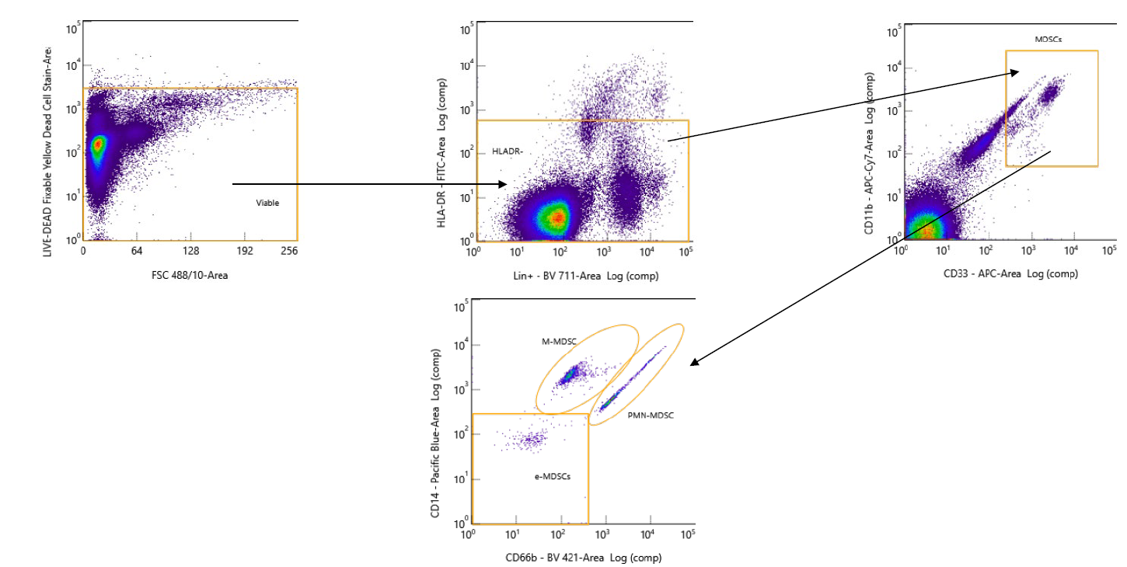

Supplemental Figure 1. Gating strategy for myeloid-derived suppressor cells with Ficoll enriched whole blood and cells fixed in 4% paraformaldehyde solution.

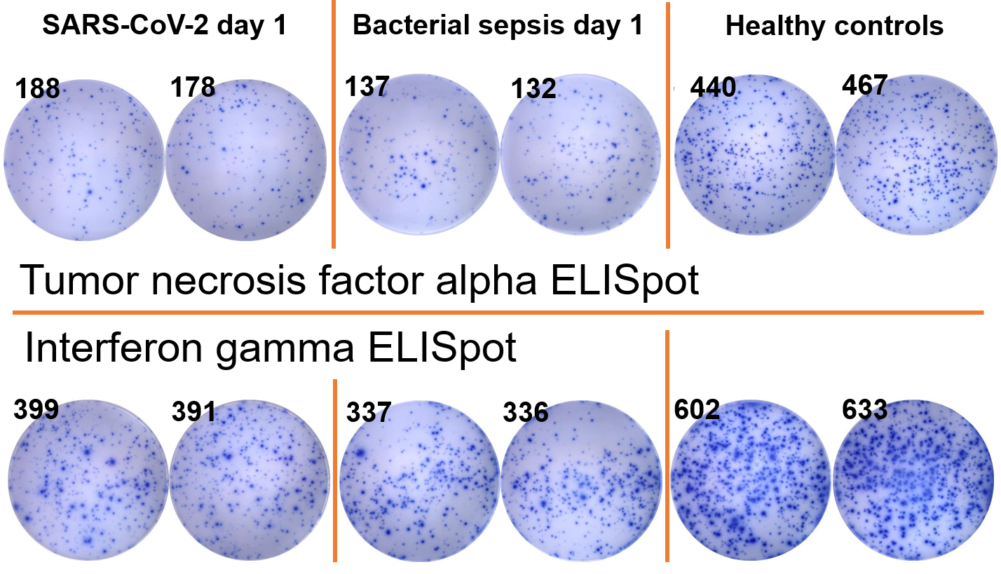

Supplemental Figure 2. Illustrative examples of enzyme-linked immunospot assays (ELISpot). Numbers appearing on the top left of each well represent spot counts.

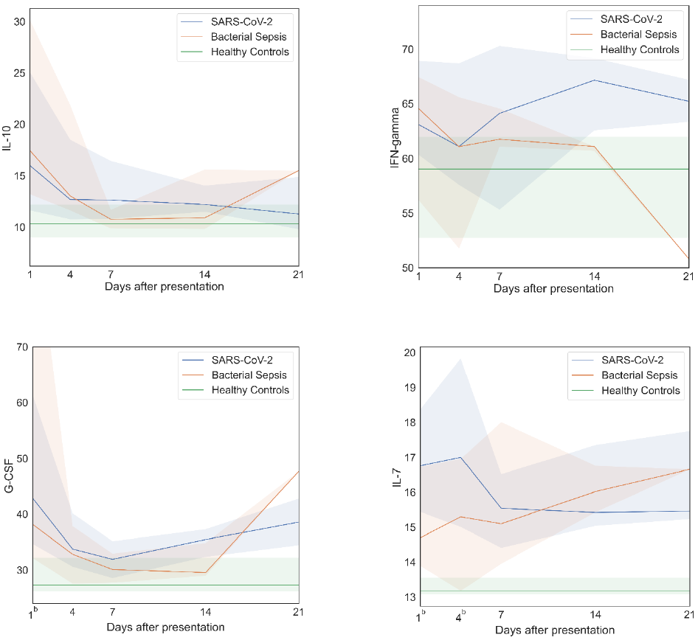

Supplemental Figure 3. Additional inflammatory cytokine time series analyses. After bacterial sepsis, inflammatory cytokines peaked on sampling day one and then declined; after SARS-CoV-2 infection, inflammatory cytokines were persistently elevated or increased over time. Data are presented as median values (colored lines) and interquartile ranges (shaded regions). Groups were compared by generalized estimating equations with p-values corrected for multiple comparisons by the Benjamini-Hochberg procedure. Superscript letters indicate time points at which group comparisons had p≤0.05. At each time point, all available values (as listed in Supplemental Table 2) were included in all statistical tests for 30 SARS-CoV-2 patients, 10 bacterial sepsis patients, and 10 healthy control patients. ªSARS-CoV-2 vs. Bacterial Sepsis; ^{b}SARS-CoV-2 vs. Healthy Controls; ^{c}Bacterial Sepsis vs. Healthy Controls. IL: interleukin, IFN: interferon, G-CSF: granulocyte colony-stimulating factor.

